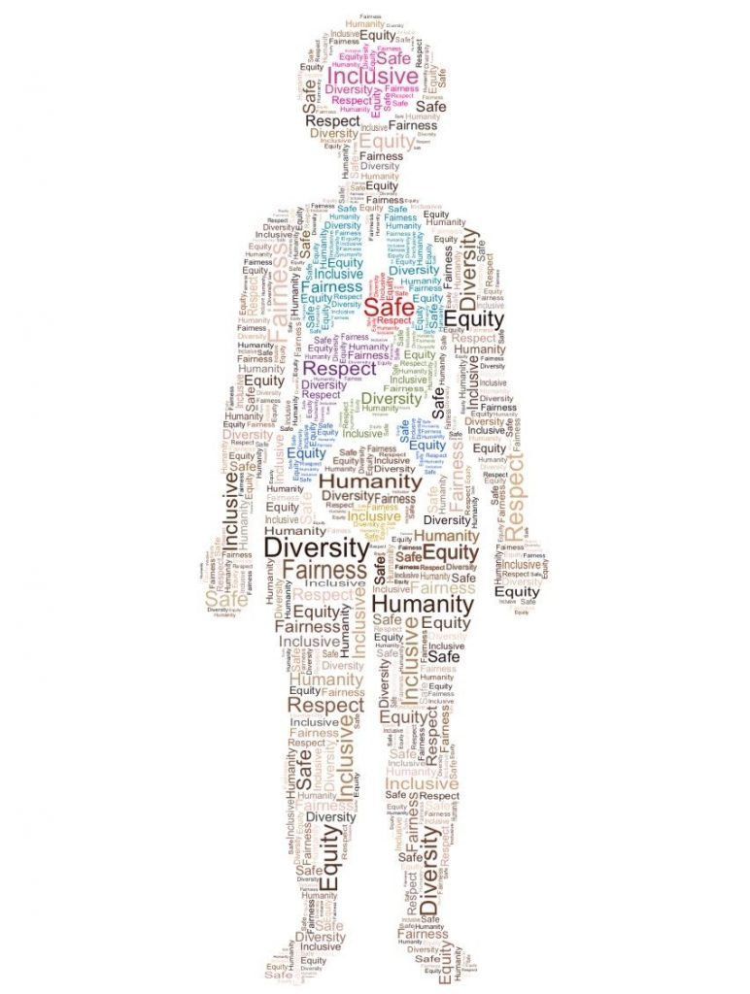

Introduction to Health Assessment for the Nursing Professional-Part II

Introduction to Health Assessment for the Nursing Professional-Part II

.

Introduction to Health Assessment for the Nursing Professional-Part II by . is licensed under a Creative Commons Attribution-NonCommercial 4.0 International License, except where otherwise noted.

Contents
- Introduction
- Contact Information and Acknowledgments
- Pain Assessment
- Learning Outcomes
- Introduction to Pain
- Conceptualizing Pain
- Classifying Pain
- Reflecting on Your Own Biases
- Racism and Pain Assessment
- Pain Assessment
- Timing and Frequency of Screening for and Assessment of Pain
- Subjective Assessment Overview
- Pain Assessment Tools
- Unidimensional Pain Assessment Tools
- Multidimensional Pain Assessment Tools
- PQRSTU Mnemonic
- Brief Pain Inventory
- Pain Scales: Clients with Cognitive Impairment
- FLACC Pain Tool
- Pain Assessment in Critical Care
- Summary: Subjective Assessment and Pain Assessment Tools
- Objective Assessment
- Clinical Judgement: Case Study
- Key Takeaways
- Integumentary System
- Learning Outcomes
- Introduction to Integumentary System
- Starting Your Assessment
- Subjective Assessment
- Objective Assessment
- Skin: Inspection
- Skin: Palpation
- Nails: Inspection and Palpation
- Hair: Inspection and Palpation
- Health Promotion and Disease Prevention: Considerations and Interventions
- Clinical Judgment: Case Study
- Key Takeaways
- Musculoskeletal System
- Learning Outcomes
- Introduction to the Musculoskeletal System
- Subjective Assessment
- Brief Scan: MSK System
- Objective Assessment
- Face, Neck, and Cranium
- Arms, Hands, and Related Joints
- Thoracic Cage and Spine
- Legs, Feet, and Related Joints
- Health Promotion and Disease Prevention: Considerations and Interventions
- Clinical Judgement: Case Study
- Key Takeaways
- Peripheral Vascular System
- Learning Outcomes
- Introduction to the Peripheral Vascular System
- Subjective Assessment
- Objective Assessment
- Inspection and Palpation of Hands and Arms
- Inspection and Auscultation of Abdominal Vasculature
- Inspection and Palpation of Feet and Legs
- Health Promotion and Disease Prevention: Considerations and Interventions
- Clinical Judgement: Case Study
- Key Takeaways
- Lymphatic System
- Learning Outcomes
- Introduction to Lymphatic System
- Subjective Assessment
- Objective Assessment
- Assessment of Lymphedema
- Inspection and Palpation of the Lymph Nodes
- Health Promotion and Disease Prevention: Considerations and Interventions
- Clinical Judgement: Case Study
- Key Takeaways
- Appendix

1
This resource is part of a series. Part I of the first Introduction to Health Assessment for the Nursing Professional can be found at: https://pressbooks.library.torontomu.ca/assessmentnursing/
Other related resources are noted below.
This book is best viewed via the online, Pressbooks format so that you can view the videos and interactive activities. However, a PDF format is made available.
“Introduction to Health Assessment for the Nursing Professional” is an open educational resource (OER) created for undergraduate nursing students at the introductory level. Educators co-curated this OER in collaboration with students for students. This resource is a unique contribution to nursing education as content is theoretically informed by health promotion in the Canadian context and by an inclusive approach to health assessment that incorporates culturally-responsive techniques related to race/ethnicity, gender/sex/sexual orientation, body sizes/types, and ability/disability. It is the first health assessment resource that is informed by clinical judgment with the goal to facilitate students’ clinical decision making and ability to prioritize care by recognizing and acting on cues and signs of clinical deterioration. Interactive clinical judgment activities and formative assessments to evaluate a student’s learning are integrated throughout the resource. The integration of clinical judgment throughout this resource will support students’ capacity to enhance patient safety and equitable health outcomes as well as their success in writing national nursing exams to become licensed to work as a Nurse.

All of these resources build on existing open resources specific to health assessment including:
The complete subjective health assessment: https://ecampusontario.pressbooks.pub/healthassessment/
Vital sign measurement across the lifespan: https://pressbooks.library.ryerson.ca/vitalsign2nd/
Physical examination techniques: A nurse’s guide: https://pressbooks.library.ryerson.ca/ippa/
Introduction to communication in nursing: https://pressbooks.library.ryerson.ca/communicationnursing/
Documentation in nursing: 1st Canadian edition: https://pressbooks.library.ryerson.ca/documentation/

All of the listed OER are published under an open license. Thus, you can use them for free or modify them to suit your student and course needs with appropriate attribution. In the future, we will be adding additional chapters to the “Introduction to Health Assessment for the Nursing Professional” OER.

Licensing
This resource is licensed under Creative Commons Attribution NonCommerical.

Funding
This project is made possible with funding by the Government of Ontario and through eCampusOntario’s support of the Virtual Learning Strategy. To learn more about the Virtual Learning Strategy visit: https://vls.ecampusontario.ca
Views expressed in the publication are the views of Recipient and do not necessarily reflect those of the Province of Ontario or OOLC

Accessibility
This book was designed with accessibility in mind so that it can be accessed by the widest possible audience, including those who use assistive technologies. The web version of this book has been designed to meet the Web Content Accessibility Guidelines 2.0, level AA. While we aim to ensure that this book is as accessible as possible, we may not always get it right. There may be some supplementary third-party materials, or content not created by the authors of this book, which are not fully accessible.
If you are having problems accessing any content within the book, please contact: Dr. Jennifer Lapum at jlapum@ryerson.ca Please let us know which page you are having difficulty with and include which browser, operating system, and assistive technology you are using.
This project is made possible with funding by the Government of Ontario and through eCampusOntario’s support of the Virtual Learning Strategy. To learn more about the Virtual Learning Strategy visit: https://vls.ecampusontario.ca

2

Contact Information and Acknowledgments

Contact Information
Dr. Jennifer Lapum, PhD, RN, Professor, Associate Director of Quality Assurance, Daphne Cockwell School of Nursing, Toronto Metropolitan University (formerly Ryerson University), Toronto, ON., Canada, jlapum@torontomu.ca, @7024thpatient
Michelle Hughes, MEd, BScN, RN, Professor, School of Community and Health Studies, Centennial College, Toronto, Ontario, Canada, mhughes@centennialcollege.ca, @hughes0311

Acknowledgments
Instructional design consultant: Nada Savicevic, MA Interactive Design, MSc Architecture, BSc Eng Arch, Educational Developer, Centre for Excellence in Learning and Teaching, Toronto Metropolitan University, Toronto, Canada
Copyeditor: Linn Clark, Research and Editing Services, Toronto, Canada
Pressbooks consultant: Sally Wilson, Web Services Librarian, Toronto Metropolitan University, Toronto, Canada
Accessibility consultant: Adam Chaboryk, IT Accessibility Specialist, Toronto Metropolitan University, Toronto, Canada
Copyright consultant: Ann Ludbrook, Copyright and Scholarly Engagement, Librarian, Toronto Metropolitan University, Toronto, Canada
Thank you to Daphne Cockwell School of Nursing at Toronto Metropolitan University for supporting this project and sharing their lab space to film the assessment videos.

Artist / Illustrators
Arina Bogdan, BScN, RN (cover art, and images in peripheral vasculature and lymphatics chapters)

Student Advisory Committee
Sarah Ahmed, Toronto Metropolitan, Centennial, George Brown Collaborative Nursing Degree Program, Toronto, Ontario, Canada
Alexis Andrew, Toronto Metropolitan, Centennial, George Brown Collaborative Nursing Degree Program, Toronto, Ontario, Canada
Ding Ding Ding, Toronto Metropolitan, Centennial, George Brown Collaborative Nursing Degree Program, Toronto, Ontario, Canada
Angelika Guanlao, Toronto Metropolitan, Centennial, George Brown Collaborative Nursing Degree Program, Toronto, Ontario, Canada
Ariana Kavianpour, Toronto Metropolitan, Centennial, George Brown Collaborative Nursing Degree Program, Toronto, Ontario, Canada
Joon Lee, Toronto Metropolitan, Centennial, George Brown Collaborative Nursing Degree Program, Toronto, Ontario, Canada
Lathania Lewis, Toronto Metropolitan, Centennial, George Brown Collaborative Nursing Degree Program, Toronto, Ontario, Canada
Celina Odvina, Toronto Metropolitan, Centennial, George Brown Collaborative Nursing Degree Program, Toronto, Ontario, Canada
Jason Salvador, Toronto Metropolitan, Centennial, George Brown Collaborative Nursing Degree Program, Toronto, Ontario, Canada
Dominic Stewart, Toronto Metropolitan, Centennial, George Brown Collaborative Nursing Degree Program, Toronto, Ontario, Canada

I

Pain Assessment

Authors:
Dr. Jennifer Lapum, PhD, RN, Professor 1
Michelle Hughes, MEd, RN, Professor 2
Ovie Onagbeboma, MBA(c), RN 3
Diane MacEachern, MScN, NP-PHC, Professor 2
Dr. Erin Ziegler, PhD, NP-PHC, Assistant Professor 1
Dr. Nadia Prendergast, PhD, RN, Assistant Professor 1
Dr. Charlotte Lee, PhD, RN, Associate Professor 1
Nada Savicevic, MA, MSc Arch, Educational Developer 1
Sheilagh Callahan, MScN, RN, Professor 4
Vikky Leung, MN, RN, Professor 2
Caitlin Cosgrove, nursing student 1
Sabrina Gebreamlak, nursing student 1
Starr Ferguson, nursing student 1

Consultants:
Margaret Verkuyl2, Evan Accettola1, Praveen Govindaraj5

1 Toronto Metropolitan University
2 Centennial College
3 Canadian Black Nurses Alliance
4 George Brown College
5 Markham Stouffville Hospital

1

Learning Outcomes

Learning Outcomes
- Apply subjective assessment skills.
- Apply objective assessment skills.
- Use clinical judgement.
- Integrate an inclusive approach to pain assessment.

2

Introduction to Pain
Almost everyone has experienced the physical sensation of pain. You may have felt a headache, a backache, or pain from a paper cut or a burn from touching a hot surface.
Consider the last time you experienced pain. What did it feel like? How did it affect you? (e.g., physically, emotionally, socially). Was there tissue damage? These questions help us understand the nature of pain and how it affects each person.
Pain is a complex phenomenon, so we need to understand how it is conceptualized, classified, and the various types of pain. All of these components influence best practices related to pain assessment. It is important to be aware of theRNAO (2013)best practice guidelines related to pain assessment and management. These guidelines provide information and resources related to assessment, planning, implementation and evaluation of pain, among other recommendations.
Let’s begin by exploring the phenomenon of physical pain.

References
RNAO (2013). Assessment and management of pain. 3rd edition.https://rnao.ca/bpg/guidelines/assessment-and-management-pain

3

Conceptualizing Pain
The International Association for the Study of Pain [IASP] (2020) recently redefined their 1979 definition of pain as “an unpleasant and sensory experience associated with, or resembling that associated with, actual or potential tissue damage.” The IASP’s definitions are widely known and accepted, and highlight the emotional, the sensory, and the potential tissue damage associated with pain.
However, pain researchers and clinicians continue to critique and expand on the IASP’s definition because it has the potential to overshadow important components. Additional considerations include:
- More emphasis on the subjective nature of pain in terms of how it is personalized to the client.
- The need to emphasize the somatic nature of pain in terms of how it is embedded within the body (Cohen et al., 2018).
- A more comprehensive descriptor of pain than “unpleasant”, which may act to minimize what may be described as quite distressing for some (Craig & MacKenzie, 2021).
- The cognitive and social features of pain (Craig & MacKenzie, 2021) in terms of how pain affects one’s cognitive capacity (how one thinks, reasons, and remembers) and social functioning (engaging in social interactions and interpersonal relationships).
- Also, keep in mind, that not all physical pain is associated with tissue damage.
By expanding and critiquing how pain is conceptualized, we can obtain a more comprehensive and inclusive understanding of what pain is and as a result, how it is best assessed and managed. What is important to take away from these definitions is that pain is complex and multifaceted.

References
Cohen, M., Quintner, J., & van Rysewyk, S. (2018). Reconsidering the International Association for the Study of Pain definition of pain. Pain Reports, 3(2), 1-7.https://doi.org/10.1097/PR9.0000000000000634
Craig, K., & MacKenzie, N. (2021). What is pain: Are cognitive and social features core components? Pediatric & Neonatal Pain, 3(3), 106-118.https://doi.org/10.1002/pne2.12046
International Association for the Study of Pain (2020). IASP announces revised definition of pain.https://www.iasp-pain.org/publications/iasp-news/iasp-announces-revised-definition-of-pain/

4

Classifying Pain
Pain can be classified in many ways. The next sections present several classifications. It is important to recognize that these are not mutually exclusive, and a person may experience multiple classifications of pain at the same time. See Figure 1 for classifications of pain.
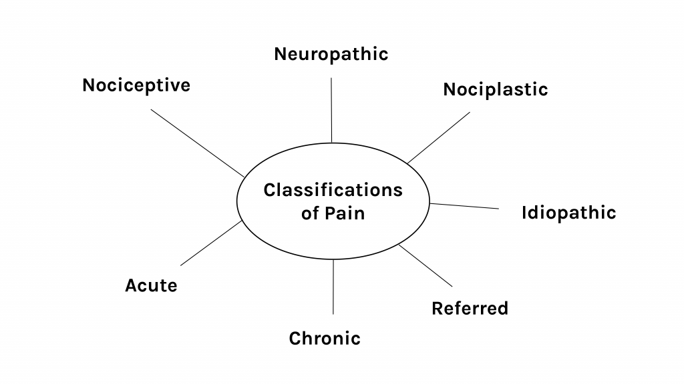
Figure 1: Classifications of pain.

Acute Pain
Acute pain is short or limited in duration and often caused by something specific. Types of acute pain are surgical pain during the operative and postoperative period, a headache, bee sting, labour pains, menstrual pain, and injuries such as an ankle sprain, fracture, or burn. Although acute pain can shift into chronic pain, it typically follows a predictable trajectory and subsides when the cause of pain is resolved or healed. Acute pain can last anywhere from a moment to upwards of three to six months. Beyond this timeframe, it is typically considered chronic pain.
The intensity of acute pain can range from mild to severe. The intensity may also influence the signs and symptoms of pain that are associated with sympathetic nervous stimulation and the fight or flight response including the stimulation of hormones such as cortisol and adrenaline.
The cascade of signs and symptoms during the acute pain period may include:
- Changes in vital signs: tachycardia, tachypnea, shallow breathing, elevated blood pressure, and elevated temperature. Sometimes oxygen saturations can decrease, particularly when clients are breathing fast and shallow and as such not taking a full inspiration. Prolonged changes in these vital signs can lead to ischemia, thus pain management is essential.
- With increased body temperature, the nervous system stimulates the sweat glands to help cool the body. Thus, clients may experience diaphoresis.
- Digestive enzymes and peristalsis are reduced which leads to difficulty with digestion and gastrointestinal upset including nausea, vomiting, and constipation.
- Other signs of pain may include increased blood glucose levels and pupil dilation.

Chronic Pain
Definitions of chronic pain have evolved and become more specific, but this kind of pain is still referred to as pain that continues to occur and recurs (persistent and recurrent) for about three months or more (Treede et al., 2019). Some definitions suggest six months or more, but in general it is fine to refer to persistent or recurrent pain that lasts three to six months or longer as chronic pain. Another conceptualization of chronic pain (when associated with an injury) is a type of pain that persists beyond the typical or expected healing time. For some, chronic pain never goes away: it may be experienced daily or recur regularly.
Common types of chronic pain include back pain, migraines, arthritis, cancer-related pain, fibromyalgia, and postsurgical and posttraumatic pain.
Chronic pain can be categorized in two broad ways:
- Secondary chronic pain refers to a type of pain that manifests as a result of a disease or condition such as arthritis, cancer, or ear infection – it is “secondary” to these pathological conditions (Treede et al., 2019). It can also be pain that is secondary to, or a result of, treatment such as cancer-related treatment.
- Primary chronic pain is a more recent classification. It is a type of pain based on a condition that is often poorly understood and cannot be accounted for by another cause or disease process (Nicholas et al., 2019; Treede et al., 2019, 2015). Common types of primary chronic pain include many types of neck and back pain, fibromyalgia syndrome, and irritable bowel syndrome (Nicholas et al., 2019).
In patients with chronic pain, the physiological and vital sign changes are not necessarily evident because the body adapts to the pain to a certain extent. The effects of chronic pain typically include cognitive and social changes, such as:
- Sleep disruptions.
- Mood disturbances including depression.
- Interference with daily activities.
- Cognitive impairment including the ability to think clearly.
- Social and relational effects.

Nociceptive Pain
Nociceptive pain involves a noxious stimulus (mechanical, thermal, or chemical) that activates nociceptors with the potential to cause non-neural tissue injury (Bonezzi et al., 2020). This is a common type of pain that many of us have experienced and is often categorized as:
- Mechanical (e.g., stubbing your toe, receiving a needle, straining a muscle).
- Thermal (e.g., touching a hot surface like a stove).
- Chemical (e.g., exposure to a chemical such as bleach).
(Bonezzi et al., 2020).
These stimuli activate the nociceptors, which are receptors in the periphery of the somatosensory nervous system (IASP, 2021). Considering these stimuli, it makes sense that nociceptive pain is described as localized with a specific location in the body. Nociceptive pain can be categorized as somatic and visceral. Somatic refers to a type of pain that originates in peripheral tissues such as the skin, bone, muscles, tendons, or ligaments, whereas visceral refers to a type of pain that originates in the body’s internal organs (e.g., heart, intestines, appendix, kidneys) (Bonezzi et al., 2020).

Neuropathic Pain
Neuropathic pain originates from a “lesion or disease of the somatosensory nervous system” (IASP, 2021). Neuropathic pain has a different subjective sensation than nociceptive pain and is often described as burning, stabbing, numbness, tingling, and shooting (electric-shock like) with sensitivity to touch and temperature. As such, the client’s qualitative description of their pain is important to assess in order to help you better understand the causative factors. Causes can be related to trauma along a nerve, conditions such as carpal tunnel syndrome, spinal cord injury, stroke, diabetes, and multiple sclerosis, and infections such as herpes simplex virus (cold sore) or varicella-zoster virus (shingles).

Nociplastic Pain
Nociplastic pain originates from “altered nociception” with unclear evidence of actual or potential tissue damage (IASP, 2021). This classification of pain has no obvious nociceptor activation or neuropathy, but involves altered nociceptive function, which can be confirmed by sensory testing (Kosek et al., 2016). To be clear: although there is no obvious tissue damage (e.g., a cut in the skin) or nociceptor activation (a stimulus that has caused pressure or extreme temperature to activate the neurons), there is an inference of altered nociceptive function that can be confirmed through sensory testing such as measuring the brain’s electrical activity (Kosek et al., 2016). This classification is relatively new compared to nociceptive and neuropathic pain and was introduced in 2016 (Kosek et al., 2016). The theory is that nociplastic pain is associated with chronic pain conditions such as fibromyalgia and irritable bowel syndrome (Kosek et al., 2016; Bonezzi et al., 2020). It requires careful consideration in terms of assessment and management because of the complexity in how it presents subjectively as well as the lack of biomarkers (Fitzcharles et al., 2021).

Idiopathic Pain
Idiopathic pain or pain of an unknown origin can also be considered a fourth classification. With this type of pain there is no obvious pathology. Although the origin and the cause may be unknown, the pain is very real for clients. Your assessment here becomes extremely important to help understand the client’s pain.

Referred Pain
Referred pain is pain felt at a bodily location that is different from the site of origin. For example, the site of origin of cardiac ischemia (lack of oxygen to the heart muscle, commonly referred to as chest pain) is the heart. However, cardiac ischemia can be felt in referred locations such as pain down the left arm or in the jaw or neck. This kind of pain referral has a neural basis in which the site of origin shares common neural pathways with another part of the body. See Figure 2 for common pain referral pathways.
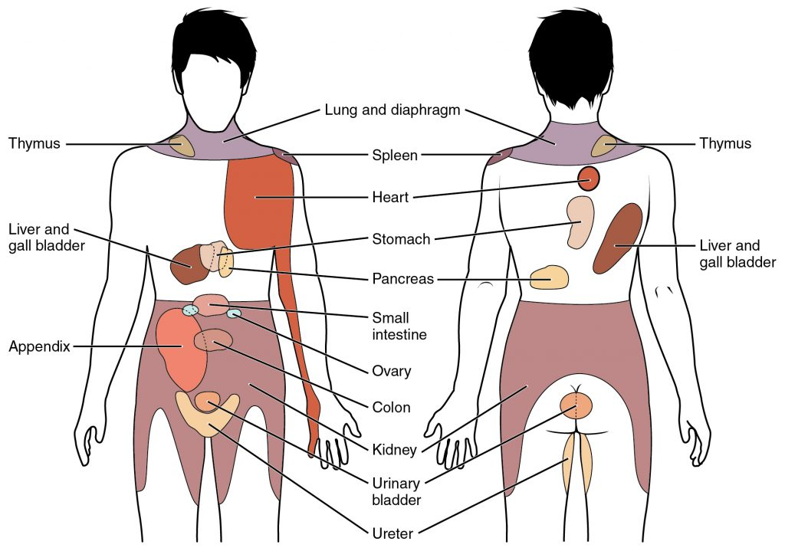
Figure 2: Common pain referral pathways
Attribution statement: Gordon Betts, J., Young, K.A., Wise, J.A., Johnson, E., Poe, B., Kruse, D.H., Korol, O., Johnson, J.E., Womble, M., & DeSaix, P. (2013). The Autonomic Nervous System. In Anatomy and Physiology. OpenStax. Creative Commons Attribution License v4.0. Book URL:https://openstax.org/books/anatomy-and-physiology/pages/1-introductionSection URL:https://openstax.org/books/anatomy-and-physiology/pages/15-2-autonomic-reflexes-and-homeostasis

Activity: Check Your Understanding

An interactive H5P element has been excluded from this version of the text. You can view it online here:
https://pressbooks.library.torontomu.ca/assessmentnursing2/?p=36#h5p-34

References
Bonezzi, C., Fornasari, D., Cricelli, C., Magni, A., & Ventriglia, G. (2020). Not all pain is created equal: Basic definitions and diagnostic work-up. Pain and Therapy, 9(Suppl 1), 1-15.https://doi.org/10.1007/s40122-020-00217-w
Fitzcharles, M., Cohen, S., Clauw, D., Littlejohn, G., Usui, C., & Häuser, W. (2021). Nociplastic pain: Towards an understanding of prevalent pain conditions. The Lancet, 397(10289), 2098-2110.https://doi.org/10.1016/S0140-6736(21)00392-5
International Association for the Study of Pain (2020). IASP announces revised definition of pain.https://www.iasp-pain.org/publications/iasp-news/iasp-announces-revised-definition-of-pain/
International Association for the Study of Pain (2021). Terminology. https://www.iasp-pain.org/resources/terminology/#pain
Kosek, E., Cohen, M., Baron, R., Gebhart, G., Mico, J., Rice, A., Rief, W., & Sluka, K. (2016). Do we need a third mechanistic descriptor for chronic pain states? Pain: The Journal of the International Association for the Study of Pain, 157(7), 1382-1386.https://doi.org/10.1097/j.pain.0000000000000507
Nicholas, M., Vlaeyen, J., Rief, W., Barke, A., Aziz, Q., Benoliel, R., Cohen, M., Evers, S., Giamberardino, M., Göbel, A., Korwisi, B., Perrot, S., Svensson, P., Wang, S., & Treede, R. (2019). The IASP Taskforce for the Classification of Chronic pain. The IASP classification of chronic pain for ICD-11: chronic primary pain. Pain: The Journal of the International Association for the Study of Pain, 160(1), 28–37. https://doi.org/10.1097/j.pain.0000000000001390
Treede, R., Rief, W., Barke, A., Azia, Q., Bennett, M., Benoliel, R., Cohen, M., Evers, S., Finnerup, N., First, M., Giamberardino, M., Kaasa, S., Korwisi, B., Kosek, E., Lavand’homme, P., Nicholas, M., Perrot, S., Scholz, J., Schug, S., Smith, B., Svensson, P., Vlaeyen, J., & Wang, S. (2019). Chronic pain as a symptom or a disease: The IASP Classification of Chronic Pain for the International Classification of Disease (IDC-11). Pain: The Journal of the International Association for the Study of Pain, 160(1), 19-27. https://doi.org/10.1097/j.pain.0000000000001384
Treede, R., Rief, W., Barke, A., Aziz, Q., Bennett, M., Benoliel, R., Cohen, M., Evers, S., Finnerup, N., First, M., Giamberardino, M., Kaasa, S., Kosek, E., Lavand’homme, P., Nicholas, M., Perrot, S., Scholz, J., Schung, S., Smith, B., Svensson, P., Vlaeyen, J., & Wang, S. (2015). A classification of chronic pain for ICD-11. Pain: The Journal of the International Association for the Study of Pain, 156(6), 1003-1007.https://doi.org/10.1097/j.pain.0000000000000160

5

Reflecting on Your Own Biases
Everyone has biases, meaning preconceived notions about something (such as pain) or someone. Biases can be related to race/ethnicity, gender/sex, age, and medical conditions, and they can develop as a result of various factors including culture, personal experiences, and popular media.
When we first see a client, we tend to make assumptions about the presence and even the severity of pain based on cues that are readily available to us (e.g., facial expression, body positioning, vocalizations) (Riva et al., 2011). These assumptions are rooted in our biases regarding what pain looks and even sounds like. These biases may emerge from our own personal experiences. Our initial impressions of a client’s pain can form what is called an “anchor” or have an “anchor effect” in which all additional assessments of the client’s pain are influenced by these initial impressions (Riva et al., 2011). These assumptions can also be based on racist ideas (discussed further in the next section) or on ageist ideas, for example that older people or newborns do not feel pain. Another biased assumption is that people living with cognitive impairment (such as dementia) do not feel pain in the same way as others because they may have difficulty articulating that pain. These assumptions can mean that pain is underassessed and undertreated in certain populations.
It is also very important to be aware that some people may openly talk about their pain and cry out in agony, while others may be stoic and hide their pain. Some people may stay home in bed when they are in pain while others may continue with their daily life and go to work.
Unexplored biases can have a strong influence on pain assessment. This is particularly important considering that healthcare professionals have been found to underestimate pain in comparison with the client’s own self-report (Seers et al., 2018). As such, it is vital that you constantly reflect upon and explore your biases related to pain and pain assessment.
For example, try to explore your own inherent biases related to what pain looks like by reflecting on the following questions:
- How would someone know that you are in pain?
- Could they tell by your facial expression or body position?
- What behaviours would you display if you were in pain? Would you be quiet, grimacing, or smiling? Would you isolate yourself? Would you be trying to sleep, walk around, or talk to others?
- Would you tell someone you were in pain or keep it to yourself? How bad would the pain have to be for you to be concerned or for you to tell someone?
- Would you exaggerate or minimize the level of pain (or pain of a family member) when describing it to a healthcare provider due to fear of discrimination?
Your answers to these questions form part of your cultural bias. If you are not aware of your cultural biases, you may judge the validity of another person’s pain based on your own answers. Ultimately, a person’s pain should be acknowledged, respected, and acted upon (RNAO, 2013).
What we might leave you with is: although your own personal experiences inform your biases, these experiences may also provide you insight into a client’s pain.

References
Riva, P., Rusconi, P., & Montali, L. (2011). The influence of anchoring on pain judgment. Journal of Pain and Symptom Management, 42(2), 265-277. https://doi.org/10.1016/j.jpainsymman.2010.10.264
RNAO (2013). Assessment and management of pain. 3rd edition.https://rnao.ca/bpg/guidelines/assessment-and-management-pain
Seers, T., Derry, S., Seers, K., & Moore, R. (2018). Professionals underestimate patients’ pain: Comprehensive review. Pain, 159(5), 811-818.https://doi.org/10.1097/j.pain.0000000000001165

6

Racism and Pain Assessment
Racism is killing people, and the silence around racism is killing people (Jones, 2021).
Some Canadians, including leaders, are beginning to recognize racism as real, present, and as a public health issue, but many remain silent on the issue and deny the presence of systemic racism in Canada and in healthcare.
Systemic racism includes processes embedded in practices and policies that disadvantage and oppress non-dominant racialized groups (Williams et al., 2019). Social institutions perpetuate racial hierarchies and socialize members of society to accept that non-dominant racialized groups are inferior (Williams et al., 2019). Racism, such as anti-Black racism, affects non-dominant groups from birth to death, and is evidenced in Canadian healthcare by the disparities affecting non-dominant racialized groups (Dryden & Nnorom, 2021).
Some examples to reflect upon:
- Disparities are visible through elevated risks of prematurity and low birthweight, lower income, and lack of access to education, resources, and opportunities for non-dominant racialized groups – all affecting their health and well-being (Williams et al., 2019).
- The stress of racism is very real. It is a vicious circle that perpetuates racial inequities negatively affecting mental and physical health in many ways for nondominant racial groups (Levy et al., 2013).
- A specific example is research funding. Cystic fibrosis mainly affects white people and receives 7–11 times more funding than sickle cell disease, which mainly affects Black people with sub-Saharan African ancestry (Power-Hays & McGann, 2020). This is a clear example of systemic racism: sickle cell disease affects substantially more North Americans, but receives substantially less research funding.
- Some racism is blatant (verbal slurs), but it is also important to consider subtle racism, such as a healthcare professional’s overuse of medication as a restraint or way to control a client.
It is essential to keep in mind that racial disparities can NOT be explained by biological differences (Dryden & Nnorom, 2021). Yet, racism – and accompanying ideas about biological differences – continues to be systemically engrained in healthcare practices and perpetuates inequities. This includes practices surrounding pain assessment and pain management. Racism and systemic inequities have led to undiagnosed pain in non-dominant racialized groups (Morais et al., 2022), including sub-optimal and even catastrophic outcomes for Black people when their pain is not believed or recognized (Akinlade, 2020). Racism and inequities in pain assessment and management is clearly manifested in the treatment of Black clients with sickle cell disease (Power-Hays & McGann, 2020). Pain among this population is often dismissed, leading to reduced quality of life and increased mortality rates: Black people describe being labelled as drug seekers when reaching out for pain management and purposefully dressing nicely before seeking help to minimize racist attitudes (Power-Hays & McGann, 2020).
These general racist attitudes contribute to racialized disparities in pain assessment and pain management (Morais et al., 2022). Additionally, long-held myths and stereotypes that Black people are subhuman were historically used to justify slavery, and these beliefs have also led to pain practices that are clearly not evidence-based.
Reflect on the following examples:
- Hoffman and colleagues (2016) discuss the false and dangerous belief that Black people are different biologically (e.g., thicker skin, fewer nerve endings) and thus, feel less pain. This will lead to an inaccurate assessment of pain and also to disparities and inequities in pain management (Hoffman et al., 2016).
- Another example highlights the existence of racial bias in pain perception. In a multi-stage experiment, participants were shown a series of Black and white faces in pain. The researchers found that white participants had more stringent thresholds to perceive pain on Black versus white faces and would perceive pain earlier on white versus Black faces (Mende-Siedlecki et al., 2019). In addition to affecting assessment practices in terms of observations, this effect is likely to result in Black clients being provided less medication, or to be given non-narcotic pain medication, compared to white clients who often receive narcotic pain medications (Mende-Siedlecki et al., 2019).
- Another study found that Indigenous clients in Canada reported feeling judged by healthcare providers and reporting discrimination when in pain or requesting medication for conditions involving chronic pain (Nelson & Wilson, 2018). This kind of experience has negative effects on the quality of care that Indigenous clients receive, and may result in them choosing not to access needed services.
- Another example of anti-Indigenous racism involves Joyce Echaquan, an Atikamekw client in Quebec. She had gone to the emergency room for stomach pain and described being overmedicated by healthcare providers (APTN News, n.d.). The coroner concluded that systemic racism played a role in how Joyce was treated and in her death (Richardson, 2021). This case highlights the importance of individualized pain assessment and listening, believing, and responding to the client.
These are just some of many examples of systemic racism that the nursing profession must challenge. It is important to recognize that pain in non-dominant racialized people may go undetected, undiagnosed, untreated, and undertreated. Moreover, these individuals may be fearful to seek out healthcare services because of past treatment and racial trauma. Many Black and Indigenous people fear hospitals due to the stigma and institutionalized racism they face.
When assessing pain, healthcare providers must be aware of and remain sensitive to racism. When we see racism, we need to name it. It’s killing people. We need to speak up. Have a discussion. Act and advocate. Advocating takes courage. Start with reflecting and having conversations with others. Voice what you are seeing and collaborate with others to challenge racism.

Clinical Tip
Always remember: pain is what the client tells you it is.
This is important for all nurses and healthcare professionals to recall because people hold unconscious biases without evidence to support them. A beginning place for change is to identify and sit with your bias – even if you believe people from all races are equal, you may still have bias (Akinlade, 2020).
Anti-racist training can help you understand and address your biases, understand how privilege (such as white privilege) perpetuates pain inequities in care, and learn how to take a critical perspective in your practice (Morais et al., 2022). In fact, anti-racist training can help you understand more than just privilege related to race, but other types of privilege too. In addition to recognizing each other’s humanity, we must advocate against racist practices including pain assessment. Remaining silent in the face of racism is the “sound of privilege”, and with racism – “silence is loud” (Jones, 2021, p. 5).

Activity: Check Your Understanding
An interactive H5P element has been excluded from this version of the text. You can view it online here:
https://pressbooks.library.torontomu.ca/assessmentnursing2/?p=40#h5p-4

References
Akinlade, O. (2020). Taking Black pain seriously. The New England of Journal of Medicine, 383(1), 68.https://doi.org/10.1056/NEJMpv2024759
APTN News (n.d.). Joyce Echaquan.https://www.aptnnews.ca/topic/joyce-echaquan/
Comas-Diaz, L., Hall, G., Nevilled, H., & Kazak, A. (2019). Racial trauma: Theory, research, and healing: Introduction to the special issue. American Psychologist, 74(1), 1-15.https://doi.org/10.1037/amp0000442
Dryen, O., & Nnorom, O. (2021). Time to dismantle systemic anti-Black racism in medicine in Canada. CMAJ, 11(193), 55-57.https://doi.org/10.1503/cmaj.201579
Hoffman, K., Trawalter, S., Axt, J., & Oliver, M. (2016). Racial bias in pain assessment and treatment recommendations, and false beliefs about biological differences between blacks and whites. Proceedings of the National Academy of Sciences of the United States of America, 113(16), 4296-4301.https://doi.org/10.1073/pnas.1516047113
Jones, B. (2021). The loud silence of racism: It is killing us all. The American Journal of Bioethics, 21(2), 4-6.https://doi.org/10.1080/15265161.2020.1864107
Levy, J., Ansara, D., & Stover, A. (2013). Racialization and health inequities in Toronto. Toronto Public Health.www.toronto.ca/legdocs/mmis/2013/hl/bgrd/backgroundfile-62904.pdf
Mende-Siedlecki, P., Qu-Lee, J., Backer, R., & Van Bavel, J. (2019). Perceptual contributions to racial bias in pain recognition. Journal of Experimental Psychology: General, 148(5), 863-889.
https://doi.org/10.1037/xge0000600
Morais, C., Aroke, E., Letzen, J., Campbell, C., Hood, A., Janevic, M., Mathur, Merriwether, E., Goodin, B., Booker, S., & Campbell, L. (2022). Confronting racism in pai research: A call to action. The Journal of Pain, 23(6), 878-892.https://doi.org/10.1016/j.jpain.2022.01.009
Nelson, S., & Wilson, K. (2018). Understanding barriers to health care access through cultural safety and ethical space: Indigenous people’s experiences in Prince George, Canada. Social Science & Medicine, 218, 21-27.https://doi.org/10.1016/j.socscimed.2018.09.017
Power-Hays, A., & McGann, P. (2020). When actions speak louder than words–Racism and Sickle Cell Disease. New England Journal of Medicine, 383, 1902-1903.https://doi.org/10.1056/NEJMp2022125
Richardson, L. (2021). Would Joyce Echaquan still be alive if she were white? Quebec coroner says ‘I think so.’ APTN News.https://www.aptnnews.ca/national-news/would-joyce-echaquan-still-be-alive-if-she-were-white-quebec-coroner-says-i-think-so/
Williams, D., Lawrence, J., & Davis, B. (2019). Racism and health: evidence and needed research. Annual Review of Public Health, 40, 105-125.https://doi.org/10.1146/annurev-publhealth-040218-043750

7

Pain Assessment
You have an important role to play in screening for and assessing pain (RNAO, 2013).
You will often be the first person to recognize that a client is in pain as a result of your assessment including observations. Nurses also spend sustained periods of time with clients, so clients are more likely to share this information with you than with other healthcare professionals. If they say they are in pain, believe them. Trust will disintegrate if clients feel you do not believe them.
Unassessed pain can lead to inadequate pain management and/or untreated pain. This is a serious problem because it can affect many body systems as well as a client’s cognitive capacity and quality of life, and even whether they live or die.
Pain can be difficult to assess because it is a personal experience that affects clients in different ways. Clients may also have difficulty articulating their pain and describing what it feels like. Sometimes pain is invisible, making it difficult to recognize, particularly in someone with chronic pain. The next sections explore the dimensions of pain so that you can develop an understanding of how pain may appear.

Dimensions of Pain Assessment
Pain has many dimensions in terms of how it affects a person (see Table 1). The various dimensions of pain can involve various descriptions and considerations (Cleeland, 2009). It is important to be aware that these dimensions are not necessarily separate; for example, the subjective dimension includes cognitive, psychological, and social features. Consider the many dimensions in terms of your pain assessment of the client and which pain assessment tools may be best in certain situations and populations (this will be discussed in more detail later).
Table 1: Dimensions of pain and related considerations.

Contextualizing Inclusivity

Activity: Check Your Understanding

An interactive H5P element has been excluded from this version of the text. You can view it online here:
https://pressbooks.library.torontomu.ca/assessmentnursing2/?p=42#h5p-35

References
Association for the Study of Pain (2020). IASP announces revised definition of pain.https://www.iasp-pain.org/publications/iasp-news/iasp-announces-revised-definition-of-pain/
Cleeland, C. (2009). The Brief Pain Inventory: User guide.https://www.mdanderson.org/content/dam/mdanderson/documents/Departments-and-Divisions/Symptom-Research/BPI_UserGuide.pdf
Laitner, M., Erikson, L., Society for Women’s Health Research Osteoarthritis and Chronic Pain Working Group, & Ortman, E. (2021). Understanding the impact of sex and gender in osteoarthritis: Assessing research gaps and unmet needs. Journal of Women’s Health, 30(5).https://doi.org/10.1089/jwh.2020.8828
RNAO (2013). Assessment and management of pain. 3rd edition.https://rnao.ca/bpg/guidelines/assessment-and-management-pain
Samulowitz, A., Gremyr, I., Eriksson, E., & Hensing, G. (2018). “Brave men” and “emotional women”: A theory-guided literature review on gender bias in health care and gendered norms towards patients with chronic pain. Pain Research and Management, article ID 6358624.https://doi.org/10.1155/2018/6358624
Zhang, L., Losin, E., Ashar, Y., Koban, L., & Wager, T. (2021). Gender bias in estimation of others’ pain. The Journal of Pain, 22(9), 1048-1059.https://doi.org/10.1016/j.jpain.2021.03.001

8

Timing and Frequency of Screening for and Assessment of Pain
All clients should be screened for the presence of pain. If pain is present, then you should assess the pain.
Timing and frequency of screening for and assessment of pain depends on several factors. You should perform routine screening for and assessment of pain at specific times and during certain situations such as:
- Admission to a healthcare setting.
- Primary healthcare visit.
- Start of shift when first assessing a client.
- Change in the client’s condition (e.g., change in vital signs) or other potential physiological or behavioural signs of pain.
- Prior to a procedure or activity to establish a baseline (e.g., walking for the first time postoperatively) as well as during and after a procedure or activity.
- After treatment (e.g., after the provision of pain medication such as analgesics) and continued reassessment until treatment takes effect. Reassessment is often based on the medication’s onset of action (how long the medication takes to begin taking effect), peak effectiveness (how long it takes for the medication to be at its maximum concentration in the body, thus its greatest therapeutic effect) and duration (length of time that a medication produces a therapeutic effect) (Chippewa Valley Technical College, n.d.). Continued reassessment of pain may be needed so that you can determine whether additional treatment is required.
- When there is a written order for pain assessment. For example, physicians and nurse practitioners sometimes provide written orders for pain assessments (e.g., pain assessment every four hours or pain assessment every eight hours).
Pain assessments are often repeated to evaluate the effectiveness of treatment and medication. First, you should assess the client’s baseline and review the client’s chart to get a full picture of the client’s pain. The timing of repeat pain assessments will depend on several factors (see Table 2). Always compare your findings to the client’s baseline.
Table 2: Pain reassessment.

Contextualizing Inclusivity
Consider forms of pain management other than traditional Western medications when making decisions regarding pain reassessment. For example, cannabis is now legal in Canada, and prescription of medical cannabis has become more common, particularly for cancer pain and neurological conditions such as multiple sclerosis (Health Canada, 2016). Cannabis may be taken alone or in conjunction with other medications and can be taken through inhalation or oral ingestion (foods/oils/capsules). Based on the onset of action (Health Canada, 2016), reassessment may be appropriate within 15 minutes, or within 30 minutes with oral ingestion. As a nurse, you will need to assess the many other forms of pain management that a client may choose to use (e.g., mindfulness meditation, acupuncture, play for children) and assess effectiveness as needed.
An open-ended and inclusive question to ask clients is: Tell me about the ways you manage your pain?
Some Indigenous clients may choose to utilize traditional medicines instead of, or along with, Western medications. To learn more about treating Indigenous clients using traditional medicines, seePain, Pain Killers and Indigenous Peoples: Choose the right medicine for you in partnership with your physician.

Activity: Check Your Understanding
An interactive H5P element has been excluded from this version of the text. You can view it online here:
https://pressbooks.library.torontomu.ca/assessmentnursing2/?p=44#h5p-10

References
Chippewa Valley Technical College (n.d.). Nursing pharmacology. https://wtcs.pressbooks.pub/pharmacology/
Health Canada (2016). Consumer information – Cannabis (Marihuana, marijuana). https://www.canada.ca/en/health-canada/services/drugs-medication/cannabis/licensed-producers/consumer-information-cannabis.html
Vahedi, H., Hajebi, H., Vahidi, E., Nejati, A., & Saeedi, M. (2019). Comparison between intravenous morphine versus fentanyl in acute pain relief in drug abusers with acute limb traumatic injury. World J Emerg Med, 10(1), 27-32. https://doi.org/10.5847/wjem.j.1920-8642.2019.01.004

9

Subjective Assessment Overview
A subjective assessment is an important component of evaluating a client’s pain. It is often referred to as a self-report because the client is reporting and describing their own pain as opposed to your observations as a nurse (objective assessment).
A cultural humility approach can help you better understand the meaning of a client’s pain. This kind of approach involves having an authentic conversation with the client. How do they understand pain? Some people reserve the word “pain” to describe severe sensations, so they might not refer to a mild symptom as pain. Others may associate pain with vulnerability and use alternative words to describe it. Therefore, if they initially tell you they are not in pain, try rephrasing your question using words such as discomfort, hurt, tenderness, and sensations. When probing further about their pain, it is also a best practice to use the words the client uses.
Another issue is that some clients believe “good” clients do not “complain” about pain. Thus, it is important to show that you care when you ask about the client’s pain and use a professional and serious tone. It may be helpful to use permission statements depending on the situation. For example, you may say “pain is common after this procedure, do you have any pain?”

Contextualizing Inclusivity
Although subjective assessment is an important way to evaluate pain, be aware that not everyone can verbally communicate their pain (e.g., clients who are pre-verbal or non-verbal). Therefore, you should use other types of assessment that focus on behavioural and physiological cues.
Always remember: Pain is what the client tells you it is. This important adage is worth repeating, because unconscious bias and/or long-held myths that have no evidence to support them still influence practice. In addition to institutional racism, there are out-dated beliefs that newborns and elderly do not feel as much pain as others, and that people who use illegal substances do not require pain management.
It’s your job to advocate and ensure that decisions are made based on evidence. The client’s subjective experience is as important as your objective assessment, because you can’t always observe pain.
The main components of a subjective assessment include:
- Presence of pain: do they have pain? If so, how long have they had it?
- Location of pain: where is it located?
- Severity/quantity of pain: how bad is the pain?
- Descriptors of pain: how do they describe the pain? Is it constant or intermittent?
- Associated factors and triggers of pain: are there any associated signs or symptoms with the pain? Is there anything that triggers their pain or makes it worse? What were they doing when the pain started?
- Impact of pain: how is it affecting them?
- Management of pain: have they tried to manage or treat it?

Priorities of Care
Certain cues require prompt and urgent action. New onset and severe pain are critical findings that require prompt action. This is especially true for chest pain, which could be angina, and is considered a first-level priority of care. In this case, ask a colleague to notify the physician or nurse practitioner while you keep the client at rest, assess pulse, blood pressure, and oxygen saturations. Depending on the setting and if appropriate, adhere to existing directives such as order an electrocardiogram and blood work, administer oxygen, initiate intravenous access, and give nitroglycerin and morphine. If you are in a home setting and/or do not have access to these treatments, call 911 if this is new onset angina for the client as they may be having a myocardial infarction. The client can chew and swallow acetylsalicylic acid (usually low-dose ASA, 81 mg) as long as there are no contraindications; this can be helpful to prevent the clot from getting bigger.

Clinical Tip: Opioid Use, Stigma, and Language Examples
Opioid use is a serious issue across Canada. Although opioids are beneficial when treating certain types of pain when used as prescribed, the risk for misuse has been described as a crisis in Canada as well as in other countries. Opioid misuse is also a stigmatizing condition and as a result can influence individuals to avoid treatment or not discuss their opioid use.
Try to use a cultural humility and harm reduction approach during your subjective health assessment, with non-judgemental and supporting language and an open interviewing approach. Specific strategies include:
- Do not judge clients or belittle them for their decisions.
- Avoid objectifying language in which people are labeled, such as “addict” and “abuser.”
- Use supportive language such as “substance use disorder” or “a client who uses drugs/substances.”
- Ask questions with an open mind so that you can better understand their opioid use and the reasons behind it.
- Support the agency of clients in making their own decisions even if you disagree with them.
- Use a harm-reduction approach including non-coercive strategies in which you help them minimize harm in their opioid use.
- Let them know about available supports and resources if they become interested in stopping their use.
Some clients may refuse opioid medications for fear of addiction or because of a history of opioid misuse. Thus, a client-centred and interprofessional approach to pain management is important.
Check out this additional Video to support your learning: Language. How do you talk about addiction? [7:37]

Activity: Check Your Understanding

An interactive H5P element has been excluded from this version of the text. You can view it online here:
https://pressbooks.library.torontomu.ca/assessmentnursing2/?p=46#h5p-23

References
Canadian Mental Health Association (2022). Harm reduction.https://ontario.cmha.ca/harm-reduction/
Greene-Moton, E., & Minkler, M. (2020). Cultural competence or cultural humility? Moving beyond the debate. Health Promotion Practice, 21(1), 1-4.https://doi.org/10.1177/1524839919884912

10

Pain Assessment Tools
Pain assessment tools are used to explore the relevant dimensions of pain in an organized way. Many have been developed: you should choose one that has been validated (RNAO, 2013). The following sections explore a few different types of pain assessment tools and discuss which may be most appropriate in various contexts.
Choice of the correct tool is informed by several factors:
- The reason for assessing. For example, are you assessing the pain to obtain an overview or comprehensive perspective of the pain? Are you assessing the pain to determine the effectiveness of a treatment?
- The client’s developmental stage. There are validated tools based on a client’s capacity to cognitively appraise their pain and communicate it.
- The client’s health status. At times, you will need a quick assessment of pain because the client’s health status is critical, or the client is deteriorating. Other times, you will need a more comprehensive understanding of the pain.
- The institution and unit. Many units specify the pain assessment tools to be used so that consistency of assessment is maintained; they may also offer training for all healthcare providers in that specific tool.
- Culture. Some people from different cultural backgrounds in terms of ethnicity and language may not be able to cognitively appraise their pain using some of the common pain tools. Thus, it is important to recognize the limits of pain tools.

Contextualizing Inclusivity
Everyone experiences pain, but not everyone has the cognitive or language capacity to understand it and optimally communicate it (e.g., newborns, infants, toddlers). Children as young as four can self-report their pain using tools that are appropriate to their developmental stage (Freund & Bolick, 2019). Other pain assessment approaches involve observing behavioural cues (e.g., crying) and physiological measures (e.g., heart rate, blood pressure). When appropriate, a combination of self-report and observation is best (Parker & Brown, 2019). With all children, but particularly those who are cognitively or developmentally delayed, you should partner with their caregiver (e.g., parent) as they are familiar with the child’s baseline behavioural cues (Freund & Bolick, 2019).
Let’s check out some of the tools!

References
Freund, D., & Bolick, B. (2019). Assessing a child’s pain. The American Journal of Nursing, 119(5), 34-41.https://doi.org/10.1097/01.NAJ.0000557888.65961.c6
Parker, M., & Brown, N. (2019). Pre-hospital pain assessment in paediatric patients. Emergency Nurse, 27(2), 16-20. https://doi.org/10.7748/en.2019.e1905
RNAO (2013). Assessment and management of pain. 3rd edition.https://rnao.ca/bpg/guidelines/assessment-and-management-pain

11

Unidimensional Pain Assessment Tools
Unidimensional pain tools assess one element of pain, typically intensity, which refers to the magnitude or the severity of pain. These unidimensional tools are important because they can be used to:
- Provide a baseline of the severity of a client’s pain.
- Determine the need for pain management/treatment.
- Evaluate treatment effectiveness.
For example, if a client has pain, you might manage the pain through repositioning or medication, and then reassess the pain again. Unidimensional pain tools are effective at evaluating pain over time between one time period to the next. However, it is important to note that because they have only one focus, they neglect other dimensions of the pain experience (Lapkin et al., 2021). Another issue is that tools should be selected for each client based on cognitive and cultural factors.
The next sections explore four unidimensional pain tools involving self-report, and that focus on assessing pain intensity.

Numeric Rating Scale
The Numeric Rating Scale (NRS) is a widely used 11-point pain scale from zero to ten (Slomp, 2019). When using the NRS, you commonly ask clients: “On a scale of zero to ten with zero being no pain and ten being the worst pain imaginable, how do you rate your pain?”
The NRS tool is used because:
- It is simple to use.
- It gives a quick assessment of the client’s pain intensity and provides a baseline.
- It is useful for frequent or repeat pain assessments such as after a treatment or medication is provided.
It is the most commonly used pain tool to evaluate pain intensity. However, it is not appropriate to use with young children. The general consensus has been that it can be used with children as young as eight and possibly younger (von Baeyer, 2009). A more recent systematic review found a strong recommendation for its use with children as young as six when assessing acute pain (Birnie et al., 2019). Use of this tool for any client should be based on their developmental age and capacity to engage with numbers. Again, keep in mind that the NRS is unidimensional: it only measures pain intensity at a specific time period (Slomp, 2019).

Visual Analogue Scale
The Visual Analogue Scale (VAS) provides a horizontal (or vertical line) with two anchors. The left side (or bottom) is marked “no pain” and the right side (or top) is marked “worst imaginable pain.” Clients may use their finger to point where on the line where their pain is; digital versions are also now available (see Figure 3).
The VAS is used for similar reasons as the NRS, but it is useful when clients do not resonate with rating pain according to numbers. It is best used with adults considering that a recent systematic review found a weak recommendation for its use with children when assessing acute or chronic pain (Bernie et al., 2019).
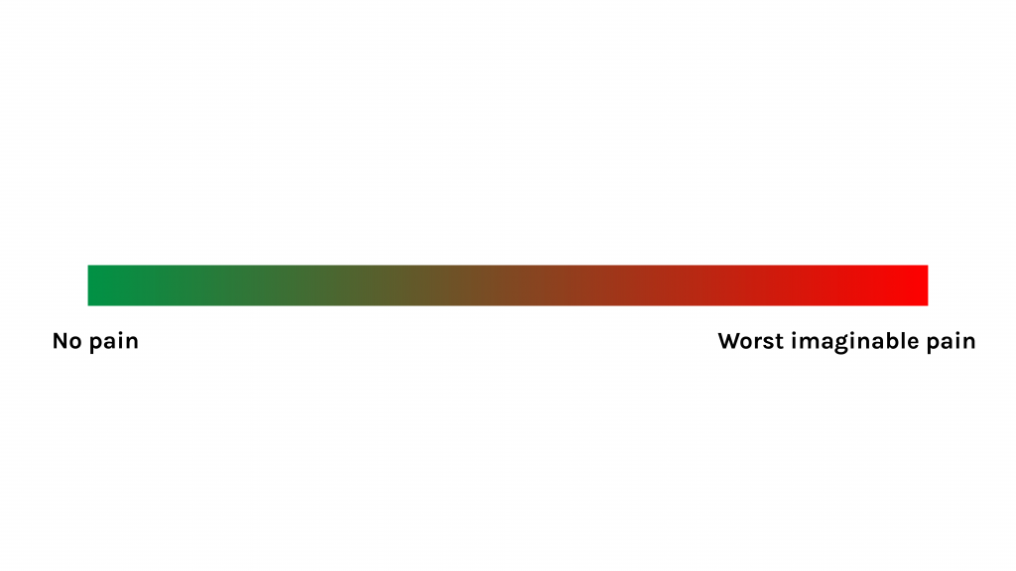
Figure 3: Example of VAS

Verbal Descriptor Tool
The Verbal Descriptor Tool (VDT) provides an opportunity for clients to describe the intensity of their pain using words (Pathak et al., 2018). The client is asked: “Which word best describes your pain intensity?” (Karcioglu et al., 2018). Various versions of the VDT have been developed (see Figure 4): the descriptors often have numbers associated with them, and additional modifiers of the descriptors such as “very mild” and “very severe” can be added.
The VDT is also used for similar reasons as the NRS, but as with the VAS it is useful when a client does not resonate with rating pain according to numbers and prefers descriptors.
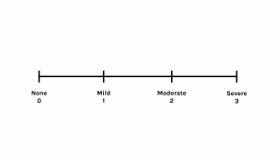
Figure 4: Verbal Descriptor Tool

FACES Pain Scales
Several pain scales involving faces have been developed specifically for children to rate the intensity of their pain. Young children do not have the same cognitive and linguistic capacity as adults, so these types of scales are more developmentally appropriate, particularly for those aged 3–7 years and even older depending on their developmental age. The two most common are the Wong-Baker FACES Pain Rating Scale and the FACES Pain Scale – Revised Version (FPS-R).
The Wong-Baker FACES Pain Rating Scale (Figure 5) is a self-assessment tool that must be understood by the patient, so they are able to choose the face that best illustrates the physical pain they are experiencing. The tool is not for use with infants or patients who are unresponsive. It is not a tool to be used by a third person (i.e., parents, healthcare professionals, or caregivers) to assess the patient’s pain. This tool has actually been used across the lifespan as well including in adolescents and adults.
Ask the child to choose the face that best shows the physical pain they are experiencing. You may need to explain what the faces mean: Face 0 doesn’t hurt at all, Face 2 hurts just a little bit, Face 4 hurts a little bit more, Face 6 hurts even more, Face 8 hurts a whole lot, and Face 10 hurts as much as you can imagine.
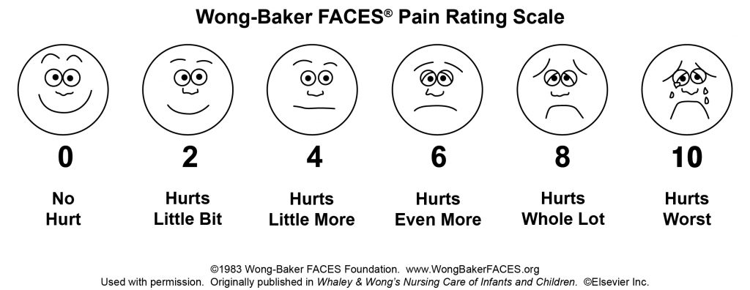
Figure 5: Wong-Baker FACES® Pain Rating Scale Wong-Baker FACES Foundation (2019).

Similarly, the Faces Pain Scale – Revised Version (FPS-R) provides a series of six faces with different expressions to illustrate pain (Hicks et al., 2001) – check out the FPS-R by clicking on the link. This revised version does not include faces with smiles or tears, which can help remove bias; for example, a smiling face may be interpreted as happiness, which does not necessarily mean the individual is not in pain.
When using this scale, say to the child something like: “These faces show how much something can hurt. This face [point to left-most face] shows no pain. The faces show more and more pain [point to each from left to right] up to this one [point to right-most face] – it shows very much pain. Point to the face that shows how much you hurt” you feel right now (Hicks et al., 2001, p. 176).
Based on the findings of a systematic review, the FPS-R is recommended for children as young as seven for acute pain (Birnie et al., 2019).

Contextualizing Inclusivity
Like all tools, including pain tools, the FACES pain scale may not translate to all cultures. The Northern Pain Scale is another adapted version of the FACES scale. It was translated into Inuktitut and recreated with facial expressions and dress to reflect the culture of Inuk people in Canada (Ellis et al., 2011). As a nurse, it is important to consider the use of culturally relevant pain tools.

Sun-Cloud-Pain Scale
Another scale that may be more relevant to assess pain and other symptoms in clients from certain cultures is the Sun-Cloud-Pain Scale. On this scale, 0 indicates that the client feels very well, whereas 5 indicates that the client is feeling very unwell specific to their pain (see Figure 6) (Lapum et al., 2019).
Figure 6: Sun-Cloud-Pain Scale. Graphic created using icons by Linseed Studio from the Noun Project.

Activity: Check Your Understanding

An interactive H5P element has been excluded from this version of the text. You can view it online here:
https://pressbooks.library.torontomu.ca/assessmentnursing2/?p=50#h5p-24

References
Birnie, K., Hundert, A., Lalloo, C., Nguyen, C., & Stinson, J. (2019). Recommendations for selection of self-report pain intensity measures in children and adolescents: A systematic review and quality assessment of measurement properties. Pain: The Journal of the International Association for the Study of Pain, 160(1), 5-18. https://doi.org/10.1097/j.pain.0000000000001377
Ellis, J., Ootoova, A., Blouin, R., Rowley, B., Taylor, M., DeCourtney, C., Joyce, M., Greenley, W., Gaboury, I. (2011). Establishing the psychometric properties and preferences for the Northern Pain Scale. International Journal of Circumpolar Health, 70(3), 274-285.https://doi.org/10.3402/ijch.v70i3.17823
Karcioglu, O., Topacoglu, H., Dikme, O., & Dikme, O. (2018). A systematic review of the pain scales in adults: Which to use? The American Journal of Emergency Medicine, 36(4), 707-714.https://doi.org/10.1016/j.ajem.2018.01.008
Lapkin, S. , Ellwood, L. , Diwan, A. & Fernandez, R. (2021). Reliability, validity, and responsiveness of multidimensional pain assessment tools used in postoperative adult patients: A systematic review of measurement properties. JBI Evidence Synthesis, 19 (2), 284-307. https://doi.org/10.11124/JBISRIR-D-19-00407
Lapum, J., St-Amant, O., Hughes, M., Petrie, P., Morrell, S., & Mistry, S. (2019). The complete subjective health assessment. https://ecampusontario.pressbooks.pub/healthassessment/
Pathak, A., Sharma, S., & Jensen, M. (2018). The utility and validity of pain intensity rating scales for use in developing countries. Pain Reports, 3(5), 1-8.https://doi.org/10.1097/PR9.0000000000000672
Slomp, F. (2019). Transforming acute pain experience into a pain score: The challenges. Doctoral dissertation, University of Alberta. https://era.library.ualberta.ca/items/39d68f48-556c-437d-92fb-164063b7a1e3/view/4c3abaf4-92bc-4b1d-83b2-bd14ef7e7fa8/Slomp_Florence_J_201901_PhD.pdf
von Baeyer, C. (2009). Numerical rating scale for self-report of pain intensity in children and adolescents: Recent progress and further questions. European Journal of Pain, 13(10), 1005-1007.https://doi.org/10.1016/j.ejpain.2009.08.006

12

Multidimensional Pain Assessment Tools
Multidimensional pain assessment tools are used to assess the many ways that pain affects a person. Although unidimensional pain assessment tools are typically used to assess pain intensity, particularly when frequent measurements are needed, multidimensional pain assessment tools are used to obtain a comprehensive understanding of pain.
Many different multidimensional pain assessment tools may be used depending on the client population, the reason for the assessment, and the unit/hospital/area of care you work. For example, when treating certain populations such as pre-verbal and non-verbal clients, your assessment may focus on behavioural cues. When treating clients with chronic pain, you may focus on understanding the many ways that pain affects a person including psychologically, socially, and functionally.
The following sections explore:
- PQRSTU mnemonic.
- Brief Pain Inventory.
- Pain scales related to cognitive impairment.
- FLACC Pain Tool.
- Behavioural Pain Scale and Critical Care Pain Observation Tool.
Let’s check out these tools!

13

PQRSTU Mnemonic
The PQRSTU mnemonic is a multidimensional pain assessment tool that is commonly used in practice to evaluate several components of pain beyond just intensity (see Table 3). It is used when first assessing a client’s report of pain on initial assessment. It is generally used for adolescents and adults, but you may be able to simplify some of the questions for younger children, possibly age five and up. For example, you might use the word “hurt” or “owwie.”
The order of questions you ask will depend on the client’s responses and also on priority. What do you need to know first? When a client first reports pain, you will usually ask about the region (where it is located) and the intensity. Pay attention to responses that appear not to align. For example, if a client responds to the question about the quantity of pain by saying “the pain isn’t too bad,” but then rates the severity of their pain as being 8/10, you should probe further in a non-confrontational manner. You might say, “I noticed you rated your pain fairly high, at 8/10, but you said it isn’t too bad. Can you tell me more about that?”
The PQRSTU mnemonic is similar to the McCaffrey Initial Pain Assessment Tool, which assesses the various components of pain beyond intensity (e.g., location, quality) as well as how the client expresses their pain and how pain affects them (e.g., sleep, emotions) (McCaffery & Pasero, 1999). Here is a link to the McCaffrey Initial Pain Assessment Tool:https://nida.nih.gov/sites/default/files/McCaffreyInitialPainAssessmentTool.pdf
Table 3: PQRSTU mnemonic (Adapted from https://ecampusontario.pressbooks.pub/healthassessment/)

Activity: Check Your Understanding

An interactive H5P element has been excluded from this version of the text. You can view it online here:
https://pressbooks.library.torontomu.ca/assessmentnursing2/?p=54#h5p-25

References
McCaffery, M., & Pasero, C. (1999). Pain: clinical manual (2nd ed). Mosby.

14

Brief Pain Inventory
The Brief Pain Inventory (BPI) (is a commonly used multidimensional tool for assessing pain in clinical environments (Cleeland, 2009). It was originally developed to assess cancer-related pain, but it is also a valid and reliable measure with other conditions (Cleeland, 2009). For example, a systematic review found a moderate quality of evidence for its clinical use related to postoperative pain assessment (Lapkin et al, 2021).
In comparison to the PQRSTU mnemonic, the BPI provides a more comprehensive evaluation of pain and has been more widely tested (Cleeland, 2009):
- It focuses on assessing pain intensity over the past week and interference with a client’s daily life.
- It takes 5–10 minutes to complete.
- It can be self-administered by clients who are literate or administered by healthcare professionals when the client has reduced literacy.
- It can be translated into other languages for clients who do not speak English, and has already been validated in many languages including French, Japanese, Chinese, Korean, Italian, Russian, German, and Spanish, among others.
Because of its focus on assessing pain over time and interference with daily lives, it is commonly used in primary care and for assessing chronic pain. Along versionandshort versionare available; the shorter version has become the standard in clinical practice (Cleeland, 2009) – thus we encourage you to review the short version and understand it. Here is a link to auser guidewith information about the tool’s development, scoring, psychometric testing, and relevant literature.

Clinical Tip
Provide clients with enough time to complete the BPI. The tool is often used at in-patient units and for clients with chronic pain, who may require additional time because pain can affect cognitive functioning. Many in-patient oncology units have clients complete the BPI on admission, and then weekly, to evaluate their pain over periods of time.

References
Cleeland, C. (2009). The Brief Pain Inventory: User guide.https://www.mdanderson.org/content/dam/mdanderson/documents/Departments-and-Divisions/Symptom-Research/BPI_UserGuide.pdf
Lapkin, S., Ellwood, L., Diwan, A., & Fernandez, R. (2021). Reliability, validity, and responsiveness of multidimensional pain assessment tools used in postoperative adult patients: A systematic review of measurement properties. JBI Evidence Synthesis, 19(2), 284-307.

15

Pain Scales: Clients with Cognitive Impairment
Assessment of pain in clients who are cognitively impaired requires a different approach because they may not be able to optimally communicate their pain via self-report. Instead, you may need to use observational tools that incorporate and sometimes rely on dimensions of pain such as behavioural and physiological cues (Lichtner et al., 2014). For example, clients with late-stage dementia often have limited cognitive capacity and are unable to understand and answer questions.
Systematic use of pain assessment tools enables better evaluation and management of pain in individuals who are cognitively impaired (Ludvigsson et al., 2020). However, to date no one tool has been widely adopted and internationally recognized for assessing pain in clients who are cognitively impaired (Kunz et al., 2020).
Over the last 30 years, many clinicians and researchers have developed and evaluated various tools for this population. One commonly used tool is the Abbey Pain Scale, and another more recent tool is the Pain Assessment in Impaired Cognition (PAIC15). All tools should be used with caution considering the complexity of psychometric testing of the validation and clinical utility of pain assessment tools with clients who have cognitive impairments like dementia (Lichtner et al., 2014).

Abbey Pain Scale
Development of the Abbey Pain Scale began in the 1990s, with the goal of assessing pain in people with late-stage dementia whose communication is severely impaired (Abbey, 2004). The scale is appropriate for clinical practice because it is simple and efficient to use and can be used by various healthcare providers; it is not time consuming and is effective with a reasonable degree of validity.
As shown in Figure 7, the scale is based on behavioural observations including:
- Vocalization.
- Facial expression.
- Changes in body language.
- Behavioural changes.
- Physiological changes.
- Physical changes.
The tool is a movement-based assessment, and therefore should be performed while moving a client such as assisting them to sit or bathing them (Abbey et al., 1998; 2002). Movement can induce pain, so assessment during movement is most informative. Higher scores indicate higher pain levels.
The Abbey Pain Scale is commonly used in long-term care settings where reassessment over time is frequently required.
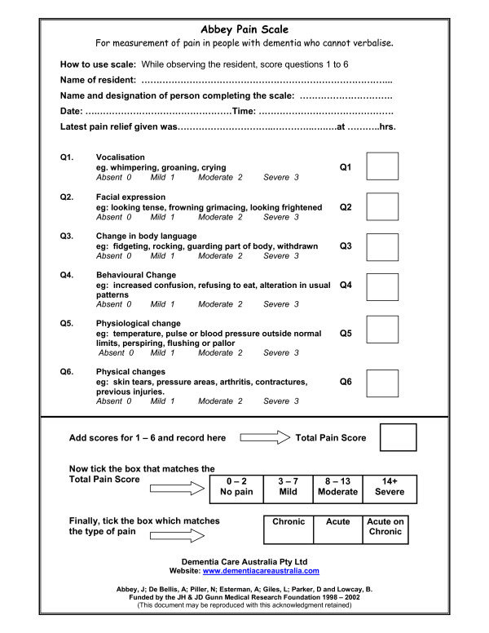
Figure 7: Abbey Pain Scale.
Copyright: Free to use. The original Abbey Pain Scale may be reproduced provided acknowledgement below is retained.
Abbey, J; De Bellis, A; Piller, N; Esterman, A; Giles, L: Parker, D and Lowcay, B.
Funded by the JH & JD Gunn Medical Research Foundation 1998 – 2002
(This document may be reproduced with this acknowledgement retained)

Clinical Tip
Nurses play an important role in assessing pain with clients who are cognitively impaired, because they provide the most regular care and are aware of the client’s baseline behaviours. It is important to assess pain regularly when establishing a baseline. Remember that the Abbey Pain Scale is designed to be used when the client is in movement: you can assess pain while assisting the client with bathing, dressing, or transferring to a chair. The assessment is quick, so you can use it frequently, for example hourly and then every four hours over a 24-hour period until an effective pain-relieving intervention is achieved.

Pain Assessment in Clients with Impaired Cognition (PAIC15)
The PAIC15 Scale is a recently developed and interesting tool for use with individuals who are cognitively impaired, particularly those with dementia. It was developed through a large multidisciplinary collaboration of clinical, research, and methodological experts, including nurses, from several European countries (Kunz et al., 2020). The team of experts developed this new meta-tool over a period of seven years, during which team members empirically evaluated items from all existing pain-related observational tools (including the Abbey Pain Scale) and reached consensus on the 15 most promising items, based on validity and reliability (Kunz et al., 2020).
As shown in Figure 8, the PAIC15 includes of 15 descriptors with five items each for:
- Facial expression.
- Body movements.
- Vocalization.
The PAIC15 is helpful when you have limited time with the client, as you can quickly assess pain either at rest or with movement. You can go to the PAIC15 Scale website for additional information about the tool and free online training.

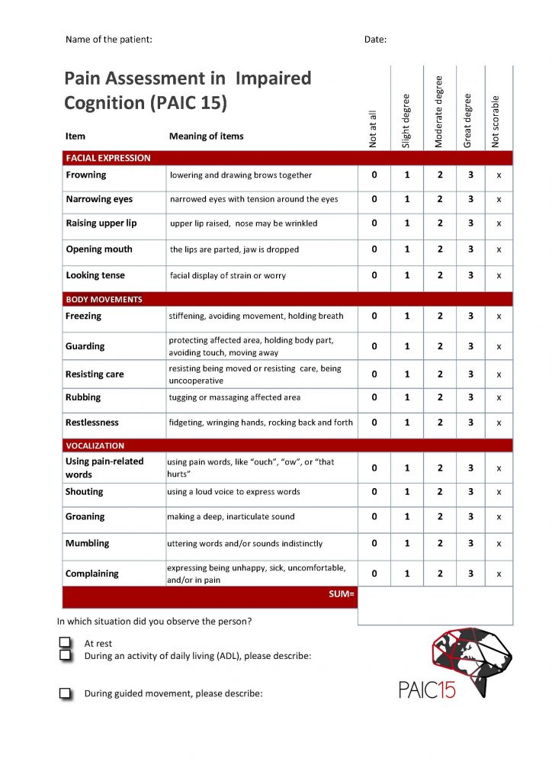

References
Abbey, J., De Bellis, A., Piller, N., Esterman, A., Giles, L., Parker, D., & Lowcay, B. (1998-2002). Abbey Pain Scale. https://www.cgakit.com/m-5-abbey-pain-scale
Abbey, J., Piller, N., De Bellis, A., Esterman, A., Parker, D., Giles, L., & Lowcay, B. (2004). The Abbey pain scale: a 1-minute numerical indicator for people with end-stage dementia. International Journal of Palliative Nursing, 10(1), 6-13.https://doi.org/10.12968/ijpn.2004.10.1.12013
Kunz, M., de Waal, M., Achterberg, W., Gimenez-Llort, L., Lobbezoo, F., Sampson, E., van Dalen-Kok, A., Defrin, R., Invitto, S., Konstantinovic, L., Oosterman, J., Petrini, L., van der Steen, J., Strand, L., de Tommaso, M., Zwakhalen, S., Husebo, B., & Lautenbacher, S. (2020). The Pain Assessment in Impaired Cognition scale (PAIC15): A multidisciplinary and international approach to develop and test a meta-tool for pain assessment in impaired cognition, especially dementia. European Journal of Pain, 24(1), 192-208.https://doi.org/10.1002/ejp.1477
Lichtner, V., Dowding, D., Esterhuizen, P., Closs, S., Long, A., Corbett, A., & Briggs, M. (2014). Pain assessment for people with dementia: a systematic review of systematic reviews of pain assessment tools. BMC Geriatrics, 14,(138), 1-19.https://doi.org/10.1186/1471-2318-14-138
Ludvigsson, C., Isaksson, U., & Hajdarevic, S. (2020). Experiencing improved assessment and control of pain in end-of-life care when using the Abbey Pain Scale systematically. NursingOpen, 7(6), 1798-1806.https://doi.org/10.1002/nop2.566

16

FLACC Pain Tool
The Face, Legs, Activity, Cry, and Consolability (FLACC) tool was originally designed to assess pain in nonverbal (young) children, based on observations of behaviours (Merkel et al., 1997). As suggested by its name, the tool includes five categories:
- Face.
- Legs.
- Activity.
- Cry.
- Consolability.
The maximum total score is 10, with scores for each category ranging from 0 to 2 (Merkel et al., 1997). This is helpful, because the FLACC findings can be easily compared to those of other common pain rating systems that are rated out of 10, such as the NRS (Voepel-Lewis et al., 2010).
The FLACC tool can be used with children as young as 2 months of age or any child who is too distressed or sedated to accurately self-report (Freund & Bolick, 2019). It has demonstrated good psychometric testing (Voepel-Lewis, 2010) and has been translated into several languages including French and Chinese, so it can be used across many client populations (Voepel-Lewis, 2010. It has also been used in practice with non-verbal adults with cognitive impairment and critically ill adults (Voepel-Lewis, 2010).
A revised FLACC pain assessment tool is also available, with additional behavioural descriptors for clients with cognitive impairment (Malviya et al., 2005). To compare the FLACC and the revised FLACC, check out the table at this link: https://www.connectedcare.sickkids.ca/quick-hits/2019/8/29/volume6-efnk4-nyn48-max8h-45bm7

Clinical Tip
Like all behavioural tools, the FLACC cannot distinguish between pain and other forms of distress (Parker & Brown, 2019). Think critically when interpreting behaviours that may be pain-related and when making treatment decisions based on the FLACC total score. You should observe the client for at least 2–5 minutes before assigning a score (Parker et al., 2019).

References
Freund, D., & Bolick, B. (2019). Assessing a child’s pain. The American Journal of Nursing, 119(5), 34-41. https://doi.org/10.1097/01.NAJ.0000557888.65961.c6
Malviya, S., Voepel-Lewis, T., Burke, C., Merkel, S., Tait, A. (2005). The revised FLACC observational pain tool: Improved reliability and validity for pain assessment in children with cognitive impairment. Pediatric Anesthesia, 16(3), 258-265. https://doi.org/10.1111/j.1460-9592.2005.01773.x
Merkel, S., Voepel-Lewis, T., Shayevitz, J., & Malviya, S. (1997). The FLACC: A behavioural scale for scoring postoperative pain in young children. Pediatric Nursing, 23(3), 293-297.
Parker, M., & Brown, N. (2019). Pre-hospital pain assessment in paediatric patients. Emergency Nurse, 27(2), 16-20. https://doi.org/10.7748/en.2019.e1905
Voepel-Lewis, T., Zanotti, J., Dammeyer, J., & Merkel, S. (2010). Reliability and validity of the Face, Legs, Activity, Cry, Consolability Behavioral Tool in assessing acute pain in critically ill patients. American Journal of Critical Care, 19(1), 55-61. https://doi.org/10.4037/ajcc2010624

17

Pain Assessment in Critical Care
A vital part of client care is assessing pain assessment in those who are critically ill and/or in intensive care. If they are alert and oriented, they may be able to self-report. They can do so verbally or by pointing to a number if they cannot speak, but clients are often too critically ill to communicate. Additionally, they may be unable to self-report due to factors such as altered levels of consciousness, distress, sedation, and mechanical ventilatory support (Gélinas, 2016; Suzuki, 2017).
In this context, the nurse’s observations of pain indicators are vital to pain assessment. These observations are most often focusing on the behavioural dimensions of pain. Typically, physiological pain indicators do not provide a valid assessment of pain because vital signs are influenced by the client’s condition (i.e., pathological processes) and medications (i.e., sedation and vasopressors) that are often used in critical care situations.
Of the many tools used in clinical practice, the Behavioral Pain Scale and the Critical Care Pain Observation Tool are recommended for assessing pain intensity, and often used in critical care (Suzuki, 2017). They are also the most validated and translated tools (Kerbage et al., 2021).

Behavioral Pain Scale (BPS)
The development and psychometric testing of the BPS was published in 2001 by Payen and colleagues (2001), and used for assessment of pain in critically ill clients who are on mechanical ventilation. It is user-friendly and has strong psychometric properties in terms of assessing pain in non-communicative critical care clients (Payen & Gelinas, 2014).
The BPS incorporates three items:
- Facial expression.
- Upper limb movement.
- Compliance with ventilation.
(Payen et al., 2001).
Each item is scored from one to four with higher scores indicating more pain. The cut-off score for when pain is identified as present is greater than five (Payen et al., 2007).

See external link to view the tool: https://www.mdcalc.com/calc/3622/behavioral-pain-scale-bps-pain-assessment-intubated-patients

Critical-Care Pain Observation Tool (CPOT)
The CPOT was developed for assessing pain in ventilated and non-ventilated clients (Gélinas et al., 2006). It was initially developed in French and later translated into English (Gélinas et al., 2009) and other languages.
The CPOT has four components:
- Facial expression.
- Body movement.
- Muscle tension.
- Compliance with the ventilator for intubated clients or vocalization for extubated clients.
Each of these sections is scored from 0 to 2, yielding a total score from 0 to 8 (Gélinas et al., 2006). The cut-off score indicating pain is a score of greater than two (Gélinas et al., 2009).
Tips for using the CPOT:
- While at rest, observe the client’s facial expression, body movements, and presence of vocalization for one minute.
- Next, perform a passive range of motion of the lower arm (flexion and extension of elbow) while holding the client’s hand and elbow to assess for muscle tension.
- Upon movement (such as turning them on their side), observe the client’s facial expression, body movements, and presence of vocalization.
(Kaiser Permanente National Patient Care Services, 2011).
Check out this external link for the CPOT: https://kpnursing.org/professionaldevelopment/CPOTHandout.pdf
For more information, check out this video on theCritical-Care Pain Observation Tool: How to use it in your ICUAdditional guidelines and instructions on using the tool can be located at:https://kpnursing.org/professionaldevelopment/CPOTHandout.pdf

Clinical Tip
Use critical thinking when assessing pain in a critical care client, because self-reporting is often compromised. In critical care, you will encounter situations where pain indicators other than behavioural responses should be considered. Behavioural pain assessment tools should only be used when the client’s motor function is intact: consider other practices for clients with limited or altered motor function such as in cases of deep sedation, paralysis, and brain injury (Gélinas, 2016). Another limitation of behavioural pain assessment tools is they only evaluate the presence of pain and no other characteristics such as intensity (Kerbage et al., 2021).

References
Gélinas, C., Fillion, L., Puntillo, K., Viens, C., & Fortier, M. (2006). Validation of the Critical-Care Pain Observation Tool in adult patients. American Journal of Critical Care, 15, 420-427.
Gélinas, C., Harel, F., Fillion, L., Puntillo, K., & Johnston, C. (2009). Sensitivity and specificity of the Critical-Care Pain Observation Tool for the detection of pain in intubated adults after cardiac surgery. Journal of Pain and Symptom Management, 37(1), 58-67.
Gélinas, C. (2016). Pain assessment in the critically ill adult: Recent evidence and new trends. Intensive and Critical Care Nursing, 34, 1-11.https://doi.org/10.1016/j.iccn.2016.03.001
Kerbage, S., Garvey, L., Lambert, G., & Willetts, G. (2021). Pain assessment of the adult sedated and ventilated patients in the intensive care setting: A scoping review. International Journal of Nursing Studies, 122. 1-22.https://doi.org/10.1016/j.ijnurstu.2021.104044
Payen, J., Bru, O., Bosson, J., Lagrasta, A., Novel, E., Deschaux, I., Lavagne, P., & Jacquot, C. (2001). Assessing pain in critically ill sedated patients by using a behavioral pain scale. Critical Care Medicine, 29(12), 2258-2263.
Payen, J., Chanques, G., Mantz, J., Hercule, C., Auriant, I., Leguillou, J., Binhas, M., Genty, C., Rolland, C., & Bosson, J. (2007). Current practices in sedation and analgesia for mechanically ventilated critically ill patients: a prospective multicenter patient-based study. Anesthesiology, 106(4), 687-695.https://doi.org/10.1097/01.anes.0000264747.09017.da
Payen, J., & Gelinas, C. (2014). Measuring pain in non-verbal critically ill patients: Which pain instrument? Critical Care, 18,(5).https://doi.org/10.1186/s13054-014-0554-5
Suzuki, T. (2017). Does the combination use of two pain assessment tools have a synergistic effect? Journal of Intensive Care, 5(1), 1-3.

18

Summary: Subjective Assessment and Pain Assessment Tools
Subjective assessment of pain is an integral step of pain management. Be aware of your own biases concerning pain: do not make assumptions. The main focus of subjective assessment is self-report, which can be elicited through a verbal account or having the client point or write it down.
The use of pain tools is also important in combination with subjective and objective forms of assessment. Many tools are available to assess pain; we have introduced you to a few, but you will come across others in your clinical practice and from reading the literature. Best practices in tool selection should focus on the reason for the assessment, developmental considerations, and the client situation and acuity. Another part of decision-making considering tool selection is related to where you work, as units and areas of care will commonly identify specific tools and procedures in using these tools. They may also provide training related to tool implementation, with the goal of ensuring all healthcare practitioners use it consistently and as it was designed. See summary in Table 4.
Table 4: Summary of pain tools.
Tools | Description
Numerical Rating Scale | Most commonly used tool with older children and adults who are able to rate their pain on a scale of zero to 10. Keep in mind, this tool focuses on rating of pain severity only.
PQRSTU mnemonic | Commonly used in many settings and populations when a more comprehensive understanding of pain is needed, beyond intensity.
Brief Pain Inventory | Used to elicit a more comprehensive understanding of pain and is often used in primary care settings, in-patient units, and to assess chronic pain.
Abbey Pain Scale and PAIC15 | Commonly used for older clients with cognitive impairments such as dementia.
FACES Pain Scale-Revised Version | Often used with young children, who can point to the face that corresponds to their pain level
FLACC Pain Tool | Used with pre-verbal or non-verbal children as young as 2 months of age or any children who are too distressed or sedated to accurately self-report. It has also been used with other populations including non-verbal adults with cognitive impairment and critically ill adults.
Behavioral Pain Scale and the Critical-Care Pain Observation Tool. | Common tools used in critical care that have a focus on behavioural dimensions of pain.

Clinical Tip
Pain intensity ratings are often categorized by healthcare providers as follows:
- 1–3: Mild pain.
- 4–6: Moderate pain.
- 7–10: Severe pain (and sometimes a 10 or above may be described as very severe).
These ratings and categories can be useful to provide a baseline for pre- and post-pain treatment so you know whether treatment has been effective for this specific client. However, the categories above are qualitative descriptors that have a subjective element to them and the potential for bias. For example, you might categorize a client’s pain as moderate if they have rated it a five, but if asked, the client might describe their pain as severe. Therefore, it is important to engage in comprehensive assessments that are client-centred and be careful about making judgements about the “number” the client provides.
Determining whether treatment is needed is dependent on the acuity of the situation and the specific client. Each situation is different in terms of an acceptable level of pain. For example:
- In an acute care situation when a client is having angina pain, treatment should result in no pain. With angina pain, think about the pathological processes leading to the pain (i.e., narrowing coronary arteries in which insufficient blood and oxygen is feeding the heart muscle). Treatment should resolve this pathological process and result in no pain.
- In a client who has chronic pain related to arthritis, typically treatment should result in no pain or to a level that is manageable for the client and does not significantly interfere with their functioning.
Depending on the situation, keep in mind that treatment includes many possibilities such as medication, repositioning, activity, distraction, and other modalities.

Priorities of Care
Some of the main priorities of care related to pain assessment include:
- Angina pain: this is a critical finding that requires immediate action.
- A significant increase in pain, particularly when rated higher on intensity scales and the pain does not respond to treatment (e.g., medication). An increase in pain should prompt you to think critically about what is going on and what could be causing the increase. In this case, a full subjective and objective assessment of the pain is required and it should be promptly reported to the physician or nurse practitioner.
- Inadequately managed postoperative pain is of concern because of the physiological effects of pain on the body, such as tachycardia and hypoxia. Additionally, poorly controlled postoperative pain has been correlated with prolonged opioid use (Goesling et al., 2016). Thus, if the prescribed medications are not controlling the pain, you should do a full subjective and objective assessment of the pain and discuss with the healthcare team alternative medications and pain management approaches.
- Pain upon movement with a suspected fracture. Complications associated with fractures include hemorrhage and blood vessel damage, which can cause ischemia distal to the fracture due to a disruption in blood flow, nerve damage, and pulmonary embolism (usually associated with hip and pelvis fractures). Therefore, during the acute period you should immobilize the affected area/limb and continually assess peripheral blood flow (temperature, pulses), quality of breathing, breath sounds, respiration rate, and heart rate. When blood flow is disrupted distal to the periphery, this can cause cool skin temperature and decreased pulse force or absent pulse in the affected limb. Notify the physician or nurse practitioner of this pain and any associated critical findings immediately.
- Back pain associated with potential spinal cord compression: this is a serious issue that may require urgent intervention. The client should remain at rest while you report findings to the physician or nurse practitioner. Compression may be suspected with new onset and severe back pain associated with loss of bladder and/or bowel function and numbness and tingling in the arms and/or legs.

Activity: Check Your Understanding

An interactive H5P element has been excluded from this version of the text. You can view it online here:
https://pressbooks.library.torontomu.ca/assessmentnursing2/?p=66#h5p-37

References
Goesling, J., Moser, S., Zaidi, B., Hassett, A., Hilliard, P., Hallstrom, B., Clauw, D., & Brummett, C. (2016). Trends and predictors of opioid use following total knee and total hip arthroplasty. Pain, 157(6), 1259-1265.https://doi.org/10.1097/j.pain.0000000000000516

19

Objective Assessment
It is always important to perform an objective assessment following a subjective assessment, but this is particularly the case for infants, young children, and non-verbal clients who may have difficulties with self-reporting.
The type of objective assessment used will depend on the location of the pain, the related body systems, and the acuity of the situation. Specific focused assessments on a body system may be necessary. For example, if a client describes knee pain, you should do a focused assessment on the musculoskeletal system. If a client describes chest pain, you should do a focused assessment on the cardiovascular and the respiratory system and possibly the musculoskeletal system.
The objective assessment does not follow a specific order; it depends on the acuity of the situation and the stability of the client. Common components of an objective assessment of pain include:
- Full set of vital signs. Vital signs can be affected by pain, particularly acute pain. Collection and assessment of vital sign data may provide important information related to the client’s stability and the potential for clinical deterioration. Vital signs are also an important component of pain tools that include physiological measures; these can be particularly helpful in clients who are pre-verbal or non-verbal such as newborns, young children, clients that may have a developmental challenge, and clients who are unconscious. However, vital sign changes cannot help you differentiate between pain and other forms of distress such as fear and anxiety. You should always consider the context when interpreting vital signs, because they can be affected by level of consciousness, medications, and sedation. Therefore, your clinical judgement will be based on a comprehensive subjective and objective assessment, along with critical thinking.
- Inspection of the area. Typically, you will inspect the area on the body where a client indicates they are having pain. Inspection is performed bilaterally in which you compare the left side to the right side. For example, if a client is having eye pain, you should compare the left eye to the right eye. Inspect for and note any abnormalities such as discoloration (e.g., redness), bruising, swelling, scarring, incisions, masses, deformities, asymmetry, lesions, non-intact skin, and pressure injuries. With chest pain, you should also inspect for cardiac heaves (forceful movements observed on the skin over the chest wall) and epigastric pulsations. With abdominal pain, you should also inspect for abdominal contour and peristaltic movements.
- Palpation of the area. After conducting a subjective assessment, you should palpate the area (and related areas) in which the client is having pain. Palpation is performed bilaterally: compare the left side to the right side. For example, if a client is having left shoulder pain, you should palpate the right shoulder first and then the painful left shoulder. Similarly, if a client is having abdominal pain, you should palpate the painful area last. During palpation, you should assess skin temperature, swelling, masses, deformities, and crepitation if associated with a joint. You should also observe any signs of pain during palpation, such as a change in respiration (e.g., holding their breath), facial grimacing, withdrawing their body/limb, and guarding.
- Auscultation and percussion.Perform auscultation and percussion when a client is describing chest or abdominal pain. For example, with chest pain, you should auscultate the lungs, and the apical pulse and cardiac valves. With abdominal pain, you should auscultate the abdomen for bowel sounds and percuss the abdominal area.

Clinical Tip
Always compare the right and left side of the body when inspecting and palpating, because the best standard of comparison is the client’s own anatomy. The presence of a bilateral versus a unilateral finding is often of clinical significance. For example, the left ankle should be symmetrical with the right ankle. The presence of edema in one ankle versus both ankles is meaningful when making judgements about the underlying pathology.
When palpating an area, be aware of responses that may be categorized as allodynia or hyperalgesia. For example, if you press gently on an area (a stimulus that does not normally result in pain) and the client communicates pain, this is considered allodynia. Additionally, if you press firmly on an area (a stimulus that would normally result in pain) and the client communicates an exaggerated response to the pain, this is considered hyperalgesia. These conditions are different, but may coexist in the presence of diseases such as migraines and diabetes.

20

Clinical Judgement: Case Study
A 78-year-old client in a long-term care home tells a personal support worker (PSW) that they are going to stay in bed and skip breakfast. The PSW asks “are you sure?” The client smiles and says “yes dear, thank you.” The PSW asks the client if they can bring them breakfast and the client states “no.” The PSW notifies the nurse who says “I am going to check on the client since they just had hip surgery three weeks ago and were just transferred back home here a week ago. If I recall, their pain was fully assessed and controlled last evening before bed.”

An interactive H5P element has been excluded from this version of the text. You can view it online here:
https://pressbooks.library.torontomu.ca/assessmentnursing2/?p=70#h5p-21

21

Key Takeaways
- Pain is a complex phenomenon that is often conceptualized as an unpleasant, sensory experience associated with, or resembling that associated with, actual or potential tissue damage.
- Although self-report is generally considered the gold standard, pain can affect individuals in many ways, so a multifaceted approach to assessment is required.
- If you are not aware of your cultural biases, you may judge the validity of another person’s pain based on your own answers.
- Always remember: pain is what the client tells you it is. This is an important tip because of the unconscious bias and myths concerning pain that result in institutional racism and ageism.
- Pain assessments are often repeated to evaluate the effectiveness of treatment and medication.
- Choosing the correct pain tool, and using a combination of subjective and objective assessments along with critical thinking, are vital to the accuracy of your assessment.

II

Integumentary System

Authors
Oona St-Amant, PhD, RN, Associate Professor 1
Michelle Hughes, MEd, RN, Professor 2
Raquel Lashley-Trambulo MN(c), BScN, RN, Professional Practice and Simulation Coordinator 1
Rezwana Rahman, MN(c), BScN, RN 1
Sheilagh Callahan, MScN, RN, Professor 3
Erin Ziegler, PhD, NP-PHC, Assistant Professor 1
Diane MacEachern, MScN, NP-PHC, Professor 2
Vikky Leung, MN, RN, Professor 2
Caitlin Cosgrove, nursing student 1
Evan Accettola, PN, RPN 1
Ovie Onagbeboma, MBA(c), RN 4
Starr Ferguson, nursing student 1
Saba Ghafouri, nursing student 1
Meera Chawda, nursing student 1
Jennifer Lapum, PhD, RN, Professor 1

Consultants
Margaret Verkuyl, MN, NP:PHC, Professor 2

1 Toronto Metropolitan University
2 Centennial College
3 George Brown College
4 Canadian Black Nurses Alliance

22

Learning Outcomes
- Apply subjective assessment skills.
- Apply objective assessment skills.
- Use clinical judgment.
- Integrate health promotion interventions into actions.
- Integrate an inclusive approach to integumentary assessment.

23

Introduction to Integumentary System
The integumentary system includes the skin, hair, nails, and sebaceous and sweat glands. It has important functions including thermoregulation, sensory functioning, ensuring fluid balance, serving as a protective barrier to external substances, and providing immune defense against foreign bodies.
The integument can be an indicator of the client’s general health status. For example, the integumentary system can signal other systemic functions of the body like diaphoresis during cardiac events, cyanosis related to respiratory insufficiency and other conditions, and pallor during times of stress and other conditions. As a nurse, it is important to hone your assessment skills and pay close attention to potential cues that may signal underlying concerns that require your intervention. See Figure 1 for an anatomical overview of the integumentary system.
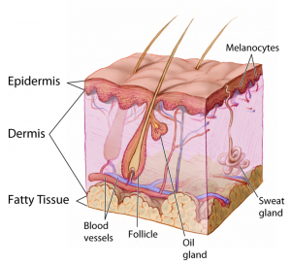
Figure 1: Integumentary system anatomy.
(Image in public domain and adapted from the National Cancer Institute:https://commons.wikimedia.org/wiki/File:Anatomy_The_Skin_-_NCI_Visuals_Online.jpg)

You have already learned about the anatomy and physiology of the integumentary system: for a quick overview seehttps://youtu.be/OxPlCkTKhzY
You need a basic understanding of disease-specific presentations to effectively interpret findings from your assessment. Be alert to signs and symptoms of greater systemic issues that may require further assessment and possibly immediate intervention. For example, Cullen’s sign (Figure 2) is a serious concern: it appears as bruising and edema of the subcutaneous fatty tissue around the navel and can be an indication of acute pancreatic trauma and/or internal bleeding. Certain skin symptoms can also prompt the use of personal protective equipment (PPE); for example, small flat red spots that appear on the face and spread down the body may be an indication of measles (Figure 3), necessitating airborne precautions.
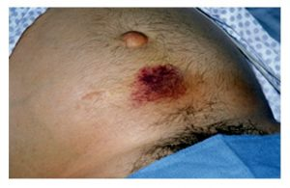
Figure 2: Cullen’s sign.
(Attribution: Photo by Herbert L. Fred, MD and Hendrik A. van Dijk – http://cnx.org/content/m14904/latest/, CC BY 2.0,https://commons.wikimedia.org/w/index.php?curid=5038484)

Figure 3: Measles.
(Attribution: This photo is in the public domain in the United States because it is a work prepared by an officer or employee of the United States Government as part of that person’s official duties under the terms of Title 17, Chapter 1, Section 105 of the US Code.https://commons.wikimedia.org/wiki/File:Measles_child_Philippines.jpg)
Contextualization of integumentary issues in relation to other symptomatology like fever, cough, and inflammation can provide insight into underlying conditions. Table 1 provides some general descriptions related to the integument and underlying pathophysiology. With experience, you will learn to identify patterns, recognize cues, and begin to discriminate between benign skin conditions and skin conditions that require further investigation.
Table 1: General descriptions of integument pathophysiology.
*genetic disorders not listed

Clinical Tip
Did you know that some dermatological conditions are emergencies? For example, necrotizing fasciitis (a rare bacterial infection also known as flesh-eating disease) can spread very quickly throughout the body, at a rate of 1 inch per hour. Symptoms include erythema, warmth to the touch, swelling, severe pain, and fever. If not treated immediately, it can lead to sepsis, shock, organ failure, and even death. As a nurse, you must report these findings to the physician or nurse practitioner so immediate treatment can be started.

Knowledge Bites: Pathophysiology
How do you distinguish between common viral and bacterial infections? Common characteristics of a bacterial infection are inflammation, exudate (such as pus), erythema, swelling, pain, odour. Common characteristics of a viral infection are a grouping/cluster of lesions, generally asymmetrical (one side of body), and specific regions on the body (e.g., mouth, nose, feet, hands).

Activity: Check Your Understanding
Name the integument pathophysiology images:

An interactive H5P element has been excluded from this version of the text. You can view it online here:
https://pressbooks.library.torontomu.ca/assessmentnursing2/?p=1031#h5p-53

24

Starting Your Assessment
The integumentary system has fundamental characteristics that you will notice immediately. With more experience, you will learn what to consider during your subjective and objective assessment. See Table 2 for descriptions of clinical manifestations related to integumentary issues.
Table 2: Clinical manifestations of integumentary issues.

Priorities of Care
Always assess levels of acuity related to the integument. Certain conditions require immediate attention, while others may require prompt or gradual interventions. Necrosis (black tissue) is a form of tissue death that is typically associated with a pathological process and requires immediate intervention. Factors that can lead to necrosis include prolonged compression, bacterial infection, injury, disease, and environmental conditions. Necrotic tissue cannot be revived and normally requires debridement (removal).
Depending on the severity, clients with acute trauma to the integument, burns, or frost exposure may require urgent intervention. Lacerations and burns can rid the body of fluids and may require immediate fluid replacement. Any infections that spread quickly also require immediate intervention. Understanding the cues that prompt critical interventions is an important nursing skill.

Contextualizing Inclusivity
Persons experiencing homelessness have a higher prevalence of skin infections and non-melanoma skin cancers compared to the general population (Adly et al., 2021). They may find it difficult to access clean water, sanitation, and hygiene facilities. Use a person-centred and non-judgmental approach to help clients manage integumentary conditions. For example, you could link clients to organizations that provide clean clothing, water, and sanitation if needed. As a nurse, you should use a critical lens to identify health inequities, and this includes advocating for systemic changes to improve health conditions for all.

References
Adly, M., Woo, T. E., Traboulsi, D., Klassen, D., & Hardin, J. (2021). Understanding dermatologic concerns among persons experiencing homelessness: A scoping review and discussion for improved delivery of care. Journal of Cutaneous Medicine and Surgery. 25(6): 616-626.

25

Subjective Assessment
Assessments of the integumentary system may be uncomfortable, embarrassing, or evoke anxiety for the client. It is possible that the client has been avoiding consultation with a healthcare provider for some time and the condition has advanced. The client may be fearful of the outcome of the assessment, for example, with concerns of malignancy.
During your assessment, try to:
- Attend to their concerns and ensure open communication with the client while commending them for seeking care. Ignoring their stress or delayed consultation may reinforce that they should be fearful of their integumentary concern and this could affect their follow-up care.
- Show unconditional positive regard for the client and empathy for their situation; this will help you collaborate with the client.
- Be clear about next steps and what the client can anticipate during their consultation; this is imperative to a positive therapeutic approach.
Start the conversation with “what brings you here today” and pay attention to their response. The client may identify a particular symptom such as itchiness, swelling, or a lump. Their responses should prompt further questions to help you better understand the underlying issue. A systematic way to approach this line of questioning is to use the PQRSTU mnemonic, which can help ensure you have covered the important basics.
As a critical thinker, you should also consider what else may warrant further inquiry beyond the PQRSTU mnemonic. For example, you might ask about previous environmental exposures, medications (including name, dose, frequency, reason it was prescribed, how long they have been taking the medication), herbal remedies, supplements, allergies, non-prescribed substance use, and exposure to contagions.
You can motivate the client to make lifestyle changes by ending the conversation with collaborative dialogue around health promotion strategies such as appropriate sunscreen application, regularly cleaning nail tools, and education about vitamins. Depending on the context, you might engage in this kind of discussion during the subjective assessment or after the objective assessment. A section on “Health Promotion Considerations and Interventions” is provided later in this chapter.

Contextualizing Inclusivity
Western health assessment textbooks have been criticized for reinforcing a Euro-centric view of disease by largely focusing on ailments of white skin, and overlooking variations of black and brown skin. This kind of systemic racism can narrow the scope of knowledge of healthcare providers and can result in conditions being missed, further marginalizing racialized populations. Inclusive care requires more attention to black and brown skin variations, and this textbook is a first step. You can also access supplementary tools such as Mind the Gap to help you recognize clinical signs in black and brown skin.
Depending on the reason for seeking care, the healthcare context, and the nature of the client’s visit, you may choose to start with screening questions about general health or enter immediately into a focused examination of the integument. Use your clinical judgement about the appropriateness of your questions and try to use a balanced approach between your own workload, the timing of visit, the urgency of the issue, and the nature of the healthcare setting. Table 3 provides some examples of symptoms, questions, and clinical tips.
Table 3: Common symptoms, questions, and clinical tips.

Priorities of Care
Personal protective equipment (PPE) like gloves and face shield may be necessary for skin variations that expel bodily fluids like blood or pus. Some lesions can expel with pressure when punctured and a face shield may be necessary.
Urticaria (hives) are itchy patches and bumps that are sometime raised and look swollen. They may look lighter or darker than one’s normal skin colour on clients with darker tones and they look red and dark pink with white centres on clients with lighter skin tones. They are sometimes caused by an allergic reaction to food, medications, or a bug bite. Although they often disappear with no treatment or an antihistamine, in rare cases they could be associated with a severe allergic reaction (anaphylaxis) including symptoms of dyspnea (difficulty breathing), wheezing, tightness or swelling of the throat. Anaphylaxis is a life-threatening condition and needs to be reported and treated immediately; administration of epinephrine is a priority if anaphylaxis is suspected.

Urticaria: Image free to use for non-commercial purposes, from: https://www.atlasdermatologico.com.br/index.jsf

Knowledge Bites
Certain medications can cause photoreactions, which are skin reactions caused by exposure to sunlight. Consumption of certain medications can lead to photosensitivity (sensitivity to sun exposure), photo-allergy (inflammation/allergic reaction after exposure to sun), and phototoxicity (hazardous sensitivity to sunlight that causes damage to tissue). Medications with these possible side effects include antibiotics, antihistamines, psychiatric agents, and cardiovascular drugs, as well as some topical medications.
Vitamins and some herbal remedies can also cause photoreactions and other integumentary responses. For example, niacin (vitamin B3) toxicity can cause flushing (reddened skin, itching, tingling). Excess vitamin A can cause itching, scaling, cheilitis (dry chapped lips), and even hair loss. Excess vitamin B6 can cause skin eruptions, typically after sun exposure. St. John’s wort can cause hives and/or other skin reactions. Other screening questions pertinent to a subjective assessment relate to personal care routines, sun exposure, and exposure to other irritants.

Contextualizing Inclusivity
Malnutrition is associated with many conditions. For example, it can be associated with alcoholism, either because of inadequate dietary intake accompanied by overconsumption of alcohol that does not contain nutrients or due to malabsorption from gastrointestinal conditions secondary to alcoholism. Persons living with alcoholism often have deficiencies in vitamin A, B1, B2, B6, C, E, and niacin, as well as other nutrient depletions like magnesium, potassium, and zinc. Chronic alcoholism can lead to skin changes related to liver disease, such as jaundice (yellowing of skin and sclera) due to bilirubin build up, hyperpigmentation, and generalized pruritus. Recognizing the signs of alcoholism is an important first step in seeking treatment. Family members are often the first to identify a problem. Always build a therapeutic relationship with the client, including unconditional positive regard; this will help establish trust and connect the client with appropriate supports.

Activity: Check Your Understanding

An interactive H5P element has been excluded from this version of the text. You can view it online here:
https://pressbooks.library.torontomu.ca/assessmentnursing2/?p=1035#h5p-54

26

Objective Assessment
Your subjective assessment should segue into your objective assessment. Typically, you will identify priority areas to examine based on your discussion with your client. For example, you may do a focused assessment of a rash, lesion, or itchy patch of skin. Depending on the healthcare context and purpose of your assessment, you may also do a general scan of the integumental system as a baseline comparison to gauge any abnormalities, or as an overview to assess any further abnormalities not identified in the subjective assessment.
Prepare before conducting your objective assessment. For example:
- Tell the client what the objective assessment will entail: how long it will take, how much touching will be involved and where, whether they will need to remove clothing, will they be in a comfortable position. (Tip: Think about things you would like to know going into an assessment).
- Prepare the environment: ensure the temperature is comfortable and the room is bright. Always ensure privacy by drawing the curtains and/or closing the door. If the room temperature is not modifiable, do your best to minimize exposing the client and keep them covered as much as possible. This keeps the client comfortable and preserves their dignity. Prepare your equipment in advance so you are not distracted with locating items while conducting your assessment. Objective assessments of the integumental system usually require pen light, gloves, pen, measuring tape, magnifying glass, and swabs and/or cotton pads. Draping may also be required depending on the region being exposed.
Objective assessment of the integumentary system includes inspection and palpation of the skin, nails, and hair.

Contextualizing Inclusivity
A person-centred approach and cultural humility is imperative when providing care considering that an objective assessment of the integumentary system may involve asking the client to expose different body parts and/or hair. For example, some Muslim women wear head coverings as a part of their Islamic faith, and head coverings can vary greatly: some women may choose to cover their hair and neck only, whereas others may choose to cover every part of their body except for their eyes. Some Muslim women also choose to limit their encounters with the opposite gender, including healthcare professionals. Do not assume a Muslim women’s level of comfort: some Muslim women may find it acceptable to reveal parts of their body in front of males if it serves a medical purpose. You should assess their needs at the beginning of a healthcare encounter. If a Muslim woman expresses discomfort with revealing parts of their body and/or hair, you might offer accommodations including a healthcare provider of the same gender, having a female colleague in the room, asking if the client would like a chaperone (friend or family member) to be present in the exam room, or allowing the patient to drape themselves so only a portion of their skin and/or hair is exposed. Ultimately, you should use an individualized approach: assess what each client is comfortable with and conduct the assessment accordingly.

27

Skin: Inspection
Inspection of the skin can be performed with the client sitting upright on the exam table or lying in a supine position. If you are doing a focused assessment, position the client so that you have the best visibility of the affected area. Use a bright light or a pen light if needed. Shadows and dark lighting may alter your visualization of the affected area and provide information about the elevation of a lump.
If you are doing a complete assessment, use a systematic approach and proceed cephalocaudally to ensure comprehensiveness. If the client has identified a specific concern, inspect that area first. If you are doing a complete assessment when the client has no specific concerns, inspect the face, arms/hands, back, abdomen, chest, and legs/feet. Always inspect the anterior and posterior side; for example, for the arms, ask the client to raise their hands/arms in front of them with their palms facing down and then turn palms up so that you can inspect both sides. Similarly, for the legs, inspect the anterior and then have the client roll over so that you can inspect the posterior. You may need to seek assistance to reposition a client that is immobile or has difficulty moving.
Keep in mind that the best control for comparison is the client’s own body, so always compare bilaterally.

Clinical Tip
Commonly overlooked areas for skin inspection include behind the knees, in skin folds, and between digits (fingers and toes). Other important areas to check are bony prominences (e.g., hips, spine, ankles), especially if the client has mobility issues. If the client is unable to reach these areas, encouraging family members to assist with checks can be helpful.
Skin inspection involves the following steps:
- Inspect the skin for colour using both a generalized and localized approach. To visualize general colour, step back and take note of their general appearance; for a localized approach, inspect specific regions. Mucous membranes, palms, sclera, and regions around the mouth can all be telltale signs for centralized colour variations. Always examine distal extremities for discolouration. Table 4 lists common colour variations. Keep in mind that skin colour varies widely from dark to light shades including black, brown, yellow, and white shades. These colours are affected by many factors. The biggest factor is how much melanin is produced by the body’s melanocytes; this also affects hair and eye colour. Additionally, the circulating hemoglobin affects skin colour and the underlying connective tissue.

  - Normally, skin colour is evenly distributed with no variations; clients with darker skin tones will have lighter coloured palms and soles of feet. Keep in mind that you may observe birthmarks, which are visible upon birth and include a wide array of sizes and colours (brown, black, blue, red, pink and purple). Most are flat and some fade over time. You should document them describing their location and description particularly since some can look like bruising.
  - If you notice variation in skin colour, note the location, colour, and other characteristics of the discolouration.
Table 4: Colour variations.
- Inspect the skin for nevi (moles). If the client has expressed concern about specific moles, check them first. Otherwise, inspect the face, arms/hands, back, chest, abdomen, and legs/feet for the presence of nevi. If you observe any, use the ABCDE mole screening mnemonic (Table 5 and Figure 4); this is vital to screen for melanoma, a life-threatening skin cancer in which early detection is essential (Rigel et al., 2005). Most moles are benign, but they can become malignant: people with more than 50 moles, light-coloured skin, regular sun exposure without sunscreen, and/or a family history of melanoma are at increased risk for melanoma.

  - Normally, nevi are smaller than 6 mm in diameter, round, smooth surfaced, with distinct/round edges. They can be elevated or not, pink, tan, brown, or dark brown. Generally, persons with darker skin tones have darker moles and persons with lighter skin tone have lighter moles. See Figure 5 for examples of what is considered normal nevi.
  - Abnormal moles are often larger than 6 mm with variation in colours and asymmetrical with irregular borders. Note any atypical moles including the location and description.
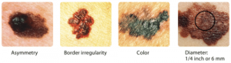
Figure 4: Abnormal nevi/moles. (Credit: Courtesy of Skin Cancer Foundation/National Cancer Institute License: Public domain. Source: Left to right: http://visualsonline.cancer.gov/details.cfm?imageid=2362; http://visualsonline.cancer.gov/details.cfm?imageid=2363; http://visualsonline.cancer.gov/details.cfm?imageid=2364; http://visualsonline.cancer.gov/details.cfm?imageid=2184).

Figure 5: Examples of normal nevi/moles.
Table 5: ABCDE mole screening. (Adapted from Rigel et al., 2005. See the American Academy of Dermatology Association about the history of the mnemonic: https://www.aad.org/public/diseases/skin-cancer/find/at-risk/abcdes)

Clinical Tip
ABCDE is a useful mnemonic for screening moles and is easily teachable to most clients. Teach-back is an effective technique: this involves presenting the ABCDE mnemonic to the client and then having them “teach” it back to you. This method helps with memory retention; fill in any gaps you may have overlooked as you taught them. Ask them to screen one of their moles based on the mnemonic; it may be appropriate to take a picture for comparison purposes.
- Inspect for skin integrity including whether the skin is intact. Look for the presence of ulcerations, erosions, contusions, or other damage that can disrupt the normal pattern of the skin. You will learn to recognize the signs of skin breakdown and who is at risk for impaired skin integrity. An important tool to assess skin integrity is the Braden Scale, which is commonly used in many healthcare settings and is especially useful for hospitalized clients and those with restricted mobility.

  - Skin is normally intact with no lesions, ulcerations, erosions, and contusions.
  - If you observe any areas where the skin is not intact, note the location and describe the area. Pressure injuries are classified into stages, as shown in Table 6. Figure 6 presents an example of staging.
- Inspect skin for other lesions such as cysts, blisters, macules, and wheals. Typically, lesions are associated with pain because they generally involve the epidermis and/or dermis which are both innervated (supplied by nerves). However, nerve damage may limit sensation and therefore pain to the region. Clients with nerve damage are at increased risk for secondary infections and lesions because they are not restricted by pain at the site. Lesions are usually categorized as primary (develop as a result of a pathological process and not modified by scratching or infection) or secondary (evolve from a primary lesion as a natural development or as a result of scratching or infection). Tables 7 and 8 provide more additional information about primary and secondary lesions.

  - Normally, there are no lesions.
  - If lesions are present, describe the location and characteristics in detail, including size, colour, movability, borders, elevation, drainage, and pain levels.

Table 7: Primary lesions. (Attribution: unless otherwise noted, lesion images adapted from https://commons.wikimedia.org/wiki/File:OSC_Microbio_21_01_LesionLine.jpg This file is licensed under the Creative Commons Attribution 4.0 International license).
Table 8: Secondary lesions. (Attribution: unless otherwise noted, lesion images adapted fromhttps://commons.wikimedia.org/wiki/File:OSC_Microbio_21_01_LesionLine.jpg This file is licensed under theCreative CommonsAttribution 4.0 Internationallicense).
- Note the findings.

  - Normal findings might be documented as: “Skin integrity intact. Skin colour consistent throughout with no variations. No lesions or rashes noted. Nevus on back examined. Located 2 inches distal to the scapula, left side. Symmetrical with even borders, tan coloured, 3 mm in size and no changes noted by the client. No pain or sensation reported. Image taken and included in the chart.”
  - Abnormal findings might be documented as: “Stage 1 pressure injury on thoracic spine 4 inches in length and 2 inches wide”

Priorities of Care
All abnormal findings should be documented and reported, but some findings are more urgent than others. For example, signs of cyanosis and pallor suggest possible issues with oxygenation, so you should conduct a primary survey, assess vital signs, and conduct a focused assessment on related systems including respiratory, cardiovascular, and peripheral vascular. A similar approach should be used when you observe mottled skin. This is a blotching and netlike discolouration that can appear as bluish, red, purple blotches, sometimes referred to as marbled. It is often associated with conditions that involved reduced blood flow and can be associated with peripheral vascular diseases, shock, and end-of-life, and sometimes cold environments. Always report signs of clinical deterioration immediately. For clients with a Stage 1 pressure injury, it is important to ensure good skin care and repositioning so that the client is not lying on a particular area for long periods of time. Medical intervention may be required for ulcers classified as Stage 2 and higher. Report any moles with warning signs to the physician or nurse practitioner, as the client may need a referral to a dermatologist and/or oncologist.

Knowledge Bite
Burns are caused when the skin is damaged by intense heat, radiation, electricity, friction, or chemicals. This damage results in the death of skin cells. Loss of the skin’s protective layers can lead to massive loss of fluid, and makes burned skin extremely susceptible to infection.
Burns are classified by the degree of their severity.
First-degree burn:
- Superficial burn affecting the epidermis.
- Mild sunburn is one example.
Second-degree burn (see Figure 7):
- Partial-thickness burn affecting the epidermis and a portion of the dermis.
- Results in swelling and a painful blistering of the skin.
Third-degree burn:
- Full-thickness burn extends fully into the epidermis and dermis, destroying the tissue and affecting the nerve endings and sensory function.
Fourth-degree burn:
- Deep full-thickness burn affecting the skin and underlying muscle, tendon, and bone.
Third- and fourth-degree burns require immediate intervention. They are usually not as painful as second-degree burns because the nerve endings are damaged. Full-thickness burns require debridement (removal of dead skin) followed by grafting of the skin from an unaffected part of the body or from skin grown in tissue culture.
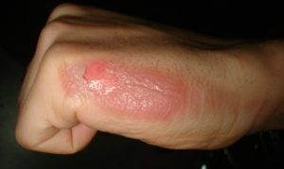
Figure 7: Second-degree burn.
(Attribution: Photo by Kronoman at English Wikipedia, CC BY-SA 3.0,https://commons.wikimedia.org/w/index.php?curid=26501619)

Activity: Check Your Understanding

An interactive H5P element has been excluded from this version of the text. You can view it online here:
https://pressbooks.library.torontomu.ca/assessmentnursing2/?p=1039#h5p-55

References
Bergstrom, N., Braden, B., Kemp, M., Champagne, M., & Ruby, E. (1998). Predicting pressure ulcer risk: A multisite study of the predictive validity of the Braden Scale. Nursing Research, 47(5), 261-269.
Bergstrom, N., Braden, B., Laguzza, A., & Holman, V. (1987). The Braden Scale for predicting pressure sore risk. Nursing Research, 36(4), 205-210.
Braden, B. (2012). The Braden Scale for predicting pressure sore risk: Reflections after 25 years. Advances in Skin & Wound Care, 25(2), 61.
Open Resources for Nursing (n.d.). Chippewa Valley Technical College.https://wtcs.pressbooks.pub/nursingfundamentals/
Rigel, D., Friedman, R., Kopf, A., & Polsky, D. (2005). ABCDE–an evolving concept in the early detection of melanoma. Arch Dermatol, 141(8), 1032-1034.

28

Skin: Palpation
Palpation of the skin can be performed with the client sitting upright on the exam table or lying in a supine position. You may need to ask or assist the client to reposition as needed. Palpate the arms from shoulder to fingertips and the leg from the upper legs to toes.
Steps for palpating the skin include:
- Palpate the skin temperature using the dorsa of your hands: start at the upper arms and move down to the fingertips. Repeat on the legs from upper legs to the tips of the toes (see Video 1 for an example).

  - Normally, the temperature is warm to touch and equal bilaterally. The hands and feet are sometimes slightly cooler than the upper arms and legs, but they should be equal bilaterally.
  - Note any asymmetry in skin temperature or extreme skin temperatures. Inflammation is typically accompanied by warmth. Describe the characteristics (e.g., warm, cool) and location of asymmetry in skin temperature or extreme skin temperatures.
One or more interactive elements has been excluded from this version of the text. You can view them online here: https://pressbooks.library.torontomu.ca/assessmentnursing2/?p=1041#oembed-1
Video 1: Palpating for temperature [0:17]
- Palpate for skin texture, thickness, and moisture using your fingertips: start at the upper arms and move down to the fingertips. Repeat on the legs from upper legs to the tips of the toes.

  - Normally, the skin is smooth and dry with uniform thickness.
  - If the skin feels excessively sweaty and clammy, this is referred to as diaphoresis. The skin should feel smooth, free from cracks, peeling, or flaking. Describe the quality and location of dry (xerosis) and flaky skin if present. Darker skin tones may have an ashy appearance, which is a result of dry skin and can appear as white/grey and can range from mild to severe. Describe and note the location of thickened areas of the skin or areas of the skin that are thin. Thickened areas of the skin may be the result of calluses. There are several factors that cause thin skin (e.g., aging, medications).
- Palpate the skin for turgorto assess for skin elasticity (see Video 2 for an example). Use your fingertips and thumb to grasp a fold of skin in the midclavicular region under the clavicle (collarbone) or on the forearm or hand. Pull upward gently and then release. The skin’s ability to recoil or return to normal may be affected by the client’s hydration status.

  - Skin that returns immediately to its normal position is considered normal/resilient and described as good skin turgor.
  - Skin that remains tented or takes time to return to its normal position is considered abnormal and is described as lacking skin turgor.

One or more interactive elements has been excluded from this version of the text. You can view them online here: https://pressbooks.library.torontomu.ca/assessmentnursing2/?p=1041#oembed-2
Video 2: Assess for skin turgor on forearm [0:19]

One or more interactive elements has been excluded from this version of the text. You can view them online here: https://pressbooks.library.torontomu.ca/assessmentnursing2/?p=1041#oembed-3
Video 3: Assess for skin turgor below clavicle [0:17]
- Palpate lesions and masses if present. Wear gloves for open lesions. Use your index finger and thumb to size the lesion and get a sense of the depth. Note innervation by asking the client if they can feel you palpating it. Press down on the lesion to see if it blanches. This provides contrast to get a better visual of the lesion, providing information about the skin variation. Petechiae generally does not blanch, while other skin lesions will momentarily blanch. Assess consistency (soft or hard) and shape (e.g., round, irregular).

  - Normally, no lesions or masses are present.
  - If you observe lesions or masses, describe the location and characteristics: what they look like, whether they are intact or open, consistency, and shape.
- Palpate for size and edema.Compare limb circumference of one arm to the other arm and from one leg to the other leg. Generally, you will visually observe the upper and lower part of each limb.

  - Normally, limb circumference is equal bilaterally at each site.
  - If you suspect a size difference, use a tape measure to accurately assess the size on both limbs on the lower and upper limb. If you observe edema, assess for pitting edema: an indentation that remains after applying pressure over the location (see Figure 8). Apply pressure with the pad of your finger on a distal location (feet and medial malleolus) for about 3-5 seconds and then release. If you observe an indentation (a “pit”), note the location and how long the indentation remains. If you observe it in a distal location, assess a proximal location such as over the tibia. Check with the unit you work on about the scale used to evaluate pitting edema. It is usually classified using a scale from Grade 1–4 based on pit depth and rebound time (time for the indentation to disappear), with 1 indicating mild, 2 moderate, 3 severe, and 4 very severe (see Figure 9 for scale).
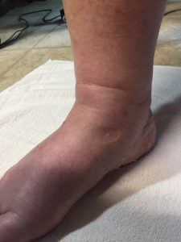
Figure 8: Pitting edema.
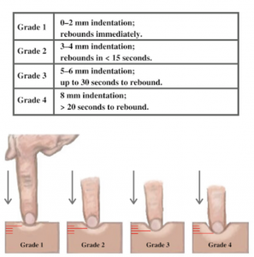
Figure 9: Pitting edema scale. (Attribution, taken fromhttps://wtcs.pressbooks.pub/nursingskills/CC-BY 4.0)
- Note the findings:

  - Normal findings might be documented as: “Skin temperature is warm and equal bilaterally on arms and legs. Skin is smooth with no perspiration and no lesions. Good skin turgor. Limb circumference is equal bilaterally with no edema.
  - Abnormal findings might be documented as: “Right foot is cold in comparison to left foot. Poor skin turgor and dry skin.”

Priorities of Care
All abnormal findings should be investigated further and reported to the physician or nurse practitioner. For example, poor skin turgor suggests possible dehydration and the client may have other signs such as dry mouth, decreased urine output/dark urine, and light-headedness. Poor skin turgor can also be associated with fever and cause tachypnea, tachycardia, and hypotension when severe, so you should assess the client’s hydration status. Ask whether they have experienced recent vomiting, diarrhea, or reduced fluid intake. If the client is an infant, ask the caregiver/parent if they have observed a decrease in the number of wet diapers. If the dehydration is mild, encourage the client to increase their fluid intake. More severe dehydration may require intravenous fluids.

Contextualizing Inclusivity
Use a trauma-informed approach to touch by creating a trusting, safe environment. Clients might have experienced trauma resulted to experiencing or observing physical, sexual and/or emotional abuse, childhood neglect, a family member with mental illness or substance use disorder, violence, and poverty and systemic discrimination (Menschner & Maul, 2016). This can affect how they perceive touch (including palpation). Discuss with the client what they can expect from the objective assessment in terms of touch and explain what you are doing and why.

References
Menschner, C., & Maul, A. (2016). Key ingredients for successful trauma-informed care implementation. Centre for Health Care Strategies Inc, Robert Wood Johnson Foundation.https://www.samhsa.gov/sites/default/files/programs_campaigns/childrens_mental_health/atc-whitepaper-040616.pdf

29

Nails: Inspection and Palpation
Inspection and palpation of nails can be accomplished with the client in a sitting upright position or lying supine. Nail polish or artificial nails must be removed to fully assess the nails. You will need to decide if a full nail assessment is warranted depending on the nature of the visit, the reason for seeking care and the client’s status. If appropriate, remind the client to arrive without nail polish or artificial nails before their appointment.
Steps for nail inspection and palpation include:
- Inspect the nail condition and nail colour by asking the client to hold their hands out in front of them (Figure 10).
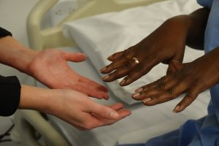
Figure 10: Inspection of nails.
(Licensed under a Creative Commons Attribution-Non-commercial 4.0 License. Arthur Labatt Family School of Nursing, “Nail Colour Assessment” (2021). Respiratory Exams. https://ir.lib.uwo.ca/clinicalskills_respexam/15)

  - Normally, the ends of the nails are smooth and nails are clean. A client’s job may influence nail cleanliness. Nails are translucent in colour and have a slight pinkish tone.
  - Abnormal findings may include ridges, pitting, brittleness, indentations, and discolourations. If you note any abnormal nail condition or discolouration, describe the appearance and location, e.g., white markings at the base of the nail on the left index finger. Table 9 lists some nail variations that you may observe. Yellowing or darkening of the nails is a common discolouration associated with nail fungus (see Figure 11)

Clinical Tip
Landmark digits (fingers and toes) appropriately. Many institutions have a body diagram to landmark anatomy. Check with your institution for specific nomenclature, which can vary in terms of how digits are referenced. Sometimes the thumb as referred to as Digit 1, index finger as Digit 2, middle finger as Digit 3, ring finger as Digit 4, and little finger as Digit 5. If you are uncertain about how to reference a specific digit, landmark as descriptively as possible (e.g., middle finger left hand, 2nd medial toe right foot).
Table 9: Nail colour changes.
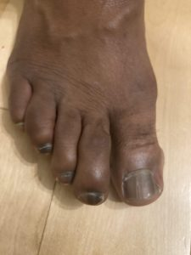
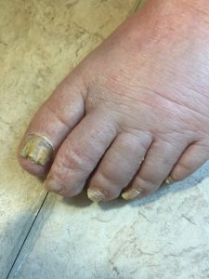
Figure 11: Nail fungus.
- Assess for the presence of clubbing (see Figure 12 and Video 4 and 5). Clubbing is related to conditions that lead to chronic hypoxia (e.g., chronic lung diseases, cystic fibrosis, congenital heart disease). Chronic hypoxia can cause the nail angle to flatten to 180 degrees or more, the nail bed to soften and become spongy, and the fingertips distal to the distal interphalangeal joint to become enlarged. Clubbing typically first develops in the thumb and then the forefingers. It is often assessed on the index finger, but in cases of early clubbing it may not have advanced to that digit, so it is best to assess the thumb first. To assess for the presence of clubbing, ask the client to point their thumb out so that it is parallel to the ground and view it at your eye level (this is considered the profile sign). Inspect the nail angle at the intersection of where the nail base meets the skin.

  - Normally, the nail angle base is about 160 degrees with normal-sized fingertips and nail beds that are firm to touch.
  - Clubbing is evident when the angle of the nail base is greater than 180 degrees (flattening of the nail base); fingertips are usually enlarged and bulb-like, and the nail base is spongy/soft upon palpation.

Figure 12: Clubbing.
(Photo by Sidsandyy, CC BY-SA 3.0, https://commons.wikimedia.org/w/index.php?curid=40100295)

One or more interactive elements has been excluded from this version of the text. You can view them online here: https://pressbooks.library.torontomu.ca/assessmentnursing2/?p=1043#oembed-1
Video 4: Inspection for clubbing on the index finger [0:19]

One or more interactive elements has been excluded from this version of the text. You can view them online here: https://pressbooks.library.torontomu.ca/assessmentnursing2/?p=1043#oembed-3
Video 5: Inspection for clubbing on the thumb [0:18]
- Palpate the nails for texture and consistency using a grasping motion: place the pad of your index finger on the client’s nail and your thumb on the underside of the client’s finger. Palpate the whole nail including the nail bed.

  - Normally, nails are smooth and firm.
  - Describe the appearance and location of thick nails and spongy/soft nails.
- Palpate the nails for capillary refill on two or three fingernails of each hand, at heart level (see Video 6). Start by applying pressure with your own finger to the client’s nail; this causes the nail to blanch (become paler in colour). Apply the pressure for 5 seconds and then release and observe the return in colour.

  - A normal finding when assessing capillary refill is colour return within 3 seconds or less.
  - Colour return taking longer than 3 seconds is considered sluggish return for capillary refill (or slow capillary refill time), and this finding suggests possible issues with oxygenated blood perfusion (this may be related to peripheral vascular and/or cardiac and/or respiratory issues). Note that capillary refill time can be slower if the client’s hands are cold from being outside or from washing in cold water; ask them to warm their hands to ensure an accurate reading.
One or more interactive elements has been excluded from this version of the text. You can view them online here: https://pressbooks.library.torontomu.ca/assessmentnursing2/?p=1043#oembed-2
Video 6: Capillary refill [0:45]
- Note the findings:

  - Normal findings might be documented as: “Nails are smooth, firm, clean with translucent colour, and no presence of clubbing. Capillary refill within 2 seconds.”
  - Abnormal findings might be documented as: “Nail angle on thumbs is slightly greater than 180 degrees, capillary refill time is 5 seconds.”

Priorities of Care
Nail concerns do not usually require immediate intervention. However, a client with sluggish capillary refill combined with other cues suggesting severely reduced blood flow to the limbs requires additional interventions to re-establish blood flow. For example, if associated with absent or diminished pulses, cool limbs, numbness, cyanosis, or pallor, report these findings to the physician or nurse practitioner.
Some other nail concerns also may need to be addressed promptly. For example, nail laceration, avulsion, and subungual hematoma may require treatment. Bleeding under the nail can cause pressure and pain, and drilling a small hole in the nail can alleviate the pain associated with pressure by allowing the blood to escape the nail bed. With some cases of laceration and avulsion, healthcare providers may need to remove or glue the nail or the surrounding skin may need to be stitched in place.

30

Hair: Inspection and Palpation
You might begin with a brief inspection of the hair, but this is typically done in combination with palpation. Always ask permission to touch. Move the hair around while observing the scalp and strands of hair; when looking for lice or nits, it is helpful to use a comb.
Steps for inspecting and palpating hair include:
- Inspect and palpate for hair colour and texture.

  - Keep in mind that hair can vary greatly in terms of colour and texture. Note any variations in hair colour not attributable to hair dye, any colour patches or other inconsistencies, hair texture, and the integrity of the scalp. If you have a concern, it can be helpful to first ask the client what their normal or baseline hair colour and texture is.
  - Note any excessive dryness or oiliness of the hair and scalp or any areas of the scalp that are not intact.
- Inspect and palpate for hair distribution.

  - Hair patterns should be consistent without patches of hair or hair loss. However, keep in mind that as a person ages, it is natural for hair to thin and for some people to experience bald areas on the scalp particularly when it is associated with male-pattern baldness.
  - Abnormal findings may include unexplained hair loss on the scalp and the body. Hair loss can be the result of certain conditions and medications. Any hair tufts on the body that are inconsistent with the rest of the hair distribution, such as patches of hair on the scapula, are considered abnormal findings. Hirsutism refers to excessive hair growth on the body. Alopecia refers to patches of baldness or total absence of hair on the scalp. Hair loss on the legs, particularly the toes, can be affected by peripheral vascular disease (you will learn more about this in another chapter).
- Inspect and palpate for lesions and other issues. Use a systematic approach generally starting from the midline of the hairline on the forehead and making your way one side at a time to the base of the skull. Then return to the midline of the hairline of the forehead and repeat on the other side. Be sure to examine behind the ears for lesions and examine strands of hair.

  - Normally, no lesions are present.
  - Describe any abnormal findings. For example, dandruff (seborrhea) is a common condition involving a dry flaking that can be seen on the scalp or hair. Because it flakes (or falls), it can sometimes be seen on the client’s clothing (e.g., on the shoulders). Lice may be found on the scalp at the neckline and behind the ears, while the nits (eggs) stick to strands of hair. Pilar cysts are often observed on the head. These are benign growths stemming from the hair follicle, but they can be painful and even disrupt rest.
- Note the findings:

  - Normal findings might be documented as: “Hair colour and distribution consistent with no dryness or oiliness and no lesions present.”
  - Abnormal findings might be documented as: “Several nits located on hair strands on the posterior and left side of the head with lice behind the left ear and at the base of the neck.”

Contextualizing Inclusivity
The beauty industry and commercialism has shaped ideals and standards of what constitutes beauty, particularly for women. Facial hair removal is a pervasive cultural practice for many women, but remember that some facial hair growth is normal regardless of gender. Hair growth along the upper lip, cheeks, and chin can be a normal finding for many women.
Consider an inclusive, anti-racist, and trauma-informed approach when assessing the hair on a client’s head. Always ask permission to touch and explain what you are doing and why. Only perform assessments when necessary, and engage the client in the process.
Clients may have alopecia due to a medical diagnosis or treatment that has caused hair loss; hair loss can be distressing and make them feel vulnerable. There is also a cultural component to hair and headwear, which can be connected to identity, culture, and body image (e.g., Jewish men may wear a kippa, married Jewish women may wear a wig or headscarf, Sikh men and women may wear a turban, transgender individuals may wear wigs or extensions). It is important to be aware of the structural racism that continues to pervade ideals of beauty, for example affecting Black women in particular (Johnson & Bankhead, 2014). Black women may wear their hair naturally, in locs, braids, wigs, or extensions such as clip-ins and weaves, and some may use coconut oil or other oil-based products in their hair. Black women continue to be affected by structural and interpersonal racism with accompanying discrimination, judgement, and marginalization (Brown, 2018). Additionally, some Indigenous people have a spiritual connection with their hair and for that reason, along with the effects of forced cutting of hair in residential schools, and intergenerational trauma more broadly, some may consider it offensive to have their hair touched.

References
Brown, S. (2018). “Don’t touch my hair”: Problematizing representations of Black women in Canada. Africology: The Journal of Pan African Studies, 12(8), 64-85.
Johnson, T., & Bankhead, T. (2014). Hair it is: Examining the experiences of Black women with natural hair. Open Journal of Social Sciences, 2, 86-100.https://doi.org/10.4236/jss.2014.21010

31

Health Promotion and Disease Prevention: Considerations and Interventions
Health promotion is an important component of any visit with clients. An assessment of the integumentary system is an opportunity to determine appropriate interventions, if required. Carefully consider all of the collected data, both subjective and objective. During your subjective data collection, you will have asked about risk factors, social determinants, and other considerations. Based on your critical reflection of all data, you might formulate additional questions. Together, your findings will inform your clinical judgment and help you determine the health promotion needed for a specific client.

Healthy Eating
A well-balanced diet is an important part of maintaining healthy skin, hair, and nails. Persons with substance use disorder, mental illness, and other conditions that affect nutrient absorption are at particular risk for developing vitamin deficiencies, which can lead to integumentary manifestations (see Table 10). Always use a non-judgemental approach when assessing healthy eating with all clients, including those with these conditions.
Probing questions related to diet may include:
- Tell me about your usual diet?
- How much fluids do you typically drink in a day? What fluids do you drink (e.g., water, caffeinated beverages, alcohol)?
- Have you had any recent changes in your life that have affected your diet?
- Do you have any issues accessing healthy food?
- Do you have enough money to buy healthy food?
Table 10: Vitamin deficiencies.

Skin, Nail, and Hair Care
Tools used on the skin, hair, and nails should be cleaned regularly to prevent the spread of microorganisms. Families that share nail clippers and hair brushes should replace these tools after an infection or infestation (e.g., lice), and it is never advisable to share razors with others. Inquire about the client’s skin, nail, and hair care routine.
Probing questions related to skin, nail, and hair care may include:
- Tell me about your usual skin care routine? Your hair routine? Your nail routine?
- What products do you use?
- Have you recently changed the products you use?

Environmental Health
Environmental exposures to irritants such as poison ivy, poison oak, poison sumac, stinging nettle, and wood nettle can cause contact dermatitis (inflammation of skin with burning/itching) and other rashes. Other irritants that may cause skin reactions can include soaps/detergents, perfumes, solvents, and disinfectants. Some clients may have occupations involving exposure to potent chemicals, for example those working at dry cleaners or nail salons. Others may have occupational exposure to pesticides, plastics, and other materials/chemicals that can cause skin reactions. Ask about all of these issues during your subjective assessment.
Another important issue is skin cancer, which can be related to environmental conditions, especially sun exposure. Mole mapping and monitoring are important strategies to prevent skin cancer or identify it in early stages. Skin cancers can vary in shape, size, and presentation. A new growth or change in skin is the most common sign: a new growth that does not heal, bleeds, is painful – or a mole that evolves – are important warning signs that should prompt further assessment. Teach clients about sun protection to prevent skin cancers, including daily application of sunscreen and use of protective clothing.
Probing questions related to environmental health might include:
- Do you have any allergies?
- Do you spend time outside in the sun?
- How do you protect yourself from the sun? (e.g., sunscreen with SPF 30 or above, limiting time in sun, wearing a hat, wearing long sleeves/pants). What is the SPF?
- Do you have a history of abnormal moles? If so, do you monitor your moles? How?
- Do you spend time outside in long grass or treed areas? Have you noticed any ticks? How do you protect yourself from ticks? (e.g., long, cuffed pants, closed shoes).
- Are you exposed to chemicals at your workplace? If so, what precautions do you take?

Knowledge Bites
Eruptive skin rashes caused by viruses can occur year-round in children and adults, but winter months tend to be correlated with higher rates of spread because more time is spent indoors.

32

Clinical Judgment: Case Study
A 64-year-old client attends a primary healthcare clinic reporting a burning and tingling sensation with pain and rash under their breast on the left side of the trunk. The client indicates difficulty sleeping due to pain and irritation and rates the pain as 6/10. The client reports that the burning and tingling pain started 8 days ago and the rash started 5 days ago and has progressively worsened and spread slightly. Upon assessment, you note a linear red rash with vesicles spanning from the midline of the trunk to the posterior scapula on the left side (following dermatome). Several vesicles appear to have erupted and are crusted over. Client’s vital signs are: blood pressure: 135/89 mm Hg, pulse 89 beats per minute, respirations 18 breaths per minute, O2 saturation: 98%, temperature: 38.6ºC tympanic. Client has not received immunizations in 20 years.

An interactive H5P element has been excluded from this version of the text. You can view it online here:
https://pressbooks.library.torontomu.ca/assessmentnursing2/?p=1049#h5p-51

33

Key Takeaways
- Common symptoms to assess related to the integumentary system include skin lesions, skin breakdown, hair loss and nail discoloration.
- The objective assessment of the integumentary system involves inspecting and palpating the skin, hair and nails.
- Health promotion interventions should be developed with the client to address what is important to them. Considerations include dietary adjustments to prevent vitamin deficiencies and preventing the spread of infection.

III

Musculoskeletal System

Authors
Michelle Hughes, MEd, RN, Professor 1
Raquel Lashley-Trambulo MN(c), BScN, RN, Professional Practice and Simulation Coordinator 2
Margaret Verkuyl, MN, NP:PHC, Professor 1
Dr. Erin Ziegler, PhD, NP-PHC, Assistant Professor 2
Paul Petrie, MScN, RN, Professor 3
Evan Accettola, PN, RPN 1
Meera Chawda, nursing student 1
Saba Ghafouri, nursing student 1
Dr. Jennifer Lapum, PhD, RN, Professor 2

Consultant:
Joseph Trambulo, (PT), BSc PT Registered Physiotherapist

1 Centennial College
2 Toronto Metropolitan University
3 George Brown College

34

Learning Outcomes
- Apply subjective assessment skills.
- Apply objective assessment skills.
- Use clinical judgement.
- Integrate health promotion interventions into actions.
- Integrate an inclusive approach to musculoskeletal assessment.

35

Introduction to the Musculoskeletal System
The musculoskeletal system (MSK) is important to assess as it is considered the body’s framework and supportive structure. It has additional roles such as hemopoiesis, and mineral and fat storage. See Figures 1 and 2 for an anatomical overview of the MSK system.
Your assessment provides information about the functioning of this system and potential cues that require your action.

Musculoskeletal System Components
The main components of the MSK system include the skeleton:
- Skull, including the cranial and facial bones.
- Vertebral column with intervertebral discs.
- Thoracic cage with sternum and ribs.
- Clavicle and scapula.
- Upper and lower limb bones.
- Hip/pelvis bones.
The skeleton also includes cartilage in particular areas of the body such as the nose, ears, costal cartilage, and articular cartilage in joints (e.g., shoulder, hips, knees, elbows, wrists/hands, and ankles/feet). See Figure 3 for an anatomical overview of the articular cartilage and synovial joint.
The skeleton is supported by muscles. Skeletal muscles specifically attach to the bones of the skeleton and provide support. The MSK system is connected and supported by joints. These joints include articular cartilage, ligaments, and tendons to connect the MSK system together. Many joints have a cavity with synovial fluid between the articulating joints that permits mobility, including the shoulders, elbows, wrists/fingers, hips, knees, and ankles/toes. Other joints do not have a cavity with synovial fluid including cranial sutures (which are not moveable) and the vertebral column (which is slightly moveable). Bones are connected by ligaments, and tendons connect muscle to bone.
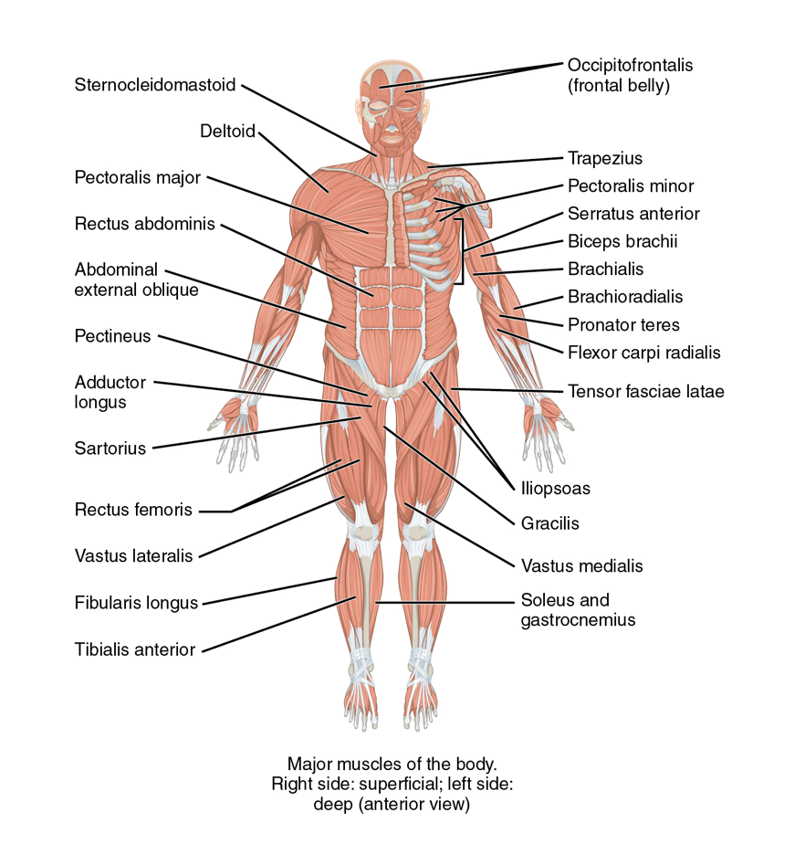
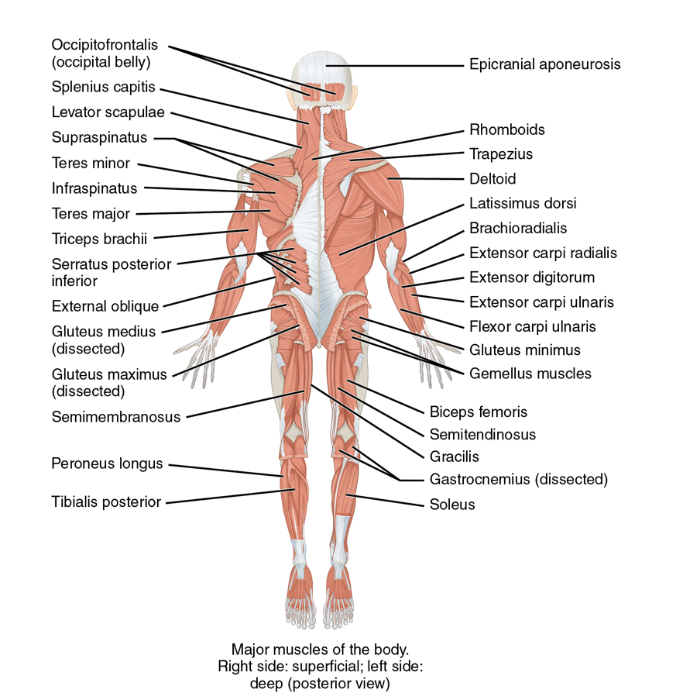
Figure 1: Muscular system (anterior view on top image, posterior view on bottom image)
Attribution:Building a Medical Terminology Foundationby Kimberlee Carter and Marie Rutherford is licensed under aCreative Commons Attribution 4.0 International License, except where otherwise noted.
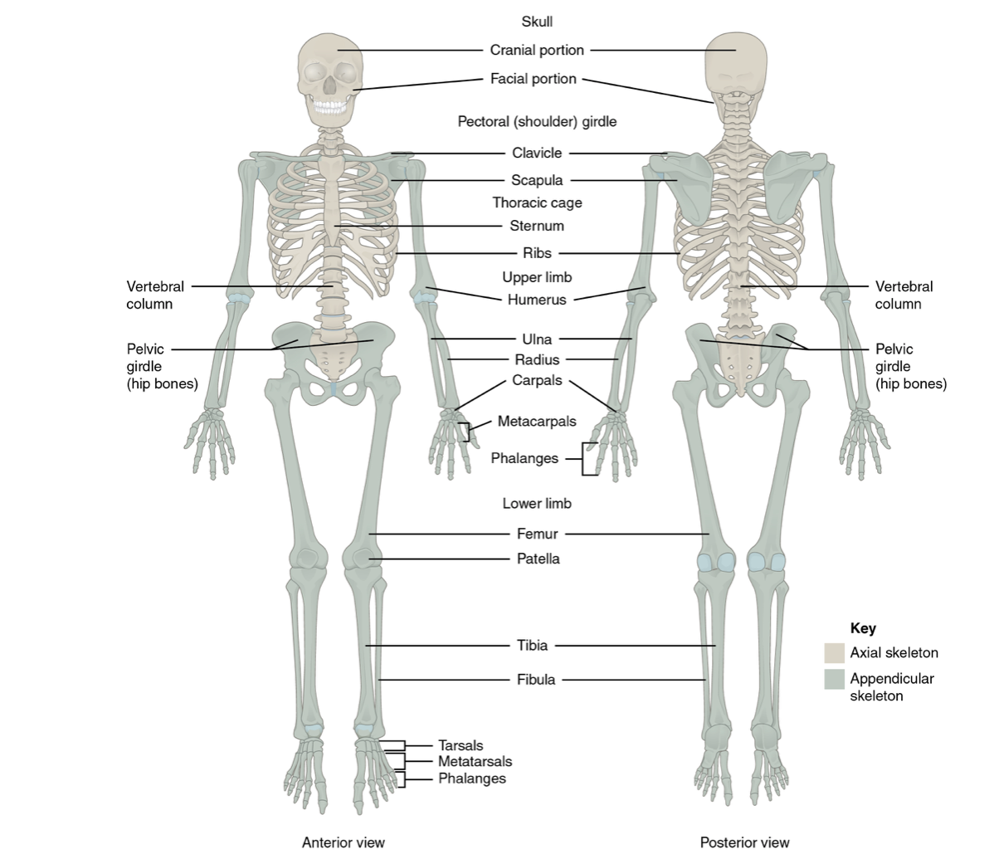
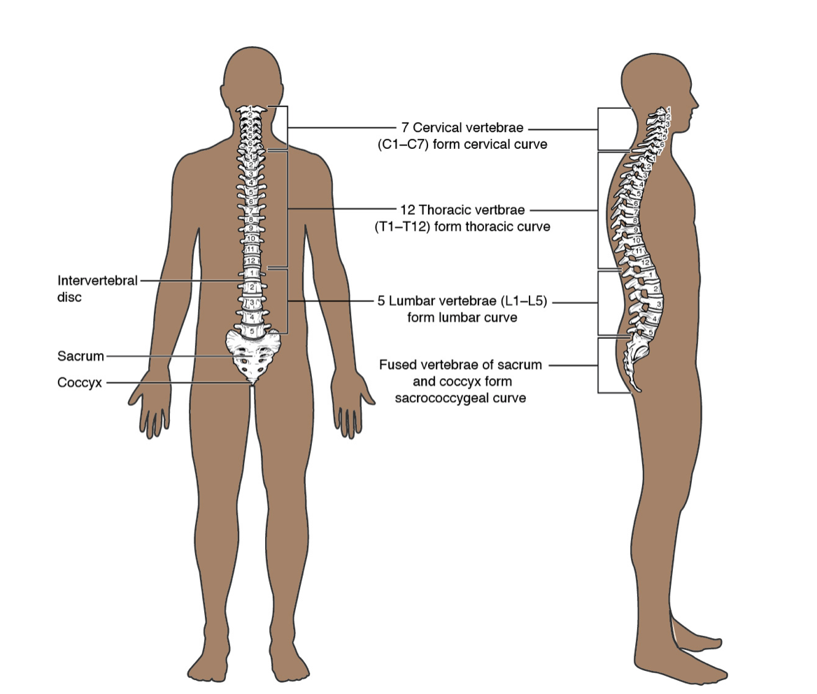
Figure 2: Skeletal system
Attribution:Building a Medical Terminology Foundationby Kimberlee Carter and Marie Rutherford is licensed under aCreative Commons Attribution 4.0 International License, except where otherwise noted.
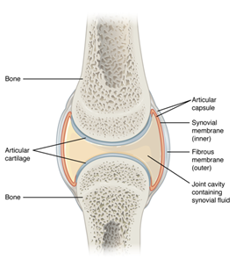
Figure 3:Articular cartilage and synovial joint.
Attribution:Building a Medical Terminology Foundationby Kimberlee Carter and Marie Rutherford is licensed under aCreative Commons Attribution 4.0 International License, except where otherwise noted.

You have already learned about the anatomy and physiology of the MSK system, but check out these helpful videos on themuscular systemexplained in six minutes and theskeletal systemexplained in seven minutes.

Clinical Tip
Your MSK assessment will begin when you first meet the client. Remember to incorporate the concept of functional health by assessing the client’s physical capacity to participate in daily activities. For example, a functional assessment includes assessing day-to-day activities such as walking into the room, moving from standing to sitting, signing a consent form, or changing into a hospital gown. Always compare bilaterally during the assessment. Ask clients if they have noticed any changes in their movement and if they have any questions or concerns. Your findings will help to guide your assessment throughout the examination, as well as provide opportunities to incorporate health promotion and prevention education.

Knowledge Bites
The MSK system is influenced by the neurological system. For example, muscle functioning (e.g., movement and strength) is innervated by the cranial nerves (12 pairs of nerves that send electrical signals from the brain to the body) and the spinal nerves.

Activity: Check Your Understanding
An interactive H5P element has been excluded from this version of the text. You can view it online here:
https://pressbooks.library.torontomu.ca/assessmentnursing2/?p=78#h5p-7

36

Subjective Assessment
Subjective assessment of the MSK system involves asking questions about the health of the client and symptoms that may occur because of pathologies that affect the muscles, bones, and joints. A full exploration of these pathologies is beyond the scope of this chapter, but common problems associated with the MSK system include back pain, repetitive strain injury (RSI) such as carpal tunnel syndrome or tendinitis, osteoarthritis, rheumatoid arthritis, sprains, and bone fractures.
Common symptoms that can be related to the MSK system include pain, headache, stiffness, muscle tightness, numbness, weakness, muscle twitches, fatigue, mobility, redness, swelling, local temperature change, deformities, and psychological distress. See Table 1 for guidance on subjective health assessment. Many of the questions in this table align with the PQRSTU mnemonic; for a reminder, check out this resource:PQRSTU. Probing of these symptoms should occur in the order of relevance, as opposed to being sequentially aligned with the PQRSTU mnemonic.
You should also ask about any medications (prescribed, over the counter, and herbal and natural products) the client is taking: the name, dose, frequency, reason it was prescribed or rationale for taking over-the-counter medications, how long they have been taking it, and the effectiveness.
The subjective assessment is performed prior to the objective assessment so that it can inform the objective assessment. Remember to always ask questions related to health promotion. Depending on the context of the assessment, you may ask these questions and engage in a discussion during a subjective assessment or after an objective assessment. A section on “Health Promotion Considerations and Interventions” is included later in this chapter after the discussion of objective assessment.

Knowledge Bites: Pathophysiology
Many MSK-related pathophysiology disorders are related to physical work (e.g., working at a computer, lifting boxes) and workplace injuries, which can be prevented or decreased by implementing health promotion strategies. MSK injuries can occur in the muscles, nerves, tendons, joints, cartilage, and bones. Certain work environments can increase the risk or worsen an MSK injury. For example, work that involves routine lifting, performing repetitive tasks, or work that challenges the ergonomics of your body (e.g., working at a computer for lengthy periods of time). Common workplace musculoskeletal disorders include sprains, back pain, tendonitis, and carpal tunnel syndrome. Proper body alignment and ergonomics can help decrease the risk of a MSK workplace injury.
Table 1: Common symptoms, questions, and clinical tips.

Priorities of Care
All abnormal findings required a focused assessment on the MSK system and possibly other systems. However, certain MSK symptoms are cues that require immediate action.
A sudden very severe headache that is worse than the client has ever experienced before requires urgent assessment. It could be a sign of a life-threatening condition such as an aneurysm or a ruptured aneurysm. Other associated symptoms include reduced consciousness, disorientation, eye pain, light sensitivity, blurred vision. If your client has this sort of headache, you should immediately report it to the physician or nurse practitioner, monitor the client’s vital signs, and conduct focused assessments (on the MSK, neurological system, and the eye).
Additionally, if a client has experienced a trauma with a potential fracture, you should perform a focused assessment. A bone fracture is highly probable if the client experiences a sharp and intense pain upon movement. Take immediate action to decrease the risk of further internal trauma to the peripheral vascular systems (e.g., circulation), nervous system, or other organ damage (e.g., punctured lung or perforated bowels). For example, with a clavicle fracture, the sharp edge of a broken bone could damage the underlying vessels (e.g., internal jugular vein), nerves (e.g., brachial plexus) or puncture the apex region of the lung (e.g., pneumothorax). When a fracture is suspected:
- Immobilize the area and do not attempt to realign the bones.
- Monitor vital signs frequently (particularly respiration, pulse, and blood pressure) and perform a primary survey.
- Assess circulation and sensation distal to the injury including skin temperature, sensations, and pulses: cool temperature, numbness/tingling, and decreased or absent pulses.
- Report findings to the physician or nurse practitioner.

Contextualizing Inclusivity
Recognize that some clients may have extensive MSK histories, particularly older clients, and ensure you allow sufficient time for assessment.
Also, you may have certain values surrounding activity and exercise and/or concerns about your own body image. Try to reflect on your own unconscious biases: this will help you support each client’s agency and their own mobility goals while connecting them with supportive resources within their communities.
Some clients with MSK limitations may feel hesitant to participate in sports or activities. For example, they may feel uncomfortable because of self-concept or body image issues associated with their limitations, mobility aids, or physical deformities. It is important that you create an inclusive environment, and be aware of the client’s potential discomfort. For example, you may begin the assessment with a non-judgemental question such as: “What type of activities (or sports) do you enjoy?” This can open a discussion about participating in sports or group activities, which can provide many benefits to the client’s concept of self. Interacting and socializing with others in a shared activity can create a sense of inclusion, as well as have positive health benefits, both physical and emotional.
Listen to Justin Gallegos’ story about being part of his high school cross-country and track team: No Such Thing As A Disability: The story of a runner with cerebral palsy [insert link:https://youtu.be/Hv3liaDDtSY]

Activity: Check Your Understanding
An interactive H5P element has been excluded from this version of the text. You can view it online here:
https://pressbooks.library.torontomu.ca/assessmentnursing2/?p=80#h5p-18

References
Canadian Patient Safety Institute (2015). Reducing falls and injuries from falls. https://www.patientsafetyinstitute.ca/en/toolsResources/Pages/Falls-resources-Getting-Started-Kit.aspx

37

Brief Scan: MSK System
A brief scan provides a quick overview of the MSK system. It can be performed when the client enters the room. Your observations provide insight into how the client may need to be supported during the assessment, ways you may need to modify the assessment, and cues that require further investigation.
Steps involved in the brief scan are:
- Assess the type of footwear and the presence of prosthetics and mobility aids such as canes, walkers, braces, splints, or wheelchairs.
  - If aids are present, you should ask further questions. You need to understand the need for the aid and should assess whether it is being used properly.
- Assess the client’s posture and balance when they enter the room and their ability to sit or stand upright and maintain this position.
  - Abnormal findings may include hunched over, unequal weight bearing, and lateral lean.
- Assess for the presence of tremors or obvious deformities. Normally, no tremors or deformities are present.
  - Abnormal findings may include deformities, which could include fractures.
  - Abnormal findings may include unilateral or bilateral tremors in head/neck region, upper or lower limbs.
- Assess the client’s symmetry of limbs in terms of length and gait. This can be done informally when the client walks in the room from the waiting room. Otherwise, you can ask them to walk about 10 feet. This may not be required if a client is in a wheelchair, particularly if they are unable to stand up.
  - Normally, limbs are symmetrical, and gait is balanced. Cues of asymmetry and a gait that is not balanced should be probed further.
- Note the findings.
  - Normal findings might be documented as: “Client’s body is symmetrical, no deformities, posture straight, steady gait and balance. No mobility aids used.”
  - Abnormal findings might be documented as: “Client has a slow and unsteady gait. Left arm hangs lower than the right arm.”

Contextualizing Inclusivity
Use a person-centred and systematic approach to assessment. The initial MSK brief scan will help guide your questioning and facilitate a non-discriminatory, anti-ableist assessment. For example, if a client uses a mobility aid, always ask for permission/consent to touch or handle the equipment.

Priorities of Care
During the brief scan, any fractures or suspected fractures should take priority. The fracture may have caused internal damage that is not visible upon inspection, such as a punctured lung, severed cranial nerve, perforated organ, or bone fragments. A primary survey approach should be performed before beginning a focused MSK assessment. If there are no life-threatening injuries, you can begin the MSK assessment. Safety should be prioritized, including prevention of falls when assessing a client’s movement, balance, strength, and gait.

38

Objective Assessment
An objective MSK assessment is generally completed after the subjective assessment. If the client shows signs of clinical deterioration, such as respiratory distress, you should focus the interview portion on pertinent questions and proceed directly to the objective assessment and associated interventions. For example, a fractured rib or vertebral fracture or a fracture that has severed circulation requires urgent intervention.
Be aware of the environmental temperature in the room and the temperature of your hands. Room temperatures are not easily modified, so try to limit exposing the client’s body parts and keep them covered with their clothes or sheet/blanket until you need to assess that body part. This also follows a trauma-informed approach and maintains the client’s dignity and limits exposing them unnecessarily. If a stethoscope is needed, warm your hands and stethoscope before placing them on the client’s body.
The objective assessment of the MSK system involves a brief scan and a focus on inspection, palpation, range of motion (ROM), and manual muscle testing (MMT), and sometimes auscultation, depending on the affected area (see Table 2). Compare the body bilaterally throughout the assessment. Assess the unaffected side first for comparison with the affected side, and when a joint is affected, at the minimum, assess above and below the joint. However, it is important to note that some causes of joint pain can go beyond the joint above and joint below.
The sequential order of the objective assessment is typically based on minimizing position changes and using a cephalocaudal (head to toe) or proximal to distal approach. Although certain positions are suggested, you may need to adapt the position if a client is not able to stand or sit up. Do not conduct ROM or muscle testing if the subjective assessment and/or inspection and palpation suggest trauma to the neck or back, or a bone fracture.
Table 2: Brief overview of a MSK assessment.
Table 3: MMT Scale (based on Medical Research Council (MRC) Manual Muscle Testing scale, 1943).

Contextualizing Inclusivity
When assessing the MSK, you will need to assist the client into various body positions. Try to reduce the number of changes in body position, particularly for older clients and clients with physical disabilities who may have difficulty and possibly reduced strength to change positions. If you are assessing a newborn or young child, you can ask someone (e.g., care partner, healthcare provider, parent) to help hold and reposition the client on the exam table or in their lap while you conduct the assessment.

Knowledge Bites
Synovial joints have a small amount of fluid in the cavity between the articulating joints, but this fluid should not be palpable. Palpable fluid is a joint effusion, which refers to an accumulation of excess fluid. When palpating, it feels soft and moveable, and is sometimes associated with warmth, redness, and pain. The cause of effusions varies, but can be associated with infection, inflammation, and injury. Effusions are considered in the context of other cues, the severity, and potential causes. Treatment may be as simple as rest, ice or heat, and non-steroidal anti-inflammatory medications. Depending on the cause and severity, other treatments may include antibiotics, arthrocentesis, and surgery.

Activity: Check your Understanding

An interactive H5P element has been excluded from this version of the text. You can view it online here:
https://pressbooks.library.torontomu.ca/assessmentnursing2/?p=82#h5p-26

References
American Academy of Orthopaedic Surgeons. Joint Motion: Method of Measuring and Recording. Chicago: AAOS; 1965.
James. (2007). Use of the Medical Research Council Muscle Strength Grading System in the Upper Extremity. The Journal of Hand Surgery (American Ed.), 32(2), 154–156.https://doi.org/10.1016/j.jhsa.2006.11.008
Luttgens, K. & Hamilton, N. (1997). Kinesiology: Scientific Basis of Human Motion, 9th Ed., Madison, WI: Brown & Benchmark
Medical Research Council. Aids to the investigation of peripheral nerve injuries (2nd ed.), Her Majesty’s Stationery Office, London (1943)
Naqvi U.Muscle strength grading. InStatpearls [Internet] 2019 May 29. StatPearls Publishing. Available from:https://www.ncbi.nlm.nih.gov/books/NBK436008/(last accessed 7.1.20)
Schmitt, W.H., Cuthbert, S.C. Common errors and clinical guidelines for manual muscle testing: “the arm test” and other inaccurate procedures . Chiropr Man Therap 16, 16 (2008).https://doi.org/10.1186/1746-1340-16-16

39

Face, Neck, and Cranium
Assessment of the face, neck, and cranium involves inspection, palpation, ROM, and MMT. This assessment is best performed with the client sitting upright on the exam table. However, depending on the client’s situation, it can be performed when they are sitting in a chair/wheelchair or lying in bed.

Inspection
Steps for inspecting the face, neck and cranium include:
- Inspect the face for colour, symmetry, swelling, masses, and deformities with a focus on the muscles, bones, and joints.

  - Normally, the face has no discolourations such as erythema and is symmetrical with no swelling, masses, or deformities. Describe the appearance and location of any discolouration, swelling, masses, and deformities.
2. Inspect the anterior, lateral, and posterior sides of the neck and cranium (as well as the superior side of the cranium). Depending on the reason for assessment, it may be appropriate to request permission to move the client’s hair so that you can directly observe the cranium.

  - Normally, the head is upright and centred and the cranium and the neck are symmetrical with no masses, swelling, deformities, or discolourations. Describe the appearance and location of any asymmetry, masses, swelling, deformities, and discolourations (these will be further assessed with palpation).
3. Note the findings.

  - Normal findings might be documented as: “Client’s head is upright and centred. No masses, swelling, deformities or discolouration on the head, face and neck.”
  - Abnormal findings might be documented as: “Client’s face has swelling over the right zygomatic (cheekbone) area with bluish-purple discolouration.”

Contextualizing Inclusivity
Consider an inclusive, anti-racist, and trauma-informed approach when assessing the cranium, which may involve touching the hair. Clients may have alopecia due to a medical diagnosis or treatment that has caused hair loss; hair loss can be distressing and make them feel vulnerable. There is also a cultural component to hair and headwear, which can be connected to identity, culture, and body image – this can apply to many people. Be aware that structural racism continues to pervade ideals of beauty and affects Black women in particular (Johnson & Bankhead, 2014). Black women may wear their hair naturally, in locs, braids, wigs, or extensions such as clip-ins and weaves. Black women continue to be affected by structural and interpersonal racism with accompanying discrimination, judgement, and marginalization (Brown, 2018). Additionally, some Indigenous people have a spiritual connection with their hair and for that reason, along with the effects of forced cutting of hair in residential schools, and intergenerational trauma more broadly, some may consider it offensive to have their hair touched. As a healthcare provider, you should be aware of these issues and use an anti-racist and trauma-informed approach. Always ask permission to touch and explain what you are doing and why. Only perform assessments when necessary and engage the client in the process.

Palpation
Steps for palpating the cranium, face, and neck include:
- Palpate the temporomandibular joint (where the maxilla and mandible meet anterior to the tragus). Do both sides at the same time and place two to three finger pads on each side and move in a circular motion in two to three areas. Then, use dorsa of hands and palpate the posterior side of neck for temperature. The rest of the facial structures are normally not palpated unless the client has indicated a concern or has experienced a physical injury.

  - Normally, the temperature is equal bilaterally, muscles are firm to touch, and no pain is felt on palpation.
2. Palpate down the cervical spine and the paravertebral muscles on the posterior side of the neck from inferior to the occipital bone (C1) down to C7 (see Video 1). Then, palpate down the trapezius muscles followed by the sternomastoid muscles. Ask the client if they have any pain/tenderness.

  - Normally, the cervical spine and muscles are symmetrical with no pain, masses, swelling, deformities, or paravertebral muscle spasms. The description and location of abnormal findings should be noted. Description of masses and swelling may include size and consistency (soft or hard).
3. Note the findings:

  - Normal findings might be documented as: “Temperature warm to touch and equal bilaterally with no pain on temporomandibular joint. Cervical spine and muscles are symmetrical with no pain, masses, swelling, or deformities noted on palpation.”
  - Abnormal findings might be documented as: “Client noted pain as a 6/10 upon palpation of the cervical spine. Swelling palpable from C6–7.”

One or more interactive elements has been excluded from this version of the text. You can view them online here: https://pressbooks.library.torontomu.ca/assessmentnursing2/?p=86#oembed-1
Video 1: Palpation of spinous processes and paravertebral muscles from C1 to C7 [0:43]

Range of Motion (ROM)
ROM related to the face is focused on the temporomandibular joint and includes vertical and lateral motions and protraction and retraction. ROM of the neck involves flexion, extension, lateral bending, and rotation (see Table 4 for normal ranges). For cervical spine ROM, you will assess the gross ROM, which is the cumulative ROM of all of the spinal segments together.
While performing the assessment, observe the ROM, listen for crepitus, and ask the client about the presence of pain.
While demonstrating the movements yourself, the steps in assessing ROM of the temporomandibular joint and the neck are:
- Ask the client to open and close their mouth (vertical motion). Then, place your index and middle fingers on the temporomandibular joints on both sides of the face and ask them to repeat the movement
  - Normally, there should be no pain and the temporomandibular joint should open and close smoothly. Sometimes, you may hear and/or feel a click (clunk) of the jaw. This is usually not of concern unless associated with pain and affecting the ability to chew food.
- Ask the client to perform neck flexion by attempting to touch their chin to their chest and bring it back to neutral position.
- Ask the client to perform neck extension by gently tilting their head back.
- Ask the client to perform neck lateral bending by tilting their head to the right then the left (e.g., “attempting to touch their ear to their shoulder”).
- Ask the client to perform neck rotation by turning their head to the right, back to neutral position, and then to the left.
- Note the findings:

  - Normal findings might be documented as: “Client’s temporomandibular joint and neck has full ROM, movements of joints are smooth and symmetrical with no obvious misalignments, no crepitus or pain noted.”
  - Abnormal findings might be documented as: “Client’s neck has limited ROM in flexion with no crepitus. Pain noted as a 3/10 while flexing.”
NOTE: See Video 2 for ROM of the neck.

Table 4: Normal ROM of temporomandibular joint and neck (adapted from Luttgens & Hamilton, 1997).

One or more interactive elements has been excluded from this version of the text. You can view them online here: https://pressbooks.library.torontomu.ca/assessmentnursing2/?p=86#oembed-2
Video 2: ROM of neck [0:58]

Manual Muscle Testing (MMT)
Assess MMT after ROM. Explain the procedure before applying force. Perform MMT on each joint bilaterally. Grade the resistance according to the institution’s grading scale (e.g., MRC) or just describe it and note whether it is equal bilaterally. Keep in mind that MMT of the neck also provides information about the functioning of cranial nerve XI (spinal accessory nerve) and whether it is innervating the muscles.
MMT of the face, neck, and cranium is focused only on the neck and is typically performed with the client in sitting position. The steps involve:
- Begin with the client’s head in a neutral position looking straight ahead. To perform cervical/neck flexion, stand slightly lateral to the client, place one hand on the thoracic spine for stability and the other on the client’s forehead, ask them to bend their neck bringing their chin to their chest while you apply force with your hand on their forehead. Ask them to resist your force. Release the force and ask them to return their head to neutral. Note if the client tries to move their shoulders or thoracic body during the procedure.
- Next, place one hand on the posterior occipital bone and the other on the client’s shoulder for stability. To perform neck extension, ask the client to look up to the ceiling to extend the cervical spine, while applying force with the hand on the occipital bone. Ask them to resist your force. Release the force and ask them to return their head to neutral. Note if the client tries to use their back during the procedure.
- Move in front of the client. For stability, place one hand on their right shoulder and the other on the client’s head above the left ear over the temporal bone structures. To perform lateral bending, ask the client to touch their left ear to their left shoulder, while you apply force to the movement. Ask them to resist your force. Release the force and ask them to return their head to neutral. Repeat the procedure on the opposite side. Note if the client tries to flex the lateral thoracic spine during the procedure.
- To perform rotation, place one hand on the right shoulder for stability and the other on the lateral side of the client’s face with fingers pointing toward the temporal bone structures. Ask the client to look left to rotate the cervical spine while you apply force. Ask them to resist your force. Release the force and ask them to return their head to neutral. Repeat the procedure on the opposite side. Note if the client tries to rotate the thoracic spine during the procedure.
- Note the findings:

  - Normal findings might be documented as: ““full resistance equal bilaterally on all neck ROM with no pain.”
  - Abnormal findings might be documented as: “partial resistance equal bilaterally on all neck ROM with mild pain.”
NOTE: See Video 3 for MMT of the neck.

One or more interactive elements has been excluded from this version of the text. You can view them online here: https://pressbooks.library.torontomu.ca/assessmentnursing2/?p=86#oembed-3
Video 3: MMT of the neck [1:34]

Priorities of Care

Activity: Check your Understanding

An interactive H5P element has been excluded from this version of the text. You can view it online here:
https://pressbooks.library.torontomu.ca/assessmentnursing2/?p=86#h5p-36

References
Brown, S. (2018). “Don’t touch my hair”: Problematizing representations of Black women in Canada. Africology: The Journal of Pan African Studies, 12(8), 64-85.
Johnson, T., & Bankhead, T. (2014). Hair it is: Examining the experiences of Black women with natural hair. Open Journal of Social Sciences, 2, 86-100.https://doi.org/10.4236/jss.2014.21010
Luttgens, K. & Hamilton, N. (1997). Kinesiology: Scientific Basis of Human Motion, 9th Ed., Madison, WI: Brown & Benchmark

40

Arms, Hands, and Related Joints
Assessment of the arms and hands progresses from the shoulders to the fingertips. Related joints include the shoulders, elbows, wrists, and fingers. This assessment involves inspection, palpation, range of motion, and manual muscle testing, and is generally completed with the client sitting upright on the exam table. ROM and muscle testing of the shoulders requires the client to stand, so it is usually reserved until the end of the MSK assessment to minimize position changes. You may also need to modify the approach if a client is unable to stand.

Inspection
Steps for inspecting the arms and hands include:
- Inspect for colour, symmetry, swelling, masses, deformities, and length of limbs with a focus on the muscles, bones, and joints on the whole arm and hand. This involves asking the client to stretch arms and hands out in front of them (pronation) and then turn them over (supination) so that you can inspect the anterior and posterior sides. You may need to ask the client to spread their fingers apart while they are moving their outstretched arms from pronation to supination. Next, ask the client to rest their hands on their lap while you inspect the shoulders and elbows as these cannot be fully visualized when pronating and supinating.

  - Normally, there is no discolouration, swelling, masses, and deformities, and the arms and hands and joints are symmetrical.
  - Describe the appearance and location of any discolouration, swelling, masses, and deformities.
2. Note the findings:

  - Normal findings might be documented as: “Client’s shoulders, arms, wrists and hands are symmetrical with no redness, swelling, masses, or deformities.”
  - Abnormal findings might be documented as: “Client’s right wrist is red and swollen on the dorsal side of wrist, 5 cm x 3 cm area.”
NOTE: See Video 4 for inspection of arms and hands.

One or more interactive elements has been excluded from this version of the text. You can view them online here: https://pressbooks.library.torontomu.ca/assessmentnursing2/?p=88#oembed-1
Video 4: Inspection of arms and hands [0:50]

Palpation
Steps for palpating the arms and hands:
- Palpate for temperature from shoulders to fingertips bilaterally. Palpate over the shoulder, elbow, wrist, and finger joints as you move down the client’s arm.
  - Temperature is normally warm to touch and equal bilaterally. Temperature may get slightly cooler toward the fingertips.
  - Abnormal findings include increased temperature over a joint and sometimes a muscle.
- Palpate for pain, masses, swelling, deformities, palpable fluid, and muscle twitching from shoulders to fingertips. Palpate the whole arm and hand including the full joint. If the client reports pain prior to assessment, assess that area last.
  - Normally, there is no pain, masses, swelling, deformities or palpable fluid.
  - If pain is present, note the location and ask client to rate the severity and describe the quality. Describe the location and characteristics of any masses, swell, deformities, or palpable fluid.
- Note the findings:
  - Normal findings might be documented as: “Client’s shoulders, arms, wrists and hands are warm to touch to fingertips, equal bilaterally. No pain, swelling, masses, deformities, or palpable fluid noted.”
  - Abnormal findings might be documented as: “Client’s right elbow is warmer to touch in comparison to left elbow. Swelling over the olecranon area. Client reported pain as a 6/10 upon palpation.”
NOTE: See Video 5 for palpation of arms and hands.

One or more interactive elements has been excluded from this version of the text. You can view them online here: https://pressbooks.library.torontomu.ca/assessmentnursing2/?p=88#oembed-2
Video 5: Palpation of arms and hands [2:03]

Range of Motion
ROM of the arms and hands is focused on the shoulders, elbows, wrists, and finger joints (see Table 5 for normal ranges). Much of this assessment can be performed in sitting position except the shoulder ROM, which is best performed in standing position (it can be performed toward the end of the MSK assessment when the client is positioned into standing). In saying this, ROM of shoulders, elbows, wrists and finger joints can all be performed in standing position if the client has no issues with mobility and balance or a supine and lying lateral position if the client is unable to stand. Begin with the unaffected arm first, then move to the affected arm for comparison.
While performing the assessment, observe the ROM, listen for crepitus, and ask the client about the presence of pain. You can demonstrate the movements yourself.
Steps for assessing ROM of the arms and hands:
- To perform shoulder flexion, ask the client to stand with their arms hanging straight at their sides (neutral position/extension), then lift their arms in front of them above their head (keeping their arms straight) until their fingertips point toward the ceiling, and finally bring them back to a neutral position.
- To perform shoulder extension, start with the client in a neutral position and ask them to move their arms/hands back as far as possible (keeping their arms straight with an upright posture and not leaning forward), and then return to a neutral position.
- To perform shoulder abduction, start with the client in a neutral position and ask them to move their arms out from their body (laterally) and up over their head until the hands meet, and then back to a neutral position. Assess movement anteriorly and posteriorly.
- To perform shoulder adduction, start with the client in a neutral position and ask them to move their arm across the midline of their body to the opposite side, keeping the arm straight, and then repeat with the other arm.
- To perform shoulder external rotation (also called lateral rotation), ask the client to bend their arm at the elbow to a 90-degree angle keeping their elbow tightly close to their side, then ask them to move their hands out to the side while keeping their elbows tight to the side of their body until their palms face forward (this externally rotates the shoulder).
- To perform shoulder internal rotation (also called medial rotation), ask the client to have their arms hanging straight down at side with thumbs pointing inward/medial to the body, and then move their thumbs/arms up their back as high as they can, and then back to a neutral position.
- To perform elbow flexion, start with the client in a neutral position, and then ask them to lift their forearm/hand arms up by bending at the elbow, moving their hands toward their shoulders while keeping the elbow joint still, and finally return to a neutral position (which is elbow extension).
- To perform elbow supination and pronation, start with the client in a neutral position, and ask them to bend their elbow at a 90-degree angle with thumbs facing up. Next, rotate the thumbs/forearms internally for pronation (palms of the hands should be facing down to the floor), and then externally for supination (palms of the hands should be facing up to the ceiling).
- To perform wrist flexion and extension, ask the client to rest their forearms and hands on a table.
  - For wrist flexion, the client’s forearms should be resting on the table in supination position (palms of the hands facing up). Ask the client to bend at the wrist joint with fingers pointing to the ceiling while keeping the forearms/wrists on the table.
  - For wrist extension, the client’s forearm should be resting on the table in a prone position (palms of the hands facing down). Ask the client to bend their wrist joint back with fingers pointing to the ceiling by keeping the forearm and wrists on the table.
- To perform wrist radial and ulnar deviation ask the client to rest their forearm on the table in a prone position (palms of the hands facing down).
  - For radial deviation, ask the client to flex their wrists inward/medially keeping the forearm/hands/fingers on the table as the fingers deviate midline and point toward each other, and then return to a neutral position.
  - For ulnar deviation, ask the client to flex wrists outward/laterally keeping the forearms/hands/fingers on the table as the fingers deviate away from midline and point away from each other, and then return to a neutral position.
- To perform finger flexion and extension/abduction, first ask the client to make a fist (flexion) by bending the fingers and then stretch and spread their fingers out straight (extension). This is also considered abduction as the fingers are spread out from one another. Ask the client to put their forearm/hands/fingers flat in a prone position on a table and lift their fingers off the table in extension, while keeping their palms flat.
- To perform thumb flexion, extension, abduction, and opposition, ask the client to rest their forearms on the table in a prone position (palms of the hands facing down), then ask the client to externally rotate their forearms so the palms are facing each other.
  - For thumb flexion and extension, ask the client to bend their thumbs into the base of the palm, and then up, pointing the tip toward the ceiling for extension.
  - For thumb abduction and adduction, ask the client to abduct their thumbs internally pointing toward each other, and then adduction moving back beside the first digit.
  - For thumb opposition, ask the client to touch their thumb tips to the tip of the 5th digit.
- Note the findings:

  - Normal findings might be documented as: “Full ROM of shoulders, elbows, wrists and hands, movements of joints are smooth and symmetrical with no obvious misalignments, crepitation, or pain bilaterally.”
  - Abnormal findings might be documented as: “Client shoulder abduction 100 degrees, no crepitation, reported tenderness 3/10.”
NOTE: See Video 6 for ROM of shoulders, see Video 7 for ROM of elbows, see Video 8 for ROM of wrists, and Video 9 for ROM of fingers.

One or more interactive elements has been excluded from this version of the text. You can view them online here: https://pressbooks.library.torontomu.ca/assessmentnursing2/?p=88#oembed-3
Video 6: ROM of shoulders [2:23]

One or more interactive elements has been excluded from this version of the text. You can view them online here: https://pressbooks.library.torontomu.ca/assessmentnursing2/?p=88#oembed-8
Video 7: ROM of elbows [1:05]

One or more interactive elements has been excluded from this version of the text. You can view them online here: https://pressbooks.library.torontomu.ca/assessmentnursing2/?p=88#oembed-4
Video 8: ROM of wrists [1:20]

One or more interactive elements has been excluded from this version of the text. You can view them online here: https://pressbooks.library.torontomu.ca/assessmentnursing2/?p=88#oembed-5
Video 9: ROM of fingers [1:19]

Table 5: Normal ROM of shoulders, elbows, wrists, and fingers (adapted from American Academy of Orthopaedic Surgeons, 1965; Luttgens & Hamilton, 1997).

Manual Muscle Testing (MMT)
Perform MMT after you assess ROM. Explain the procedure before applying force and perform MMT on each joint, one at a time. Grade the resistance according to the institution’s grading scale (e.g., MRC) or just describe it and note whether it is equal bilaterally.
Steps for MMT of shoulders, elbows, wrists, and fingers:
- To perform MMT for shoulder flexion and then extension, ask the client to stand with their arms hanging straight down at the side (neutral position). With their shoulder joints still and arms straight, place your hands on the client’s forearm and apply force while you ask the client to raise their arm straight up in front of them and resist your force. Release the force and ask them to return their arm to a neutral position. Repeat on the other arm. Then, have the client raise one arm straight out in front of them and above their head. Place your hands on their elbow/forearm, apply pressure and ask them to resist your force while pushing their arm down back to a neutral position. Release the force and ask them to return their arm to a neutral position. Repeat on the other arm.
- To perform MMT for shoulder abduction and then adduction, ask the client to stand in a neutral position. Place your hands over the elbow/top of the forearm. Ask the client to try to raise their straight arm out to the sides while you apply force and they try to resist it. Release the force and ask them to return their arm to a neutral position. Repeat on the other arm. For adduction, assess one arm at a time: place your hand on their inner forearm and ask them to move their straight arm across the midline while you apply force and they resist it. Release the force and ask them to return their arm to a neutral position. Repeat on the other arm.
- To perform MMT for elbow flexion and then extension, ask the client to stand in a neutral position. Place your hands in the middle of one forearm and ask the client to flex/bend their arm (at the elbow) in front of them while you apply force and they resist it. Release the force. Repeat on the other arm. Next, ask the client to bend their arm about 100 degrees (at the elbow) in front of them; place your hands on the middle area of the forearm and ask them to attempt to straighten their arm while you apply force and they resist it. Repeat on the other arm.
- To perform MMT for wrist flexion and then extension, ask the client to rest their forearms/hands on a table in a supination position. Place one of your hands on their forearm and the other touching the palm of their hand. Ask the client to bend their wrists by pushing their palm up into your palm while you apply force and they resist it. Repeat on the opposite side. Next, ask the client to rest their forearm/hands on the table in a pronation position. Place one hand on their forearm to stabilize the arm; place the other on the dorsal side of their hand. Apply force to the dorsal side of the hand and ask the client to bend their wrist back by pushing their hand up into yours while resisting your force. Repeat the procedure on the opposite side.
- To perform MMT for finger flexion, ask the client to grasp your two fingers with their hands (or with a handshake) to assess their strength bilaterally.
- Note the findings:

  - Normal findings might be documented as: “full resistance equal bilaterally on all upper limb ROM with no pain.”
  - Abnormal findings might be documented as: “partial resistance on left wrist ROM with mild pain.”
NOTE: See Video 10 for MMT of shoulders, see Video 11 for MMT of elbows, and see Video 12 for MMT of wrists.

One or more interactive elements has been excluded from this version of the text. You can view them online here: https://pressbooks.library.torontomu.ca/assessmentnursing2/?p=88#oembed-6
Video 10 for MMT of shoulders [1:19]

One or more interactive elements has been excluded from this version of the text. You can view them online here: https://pressbooks.library.torontomu.ca/assessmentnursing2/?p=88#oembed-9
Video 11 for MMT of elbows [0:51]

One or more interactive elements has been excluded from this version of the text. You can view them online here: https://pressbooks.library.torontomu.ca/assessmentnursing2/?p=88#oembed-7
Video 12: MMT of fingers [0:58]

Priorities of Care
A priority of care related to the upper limbs is a functional assessment, which helps determine whether the client can complete activities of daily living such as personal hygiene, getting dressed, picking up a fork or cup, and opening doors. Clients with a limited ROM caused by pain, inflammation, or contractures can experience difficulties completing these activities, and an interprofessional team approach can help promote autonomy, independence, and comfort among these clients. For example, a nurse can identify these healthcare issues when performing assessments and help relieve or reduce the client’s pain level using pharmaceutical or non-pharmaceutical strategies. Nurses can also advocate for additional referrals, such as interprofessional assessments and treatments: for example, an occupational therapist can provide clients with therapeutic devices such as large-handled utensils, or safety hand bars or shower chairs for their bathrooms; a physiotherapist can help adapt an appropriate exercise program; and a psychologist can help clients cope with their new health status. An interprofessional healthcare team can help clients to maintain their independence, overcome any potential barriers, and help them find supportive resources to address their specific needs.

Activity: Check your Understanding

An interactive H5P element has been excluded from this version of the text. You can view it online here:
https://pressbooks.library.torontomu.ca/assessmentnursing2/?p=88#h5p-38

References
American Academy of Orthopaedic Surgeons. Joint Motion: Method of Measuring and Recording. Chicago: AAOS; 1965.
Luttgens, K. & Hamilton, N. (1997). Kinesiology: Scientific Basis of Human Motion, 9th Ed., Madison, WI: Brown & Benchmark

41

Thoracic Cage and Spine
Ask the client to reposition into a sitting position on the exam table with their legs and feet hanging off the side. Parts of the assessment can be performed in a sitting position and then reposition into standing. If the client cannot sit or stand, you will need to modify the assessment approach.
As always, use a trauma-informed approach. You will need to expose the thoracic cage and back, so you should explain what you are doing and why and provide a drape as needed. The thoracic cage is part of both MSK and respiratory systems, so these assessments are often combined.

Inspection and Palpation
Steps for inspection and palpation include:
- Inspect the thoracic cage for deformities that may be related to injury/trauma or congenital anomalies.
  - The thoracic cage is normally symmetrical.
  - Abnormal findings may be related to fractured ribs that can appear as a deformity or a sunken chest such as with pectus excavatum. If you note these abnormal findings, auscultate the lungs because both conditions can affect breathing. For example, a broken rib can be associated with a risk of pneumothorax.
- Use your four finger pads to palpate the thoracic cage for masses, swelling, and deformities. You may also palpate for subcutaneous emphysema, which can result from a rib fracture. Ask the client if they have pain.
  - Normally, no pain, masses, swelling, and deformities are present.
  - Describe the characteristics and location of any pain, masses, swelling and deformities.
- To palpate for temperature, use the dorsa of your hands to palpate down the spine from T1 to the lower back (about L4 at the superior iliac crest).
  - Temperature is normally warm to touch.
  - Be attentive to areas that are excessively warm and possibly associated with redness, swelling, and deformities.
- Using two or three finger pads, including the index and middle finger, palpate down spinous processes to feel for deformities and pain from T1 to L4. A moderate pressure with a circular motion is best. Use the same technique, with both hands, to palpate down the paravertebral muscles on either side of the vertebra for pain and spasms.
  - Normally, there are no deformities or pain along the spinous process and no pain and spasms on the paravertebral muscles.
  - Describe the location and characteristics of pain, deformities, or spasms.
For the next steps, ask the client to stand.
- From a posterior view, inspect the spinal alignment from C1 to L4. At this point, you have already inspected the neck, but it can be helpful to look at the whole spine to assess alignment as well as head position. Also inspect the back for symmetry: compare the level of the shoulders, scapula, iliac crest, gluteal folds, and arm hang bilaterally. Ask the client to keep their legs straight and bend down toward their toes; this can accentuate any asymmetry if present.
  - Normally, the spine is straight with no curvature from a posterior view and the back is symmetrical and arms hang at an equal length.
  - Any curvature and asymmetry should be described including the location. One type of curvature is a spinal condition called scoliosis (Figure 4). It appears as an S or a C curve affecting either or both thoracic and lumbar sections of the spine. This curvature also affects the head position and asymmetry of the arm hang.
- From a lateral view, inspect the spinal curvature.
  - Note the normal thoracic convex (outward) curve and the cervical and lumbar concave (inward) curve.
  - Note any variations in curvature such as kyphosis and lordosis (Figure 4). Kyphosis is increased curvature of the thoracic section of the spine (the upper back). A person can be born with it (congenital) or it can develop as a result of poor posture (postural kyphosis) or MSK-related conditions such as osteoporosis. Lordosis is an inward curve of the lumbar section of the spine. It can occur for pathological reasons in various age groups, but especially during pregnancy as a way to realign the centre of gravity as the fetus grows.
Figure 4: Scoliosis, kyphosis, and lordosis.
Attribution: Gordon Betts, J., Young, K.A., Wise, J.A., Johnson, E., Poe, B., Kruse, D.H., Korol, O., Johnson, J.E., Womble, M., & DeSaix, P. (2013). The Autonomic Nervous System. In Anatomy and Physiology. OpenStax. Creative Commons Attribution License v4.0. Book URL:https://openstax.org/books/anatomy-and-physiology/pages/1-introduction. Section URL: https://openstax.org/books/anatomy-and-physiology/pages/7-3-the-vertebral-column
- Note the findings:

  - Normal findings might be documented as: “Client’s thoracic cage is symmetrical with no reported pain, and no swelling, masses, or deformities, temperature warm to touch and equal bilaterally. Spinal column is straight with no abnormal curvatures. No deformities and pain along the spinous process and no pain and spasms on the paravertebral muscles.”
  - Abnormal findings might be documented as: “Swelling at L4-5, tender to touch, with tingling and radiating pain to the right buttock and upper thigh area. Client reported tenderness as 4/10 upon palpation.”
NOTE: See Video 13 for inspection and palpation of thoracic cage and spine.

One or more interactive elements has been excluded from this version of the text. You can view them online here: https://pressbooks.library.torontomu.ca/assessmentnursing2/?p=92#oembed-1
Video 13: Inspection and palpation of thoracic cage and spine (note, you can also inspect the spinal curvature from the lateral view) [3:17]

Contextualizing Inclusivity
An inclusive approach to health assessment is vital because clients need to feel accepted for who they are. For example, some non-binary and transmasculine clients may wear a chest binder because they feel uncomfortable or distressed about having breast tissue. Binders are garments designed to flatten the appearance of the chest wall. They come in different forms and can extend from the chest down to the diaphragm or to the hips: they may look like a sports bra or tank top, and some clients may use compression bandages.
The binder needs to be removed to adequately assess inspect and palpate the spine. First, decide whether the assessment is necessary. Also, you may or may not be aware of whether the client you are assessing wears a chest binder, so you can apply an inclusive approach by acknowledging the vulnerability that clients may feel. Provide step-by-step instructions so that they are prepared, and ask non-judgmental questions like “Assessing your spine requires me to assess on the bare skin of your back. Is there anything that would impede me from doing so?” You can also ask if they have any questions before beginning.
You should also assess the binder for proper fit: a good fit allows for normal movement and chest expansion.

Range of Motion (ROM)
When possible, ROM of the spine is best performed in a standing position to ensure full movement. Start with the client standing straight, looking forward with the face and body, and arms/hands hanging at the side (neutral position). When assessing cervical spine ROM, you will assess the gross ROM, which is the cumulative ROM of all of the spinal segments together. See Table 6 for normal ROM for each movement.
Steps for assessing ROM:
- To perform lumbar spine flexion and extension, ask the client to bend forward at the waist, keeping their legs straight and bending down toward their toes, and then return to a neutral position. Next, ask the client to bend back at the waist, keeping their pelvis and hips still, and then return to a neutral position.
- To perform lumbar spine lateral flexion, ask the client to bend to the right side with arms/hands reaching toward their toes while looking forward and keeping pelvis/hips still and facing forward. Repeat on the opposite side.
- To perform lumbar spinal rotation, ask the client to twist to the right while keeping arms/hands at the side and legs/pelvis/hips facing forward. Repeat on the opposite side.
- Note the findings:

  - Normal findings might be documented as: “Full ROM of lumbar spine with symmetrical and smooth movements, no crepitation and pain noted.”
  - Abnormal findings might be documented as: “Client has limited ROM of lumbar spine flexion of 30 degree, no crepitation. Rates pain 3/10 during movement.”
Note: See Video 14 for ROM of the spine.

Table 6: ROM of spine (adapted from Luttgens & Hamilton, 1997).
NOTE: There are many variations of what is described as “normal” spine flexion; we have based these numbers on “lumbar” spine flexion specifically. Always ensure that the client does not engage/move the hips when assessing spine flexion.

One or more interactive elements has been excluded from this version of the text. You can view them online here: https://pressbooks.library.torontomu.ca/assessmentnursing2/?p=92#oembed-2
Video 14: ROM of spine [1:07]

Manual Muscle Testing (MMT)
You should assess MMT after completing your assessment of ROM. Demonstrate the procedure before applying resistance, and then perform MMT on each joint bilaterally. Ask the client if they experience any pain and where. Grade the resistance according to the institution’s grading scale (e.g., MRC or Oxford testing scale).
MMT of the spine begins with the client in a standing position with feet placed under hips (slightly apart) for stability and arms hanging down at the side (neutral position).
Steps for MMT of the spine:
- To perform MMT of spinal flexion, stand in front of the client with each hand on the anterior aspect of the shoulder applying force, and ask the client to flex the spine by bending (at the waist) forward toward their toes while resisting your force. Apply resistance once the client begins to bend (about 10 degrees). This technique can also be performed in a supine position if needed. Note any engagement of surrounding muscles to compensate for the movement.
- To perform MMT of spinal extension, stand behind the client with each hand on the posterior aspect of the shoulders and scapula applying force, and ask the client to extend the spine by bending back at the waist while resisting your force. Apply resistance once the client begins to extend (about 10 degrees). This technique can also be performed in a prone position if needed. Note any engagement of surrounding muscles to compensate for the movement.
- Note the findings:

  - Normal findings might be documented as: ““full resistance on spine ROM with no pain.”
  - Abnormal findings might be documented as: “partial resistance equal bilaterally on spine ROM with mild pain.”

Priorities of Care

Activity: Check Your Understanding
An interactive H5P element has been excluded from this version of the text. You can view it online here:
https://pressbooks.library.torontomu.ca/assessmentnursing2/?p=92#h5p-16

References
American Academy of Orthopaedic Surgeons. (1965). Joint motion: Method of measuring and recording. AAOS.
Arthritis Society. (2022). Support for Childhood Arthritis. Retrieved fromhttps://arthritis.ca/support-education/support-resources/support-for-childhood-arthritis
Edgecombe L, Sigmon DF, Galuska MA, et al. Thoracic Trauma. [Updated 2022 May 8]. In: StatPearls [Internet]. Treasure Island (FL): StatPearls Publishing; 2022 Jan-.https://www.ncbi.nlm.nih.gov/books/NBK534843/
Luttgens, K. & Hamilton, N. (1997). Kinesiology: Scientific basis of human motion, 9th Ed., Brown & Benchmark.
Šavlovskis, J. & Raits, K. (2021). Range of the motion (ROM) of the cervical, thoracic and lumbar spine in the traditional anatomical planes.https://www.anatomystandard.com/biomechanics/spine/rom-of-spine.html
Washington State Department of Social & Health Services. (2014). Range of motion evaluation chart.https://www.dshs.wa.gov/sites/default/files/forms/pdf/13-585a.pdf

42

Legs, Feet, and Related Joints
Assessment of the legs and feet progresses from the upper leg to the toes; related joints include the hips, knees, ankles, and toes. This assessment involves inspection, palpation, range of motion, and muscle testing. Most of it is completed with the client in a supine position with their head on the pillow and their arms relaxed at their side.
Use a trauma-informed approach: tell the client you need to inspect their legs, including their hips, and provide them with a drape. Only expose the areas that you are assessing, particularly the hips, because clients may feel a sense of discomfort exposing this area.

Inspection
Steps for inspecting the legs and feet:
- Inspect for colour, swelling, masses, and deformities with a focus on the muscles, bones, and joints. This involves inspecting from the hips/upper leg to the toes on the anterior, lateral, and posterior sides of the legs. To inspect the posterior side, you can either ask the client to lift their leg into the air or to reposition on their lateral side. Then, you should expose the full area of the hip ensuring the client is draped. Inspect all of the joints (hip, knee, ankles, and toes).
  - Normally, there will be no discolouration, swelling, masses, or deformities.
  - Describe the appearance and location of any discolouration, swelling, masses, and deformities.
- Inspect for symmetry in terms of leg size and length. This can be done by just looking at the legs: compare the thigh size and the calf size from one limb to the other and from the hips to the feet. You can evaluate with a tape measure for accuracy if upon inspection you notice a potential discrepancy, or the client has indicated a concern. For circumference, measure at the largest point around the thigh and the calf. For leg length, place the tape measure at the anterior-superior point of the iliac crest to the inferior point of the bony prominence of the medial malleolus and repeat again. Begin at the umbilicus as opposed to the iliac crest. Because many factors can affect accuracy, it is best to measure twice and take an average of the two measurements (Applebaum et al., 2021).
  - The legs are usually of equal length and circumference.
  - Describe any asymmetry that is greater than 10 mm (1 cm).
- Note the findings:
  - Normal findings might be documented as: “Thigh and calf circumference and leg length are equal bilaterally. No discolouration, swelling, masses, and deformities noted on hips, legs, knees, ankles, or toes.”
  - Abnormal findings might be documented as: “Swelling and purple-blue discolouration over lateral side of left knee. No deformities noted. Client reported they were ‘side tackled’ during rugby.”

Palpation
Steps for palpating the legs and feet:
- Palpate for temperature from the hips/upper legs to the toes bilaterally. Palpate around each of the joints as you move down the client’s legs.
  - Temperature is normally warm to touch and equal bilaterally. Temperature may get slightly cooler toward the feet.
  - Abnormal findings include increased temperature over a joint and sometimes a muscle. Describe the characteristics and the location.
- Palpate for pain, masses, swelling, deformities, and palpable fluid from hips to toes. Palpate the whole leg and foot including the full joint. If the client reports pain prior to assessment, assess that area last.
  - Normally, there will be no pain, masses, swelling deformities or palpable fluid.
  - If present, describe the characteristics and the location.
- Note the findings:
  - Normal findings might be documented as: “Client’s hips, legs, knees, ankles, and toes are warm to touch and cooler at toes, equal bilaterally with no swelling, masses, deformities, pain, or palpable fluid noted.”
  - Abnormal findings might be documented as: “Client’s left ankle to toes are cool to touch in comparison to right ankle. Swelling around the base of the ankle. Client reported discomfort as a 4/10 upon palpation. Client reported ‘twisting ankle’ stepping off a ladder.”

Range of Motion
ROM of the legs and feet is focused on the hips, knees, ankles, and toes (see Table 7 for normal ranges). While performing this assessment, observe the ROM and also listen for crepitus and ask the client about the presence of pain. Start with the unaffected leg first, and then move to the affected leg for comparisons.
The assessment begins with the client in a supine position with the legs straight – this is considered: neutral position.
Steps for assessing ROM of the legs and feet:
- To perform hip flexion with straight leg and hip flexion with knee flexion, ask the client to lie with their hips/pelvis still. Ask the client to lift one leg up (with leg straight) while bending it at the hip and moving it as close to the upper body as they can, then return to a neutral position (this is hip flexion with straight leg). Next, ask the client to lift the leg up as high as they can while bending it at the hip and the knee (hip flexion with knee flexion). Perform on the other leg.
- To perform hip extension, ask the client to stand and move one straight leg back while keeping their body facing forward and upright. This is normally done at the end of the exam when the client stands up for you to assess their spine. If the client cannot stand, you may assess in the prone position. NOTE: this ROM can be performed toward the end of the assessment when asking the client to stand to assess the spine.
- To perform hip abduction and adduction, ask the client to lie in a neutral position. For hip abduction, ask the client to move their leg out (keeping leg straight) toward the side (moving off the bed) and back to neutral. Repeat on the opposite leg. Next, for hip adduction, place one hand proximal to the ankle and one proximal to the knee on the underside of the leg and lift the client’s legs up enough so that the client can slide their other leg underneath. Next, ask the client to slide the opposite leg underneath the leg that you are holding up. Return to a neutral position and repeat on the opposite leg.
- To perform hip internal rotation (also called medial rotation) and external rotation (also called lateral rotation), first ensure the client does not engage the spine with any sort of spinal rotation. For hip internal rotation, ask the client to bend one leg up at the knee, keeping their foot flat on the table with the knee pointing to the ceiling, then tip their knee inward (medially) and keeping their heel fixed to the table and their hips still (flat on table). Then, return the leg so that the knee is pointing to the ceiling. For external rotation, ask the client to tip their knee outward (laterally) while keeping the heel fixed to the surface and keeping their hips still (flat on table). Then, return to the leg to a neutral position with both legs straight. Repeat on the opposite leg. Note, both of these ROM can also be done in sitting position, which is commonly seen in practice.
- To perform knee flexion and extension, ask the client to bend their leg at the knee by sliding their foot/heel toward their buttocks (knee flexion), and then back to a neutral position (extension). Repeat on the opposite leg.
- To perform dorsiflexion and plantar flexion, ask the client to point and move their toes on both feet toward their shin or head (dorsiflexion), and then back to a neutral position. Next, ask the client to point and move their toes away from the body with the soles of the feet facing down (plantar flexion), and then return to a neutral position.
- To perform ankle inversion and eversion, place one hand on the client’s lower leg to stabilize their tibia and ask the client to tilt/move the sole/bottom of the feet inward (medially) facing each other (inversion), and then back to a neutral position. Next, for ankle eversion, ask the client to move the sole/bottom of the feet outward (away from each other), and then return to a neutral position.
- To perform toe flexion and extension, ask the client to curl their toes toward the bottom of the foot, and then ask the client to uncurl their toes and point the tips of their toes up as much as possible, and then back to a neutral position.
- Note the findings:

  - Normal findings might be documented as: “Full range of motion, no crepitation, and pain of hip, knees, ankles, and toes bilaterally, smooth and symmetrical movements of joints with no obvious misalignments.”
  - Abnormal findings might be documented as: “Right knee flexion is 110 degrees and extension 10 degrees, no crepitation. Reported muscle tightness on movement.”
NOTE: See Video 15 for ROM of hips, Video 16 for ROM of the knees, Video 17 for ROM of the ankles, and Video 18 for ROM of the toes.

One or more interactive elements has been excluded from this version of the text. You can view them online here: https://pressbooks.library.torontomu.ca/assessmentnursing2/?p=90#oembed-1
Video 16: ROM of the hips [1:59]

One or more interactive elements has been excluded from this version of the text. You can view them online here: https://pressbooks.library.torontomu.ca/assessmentnursing2/?p=90#oembed-7
Video 17: ROM of the knees [0:29]

One or more interactive elements has been excluded from this version of the text. You can view them online here: https://pressbooks.library.torontomu.ca/assessmentnursing2/?p=90#oembed-2
Video 18: ROM of the ankles [0:37]

One or more interactive elements has been excluded from this version of the text. You can view them online here: https://pressbooks.library.torontomu.ca/assessmentnursing2/?p=90#oembed-3
Video 19: ROM of toes [0:21]

Table 7: Normal ROM of hips, knees, ankles, and toes (adapted from American Academy of Orthopaedic Surgeons, 1965; Luttgens & Hamilton, 1997)

Manual Muscle Testing (MMT)
Perform MMT after you assess ROM. Explain the procedure before applying force. Perform MMT on each joint bilaterally. Grade the resistance according to the institution’s grading scale (e.g., MRC) or just describe it and note whether it is equal bilaterally.
This testing generally begins with the client in a supine position with the legs straight (neutral position).
Steps for MMT:
- To perform hip flexion with straight leg, place one hand proximal to the ankle and the other proximal to the knee. Ask the client to bend/flex their leg at the hip as if they were going to lift their leg up (keeping leg straight) while you apply force and they resist it. Return to a neutral position and then repeat the procedure on the opposite side.
- To perform hip extension, ask the client to raise their straight leg up (hip flexion with leg straight), place one hand proximal to the ankle and the other proximal to the knee (both on the underside of the leg), and then ask the client to move their leg back down to the table while you apply force and they resist it. Return to a neutral position and repeat on the opposite leg.
- To perform hip abduction and adduction, place one hand proximal to the knee and the other proximal to the ankle on the lateral side of the leg. Ask the client to move their leg out toward the side (moving off the bed) while you apply force and they resist it. Return to a neutral position and repeat on the opposite leg. Next, ask the client to move their leg out/abduct toward the edge of the bed (about 15 degrees). Place one hand proximal to the knee and the other proximal to the ankle on the medial side of leg. Ask the client to move their leg in toward the centre (moving their leg toward the other leg) while you apply force and they resist it.
- To perform knee extension and flexion, ask the client to bend their leg/knee keeping their foot flat on the table (about 90 degrees) with the other leg remaining straight in neutral position. Place one hand proximal to the knee for support and the other proximal to the ankle so that you can apply force. Ask the client to extend their leg by moving their foot off the bed (like a kicking action) while you apply force and they resist it. Return to the 90-degree position with the foot flat on the table. Next, for flexion, place one hand proximal to the knee for support and the other proximal to the ankle to apply force on the posterior side of the leg. Ask the client to move their foot off the table so that their lower leg is parallel to the table and knee at about 90 degrees, and then bend their knee and bring the heel of their foot back down to the table while you apply force and they resist it. Repeat on the opposite leg.
- To perform ankle dorsiflexion and plantarflexion, place your hand on the top (dorsal) side of one foot. Ask the client to point and move their toes toward their shin or head while you apply force and they resist it. Repeat on the other foot. For plantar flexion, place your hand on the bottom (plantar) side of the foot. Ask the client to point and move their toes away from the body, with the sole of the foot facing down, while you apply force and they resist it. Repeat on the other foot.
- Note the findings:

  - Normal findings might be documented as: ““full resistance equal bilaterally on all lower limb ROM with no pain.”
  - Abnormal findings might be documented as: “partial resistance with left hip ROM with mild pain.”
NOTE: see Video 20 for MMT of hips, Video 21 for MMT of knees, Video 22 for MMT of ankles.

One or more interactive elements has been excluded from this version of the text. You can view them online here: https://pressbooks.library.torontomu.ca/assessmentnursing2/?p=90#oembed-4
Video 20: MMT of hips [3:08]

One or more interactive elements has been excluded from this version of the text. You can view them online here: https://pressbooks.library.torontomu.ca/assessmentnursing2/?p=90#oembed-5
Video 21: MMT of knees [1:47]

One or more interactive elements has been excluded from this version of the text. You can view them online here: https://pressbooks.library.torontomu.ca/assessmentnursing2/?p=90#oembed-6
Video 22: MMT of ankles [1:11]

Contextualizing Inclusivity
Clients may require a leg or arm amputation and may choose to wear a prosthetic to replace the amputated limb. Prosthetics can be expensive and require replacing from use or damage; the cost and resources available vary by province or territory. Aesthetics and functionality of prosthetics have evolved over time (Franzino, 2020) from uncomfortable wooden limbs to functional life-like or artistic structures. Clients often choose a prosthetic that is closest to their skin tone (Hussain, 2011) or may choose an alternative style for sports or fashion (Burton, & Melkumova-Reynolds, 2019). As a nurse, you should advocate for clients’ needs and preferences as they may encounter unconscious bias and barriers during the process. Another issue is that while the prosthetic assists with mobility and function, it also becomes a part of their body, or an extension of their body, and part of their self-identity. Always ask permission to touch when assessing the client’s prosthetic. A trauma-informed approach will help foster a safe environment for the client to share their thoughts and feelings about the amputation and their prosthetic limb. Focusing on the client’s needs fosters collaboration and a client-centred decision-making process.

Activity: Check Your Understanding
An interactive H5P element has been excluded from this version of the text. You can view it online here:
https://pressbooks.library.torontomu.ca/assessmentnursing2/?p=90#h5p-17

References
Applebaum, A., Nessim, A., & Cho, W. (2021). Overview and spinal implications of leg length discrepancy: Narrative review. Clinics in Orthopedic Surgery, 13(2), 127-134.https://doi.org/10.4055/cios20224
American Academy of Orthopaedic Surgeons. Joint Motion: Method of Measuring and Recording. Chicago: AAOS; 1965.
Burton, & Melkumova-Reynolds, J. (2019). “My Leg is a Giant Stiletto Heel”: Fashioning the Prosthetised Body. Fashion Theory, 23(2), 195–218.https://doi.org/10.1080/1362704X.2019.1567061
Franzino, J. (2020). “Harmonies of form and color”: Race and the prosthetic body in civil war America. Literature and Medicine, 38(1), 51–87.https://doi.org/10.1353/lm.2020.0003
Hussain. (2011). Toes That Look Like Toes: Cambodian Children’s Perspectives on Prosthetic Legs. Qualitative Health Research, 21(10), 1427–1440.https://doi.org/10.1177/1049732311411058
Luttgens, K. & Hamilton, N. (1997). Kinesiology: Scientific Basis of Human Motion, 9th Ed., Madison, WI: Brown & Benchmark

43

Health Promotion and Disease Prevention: Considerations and Interventions
Health promotion and disease prevention strategies for a healthy musculoskeletal system need to be appropriate for each specific individual, so you should carefully consider all collected data, both objective and subjective. Subjective data collection involves asking the client about risk factors, social determinants, and other considerations. This kind of inquiry should be integrated throughout the entire assessment. You will ask many probing questions during the subjective assessment, but you should also formulate questions based on critical reflection of the data you have collected during the subjective and objective assessment. Together, the findings will inform your clinical judgement for each specific patient and the health promotion needed.

Activity/Exercise
A sedentary lifestyle with limited activity/exercise is a risk factor that contributes to MSK conditions. Many clients will sit for long periods at work, and then sit at home to relax. Oftentimes, activity is described as one’s general activity in the day (such as the activity they do around the house or at work). Exercise is a form of activity, but is considered intentional and planned physical activity often referred to as “working out.”
Listen to Murat Dalkilinç TED-Ed on Why sitting is bad for you [4:50].
One or more interactive elements has been excluded from this version of the text. You can view them online here: https://pressbooks.library.torontomu.ca/assessmentnursing2/?p=94#oembed-1
Exercise, including aerobic and strength-training exercise, strengthens the muscles, bones, and joints of the MSK system. Guidelines vary based on age and health, but in general individuals should engage in about 30–60 minutes of aerobic activity, 5–7 times a week. Stretching is also an important element of activity in the workplace or during exercising. Watch the video byPhysiopediacalledMusculoskeletal Disorders (MSD) & Work Placeto learn more about MSD and how stretching can help decrease the risk. Strength training is also important throughout life, and can include weight lifting, resistance bands, and using one’s own body weight for resistance, e.g., squats and push-ups.
Exercise is an important part of life for many clients, and can be part of their self-concept. However, individuals with MSK conditions may not be able to perform activities as they once did. You should assess what an active lifestyle means to the client, learn about their past experiences, and collaboratively design a new exercise program that fits their specific needs and interests.
Probing questions related to activity may include:
- Do you have any concerns about your level of activity or exercise?
- Tell me about your daily pattern of activity? What activities are you involved in?
- What exercise do you engage in? How long do you engage in this type of exercise? How many days of the week do you participate in exercise? (If the client plays sports, ask about their use of protective equipment.)
- What does an active lifestyle mean to you?
Collaborate with the client to create an activity/exercise care plan/program that is specific to their needs and personal goals. For example, low-impact activities such as walking, cycling, and water exercises involve less stress on the joints and muscles, and yoga and tai chi can help release endorphins, control breathing, strengthen balance and posture, and increase flexibility while strengthening muscles. Start at a realistic and attainable level, depending on the client’s physical capabilities and energy level, and slowly start to increase the time and duration of the physical activity. Clients should keep active but maintain pain-free activities and avoid over-strenuous activities when joints and muscles become inflamed or tired. For example, a client with an injury to the back muscles could engage in light activity (such as walking and stretching), but should avoid heavy lifting. Strength training can be resumed when the acuity of the injury subsides.
Many interventions are available to support clients to achieve their activity goals: community walking groups, fitness apps, and joining a local gym or group activity. The participACTION website is a helpful resource related to activity guidelines:https://www.participaction.com/en-ca. Consider activity interventions from a structural health promotion approach, considering the financial costs associated with many of these resources.

Ergonomics and Back Health
Ergonomics is essential to back health and the overall health of the MSK system. Many injuries and chronic health issues are related to inattention to ergonomics science.
Broadly speaking, ergonomics refers to designing a space for the body to move and function based on the needs of the human body. For example, consider body positioning when sitting at a desk, during repetitive actions, or picking up and moving heavy objects. Teach the client about how to maintain proper body alignment by using large muscle groups, keeping the objects close to their centre of gravity, avoiding twisting motions, and instead using pivoting motions or asking for assistance. For example, when picking an object up from the ground, a client should stand directly in front of the object, place their feet hip distance apart to create a supportive centre of gravity, bend down using the knees to engage the large quadricep muscles, keep the object close to the body’s centre of gravity during lifting and standing, engaging their quadriceps and glutes. Maintaining proper body alignment by stabilizing the centre of gravity and core can decrease the risk of injuries. The ultimate aim is to increase comfort and decrease injuries and pain. The workspace is often a focus when considering ergonomics, but it is also important to also consider common spaces in the home.
Listen to Murat Dalkilinç TED-Ed on The benefits of good posture [4:11].
One or more interactive elements has been excluded from this version of the text. You can view them online here: https://pressbooks.library.torontomu.ca/assessmentnursing2/?p=94#oembed-2
Probing questions related to ergonomics and health may include:
- Tell me about any concerns you have related to ergonomics and your back health at work or at home?
- What physical position are you typically in at work (e.g., sitting, standing)?
- Are you engaged in any repetitive motions at home or at work (e.g., typing at a computer, lifting heavy objects, or other activities such as dishes/sewing)?
- Additional probing questions may be required based on the client’s answers:
  - Tell me more?
  - How does it affect your back or body?
  - Do you experience any pain?
When considering interventions for a client, think about activities the client is concerned about, for example those that cause pain or other issues. Always consider health promotion from a preventative perspective, based on cues that are suggestive of potential issues.
Use relational and structural health promotion perspectives to further assess a client’s ergonomics and back health. Health is affected by relationships with others in the workplace and at home, and broader structural influences may require discussions and advocacy, especially with regard to the work space.

Diet
A healthy diet is important for musculoskeletal health because nutrients and hydration are important for the bones, joints, and muscles to grow and function. A healthy diet is also essential to help maintain an ideal body weight: when a person is overweight, the MSK system has to work harder to move the body because of the excess weight on the joints.
A well-balanced diet includes protein, calcium, vitamins D and K, magnesium, and zinc, which help with muscle and bone growth, repair, and maintenance, and adequate water intake helps with hydration and joint fluid. Inadequate nutrition can increase the risk of injury and negatively affects muscle, bone, and joint repair. Clients should avoid foods that cause inflammation such as refined carbohydrates (e.g., white bread), fried foods, processed meats, sugar, and trans and saturated fats.
Probing questions related to diet may include:
- Tell me about your usual diet?
- What have you eaten in the last 24 hours? Is that your usual diet?
- How much fluids do you typically drink in a day? What fluids do you drink (e.g., water, caffeinated beverages, alcohol)?
- Have you had any recent changes in your life that have affected your diet?
- With rising food costs, purchasing food can be difficult. Do you have enough money to buy healthy food?
Assess the client’s familiarity with Health Canada’s Food Guide (Government of Canada 2021) and discuss how they might use it to guide their food choices:https://food-guide.canada.ca/en/. Be aware that this new guide still has a Eurocentric element to it, so you should collaborate with the client about its relevance in the context of their cultural food practices. A snapshot of the guide is now available in dozens of languages:https://www.canada.ca/en/health-canada/services/canada-food-guide/resources/snapshot/languages.html. Many resources have also been developed related to healthy eating and food safety for Indigenous individuals:https://www.sac-isc.gc.ca/eng/1581522106156/1581522147811
Based on the food guide, some key elements to consider are:
- Water should be the drink of choice: hydration can help keep muscles and joints lubricated.
- A meal/dinner plate should have half vegetables/fruit, one-quarter protein, and one-quarter whole grains.
- Cook whenever possible, as opposed to eating processed meals and purchasing fast foods.
Assess each client’s situational environment to understand how it affects their diet. For example, people with arthritis may have difficulty opening certain food items; you can help the client find adaptive tools that help with their grip. Nurses can collaborate with occupational therapists and physiotherapists to help clients create an accessible living environment that meets their specific needs.
From a structural health promotion approach, consider a client’s geographical access and financial ability to purchase healthy food. These are elements of food security, and the rising cost of food globally has made it difficult to ensure everyone is food secure. This is especially true in many remote regions of Canada’s North, where access to nutritious food is limited in terms of availability, and even when available, the costs are excessive. There may be times when you should refer the client to a dietician with certain and more severe musculoskeletal conditions.

Stress
Stress is a risk factor for MSK-related conditions as it can have physical, social, mental and emotional effects. Talking about stress factors can be triggering, so always use a trauma-informed approach to support the client during this type of conversation.
Stress can:
- Change and disrupt sleep patterns.
- Cause tooth-grinding, which can affect the temporomandibular joint.
- Lead to feelings of self-consciousness and subsequent self-isolation.
- Increase muscular tension in the trapezius muscles, causing neck or lower back pain.
- Affect breathing, thereby decreasing oxygen to muscles.
- Release hormones that increase inflammation in the body.
- Lead to injury due to distractions caused by a trigger.
Stress is usually a combination of multiple stressors. You should pay attention to how clients perceive or talk about themselves, their life, and their current situation, as these can indicate potential concerns and areas that need further assessment.
Probing questions related to stress may include:
- Tell me about stressors in your life?
- Have you experienced stress recently? Physically? Socially? Emotionally?
- Have you had any recent changes in your life? Tell me more?
- How does stress affect you?
- How often do you experience stress?
- How do you handle this stress?
- Tell me about the coping strategies you use?
When considering interventions for a client, consider their daily patterns of living and potential stressors that may be disrupting these patterns.
Stress management and coping strategies may include:
- Engaging in regular physical activity.
- Spending time with family and friends.
- Practicing relaxation techniques such as yoga, deep breathing exercises, and tai chi.
- Taking time for oneself and personal interests.
- Getting adequate sleep (usually 7–9 hours). (Wang et al., 2022).
Use a relational and structural health promotion approach to further assess the client’s situation in relation to stress and potential strategies/resources. Once you understand how the client experiences, perceives, and manages stress in relation to themself and their relationships, you can start to create a collaborative plan of action.
All clients experience stress at some point in their lives, but structural factors influence whether they are more at risk for stress or are better able to manage stress. For example, ableism is a determinant that can lead to highly stressful experiences, such as not being able to access community services due to lack of wheelchair/walker accessibility. In this case, use a trauma-informed approach to stress and stress management to understand how the client is being influenced by ableism and how best to support them. Socioeconomic status can also influence a person’s access to resources to cope with stress; when collaborating with clients to develop stress management techniques, you must be aware of these structural influences.

Contextualizing Inclusivity
Arthritis is a common condition affecting many older people. However, about 25,000 Canadians under the age of 18 live with arthritis (Arthritis Society, 2022); a pediatric client can be diagnosed with arthritis as early as 12 months. A client-centred approach is essential for these cases, as the disease affects each individual differently. Arthritis affects the joints in fingers, hands, hips, knees, ankles and toes, which affect daily activities such as writing school assignments, participating in school activities, playing sports, and eating lunch with friends. Inflamed joints can cause pain, stiffness, and limitations in mobility, which can affect the physical, emotional, and social health of a young person, who may feel embarrassed or self-conscious or isolated because of their limitations. You can help the client adapt by using open supportive dialogue for them to share their feelings (verbally and nonverbally), and discuss strategies on how to adapt to specific situations so they can still participate. Use an interprofessional team approach, which can include nurses, doctors, occupational therapists, pharmacists, physiotherapist, school counsellors, teachers, care partners, and sometimes peers. A strong community network can help the client build meaningful relationships and decrease their risk of isolation.
Gillian Taylor, a Clinical Nurse Specialist in Rheumatology, from Montreal Children’s Hospital, highlights experiences of individuals living with juvenile arthritis in the video Juvenile Arthritis – Kids Get it Too What Educators Need to Know About Juvenile Arthritis [9:01].

To learn more about arthritis go towww.arthritis.ca
One or more interactive elements has been excluded from this version of the text. You can view them online here: https://pressbooks.library.torontomu.ca/assessmentnursing2/?p=94#oembed-3

Priorities of Care
Falls are a common cause of injury at any age, but they are the leading cause of injury among older adults in Canada, affecting 30% of the population each year (Public Health Agency of Canada, 2014). Falls can result in hospitalization due to head injuries or hip fractures, and can have a psychological impact on an individual’s self-concept. Completing a fall assessment and implementing prevention strategies can help decrease the risk.
One preventative strategy is wearing proper footwear. Shoes that do not properly fit or support the foot during an activity (e.g., walking or running) can lead to knee, hip, and lower back pain, as well as skin integrity and foot issues (e.g., nail damage). Outdoor and indoor shoes should have an intact non-slip sole, laces or Velcro to increase ankle support and maintain a snug fit around the foot, and an appropriate length with no extra space for the foot to slide. Walking in socks or bare feet can increase the risk of falling.
Other strategies to help prevent falls include regular medical checkups (e.g., eye and hearing exams), creating a safe home environment (e.g., grab bars, lighting, non-slip carpets, mobility aids), eating nutritious meals (e.g., protein, calcium, water), exercising (e.g., walking, yoga, swimming), monitoring alcohol intake, and managing medications (e.g., side effects). Clients begin to lose muscle mass after about age 30, so it is important to engage in exercise as a preventative strategy.

Activity: Check Your Understanding
An interactive H5P element has been excluded from this version of the text. You can view it online here:
https://pressbooks.library.torontomu.ca/assessmentnursing2/?p=94#h5p-11

References
Public Health Agency of Canada. (2014). Senior’s falls in Canada: Second report.https://www.canada.ca/en/public-health/services/health-promotion/aging-seniors/publications/publications-general-public/seniors-falls-canada-second-report.html
Wang, C., Colley, R.C., Roberts, K.C., Chaput, J-P., & Thompson, W. (2022). Sleep behaviours among Canadian adults: Findings from the 2020 Canadian Community Health Survey healthy living rapid response module. Statistic Canada Health Reports, 33(3), 3-14. https://www.doi.org/10.25318/82‐003‐x202200300001‐eng

44

Clinical Judgement: Case Study
A 48-year-old client comes to the clinic with back pain. They report feeling pain in their back after moving some boxes. Yesterday their back spasmed as they tried to get out of bed, and now they’re unable to bend over to tie their shoes without feeling pain. The client has a history of back pain for the past 10 years. They play rugby and go to cross-fit exercises 2x/week. Due to the spasms, they are unable to do anything or go out and are feeling useless. Vital signs: blood pressure 124/78 mm Hg, pulse 98 beats per minute, respirations 20 breaths per minute and shallow, oxygen saturation 98%, oral temperature 36.9 degrees Celsius, BMI: 26. Upon a brief inspection, the client’s trapezius muscles are elevated and tense, and their posture is leaning slightly forward to the left while walking slowly. Client slowly sat down in the chair with their face grimacing and using pursed lip breathing.

An interactive H5P element has been excluded from this version of the text. You can view it online here:
https://pressbooks.library.torontomu.ca/assessmentnursing2/?p=96#h5p-8

The client has been diagnosed with strained lower back muscles and inflammation along the L4-5. The client is being discharged and requires health teaching. Identify which health teaching strategies are required by dragging and dropping each strategy in the Indicated or Not Indicated columns.

An interactive H5P element has been excluded from this version of the text. You can view it online here:
https://pressbooks.library.torontomu.ca/assessmentnursing2/?p=96#h5p-39

45

Key Takeaways
- Common symptoms related to the MSK system can include headache, pain, stiffness, muscle tightness, numbness, weakness, muscle twitches, fatigue, mobility, redness, swelling, temperature change, deformities, and psychological distress.
- The objective assessment of the MSK system involves a brief scan, as well as inspection, palpation, range of motion, manual muscle testing, and sometimes auscultation, depending on the affected area.
- The objective assessment is performed in sequential order to minimize position changes.
- Health promotion interventions should be developed with the client to address what is important to them.

IV

Peripheral Vascular System

Authors:
Dr. Jennifer Lapum, PhD, RN, Professor1
Michelle Hughes, MEd, RN, Professor2
Ovie Onagbeboma, MBA(c), RN3
Dr. Kateryna Metersky, PhD, RN, Assistant Professor1
Rezwana Rahman, BScN, RN1
Diane MacEachern, MScN, NP-PHC2
Dr. Charlotte Lee, PhD, RN, Associate Professor1
Dr. Oona St-Amant, PhD, RN, Associate Professor1
Dr. Erin Ziegler, PhD, NP-PHC, Assistant Professor1
Paul Petrie, MScN, RN, Professor4
Caitlin Cosgrove, nursing student1
Meera Chawda, nursing student1
Saba Ghafouri, nursing student1
Sabrina Gebreamlak, nursing student1

Consultants:
Margaret Verkuyl, MN, NP:PHC, Professor2, Shelly Philip LaForest, MN, RN CVAA(c), PhD student2, Evan Accettola, PN, RPN 1, Mahi Pemasani, BScN, RN5

1 Toronto Metropolitan University
2 Centennial College
3 Canadian Black Nurses Alliance
4 George Brown College
5 Trillium Health Partners

46

Learning Outcomes
- Apply subjective assessment skills.
- Apply objective assessment skills.
- Use clinical judgement.
- Integrate health promotion interventions into actions.
- Integrate an inclusive approach to peripheral vascular assessment.

47

Introduction to the Peripheral Vascular System
The peripheral vascular system (PVS) is a continuous network of blood vessels that carry oxygenated blood away from the heart to the periphery and carry deoxygenated blood back to the heart and to the lungs for reoxygenation. This system is important in the perfusion and oxygenation of tissues in the periphery. If this system is not functioning properly, perfusion issues can arise including hypoxia and tissue damage.
Assessment of the PVS provides information about the functioning of this system and cues that may require action.

Peripheral Vascular System Components
The main components of the PVS (see Table 1 and Figures 1 and 2) include:
- Arteries: vessels that carry blood away from the heart to the periphery. Blood in the arteries is referred to as arterial blood. The multiple layers of the arteries are strong and elastic and can dilate (expand in circumference) and recoil (decrease or return to normal size) in relation with cardiac systole and diastole. These high-pressure vessels dilate when the heart contracts and pumps blood out into them and then recoil to push blood through the arteries, creating a wave of blood through the vessels (felt as a pulse).
- Veins: vessels that carry blood back to the heart from the periphery. Blood in the veins is referred to as venous blood. The walls of these vessels are thin in comparison to arteries but have good stretching capacity, so they can acclimate to larger volumes of fluid (blood) when needed. Veins are low-pressure vessels because they are further away from the heart than arteries. Cardiac systole (contraction of the heart) does not assist with the forward movement of venous blood the way it does with arterial blood. Rather, forward movement of venous blood is mainly achieved through contraction of the skeletal muscles surrounding these veins and intraluminal valves in the veins that maintain unidirectional blood flow and prevent backward flow of blood.
- Capillaries: small blood vessels that connect the arteries to the veins. Their main function is to facilitate the exchange of materials between blood and body tissues (e.g., muscles, kidneys, liver). They deliver blood and its components (nutrients and oxygen) to tissues throughout the body and transport waste products.
You have already learned about the anatomy and physiology of the PVS assessment: see this video for a quick overview: https://youtu.be/v43ej5lCeBo

Table 1: Comparison of arteries and veins. (Image fromAnatomy and Physiology[onOpenStax] by Betts et al., used under aCC BY 4.0 international license. Download and access this book for free athttps://openstax.org/books/anatomy-and-physiology/pages/1-introduction)
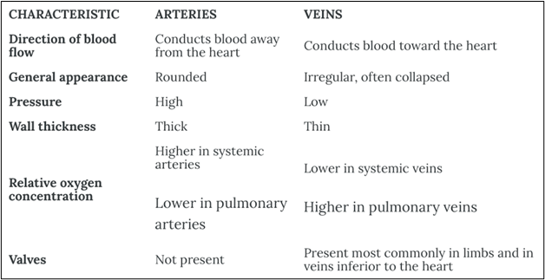

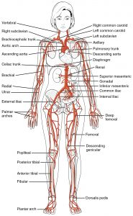
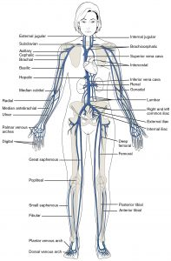
Figure 1: Peripheral vascular system anatomy. (Image fromAnatomy and Physiology[onOpenStax] by Betts et al., used under aCC BY 4.0 international license. Download and access this book for free athttps://openstax.org/books/anatomy-and-physiology/pages/1-introduction)

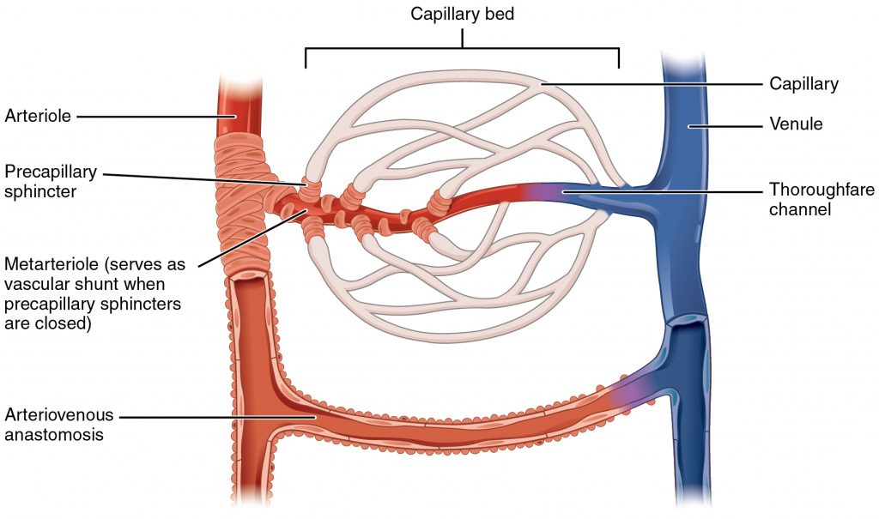
Figure 2: Capillaries. (Image fromAnatomy and Physiology[onOpenStax] by Betts et al., used under aCC BY 4.0 international license. Download and access this book for free athttps://openstax.org/books/anatomy-and-physiology/pages/1-introduction)

Clinical Tip
The PVS is interconnected with many other body systems, so it is rarely assessed in isolation. When attempting to make sense of cues, nurses commonly assess other body systems including cardiovascular, integumentary, lymphatic, and musculoskeletal. See Figure 3 for related systems. For example, the PVS might be assessed along with a cardiovascular assessment to assess perfusion and also with the musculoskeletal system to assess potential blood flow interruptions. The PVS is also closely related to the lymphatic system and connected via the capillaries. In addition, many PVS conditions affect the skin, thus the integumentary system is often assessed.
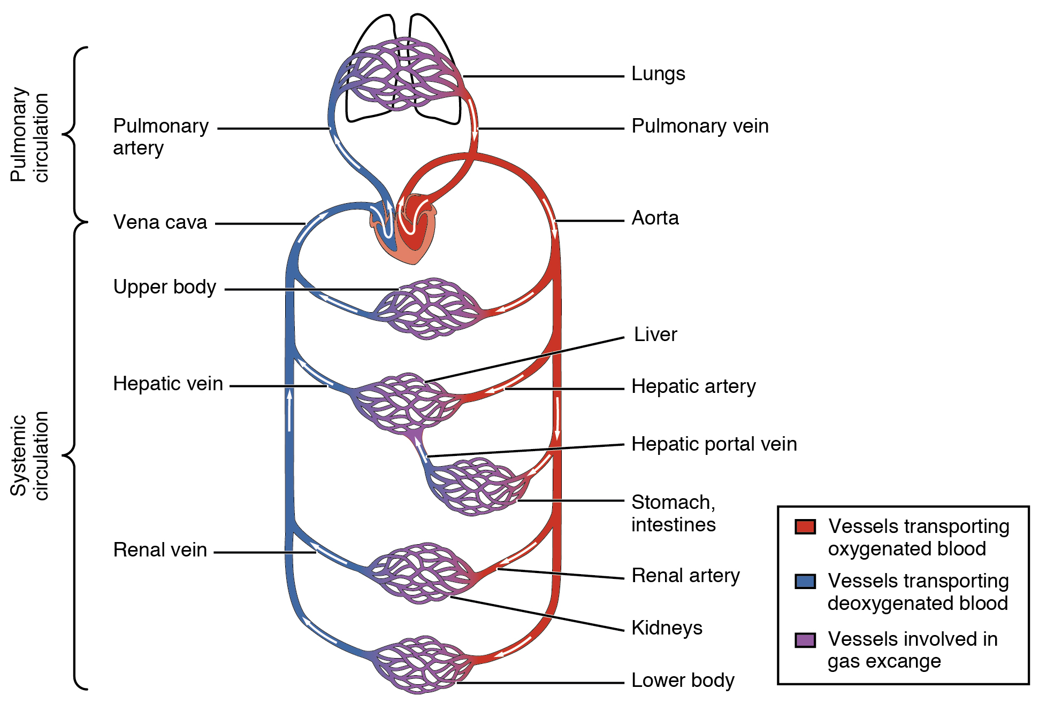
Figure 3: Pulmonary and systemic circulation.
(Image fromAnatomy and Physiology[onOpenStax] by Betts et al., used under aCC BY 4.0 international license. Download and access this book for free athttps://openstax.org/books/anatomy-and-physiology/pages/1-introduction)

Activity: Check your Understanding

48

Subjective Assessment
Subjective assessment of the peripheral vascular system (PVS) involves asking questions about the health of the client and symptoms that occur because of pathologies that affect the vasculature of the body. A full exploration of these pathologies is beyond the scope of this chapter, but common problems associated with this system include peripheral vascular disease (PVD), atherosclerosis, arteriosclerosis, venous stasis, varicose veins, and ulcers.

Knowledge Bites
Many peripheral vascular symptoms are related and are caused by the same issue. See Table 2 for the signs and symptoms of arterial and venous issues and watch Video 1:

Video 1: ​​Arterial and venous issues [5:00]
Peripheral arterial issues occur when there is a problem with perfusion (blood flow is restricted or blocked) in the arteries due to a blockage. This can be caused by atherosclerosis (narrowing of the arteries caused by plaque build up on the arterial walls) and arteriosclerosis (hardening, stiffening and loss of elasticity of the arterial walls); these are both forms of peripheral arterial disease. When blood flow is restricted, oxygen and nutrients are not efficiently delivered to body tissues. When tissues in the periphery do not get sufficient oxygen-rich blood, hypoxia can develop, leading to pain, numbness, ulcers, fatigue, and other symptoms and signs. However, it’s important to note that many clients with arterial disease don’t have symptoms, so your assessment of risk factors is important.
Peripheral venous issues are related to venous insufficiency: veins in the periphery (typically the legs) restrict the return of blood to the heart, causing venous stasis (collection or pooling of blood) in the peripheral limbs (typically the feet and lower legs). This is often caused when the one-way venous valves are not working properly and allow backflow of blood, as opposed to the forward movement of blood. It can also be caused by blood clots. Venous hypertension and varicose veins can arise secondary to venous insufficiency and venous stasis (Anwar et al., 2021). Varicose veins (see Figure 4) are dilated, bulging, and twisted veins that can be superficial (observed on the skin’s surface) or deep within the leg and not visible upon inspection. You may hear the term tortuous veins, which refers to twisted veins. Varicose veins can have a genetic component and can also have primary causes that are relatively unknown (Anwar et al., 2021). Some varicose veins are painful and depending on the associated cause may result in blood clots. Another venous issue is spider veins (Figure 5), which appear as small flat dark red, blue, or purple venous patterns close to the surface. Spider veins can cause body image issues, but they are not painful and are not related to serious problems such as blood clots.
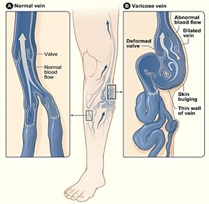
Figure 4: Comparison of a normal and varicose vein.
(Attribution: Photo by National Heart Lung and Blood Institute. – Varicose veins., Public Domain,https://commons.wikimedia.org/w/index.php?curid=6885995)
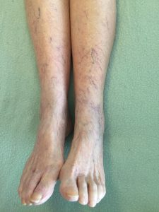
Figure 5: Spider veins.

Table 2: Venous and arterial issues signs and symptoms.
Venous issues | Arterial issues

One or more interactive elements has been excluded from this version of the text. You can view them online here: https://pressbooks.library.torontomu.ca/assessmentnursing2/?p=570#oembed-1
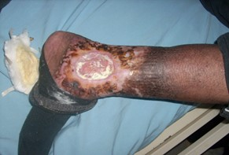
Figure 6: Chronic venous insufficiency and venous ulcer.
(Attribution: Photo by Ashashyou – Own work, CC BY-SA 4.0,https://commons.wikimedia.org/w/index.php?curid=122884459)
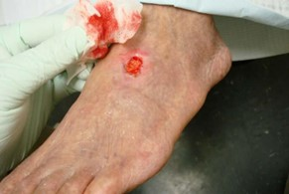
Figure 7: Arterial ulcer PVD.
(Attribution: Photo by Jonathan Moore – Creating the Ideal Microcosm for Rapid Incorporation of Bioengineered Alternative Tissues Using An Advanced Hydrogel Impregnated Gauze Dressing: A Case Series. The Foot and Ankle Online Journal 1 (9): 2., CC BY 3.0,https://commons.wikimedia.org/w/index.php?curid=6886430)

Common symptoms that can be related to the PVS include pain-related sensations, numbness, skin discolouration changes, skin temperature changes, edema, and ulcers. See Table 3 for guidance on the subjective health assessment. Many of the questions in the table align with the PQRSTU mnemonic, but you should probe symptoms in the order of relevance, as opposed to sequentially with the PQRSTU mnemonic.
Ask about any medications the client is taking: name, dose, frequency, reason it was prescribed, and how long they have been taking it.
Also ask questions focused on health promotion. Depending on the context, you may ask these questions and engage in a discussion during a subjective assessment or after an objective assessment. A section on “Health Promotion Considerations and Interventions” is included later in this chapter after the discussion of objective assessment.
Table 3: Guidance on subjective assessment.

Contextualizing Inclusivity
The risk of PVD increases with age, particularly for those over the age of 50. Risk factors include sedentary lifestyle, physical inactivity, obesity, high blood pressure, high cholesterol, diabetes, smoking, and diets high in saturated and trans fat, red meat, sodium, and sugar.
While assessing and responding to these risk factors, always use an inclusive approach in conducting your subjective health assessment. Inclusive health assessments should be grounded in social justice: uphold the humanity of all clients in all aspects of care, regardless of their race, ethnicity, gender, sexuality, age, ability, health decisions, and any other factors that makes them who they are. Treat everyone with dignity and recognize that each client is a human being with unique health experiences. Be aware of your biases and use a non-judgemental approach to interviewing.

Priorities of Care
All abnormal symptoms need to be explored and followed up by an objective assessment.
New onset or worsening pain-related symptoms, changes in skin colour and skin temperature, edema, and ulcers need to be fully assessed and reported to the physician or nurse practitioner. Prompt intervention is required with rapid weight gain in a short period of time (e.g., 2–3 lb or 0.9–1.3 kg in 24 hours). These issues should be reported to the physician or nurse practitioner.
With regard to arterial issues, you should be attentive to signs and symptoms that may indicate acute ischemia to the limbs: this is a decrease in peripheral perfusion that could threaten the viability of the affected limb. These signs and symptoms should be monitored and reported to the physician or nurse practitioner; they are often referred to as the 5 Ps (Obara et al., 2022):
- Pain (this could be acute pain in the affected limb and extremity that gets progressively worse).
- Pallor (extremities that become paler than the client’s normal skin colour in the affected limb).
- Pulselessness (absent pulses in the affected limb).
- Paresthesia (decreased sensation in the affected limb or a tingling or a numbness sensation).
- Paralysis (inability to move the affected limb).
Additionally, reports of gangrenous tissue (Figure 8) require prompt intervention and should be reported to the physician or nurse practitioner.

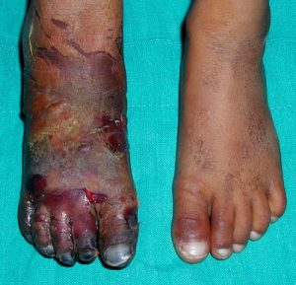
Figure 8: Gangrene: By Dr. Andreas Settje – This Picture was copied under GFDL from the german PflegeWiki., CC BY-SA 3.0,https://commons.wikimedia.org/w/index.php?curid=168739

Activity: Check your Understanding

References
Anwar, M., Georgiadis, A., Shalhoub, J., Lim, C., Gohel, M., & Davies, A. (2012). A review of familial, genetic, and congenital aspects of primary varicose vein disease. Circulation: Cardiovascular Genetics, 5(4), 460-466.https://doi.org/10.1161/CIRCGENETICS.112.963439
London, N., & Donnelly, R. (2000). Ulcerated lower limb. BMJ, 320(7249), 1589-1591.https://doi.org.10.1136/bmj.320.7249.1589
Obara, H., Matsubara, K., & Kitagawa, Y. (2018). Acute limb ischemia. Ann Vasc Dis, 11(4), 443-448.https://doi.org.10.3400/avd.ra.18-00074
Vivas, A., Lev-Tov, H., & Kirsner, R. (2016). Venous leg ulcers. Ann Intern Med, 165(3), ITC17-ITC32.https://doi.org.10.7326/AITC201608020

49

Objective Assessment
An objective assessment is usually completed after the subjective assessment, unless symptoms require urgent interventions.
An objective assessment of the peripheral vascular system (PVS) includes:
- Inspection and palpation of hands and arms.
- Inspection and auscultation of abdominal vasculature areas.
- Inspection and palpation of feet and legs.
All assessments should be performed on bare skin. You will need a penlight and a stethoscope.
Be aware of the environmental temperature in the room and the temperature of your hands. Room temperatures are not easily modified, so you should only expose the body part(s) you are assessing. Try to warm your hands before placing them on the client’s body. Don gloves if you observe skin that is not intact.
Ensure the client is positioned in the best way to assess the arms, abdomen, and legs. You will usually begin with the client seated on the side of the exam table with legs or feet dangling or in the high-Fowler’s position. If you are assessing a young child or newborn, you could ask someone (e.g., care partner, healthcare provider, parent) to hold them on their lap or on the exam table.
When assessing the PVS, you will usually assess arterial and venous sufficiency. Your findings from the objective assessment, along with those from the subjective assessment, will provide cues about whether any issues are arterial or venous related. Recall Table 3 from the Subjective Assessment section.

Clinical Tips
Trauma-informed approach: Always use a trauma-informed approach. This is particularly important considering that areas of the abdomen and legs will be exposed. Don’t assume who may have experienced trauma: it can happen to anyone, regardless of gender, age, or socioeconomic/educational level. Trauma is also subjective and personal to each individual; trauma for one person might not be trauma for another.
You could start by asking the client if they would like a family member or friend or another healthcare provider present. Always maintain privacy by closing the door and/or curtains and using draping. Ask permission to touch and explain what you are going to do so the client knows what to expect. If relevant, ask permission to touch any mobility aids and prosthetics; the client may view these as an extension of their body and part of their self-identity.
What if pulses are not palpable? If a pulse is not palpable in the distal most aspect of the limb, you should assess the next proximal pulse (or medial). For example, if you can’t feel a radial pulse, you might assess the brachial or ulnar pulses. It can also be helpful to use a Doppler ultrasound device (often just referred to a doppler) when you are struggling to feel a pulse and are concerned about perfusion into the limbs. This is a handheld device that allows you to hear the whooshing sound of the pulsatile blood flow. See Figure 8 and Video 2 for use of a Doppler device.
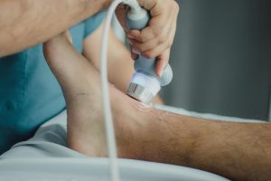
Figure 8: Doppler ultrasound device. (Photo byJuan Manuel Montejano Lopezon Pexel.)

Video 2: Use of a Doppler ultrasound device [1:51]
One or more interactive elements has been excluded from this version of the text. You can view them online here: https://pressbooks.library.torontomu.ca/assessmentnursing2/?p=572#oembed-1

Contextualizing Inclusivity
Objective assessment involves assessing skin discolouration. Two common kinds of skin discolouration related to peripheral vascular assessment are cyanosis and pallor.
- Cyanosis involves an increase in deoxygenated hemoglobin in the blood (hypoxemia). Reduced oxygen makes blood a darker red colour. When this blood is circulated to the limbs, the tissues receive inadequate oxygen (hypoxia) and as result the skin becomes dull in colour and the skin and nail beds change in colour. The skin can become a variation of blue/purple and grey/green shades. In people with dark skin, cyanosis appears as a dark purple and sometimes a grey colour, but it is difficult to see with early cyanosis. People with yellowish tones to their skin can have a greyish/green shade (Lewis, 2020; Sommers, 2011), and people with lighter skin tones tend to develop a dusky bluish/purple shade (Lewis, 2020). Acrocyanosis is cyanosis that happens in the extremities (feet and hands). Newborns can be born with acrocyanosis, but it should disappear after a couple of hours and should be monitored.
- Pallor occurs when there is decreased perfusion to the limbs. In clients with darker skin, it is best assessed on the palms of the hands and the nail bed, as these areas are already paler in colour; with pallor, these areas become paler than the client’s normal skin colour (Lewis, 2020). This is also true for clients with lighter skin colour, but with these clients you will also observe paler toes and feet. In people with lighter brown skin, you might observe pallor as a yellowish shade (Lewis, 2020).

References
Lewis, G. (2020). Identifying AEFI in diverse skin colour.https://mvec.mcri.edu.au/references/identifying-aefi-in-diverse-skin-colour/
Mukwende, M., Tamony, P., & Turner, M. (n.d.). Mind the gap: A handbook of clinical signs in black and brown people. (1st edition).https://litfl.com/wp-content/uploads/2020/09/Mind-the-Gap-A-handbook-of-clinical-signs-in-Black-and-Brown-skin.-first-edition-2020.pdf
Sommers, M. (2011). Color awareness: A must for patient assessment. American Nurse.https://www.myamericannurse.com/color-awareness-a-must-for-patient-assessment/

50

Inspection and Palpation of Hands and Arms
Peripheral vascular issues usually affect the lower limbs (feet and legs) more than the upper limbs, but you should begin a complete peripheral vascular assessment with the hands and arms because most clients feel comfortable exposing these areas. However, you might focus on a particular area such as the legs if the assessment is related to a physical trauma and you are concerned about perfusion to that limb. Assessment of the hands and arms can be done while the client is sitting on the side of the exam table or in a high Fowler’s or supine position.
Steps for inspecting and palpating hands and arms include:
- Inspect the skinof the hands and arms for colour (including nails), edema, limb circumference discrepancy, lesions, presence of ulcers, and venous patterns. Ask the client to place their hands and arms in front of them with their palms facing downwards, and then turn their palms upwards. Next, palpate skin temperatureusing the dorsa of your hands from the shoulders down the arms to the fingertips (see Video 3).

  - Normally, the skin colour is consistent and skin temperature is warm to touch and equal bilaterally from shoulders to fingertips, although the fingertips can be slightly cool to touch. Normally, there are no signs of cyanosis or pallor in the nails or fingertips. Nails are translucent in colour with a slight pinkish tone underneath. Remember that the palms of hands are a lighter skin colour, particularly among people with darker skin tones. Normally, there is no edema, no ulcers, no lesions and circumference is equal bilaterally.
  - Describe the location, size, and quality of any abnormal findings such as skin discolouration, signs of cyanosis, pallor, venous pattern, and presence of ulcers or lesions. With regard to quality, for example, you should note what the discolouration and the ulcers look like. Describe the location and quality of abnormal skin temperatures, particularly if asymmetrical. If you notice any discrepancy in terms of unequal limb circumference, measure with a flexible tape measure at the same location on both limbs to ensure accuracy. Note the location of any edema.

One or more interactive elements has been excluded from this version of the text. You can view them online here: https://pressbooks.library.torontomu.ca/assessmentnursing2/?p=574#oembed-1
Video 3: Palpation of skin temperature [0:17]
- Test capillary refill on two or three fingernails of each hand at heart level (see Video 4). Start by applying pressure with your own finger to the client’s nail; this causes the nail to blanch (become paler in colour). Apply the pressure for 5 seconds and then release and observe the return in colour.
  - A normal finding when assessing capillary refill is colour return that is equal to or less than 3 seconds when assessing capillary refill.
  - Colour return that is greater than 3 seconds is described as sluggish return for capillary refill (or slow capillary refill time), and this finding suggests that there may be issues with oxygenated blood perfusion (this may be related to peripheral vascular and/or cardiac and/or respiratory issues). Capillary refill time can be slower if the client’s hands are cold; if the client’s hands are cold from being outside or from washing in cold water, ask them to warm their hands to ensure an accurate reading.
One or more interactive elements has been excluded from this version of the text. You can view them online here: https://pressbooks.library.torontomu.ca/assessmentnursing2/?p=574#oembed-2
Video 4: Testing capillary refill [0:45]
- Palpate the radial pulses bilaterally and simultaneously, and then palpate the brachial pulses (see Figure 9). Assessing the pulses simultaneously allows you to compare the strength of pulsation; recall the4-point scale for force. Assessing pulses for the presence, force, and symmetry of force provides information about perfusion (flow of blood) to the limbs. If these pulses are not palpable, you can use a Doppler ultrasound device to assess pulsatile blood flow.
  - Normally, pulses are present, 2+ force and equal bilaterally.
  - Decreased pulse force or absent pulses can be associated with arterial insufficiency. A decreased pulse force (1+) can be described as “thready,” which refers to a weak pulse that is difficult to feel.
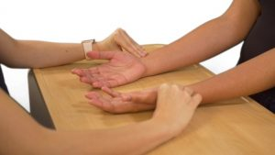
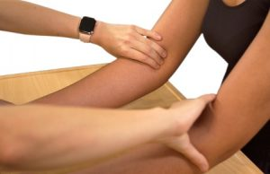
Figure 9: Palpation of radial and brachial pulses.
- Note the findings:

  - Normal findings might be documented as: “From shoulders to fingertips: equal limb circumference with no edema or ulcers, and skin colour consistent. Good capillary refill. Radial and brachial pulses 2+ force and equal bilaterally. Skin temperature warm to touch and equal bilaterally from shoulders to fingertips.”
  - Abnormal findings might be documented as: “Pallor in fingernails, cool to touch in fingers bilaterally, sluggish capillary refill 4–5 seconds, 1+ radial pulses equal bilaterally.”

Activity: Check your Understanding

An interactive H5P element has been excluded from this version of the text. You can view it online here:
https://pressbooks.library.torontomu.ca/assessmentnursing2/?p=574#h5p-43
(Photo byJames Heilman, MD, Creative Commons Attribution-Share Alike 3.0fromWikimedia Commons.)

51

Inspection and Auscultation of Abdominal Vasculature
Inspection and auscultation of abdominal vasculature is best performed with the client in a supine position with their head on a pillow. You will be assessing the area over the abdominal aorta, renal arteries, iliac arteries, and femoral arteries (Figure 10). Draping is important because you will need to expose the abdomen and groin area.
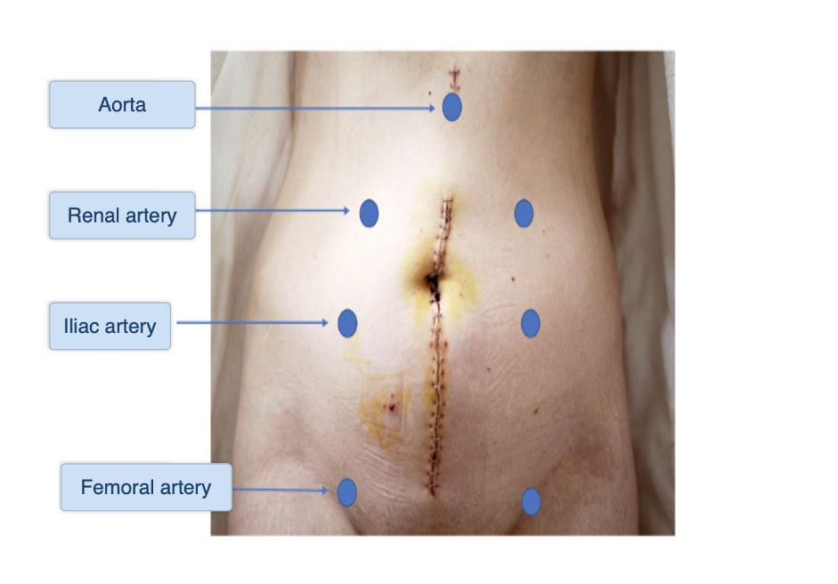
Figure 10: Abdominal vasculature. (Attribution: Adapted photo by Alexander Grey on Unsplash, CC BY-NC 4.0)
Steps for assessing the abdominal vasculature include:
- Observe for pulsations over the areas of the abdominal vasculature. Use tangential lighting with a penlight; this will help highlight any small imperfections/shadows, which accentuate visible pulsations.
  - Normally, no pulsations are present. Pulsations may be present with a client who has a thin abdominal wall, but these are never considered normal in a client who has increased adipose tissue.
  - Note the location of any pulsations.
- Auscultate over the abdominal vasculature (see Figure 10 and Video 4) using the bell of a cleansed stethoscope. Use slightly firmer pressure than when you use the diaphragm over the lungs or intestines. Listen for vascular sounds related to the flow of the blood through the arteries. Placing your stethoscope in each location for about 2-3 seconds is usually sufficient.
  - Normally, you won’t hear any vascular sounds because unobstructed blood flow through an artery is silent.
  - Note the location of any vascular sounds. Partial obstruction of an artery creates turbulent blood flow, leading to vascular sounds such as a bruit: blowing/swooshing noises. Atherosclerosis can cause stenosis (narrowing of the vessel), leading to a bruit. If you hear a bruit, notify the physician or nurse practitioner while you keep the client still and continue to monitor them. Do not palpate the abdomen if a bruit is present, as this finding suggests that blood flow is already compromised.
- Note the findings:
  - Normal findings might be documented as: “No pulsations observed or bruits heard over the abdominal aortic artery and the renal, iliac, and femoral arteries.”
  - Abnormal findings might be documented as: “Pulsation observed over aortic artery with a bruit noted.”
One or more interactive elements has been excluded from this version of the text. You can view them online here: https://pressbooks.library.torontomu.ca/assessmentnursing2/?p=576#oembed-1
Video 4: Auscultation of the abdominal vasculature [1:27]

Priorities of Care
If you hear a bruit, do not palpate the area. Ask if the client has experienced any recent pain in their chest, back, abdomen, or groin, and if they have ever been diagnosed with an aneurysm. You should also complete a primary survey and measure blood pressure in both arms. Notify the physician and nurse practitioner of the findings. Until an aneurysm is ruled out or assessed, it is best to keep the client in bed, at rest, and under continuous monitoring.

Activity: Check Your Understanding

An interactive H5P element has been excluded from this version of the text. You can view it online here:
https://pressbooks.library.torontomu.ca/assessmentnursing2/?p=576#h5p-45

(Attribution: Activity Photo by Alexander Grey on Unsplash)

52

Inspection and Palpation of Feet and Legs
This assessment can be done while the client is supine with their head on a pillow. The client will need to remove their shoes and socks and uncover the legs from the upper legs down to the feet. You should inspect the anterior as well as the posterior side of the legs; ask the client to roll on their side to do so.
Steps of inspection and palpation of legs and feet include (see Video 5 for technique):
One or more interactive elements has been excluded from this version of the text. You can view them online here: https://pressbooks.library.torontomu.ca/assessmentnursing2/?p=578#oembed-1
Video 5: Inspection and palpation of feet and legs (showing technique) [1:44]
- Inspect the legs and feet for colour and hair distribution. Remember that clients will have different skin tones: assess abnormal findings related to skin discolouration in comparison to the rest of the skin. In addition to inspecting the legs, it is important to assess the toes for hair distribution, because hair loss associated with peripheral arterial disease (PAD) often begins at the toes and moves upward.

  - Normally, the skin colour is consistent and hair distribution is equal. Remember that the plantar side of the feet are lighter in colour, particularly among clients with darker skin tones.
  - Describe any abnormal findings such as skin discolouration (e.g., colour and location) and any uneven hair distribution, particularly if asymmetrical. Some clients remove leg hair with hair laser removal, waxing, or shaving; this is not considered an abnormal finding related to hair distribution.
- Inspect (and palpate) the legs and feet for size and edema.
  - Normally, the upper and lower leg circumference and ankle circumference are equal bilaterally at each site.
  - If you suspect a size difference of the ankle, calf or upper leg circumference, use a tape measure to accurately note the size on both limbs.
  - If you observe edema, assess for pitting edema: an indentation that remains after applying pressure over the location. See Figure 11 for a picture of pitting edema. Apply pressure with the pad of your finger on a distal location (feet and medial malleolus) for about 3-5 seconds and then release. If you observe an indentation (a “pit”), note the location and how long the indentation remains. If you observe it in a distal location, assess proximal such as over the tibia. Always check with the unit you work on about the scale used to evaluate pitting edema; scales are usually 1 to 4 (see Figure 12). Assess the pit depth and the rebound time (the time for the indentation to disappear). Pitting edema is often rated as 1 mild, 2 moderate, 3 severe, and 4 very severe.
Figure 11: Pitting edema.
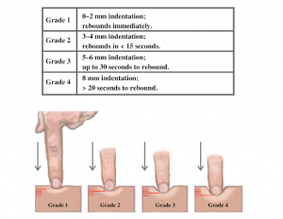
Figure 12: Pitting edema scale. (Attribution, taken from https://wtcs.pressbooks.pub/nursingskills/ CC-BY 4.0.)
- Inspect the feet and legsfor lesionsand ulcers. Ensure you inspect between the toes and on the plantar side of the feet.
  - Normally, no lesions or ulcers are present.
  - Describe the location and quality of any lesions and ulcers.
- Palpate skin temperature using the dorsa of your hands from the anterior side of the upper legs down to the toes. Use your fingertips to assess skin texture.
  - Normally, the temperature is warm to touch and equal bilaterally. The feet are sometimes slightly cooler than the upper legs, but they should be equal bilaterally. The skin texture is normally smooth.
  - Describe any asymmetry in skin temperature, extreme temperatures, and skin textures such as dry, flaky skin.
- Inspect the nails for colourand test capillary refillon two or three toenails of each foot. Start by applying pressure with your own finger to the client’s nail; this causes the nail to blanch (become pale in colour). Apply the pressure for 5 seconds and then release and observe the return in colour.
  - Normally, the nail colour reflects the skin tone. Colour should return within 1–2 seconds when assessing capillary refill.
  - Describe any pallor or cyanosis of the nails. A sluggish return for capillary refill suggests that there may be issues with oxygenated blood perfusion, which might be related to peripheral vascular issues (and/or cardiac and/or respiratory issues).
- Gently palpate the dorsalis pedis pulsesbilaterally and simultaneously, and then palpate the posterior tibial pulses(see Figure 13 and Video 6). Simultaneous assessment helps you compare the force (strength of pulsation); recall the 4-point scale for pulseforce. Assessment of pulses for presence, force, and symmetry of force provides information about perfusion (flow of blood) to the limbs. If you are concerned about blood flow into the extremities (e.g., neither the dorsalis pedis or posterior tibial pulses are palpable on one foot), use a Doppler device to assess blood flow.
  - Normally, pulses are present, 2+ force and equal bilaterally.
  - Decreased pulse force or absent pulses can be associated with arterial insufficiency. A decreased pulse force (1+) can be described as “thready,” which is a weak pulse that is difficult to feel.

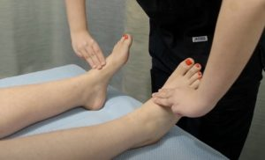
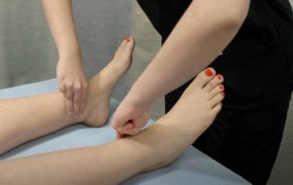
Figure 13: Location of dorsalis pedis and posterior tibial pulses.

One or more interactive elements has been excluded from this version of the text. You can view them online here: https://pressbooks.library.torontomu.ca/assessmentnursing2/?p=578#oembed-2
Video 6: Palpating dorsalis pedis and posterior tibial pulses [0:30]
- Palpate the popliteal (Figure 14) and femoral pulses. For the popliteal pulse, slide your fingers behind the knee just medial to the the middle of the popliteal fossa (typically located slightly lateral to the medial tendon). While palpating, push up with pressure, because this pulse is high up in the fossa and can be difficult to palpate. For the femoral pulse, palpate inferior to the inguinal ligament less than halfway from the pubis bone to the anterior superior iliac spine. While palpating, press firmly up into the bone. If you do not feel a pulse right away, reduce the pressure slightly.
  - Normal and abnormal findings are the same as item 6 above: if you can find a femoral and dorsalis pedis pulse, a non-palpable popliteal pulse is usually not of concern.
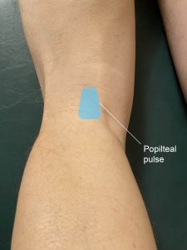
Figure 14: Popliteal pulse.
- If the findings from the above assessments make you suspect arterial insufficiency, assess for elevational pallor anddependent rubor(Wennberg, 2013). Elevational pallor is when the extremities become pale when they are raised above the heart level. Dependent rubor is an erythematous discolouration, particularly of the dorsal sides of the toes, when the feet/legs are below the level of the heart (Bahrani & Sladden). Step 1: While the client is in a supine position, hold their legs at 45 degrees for about 30 seconds; this action helps push the venous blood back to the heart, and the skin colour is reflective of the sufficiency of arterial blood flow. Step 2: Return the client’s legs to the table and assist the client into a sitting position with their legs dangling over the edge or into a standing position.
  - During Step 1, the skin colour normally becomes just slightly paler in comparison to the client’s normal skin colour (best seen on the sole of the foot), demonstrating good arterial blood flow. During Step 2, the colour of the client’s foot normally returns within 10 seconds.
  - Abnormal findings associated with Step 1 include significant pallor in comparison to the client’s normal skin colour (best seen on the sole of the foot). Abnormal findings associated with Step 2 are the normal colour of the client’s feet taking more than 10–15 seconds to return, as well as dependent rubor. Dependent rubor in combination with other cues (such as claudication) may be associated with PAD.
- Ask the client to stand so that you can inspect the legs andfeet for vascularity. If the client is unable to stand, you can complete the inspection while they are in a supine position.
  - Normally, you will observe no vascularity or a fine and flat venous pattern. Athletes may have superficial veins.
  - Describe any vascular patterns you observe on the legs and feet, such as varicose veins.
- Note the findings:
  - Normal findings might be documented as: “Skin colour consistent from upper legs to toes, equal limb circumference with no edema or ulcers. No presence of cyanosis or pallor on nails. Good capillary refill. Dorsalis pedis and posterior tibial pulses 2+ force and equal bilaterally. Skin temperature warm to touch and equal bilaterally from upper legs to toes.”
  - Abnormal findings might be documented as: “Pallor in nails, cool to touch in feet and toes bilaterally, sluggish capillary refill 4-5 seconds, 1+ dorsalis pedis pulses equal bilaterally.”

Contextualizing Inclusivity
A large majority of pregnant people have edema in their feet and legs due to increased blood volume and pressure on veins from the growing fetus (Smyth et al., 2015). In addition to edema, the increased volume and pressure on veins can lead to venous insufficiency and varicose veins, in which the blood pools in the feet and legs, particularly when in dependent positions (Smyth et al., 2015). Although edema is a normal part of pregnancy, a pregnant person should be referred to their physician or nurse practitioner if they experience a sudden onset of edema associated with other symptoms such as headache, high blood pressure, and vision changes; these symptoms can be associated with preeclampsia.

Knowledge Bites
The ankle-brachial index (ABI) test is one test used to assess the presence of peripheral arterial disease. The test is sometimes performed by nurses, but it is usually associated with an advanced practice nursing role.
The ABI can be performed in various ways, so you should receive advanced training in the procedure and always be consistent with your practice.
Begin with the client in supine position at rest (US Preventive Services Task Force, 2018). Measure BP using a Doppler ultrasonic device (Fowkes, 2008). Follow this sequence:
- Measure BP:
  - right arm (brachial)
  - right posterior tibial
  - right dorsalis pedis
  - left posterior tibial
  - left dorsalis pedis
  - left arm
  - repeat right arm measurement (average both right arm measurements).

- Next, calculate an ABI for the right side and an ABI for the left side using the following equation:
highest systolic pressure of the posterior tibial or dorsalis pedis is the numerator (some may average the two)
Highest systolic arm pressure is the denominator (some may average the two)

(Aboyans et al., 2012)
Divide the numerator by the denominator to obtain a ratio, which is the ABI. A ratio of less than 0.9 indicates the presence of PAD (Fowkes, 2008; US Preventive Services Task Force, 2018).
For example, if the ankle pressure is 122 and the brachial systolic is 148, the ABI is 0.82, which is suggestive of peripheral arterial disease.

Priorities of Care
An urgent priority of care is signs suggesting absent or severely reduced arterial blood flow such as absent or diminished pulses, which are usually accompanied by sluggish capillary refill, cool limbs, pain, numbness, decreased sensation, and pallor or cyanosis. Assess these if you have not already. If you cannot detect dorsalis pedis and/or posterior tibial pulses, use a Doppler device. Report these findings immediately to the physician or nurse practitioner so that additional intervention can be taken to re-establish blood flow.
Any signs related to deep vein thrombosis (DVT) should also be reported to the physician or nurse practitioner. A combination of unilateral leg pain, swelling, warmth, and erythema can be an urgent situation: a DVT may be blocking blood flow. A DVT can loosen from the vessel wall and travel to the lungs, causing a pulmonary embolism that blocks blood flow. Risk factors for blood clots and DVT include advancing age, smoking, oral contraceptives, sedentary lifestyle, obesity, and pregnancy. Other conditions related to DVT include prolonged sitting, immobilization of limbs, fractures, damage to veins, varicose veins, and sickle cell disease.

Activity: Check Your Understanding

An interactive H5P element has been excluded from this version of the text. You can view it online here:
https://pressbooks.library.torontomu.ca/assessmentnursing2/?p=578#h5p-44

References
Aboyans, V., Criqui, M., Abraham, P., Allison, M., Creager, M., Diehm, C., Fowkes, G., Hiatt, W., Jonsson, B., Lacroix, P., Marin, B., McDermott, M., Norgren, L., Pande, R., Preux, P., Stoffers, H., & Treat-Jacobson, D. (2012). Measurement and interpretation of the ankle-brachial index: A scientific statement from The American Heart Association, 126(24), 2890-2909. https://doi.org/10.1161/CIR.0b013e318276fbcb
Bahrani, B., & Sladden, C. (2017). Dependent erythema of the legs associated with mild autonomic nervous system dysfunction. J Cutan Med Surg, 21(6), 556-558. https://doi.org/10.1177/1203475417714801
Brodovicz, K., McNaughton, K., Uemura, N., Meininger, G., Girman, C., & Yale, S. Reliability and feasibility of methods to quantitatively assess peripheral edema. Clinical Medicine & Research, 7, 1-2, 21-31. https://doi.org/10.3121/cmr.2009.819
Fowkes, G. (2008). Ankle brachial index combined with Framingham Risk Score to predict cardiovascular events and mortality: A meta-analysis. JAMA, 300(2), 197-208. https://doi.org/10.1001/jama.300.2.197
Smyth, R., Aflaifel, N., & Bamigboye, A. (2015). Interventions for varicose veins and leg oedema in pregnancy. Cochrane Database of Systematic Reviews, 10, https://doi.org/10.1002/14651858.CD001066.pub3
US Preventive Services Task Force (2018). Screening for peripheral artery disease and cardiovascular disease risk assessment with the ankle-brachial index: US Preventive Services Task Force Recommendation Statement. JAMA, 320(2), 177-183. https://doi.org/10.1001/jama.2018.8357
Wennberg, P. (2013). Approach to the patient with peripheral arterial disease. Circulation. 128, 2241-2250. https://doi.org/10.1161/CIRCULATIONAHA.113.000502

53

Health Promotion and Disease Prevention: Considerations and Interventions
When developing health promotion and disease prevention strategies for a healthy peripheral vascular system (PVS), always select an appropriate intervention based on careful consideration of all collected data, both subjective and objective. Subjective data collection should include asking about risk factors, social determinants, and other considerations.
This kind of inquiry should be integrated throughout the assessment. You will ask many probing questions during the subjective assessment phase, but you will also come up with some questions based on your critical reflection of all data collected during the subjective and objective assessments. All of these data will inform your clinical judgement and appropriate health promotion strategies for a specific patient.

Activity
Any activity, including general daily activity, aerobic exercise, and strength training, improves blood flow within the body, lowers blood pressure, and supports the transportation of oxygen throughout the PVS. An active lifestyle and regular exercise lower the risk of vascular diseases. Exercise and participating in social activities can also help reduce stress, which in turn can help lower blood pressure and decrease the risk of peripheral vascular disease (PVD); a sedentary lifestyle with limited activity increases the risk factors that contribute to PVD. Standing and sitting for sustained periods of time can increase venous stasis and risk of deep vein thrombosis (DVT). For example, DVT can be an issue for some people with lengthy air travel due to the sustained period of sitting and lack of activity.
Guidelines for activity vary based on age and health status. Most people should engage in about 30–60 minutes of aerobic activity, five to seven times per week.
Probing questions related to activity might include:
- Tell me about your daily exercise? What activities are you involved in? (Probe about the type and amount each day.)
- Do you have any concerns about your level of activity or exercise? Do you have any limitations to your mobility that affect your activity?
- Do you experience leg pain or cramps when walking? Do you experience a lack of sensation to heat or cold in the extremities?
Collaborate with the client to create an activity/exercise plan that is specific to their needs and goals. Be aware of your own biases related to activity/exercise with certain populations such as older clients or clients who may currently live sedentary lifestyles or have mobility issues. Also, recognize that some clients may have concerns about starting an exercise plan: these might include exacerbating pain, fear of falling, mobility issues, and/or a history of previous falls. Try to connect with the client and get to know them and their needs and fears. Start at a realistic and attainable level, depending on the client’s physical capabilities and energy level, and then begin to increase the time and duration of the physical activity. Many interventions are available to help clients achieve their activity goals: community walking groups, fitness apps, or joining a local gym or group activity. When appropriate, encourage clients to ask family and friends to get active with them: a strong support system can help clients stay active and achieve their health goals. The participACTION website is a helpful resource for activity guidelines:https://www.participaction.com/en-ca. Also, consider activity interventions from a structural health promotion approach: for example, consider the financial costs associated with many resources and the client’s financial ability to pay for them.

Diet
A healthy diet helps maintain healthy blood vessels of the PVS and decreases the risk of plaque buildup in the blood vessels. A heart-healthy diet of leafy greens, vegetable, fruits, whole grains, nuts, fish, lean meats, low-fat dairy, and monounsaturated fats (e.g., olive oil) helps the body function, controls blood pressure, lowers cholesterol and blood glucose levels, and helps maintain an ideal body weight. In contrast, an unhealthy diet of refined sugars, carbohydrates, saturated and trans fats, and high levels of cholesterol and salt can lead to buildup of plaque in the arteries, high blood pressure, obesity, and an increased risk of PVD.
Canada’s guidelines now suggest that there are health risks associated with any level of alcohol consumption, although negligible with two drinks or less weekly (Paradis et al., 2022). The current literature indicates that drinking alcohol of any kind does not decrease risks of heart disease, and high levels of consumption increase risk for coronary artery disease, myocardial infarction, heart failure, hypertension, and stroke (Paradis et al., 2022).
Probing questions related to diet might include:
- Tell me about your typical diet? What sorts of food do you eat each day?
- What have you eaten in the last 24 hours? Is that your usual diet?
- Do you have enough money to buy healthy food? Do you pack a lunch or purchase your food when out?
- Tell me about your cultural practices related to diet?
Explore the client’s familiarity with Health Canada’s Food Guide (Government of Canada, 2021) and explain that it can help them guide their food choices:https://food-guide.canada.ca/en/. However, this guide still includes Eurocentric elements, so you should collaborate with the client about its relevance in the context of their cultural food practices. A snapshot of the food guide is now offered in dozens of languages:https://www.canada.ca/en/health-canada/services/canada-food-guide/resources/snapshot/languages.htmland many resources have been developed for Indigenous populations:https://www.sac-isc.gc.ca/eng/1581522106156/1581522147811.
Assess the client’s lifestyle to understand how it affects their diet and how you can help them adapt to include healthier food choices when possible. Use a relational health promotion approach to learn what a healthy diet means to the client and how their environment and the people within it can influence their choices. For example, some clients may choose fast food vendors for lunch due to accessibility (e.g., school or work cafeteria options). Try to help the client find accessible food services or learn how to pack healthy lunches. Issues related to food security, and the increasing costs of food globally, has made it difficult to ensure everyone can have a healthy diet. As a nurse, you can advocate to ensure the particular needs of each client are being met using the available socioeconomic and environmental resources. Advocacy might include identifying and securing access to resources for clients, as well as political advocacy efforts related to food costs and geographical access to food. By working in partnership with clients, you can create effective interventions that help them achieve a healthy diet.

Smoking
Smoking tobacco has negative effects on the PVS because it can damage blood vessels and increase the risk of atherosclerosis and PVD. Smoking can cause the blood vessels to narrow, which reduces blood flow and the transportation of oxygen to the peripheral areas (e.g., limbs). There has been some recent interest in the health effects of cannabis use, but the literature remains inconclusive in terms of peripheral vascular and cardiovascular diseases (Page et al., 2020). Some have suggested that smoking cannabis may lead to arteritis and should be considered in adults younger than 50 years of age who are presenting with signs and symptoms associated with PVD (Cottencin et al., 2010 as cited in Page et al., 2020).
Always use a culturally inclusive and non-judgemental approach when you are asking about consuming tobacco and cannabis or providing health education. For example, be aware that tobacco plays an important part in traditional and spiritual practices in many communities, such as some Indigenous communities, where individuals may use it for ceremonial and medicinal purposes (CAN-ADAPTT, 2011).
Probing questions related to smoking tobacco and cannabis might include:
- Do you smoke cigarettes or use any tobacco- or cannabis-related products? If affirmative, ask probing questions such as: How much per day? What type of product do you use (e.g., smoking, vaping, chewing)? For how long? Can you tell me the reasons you began smoking? Have you ever considered quitting smoking?
- If you do not currently smoke, have you ever? If affirmative, ask similar probing questions, including the reason that the client quit.
- Are you exposed to second- or third-hand smoke? If affirmative, ask similar probing questions, including whether the client is still exposed and possible interventions to reduce the risk.
Health education should focus on the client’s lifestyle, living situation, and reasons for using tobacco. ​​Interventions related to using safely or quitting should be tailored to each client and could include counselling, cognitive-behavioural therapy, and support groups. You should also consider a relational approach. For example, a client’s smoking or second- and third-hand exposure can be influenced by their surrounding environment (e.g., family, friends, workplace).

References
CAN-ADAPTT. (2011). Canadian Smoking Cessation Clinical Practice Guideline. Canadian Action Network for the Advancement, Dissemination and Adoption of Practice-informed Tobacco Treatment, Centre for Addiction and Mental Health.https://www.nicotinedependenceclinic.com/en/canadaptt/PublishingImages/Pages/CAN-ADAPTT-Guidelines/CAN-ADAPTT%20Canadian%20Smoking%20Cessation%20Guideline_website.pdf
FAO, IFAD, UNICEF, WFP and WHO. (2021). The State of Food Security and Nutrition in the World 2021. Transforming food systems for food security, improved nutrition and affordable healthy diets for all. Rome, FAO.https://doi.org/10.4060/cb4474en
Page, R., Allen, L., Kloner, R., Carriker, C., Martel, C., Morris, A., Piano, M., Rana, J., Saucedo, J, on behalf of American Heart Association Clinical Pharmacology Committee and Heart Failure and Transplantation Committee of the Council on Clinical Cardiology; Council on Basic Cardiovascular Sciences; Council on Cardiovascular and Stroke Nursing; Council on Epidemiology and Prevention; Council on Lifestyle and Cardiometabolic Health; and Council on Quality of Care and Outcomes Research (2020). Medical marijuana, recreational cannabis, and cardiovascular health: A scientific statement from the American Heart Association. Circulation, 142(10), e131-e152.https://doi.org/10.1161/CIR.0000000000000883
Paradis, C., Butt, P., Shield, K., Poole, N., Wells, S., Naimi, T., Sherk, A., & the Low-Risk Alcohol Drinking Guidelines Scientific Expert Panels. (2022). Update of Canada’s Low-Risk Alcohol Drinking Guidelines: Final Report for Public Consultation. Ottawa, Ont.: Canadian Centre on Substance Use and Addiction.

54

Clinical Judgement: Case Study
A 74-year-old white client was admitted to the hospital. The client has a history of heart failure, hypertension, peripheral vascular disease (PVD), and arthritis. The client stated they have a “heavy, dull, achy feeling” in their legs. Skin on the lower legs has a brownish yellow discolouration. No visible veins. Client has +2 pitting edema bilaterally in the lower legs and feet, pulses difficult to palpate due to edema. Legs warm to touch down to toes. Open sore on the lateral malleoli is irregular in shape and shallow, no discharge or smell. Client smokes 3–5 cigarettes a day. Client has been smoking for 40 years and stated they have slowly been decreasing the amount each day for the past year. Client moved to a new community 6 months ago and has not been going out as much because they do not know anyone and has been more sedentary than usual. Client stated their legs usually feel worse at the end of the day and when making dinner if standing too long. Vital signs: R20, P90, BP 140/90, O2 saturation 97%, T 36.1, BMI 34.5.

An interactive H5P element has been excluded from this version of the text. You can view it online here:
https://pressbooks.library.torontomu.ca/assessmentnursing2/?p=582#h5p-40

55

Key Takeaways
- The peripheral vascular system (PVS) is a continuous network of vessels that carry oxygenated blood away from the heart to the periphery (arteries) and deoxygenated blood back to the heart and to the lungs for reoxygenation (veins).
- Common symptoms that can be related to the PVS include pain-related sensations, skin discolouration changes, skin temperature changes, edema, and ulcers.
- An objective assessment of the PVS includes inspection and palpation of hands and arms; inspection and auscultation of abdominal vasculature areas; and inspection and palpation of feet and legs.
- Health promotion interventions should be developed in collaboration with the client and focus on what is important to them.

V

Lymphatic System

Authors:
Dr. Jennifer Lapum, PhD, RN, Professor 1
Michelle Hughes, MEd, RN, Professor 2
Raquel Lashley-Trambulo MN(c), RN, Professional Practice and Simulation Coordinator 1
Dr. Kateryna Metersky, PhD, RN, Assistant Professor 1
Arina Bogdan, MPH, RN, Knowledge Translation and Implementation Coordinator 3
Evan Accettola, PN, RPN 1
Starr Ferguson, nursing student 1
Sheilagh Callahan, MScN, RN, Professor 4
Paul Petrie, MScN, RN, Professor 4
Sabrina Gebreamlak, nursing student 1

Consultants:
Margaret Verkuyl, MN, NP:PHC, Professor 2

1 Toronto Metropolitan University
2 Centennial College
3 Waypoint Research Institute
4 George Brown College

56

Learning Outcomes
- Apply subjective assessment skills.
- Apply objective assessment skills.
- Use clinical judgment.
- Integrate an inclusive approach to lymphatic system assessment.
- Integrate health promotion interventions into actions.

57

Introduction to Lymphatic System
The lymphatic system (see Figure 1, 2, and 3 for an anatomical overview) includes lymphatic capillaries, lymphatic vessels, lymph nodes, and other lymphoid tissues. This system plays a valuable role in fluid balance and filtering pathogens and waste such as cellular debris. Assessment of the lymphatic system provides important information about the functioning of this system and potential cues that require further action.
The lymphatic system involves the following processes:
- Fluids and proteins leak from the vascular system into the interstitial space. As previously discussed in the peripheral vascular chapter, much of this fluid is reabsorbed back into the venous system.
- Some of the fluid and proteins (including waste and pathogens) in the interstitial space are absorbed by the lymphatic capillaries into the lymphatic system, which becomes lymph (i.e., lymphatic fluid that is rich in proteins).
- The lymph travels along the lymphatic vessels so that fluid and proteins can be returned from the lymphatic system into the bloodstream to ensure sufficient blood volume in the cardiovascular system. The lymph is returned to the bloodstream through the right lymphatic duct and the thoracic duct into the subclavian veins. Attached to the lymphatic vessels are hundreds of lymph nodes throughout the body, which filter the lymph and cleanse it.
- Lymph nodes can be found all over the body and are often assessed in the head/neck, axilla, anterior chest, upper arm, and groin areas.
You have already learned about the anatomy and physiology of the lymphatic system, here is a quick overview of how it works:https://www.youtube.com/watch?v=QD9AdNXSQe4
An additional resource is this video:https://www.youtube.com/watchv=I7orwMgTQ5I&list=PL8dPuuaLjXtOAKed_MxxWBNaPno5h3Zs8&index=46

Clinical Tip

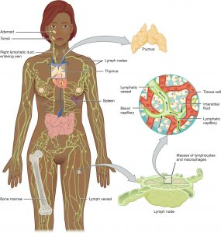
Figure 1: Overview of lymphatic system.
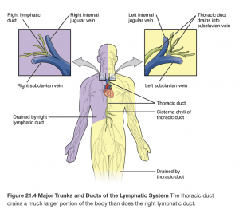
Figure 2: Lymphatic ducts.
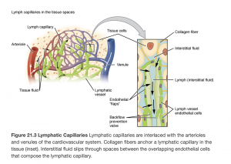
Figure 3: Lymphatic capillaries.
(Attribution for all three images: Gordon Betts, J., Young, K.A., Wise, J.A., Johnson, E., Poe, B., Kruse, D.H., Korol, O., Johnson, J.E., Womble, M., & DeSaix, P. (2013). The Lymphatic and Immune System. In Anatomy and Physiology. OpenStax. Creative Commons Attribution License v4.0. Book URL:https://openstax.org/books/anatomy-and-physiology/pages/1-introduction
Section URL: https://openstax.org/books/anatomy-and-physiology/pages/21-1-anatomy-of-the-lymphatic-and-immune-systems)

Activity: Check Your Understanding
An interactive H5P element has been excluded from this version of the text. You can view it online here:
https://pressbooks.library.torontomu.ca/assessmentnursing2/?p=873#h5p-46

58

Subjective Assessment
Subjective assessment of the lymphatic system involves asking questions about the health of the client and symptoms that occur because of pathologies affecting this system. Subjective assessment related to the lymphatic system is typically conducted as part of assessments related to peripheral vascular, gastrointestinal, respiratory, genital, and musculoskeletal systems.
A full exploration of pathologies is beyond the scope of this chapter, but common problems associated with the lymphatic system include lymphadenopathy, lymphedema, and cancers of the lymphatic system such as lymphomas.
Common symptoms that can be related to the lymphatic system include noticeable lymph nodes, skin changes (swelling, tight, hard skin, leaking fluid), headache, general fatigue, and fever. See Table 1 for guidance on subjective health assessment. Many of the questions in the table align with the PQRSTU mnemonic; you should probe symptoms in the order of relevance, rather than sequentially according to the mnemonic. For a reminder, check out this resource: PQRSTU.
You should also ask about any medications (prescribed or over the counter) the client is taking: name, dose, frequency, reason it was prescribed, how long they have been taking it, and effectiveness. Always ask about herbal and natural products.
Also ask questions related to health promotion. Depending on the context of the assessment, you may ask these questions and engage in a discussion during a subjective assessment or after an objective assessment. A section on “Health Promotion Considerations and Interventions” is included later in this chapter, after the discussion of objective assessment.

Knowledge Bites
Many lymphatic system pathologies result in swelling. For example, clients may report or you may observe lymph node swelling (a raised lump under the skin). Lymph node swelling is often the body’s way of filtering pathogens possibly related to an upper respiratory infection, flu, or cold; swelling is typically localized (in one area) and usually resolves within 1–2 weeks after the condition resolves. In these cases, lymph nodes are often tender, enlarged, and warm to touch with some localized redness. Abnormal characteristics are discussed below under priorities of care.
Table 1: Common symptoms, questions, and clinical tips.

Priorities of Care
In cases of severe lymphedema, you should assess for cellulitis, which is a bacterial infection resulting in fever and inflammation (heat, erythema, swelling, and pain) over the affected area. With severe infection, you may observe red, purple, or other deeply coloured streaks radiating from the affected site (see Figure 4 for signs of cellulitis). Keep in mind that these streaks may be less visually obvious in clients with darker skin tones. Severe lymphedema is usually treated with antibiotics and can be life-threatening if untreated. Any signs of cellulitis should be reported to the physician or nurse practitioner. Mark the borders with a skin marker pen and monitor for enlargement. If the client is outpatient, tell them to contact their healthcare provider if it enlarges beyond the original borders.
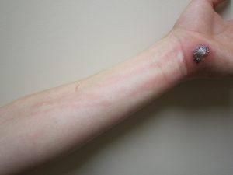
Figure 4: Signs of cellulitis.
(Image CC-BY-SA, By James Heilman, MD, https://commons.wikimedia.org/wiki/File:CellulitisJmh649.JPG)
Keep in mind that enlarged lymph nodes often simply indicate that the body is fighting an infection such as a cold. However, they are sometimes associated with serious conditions such as cancer, so you should always conduct a focused subjective and objective assessment when lymph nodes are enlarged. Any lymph node swelling with the following abnormal characteristics requires further investigation and should be reported to the physician or nurse practitioner:
- Nodes that are larger than 1 cm.
- Nodes that have developed for no apparent reason (i.e., no sign of infection) and remain swollen for more than 3 weeks or continue to enlarge.
- Nodes that are fixed/attached to the skin and not easily moveable.
- Nodes that are hard like a stone upon palpation or rubbery as opposed to soft.
- Nodes that are matted (in a group and attached to each other) as opposed to a discrete node (an individual node not attached to other nodes).
- Nodes associated with sustained symptoms such as fatigue, unexplained weight loss, persistent fever, fainting, and breathing issues.
Note whether nodes are non-painful or painful. Be aware that even a non-painful node may be a cause for concern: some non-painful nodes can meet some of the above characteristics and be associated with certain cancers. Nodes can also grow large enough to press on surrounding nerves. A systemic issue may be the cause of generalized swollen nodes found in multiple locations throughout the body, as opposed to localized. A local infected lymph node can also become systemic, so it is important to ask the client about symptoms such as fever, fatigue, chills, and anorexia.

Contextualizing Inclusivity
Children have active immune systems and are exposed to many viral and bacterial infections (e.g., cold, flu) at daycare and school. As a result, palpable soft, moveable, and small lymph nodes are common in children. These changes are the body’s normal response to fighting infection and indicate that the lymphatic system is working properly. Prompt assessment and intervention is required if the lymph nodes continue to enlarge when an infection has resolved or the swelling is associated with symptoms such as difficulty breathing or swallowing or any of the abnormal characteristics described in the box above.

Activity: Check Your Understanding

An interactive H5P element has been excluded from this version of the text. You can view it online here:
https://pressbooks.library.torontomu.ca/assessmentnursing2/?p=875#h5p-47

References
Jones, G., & Mansour, S. (2017). An approach to familial lymphoedema. Clinical Medicine, 17(6), 552-557. https://doi.org.10.7861/clinmedicine.17-6-552

59

Objective Assessment
The objective assessment of the lymphatic system is usually completed after the subjective assessment. Position the client depending on the related area being assessed.
Be aware of the environmental temperature in the room and the temperature of your hands. Room temperatures are not easily modified, so try to limit exposing the client and keep them covered, and try to warm your hands before placing them on the client’s body.
Objective assessment of the lymphatic system involves the techniques of inspection and palpation. Compare your assessment bilaterally and ask the client if they feel any pain. If you notice leaking fluid or blisters, wear gloves to help prevent and control infection.

Contextualizing Inclusivity
You will be exposing various areas of the body, so it is important to be attentive to the client’s needs during the assessment. Always use a trauma-informed approach: ask permission to touch and explain what you are doing before you proceed.
A cultural humility approach to assessment is also important because you cannot know and fully understand all cultures. This kind of approach requires a life-long process of reflection and self-critique to address power imbalances within systems and develop mutually beneficial partnerships and relationships (Tervalon & Murray-Garcia, 1998). Healthcare professionals should engage in continuous, critical reflection on power and privilege, and find ways to interact with clients of different race, sex, gender, age, and ability.
For example, some of your clients may wear head coverings or coverings over their face or body. Some Muslim women wear hijabs that cover their heads or niqabs that cover their faces; some Sikh individuals wear turbans; and some married Jewish women cover their hair with scarves or wear wigs. These are just some examples. For some clients, touch (i.e., physical assessment) from a person of the opposite gender may not be permissible or encouraged. Some Muslim women may prefer or require a female healthcare provider of the same gender, but others may feel that receiving healthcare from a male practitioner can be medically necessary and is therefore permitted.
Another consideration is that many clients are uncomfortable with assessments of the lymph nodes in the groin area. This kind of assessment may be particularly uncomfortable for clients who have experienced trauma and/or clients who experience gender incongruence.
Overall, you should first determine whether the assessment is necessary, if the client feels comfortable with you doing the assessment, and if accommodations can be made for the client. You can find some tips for providing sensitive care to 2SLGBTQ+ clients at https://soginursing.ca/.

References
Tervalon, M., & Murray-García, J. (1998). Cultural humility versus cultural competence: A critical distinction in defining physician training outcomes in multicultural education. Journal of Health Care for the Poor and Underserved, 9(2), 117–125. https://doi.org/10.1353/hpu.2010.0233

60

Assessment of Lymphedema
Assessment of the lymphatic system includes inspecting the skin for signs of lymphedema (Figure 5 shows signs of severe edema). The most common sign is swelling, but other signs may be present when the condition is severe or not well managed.
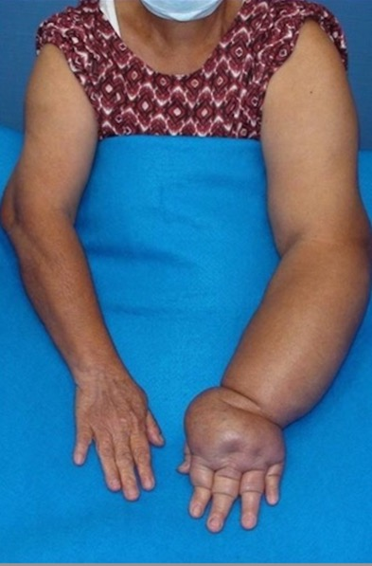
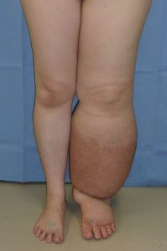
Figure 5: Lymphedema.
(Attribution: Photo of legs by Medical doctors – https://commons.wikimedia.org/w/index.php?curid=37663127 and photo of arms has been cropped. Photo by DocHealer – https://commons.wikimedia.org/w/index.php?curid=64120555, both own work, CC-BY SA 4.0)

Clients with lymphedema will usually report that they are experiencing swelling or that their clothes or jewelry appear to be fitting tighter. This will help you to determine where to begin your assessment. If you are doing a general assessment, it is appropriate to observe the face, neck, arms and legs in a sitting or supine position. Observe the client’s bare skin and compare bilaterally.
Assessment for lymphedema involves the following steps:
- Inspect for swelling and symmetry over the face, neck, arms, and legs.
  - Normally, no swelling is present on the face, neck, arms, and legs, and limb circumference is equal bilaterally.
  - If swelling or asymmetry is present, describe the location. If you observe asymmetrical limbs in terms of circumference, measure with a flat/flexible tape measure around the largest area of swelling on the affected limb and measure at the same location on the other limb.
If you note swelling, assess for pitting edema: an indentation that remains after applying pressure over the location (see Figure 6). Apply pressure with the pad of your finger on a distal location (feet and medial malleolus) for about 3-5 seconds and then release. If you observe an indentation (a “pit”), note the location and how long the indentation remains. Then, assess a proximal location to assess how high the edema goes (e.g., over the tibia). Always check with the unit you work on about the scale used to evaluate pitting edema. Scales are usually 1–4 as shown in Figure 7 and are used to record the pit depth and rebound time (the time for the indentation to disappear). Often, 1 is classified as mild, 2 as moderate, 3 as severe, and 4 as very severe.

Figure 6: Example of pitting edema
Figure 7: Pitting edema scale. (Attribution: https://wtcs.pressbooks.pub/nursingskills/ CC-BY 4.0).
- Inspect for skin discolouration, skin breakdown (cuts, cracks), and ulcers over the face, neck, arms, and legs. Inspect anterior and posterior sides, in between skin folds and toes, and on the bottom of the feet.
  - Normally, skin colour is even throughout the body and skin is intact.
  - If you observe any skin discoloration from the client’s baseline, identify the location and colour. If skin is not intact or ulcers are present, note the location and record a description. If applicable, describe the colour, odour, consistency and quantity of discharge.
- Palpate for temperature using the dorsa of hands from the top of the limb (e.g., shoulder/upper leg) to the extremities (hand/fingers and feet/toes).
  - Normally, the temperature is equal bilaterally. The distal portions of the limbs (hands and feet) may be slightly cooler, but should be equal bilaterally.
  - If you note any asymmetry in temperature or extreme temperatures, identify the location and temperature (i.e., cold or hot).
- Palpate skin texture and consistency with your first two or three fingers and thumb over the limbs or any areas where lymphedema is suspected.
  - Normally, the skin texture is smooth and soft with no lumps.
  - Describe the quality and note the location of any dry, moist, dimpled, or firm areas on the skin.
- If you suspect lymphedema, assess the client’s mobility of the affected limb and range of motion.
  - Normally, clients should have no difficulty moving their arms and legs, with full range of motion and no pain.
  - Note any difficulty moving, limited range of motion, or pain.
- Note the findings:
  - Normal findings might be documented as: “No swelling or discolouration present on the face, neck, arms, and legs, and limb circumference is equal bilaterally. Temperature is warm to touch and equal bilaterally, and skin texture is smooth with no lumps on arms and legs.”
  - Abnormal findings might be documented as: “Redness and swelling noted on left arm, left upper arm circumference 19 inches and forearm circumference 12 inches. Right upper arm circumference 14 inches and forearm circumference 10 in inches. Full range of motion of both arms. Client describes slowness and difficulty moving arm.”

Priorities of Care
A main priority of care is to prevent and/or treat infection. Clients with lymphedema are at risk for skin breakdown, ulcers, and infection. Skin should be kept clean, dry, and moisturized. Clients should also be careful to prevent any scratches or cuts that could lead to infection. Assess and monitor any areas of the skin that are not intact and/or show potential infection. It is important to observe if any areas of concern worsen (e.g., get bigger). Report to the physician or nurse practitioner if you observe any ulcers or signs of infection.
Clients with lymphedema may be referred to a physiotherapist and encouraged to perform light exercises to assist with lymphatic fluid transportation. For similar reasons, compression stockings are often prescribed: these are fitted elastic stockings that apply a certain amount of pressure to the limb. It is also often recommended to elevate limbs with lymphedema.

Activity: Check Your Understanding
An interactive H5P element has been excluded from this version of the text. You can view it online here:
https://pressbooks.library.torontomu.ca/assessmentnursing2/?p=879#h5p-48

61

Inspection and Palpation of the Lymph Nodes
This assessment is often performed with the client sitting upright on the exam table to assess the lymph nodes in the head and neck, the upper arm, and the axillae, and then with the client repositioned into a supine position to assess the lymph nodes in the groin.
- NOTE: Lymph nodes are located in many areas of the body, some of which are not physically accessible. Although some of the axilla lymph nodes are associated with the breast, other lymph nodes associated with the breast will be explored in another chapter.
Use the following techniques to palpate the lymph nodes:
- Prior to palpation, say to the client “let me know if you have any pain or tenderness when I touch you.”
- Use the finger pads of two to three fingers and move them in a circular motion.
- Use a light touch with gentle pressure so that you don’t forcefully push the node inwards.
- After you palpate in one spot, shift your fingers to a new spot within the same area, because there are strands of lymph nodes in each area. This should be done about two to three times in each area.
- Typically, you palpate bilaterally at the same time and compare the right side to the left side.
- Conclude by asking the client if they had any pain or tenderness.
See Table 2 for what to note when assessing lymph nodes and abnormal characteristics.
Table 2: Lymph node assessment.

Lymph Nodes of Head and Neck
Steps for assessing lymph nodes of the head and neck are as follows:
- Inspect the lymph node areas on the head and neck (see Figure 8) for swelling, asymmetry, and erythema.
  - Normally, the lymphatic areas are symmetrical between sides with no discolouration, swelling, or visible nodes.
  - Abnormal findings may include asymmetry and visible nodes due to swelling with erythema overlying the skin.
- Palpate for lymph nodes using a systematic approach moving from proximal to distal; thus moving from preauricular to supraclavicular area (see Figure 8, Table 3 and Video 1). Consider lymphatic drainage patterns (see Figure 9); this approach allows you to reflect on the origins of the cause when there is an abnormality.
  - Recall to palpate nodes bilaterally at the same time: for example, assess the preauricular nodes on the left and right side at same time. However, for the submental lymph nodes, you should use the fingers of your dominant hand to palpate just under the chin behind the bony prominence. When assessing the deep cervical chain on clients with a muscular neck, you may ask the client to tip their head toward the side you are assessing to relax the sternomastoid muscle; thus, you will need to do one side at a time. For the supraclavicular nodes, you can ask the client to gently raise their shoulders.
    - Normally, lymph nodes are not palpable, but remember that normal lymph nodes can sometimes be palpable in young children.
    - If a lymph node is palpable, assess them as per Table 2 noted above.
- If lymph nodes are visible or palpable, palpate the temperature over the lymph node areas of the head and neck using the dorsa of your hands, comparing bilaterally.
- Note the findings:
  - Normal findings might be documented as: “No lymph nodes palpable in the head and neck, no swelling, no asymmetry, no discolouration or increased temperature over lymph node locations, and no pain.”
  - Abnormal findings might be documented as: “Visible lymph nodes in the neck, hard, matted, and palpable cervical and supraclavicular lymph nodes on the right side, 3 cm. Client indicates they are tender.”
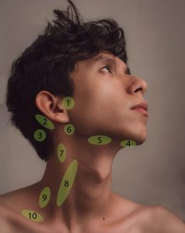
Figure 8: Lymph node areas on head and neck
Table 3: Lymph node locations on the head and neck.
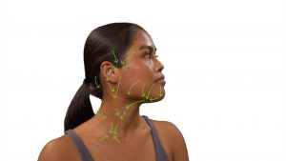
Figure 9: Lymphatic drainage of head and neck lymph nodes.

One or more interactive elements has been excluded from this version of the text. You can view them online here: https://pressbooks.library.torontomu.ca/assessmentnursing2/?p=881#oembed-1
Video 1: Palpation of head and neck lymph nodes [1:16]

Lymph Nodes of Upper Arm and Axillary Area
Steps for assessing lymph nodes of the upper arm and axillary area:
- Inspect the area surrounding the upper arm where the epitrochlear lymph nodes are located (see Figure 10-the area under the finger tips is where you should inspect which is superior and behind the medial epicondyle of the humerus) and inspect the axillae where the axillary lymph nodes are located (see Figure 11).

  - Normally, the lymphatic areas are symmetrical on each side with no discolouration, swelling, or visible nodes.
  - Abnormal findings may include asymmetry and visible nodes due to swelling with erythema overlying the skin. If a lymph node is palpable, assess it for abnormal characteristics (Table 2).


Figure 10: Epitrochlear lymph node area.
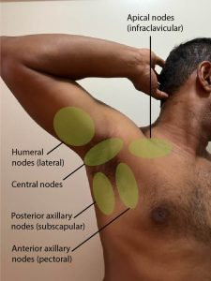
Figure 11: Axillary lymph node area.
- Palpate the epitrochlear (Video 2) and axillary lymph nodes(Video 3). Prior to palpation, say to the client “let me know if you have any pain or tenderness when I touch you.” For the epitrochlear lymph nodes: Ask the client to place their forearm on the bedside table with the palm facing up and palpate in a gentle circular motion in about two to three locations just superior to and behind the medial epicondyle of the humerus (about 1–2 cm). For the axillary lymph nodes: Ask the client to raise their arm and rest their hand on the back of their head. Use a gentle circular motion to palpate. Begin in the axilla: palpate in one row high in the axilla, then palpate in three rows away from the axillae along the upper arm, then three rows away from the axillae down the chest wall, and then in one row medially (see Figure 12 for pattern). For each row, palpate about three to four locations.
  - Normally, there are no palpable lymph nodes.
  - If a lymph node is palpable, assess them as per Table 2 and pay attention to the drainage patterns noted in Figure 13. It is important to recognize that a large amount of the lymph from the breast drains into the anterior axillary nodes, lymph from the back drains into the posterior axillary nodes, and lymph from the arm drains into the lateral nodes. Additionally, this lymph drains into the central nodes to the apical nodes to the supraclavicular and then, often returns to the vascular system through the subclavian vein via the thoracic duct.
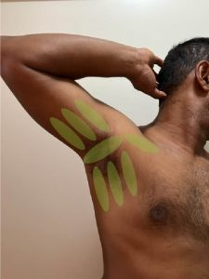
Figure 12: Axillary lymph node palpation pattern.

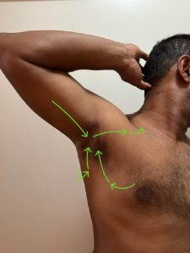
Figure 13: Lymphatic drainage of axillary lymph nodes.

- If lymph nodes are visible or palpable,palpate the temperatureover the lymph node areas of the axillary and epitrochlear areas using the dorsa of your hands comparing side to side.
  - Normally, there is no increase in temperature.
  - Some abnormal lymph nodes will have increased localized skin temperature overlying the node.
- Note the findings:
  - Normal findings might be documented as: “No lymph nodes palpable in the upper arm or axillae, no swelling, no asymmetry, no discolouration and no increased temperature over lymph node locations, and no pain reported by the client.”
  - Abnormal findings might be documented as: “Hard, matted and palpable lymph nodes on the left axillary side. Tenderness reported by the client.”
One or more interactive elements has been excluded from this version of the text. You can view them online here: https://pressbooks.library.torontomu.ca/assessmentnursing2/?p=881#oembed-2
Video 2: Palpation of the epitrochlear lymph nodes (showing technique on right arm) [0:25]

One or more interactive elements has been excluded from this version of the text. You can view them online here: https://pressbooks.library.torontomu.ca/assessmentnursing2/?p=881#oembed-3
Video 2: Palpation of the axillary lymph nodes (showing technique on right side) [1:05]

Lymph Nodes of the Groin
Steps for assessing lymph nodes in the groin area:
- Inspect and palpate the groin area for the inguinal lymph nodes. Assist the client into supine position and provide a drape. Briefly expose one side to inspect and palpate, and then repeat on the other side. Prior to palpation, say to the client “let me know if you have any pain or tenderness when I touch you.” Palpate about four to five times in the groin area (Figure 14). If nodes are palpable, assess for temperature (comparing bilaterally)
  - Normally, the lymphatic areas are symmetrical on each side with no discolouration, swelling, or visible or palpable nodes.
  - Abnormal findings may include asymmetry and visible nodes due to swelling with erythema overlying the skin. If a lymph node is palpable, assess it for abnormal characteristics (Table 2).
- Note the findings:
  - Normal findings might be documented as: “No lymph nodes palpable in the groin, no swelling, asymmetry, discolouration or increased temperature over lymph node locations, and no pain reported.”
  - Abnormal findings might be documented as: “Palpable, soft right-sided inguinal lymph node. Tenderness reported by the client.”
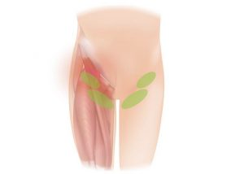
Figure 14: Inguinal lymph node area.

Priorities of Care
Lymph nodes with abnormal characteristics require further investigation and should be reported to the physician or nurse practitioner. Depending on the client, you may ask about whether they have been recently unwell or have noted any other concerns in the affected area (pain, itching, rashes). You might also ask whether they shave or have had a recent cat scratch or bite. Lymph node swelling can be associated with certain infections such as skin and yeast infections, sexually transmitted infections, and eye, ear, and throat infections. In rare situations, it can also be associated with cancer, particularly when accompanied by other symptoms such as fatigue, unexplained weight loss, persistent fever, fainting, breathing issues, and if the lymph nodes have continued to enlarge with no obvious signs of infection.
Contextualizing Inclusivity
The lymphatic system undergoes changes as a person ages; the lymphatic vessels become thinner and the lymph nodes atrophy. As a result, older people may have more difficulty fighting infection and are more prone to lymphedema.
Always use a trauma-informed approach, particularly when assessing the inguinal lymph nodes due to their location. Explain what you are doing and why, ask permission to touch, provide a drape, and ask if the client would like someone present (a friend, family member, or another healthcare provider).

Activity: Check Your Understanding
An interactive H5P element has been excluded from this version of the text. You can view it online here:
https://pressbooks.library.torontomu.ca/assessmentnursing2/?p=881#h5p-49

62

Health Promotion and Disease Prevention: Considerations and Interventions
Health promotion is an important component of a healthy lymphatic system. To determine appropriate interventions, carefully consider all of the collected data, both subjective and objective. As part of subjective data collection, you should inquire about risk factors, social determinants, and other considerations.
Integrate this kind of inquiry throughout the assessment. You will ask many probing questions during the subjective assessment, but other questions will emerge based on your critical reflection of data collected during the subjective and objective assessment. These findings will inform your clinical judgment and help you develop appropriate health promotion interventions for each specific patient.

Preventing the Spread of Infection
The spread of infections can be prevented with simple techniques such as hand hygiene, staying home when sick, covering the mouth when coughing, wearing a mask, and receiving an annual influenza vaccine. You may need to assess the knowledge of the client and provide education about infection control. Also, with young children, you may need to assess the knowledge of parents/caregivers and educate them about infection control so that they can teach their children. Children learn about preventing the spread of infection by watching their parents/caregivers/siblings and practicing the techniques they use, so it is important to reinforce proper technique and infection prevention behaviours.
Probing questions might include:
- When do you perform hand hygiene?
- How do you perform hand hygiene?
- What do you do when you are sick?

Activity
Activity is another important part of assisting with effective lymph fluid transportation. For example, the pump action associated with muscle contraction helps aid in lymphatic drainage. Activity and exercise also help maintain a healthy body weight and prevent obesity.
It is often recommended that clients with lymphedema engage in gentle movement of limbs to help transport lymph fluid. Activities can include walking, swimming, and bike riding. Depending on the severity of lymphedema, clients may be assisted with range of motion exercises and referred to a physiotherapist or a registered massage therapist specializing in lymphedema.
Probing questions may include:
- Tell me about any activity/exercise you are involved in?
- How many times do you participate in exercise a week?
- How long each time?
- Do you have limitations related to activity/exercise?
- Do you have any concerns related to activity/exercise?

HealthyEating
Healthy eating promotes healthy cell function, so it is important that clients have an appropriate level of water intake, nutrients, and vitamins. Healthy eating can also help maintain a healthy body weight; extra body weight can interfere with the lymphatic system’s ability to transport lymph fluid.
Probing questions may include:
- Tell me about your normal diet?
- What do you eat and drink each day?
- Do you have sufficient access to healthy food?
- Do you have sufficient funds to access healthy food?

Alcohol and Drug Use
Alcohol and drug use can affect the lymphatic system in many ways. For example, these activities can be associated with certain cancers, cause inflammation, and increase the risk for injury and infections. The most recent Canadian guidelines now suggest that there are health risks associated with any level of alcohol consumption, although negligible with two drinks or less weekly (Paradis et al., 2022). Alcohol is considered a carcinogen and linked to several types of cancers and can affect the arteries (Paradis et al., 2022).
Reflect on your own biases about alcohol and drugs. Use of these substances can be stigmatized, so self-reflection is crucial to help facilitate a non-judgmental approach to care.
Probing questions may include:
- Tell me about how much alcohol you consume in a day? If the client does not consume alcohol daily, you can assess consumption based on weekly, monthly, or none. If the client’s answer is affirmative, ask probing questions such as: How much (e.g., ounces a day)? What type of alcohol (e.g., red wine, beer)? For how long? Can you tell me the reasons?
- If you do not currently consume alcohol, have you ever? If affirmative, ask similar probing questions, including why the client quit.
Ask similar questions related to drug use.
Contextualizing Inclusivity
Consider a client’s socio-economic status during your assessment, particularly as it relates to healthy eating. For example, does the client have geographical access and sufficient funds for healthy foods such as fresh fruits and vegetables? If not, discuss alternatives with the client (e.g., frozen vegetables). Another issue is that discussions about weight can be triggering for some clients, especially those with moderate to severe lymphedema, which can affect body image. Always use a compassionate, open, and non-judgmental approach to assessment.

63

Clinical Judgement: Case Study
A 26-year-old client has not been feeling well for 4 days. The client reports starting a new job at a drop-in centre for adolescents in the community. Enlarged tonsillar lymph nodes, 2 cm bilaterally, tender to touch, and accompanied with a sore throat, cough, ear ache, and fatigue. The client reports feeling excited and stressed with the new job, and has not been eating very much due to an unsettled stomach. Client’s vital signs are: blood pressure 100/68 mm Hg, pulse 64 bpm, respiration 12 bpm, O2sat 97%, temperature 38.2ºC tympanic.

An interactive H5P element has been excluded from this version of the text. You can view it online here:
https://pressbooks.library.torontomu.ca/assessmentnursing2/?p=886#h5p-50

64

Key Takeaways
- Common symptoms to assess related to the lymphatic system include noticeable lymph nodes and pain, skin changes (swelling, tight, hard skin, leaking fluid), headache, general fatigue, and fever.
- Objective assessment of the lymphatic system includes assessment for lymphedema and inspection and palpation of the lymph nodes in the head and neck, axilla, groin, and related area of the body.
- Health promotion interventions should be developed with the client to address what is important to them. Considerations include preventing infection spread, activity, healthy eating, and alcohol and drug use.

1

Appendix
This is where you can add appendices or other back matter.

