

Introduction to Communication in Nursing

Introduction to Communication in Nursing

Edited by Jennifer Lapum; Oona St-Amant; Michelle Hughes; and Joy Garmaise-Yee

Introduction to Communication in Nursing by Edited by Jennifer Lapum; Oona St-Amant; Michelle Hughes; and Joy Garmaise-Yee is licensed under a Creative Commons Attribution-NonCommercial 4.0 International License, except where otherwise noted.

Contents
- Preface
- Chapter 1 - Introduction to Communication and Communication Theory in Nursing
- Learning Outcomes
- Overview of Communication
- Professional Communication
- A Positive Lens of Conflict
- Conflict Resolution
- Social Media
- Models of Communication
- Transmission Model of Communication
- Interaction of Model of Communication
- Transaction Model of Communication
- Summary of Communication Models
- Communication is Learned
- Theoretical Approaches to Communication and Interviewing
- Trauma-informed Approach to Communication
- Relational Inquiry Approach to Communication
- Anti-racist Approach to Communication
- Key Takeaways
- References
- Chapter 2 - Therapeutic Communication and Interviewing
- Learning Outcomes
- Introduction: Therapeutic Communication
- Therapeutic Communication: CNO Standard Statement
- The Client Interview
- Preparing for the Interview
- Self Reflection Prior to the Interview
- Beginning the Interview
- Types of Interviewing Questions
- Communication Strategies
- Non-Verbal Communication Strategies
- Cultural Considerations
- Developmental Considerations
- Young Children
- Older Children and Adolescents
- Adults and Older Adults
- Additional Considerations
- Concluding the Interview
- Key Takeaways
- References
- Chapter 3 - Interprofessional Communication in Nursing
- Learning Outcomes
- Interpersonal Communication
- Interprofessional Communication
- Interprofessional Communication and Collaboration
- Factors Influencing Interprofessional Communication
- Conflicts in an Interprofessional Environment
- Harassment and Communication
- Resources to Facilitate Interprofessional Communication
- Self-reflection in Interprofessional Communication
- Key Takeaways
- References
- Glossary

1
Communication for the Nursing Professional – 1st Canadian Edition, 2020
This open access textbook is intended to guide best practices in communication in the context of the nursing profession. The resource addresses communication theory, therapeutic communication and interviewing, and interprofessional communication as it relates to nursing. This resource is designed for students in undergraduate nursing programs. The project is supported and funded by the Ryerson University Faculty of Community Services Publication Grant.

Level of Organization
Chapter 1 – Introduction to Communication and Communication Theory in Nursing
Chapter 2 – Therapeutic Communication and Interviewing in Nursing
Chapter 3 – Interprofessional Communication in Nursing

About the Authors
Jennifer Lapum, PhD, MN, BScN, RN, Professor, Daphne Cockwell School of Nursing, Ryerson University, Toronto, Ontario, Canada
Oona St-Amant, PhD, MScN, BScN, RN, Associate Professor, Daphne Cockwell School of Nursing, Ryerson University, Toronto, Ontario, Canada
Michelle Hughes, MEd, BScN, RN, Professor, School of Community and Health Studies, Centennial College, Toronto, Ontario, Canada
Joy Garmaise-Yee, DNP, MN, RN, CNE, Professor, Sally Horsfall Eaton School of Nursing, George Brown College, Toronto, Ontario, Canada
Charlotte Lee, PhD, BScN, RN, Assistant Professor, Daphne Cockwell School of Nursing, Ryerson University, Toronto, Ontario, Canada

Contact person
Dr. Jennifer L. Lapum
jlapum@ryerson.ca
415-979-5000 ex. 556316
@7024th patient
350 Victoria St., Toronto, ON, M5B 2K3
Ryerson University

Note to Educators Using this Resource
We encourage you to use this resource and would love to hear if you have integrated some or all of it into your curriculum. If you are using it in your course, please consider notifying Dr. Lapum and include the course/program and the number of students.

Acknowledgments
Meera Chawda, BScN student, Student Assistant, Ryerson University
Linn Clark, Editor, Toronto, Ontario, Canada
Frances Dimaranan, BScN student, Student Assistant, Ryerson University
Ann Ludbrook, Copyright and Scholarly Engagement Librarian, Ryerson University
Jeevan Marway, BScN, RN, MN Student, Artist and Infographic expert, Ryerson University
McKenzie Quevillon, BScN, RN, MN student, Multimedia Developer, Ryerson University
Nada Savicevic, MA Interactive Design, MArch, BScEng, Educational Developer, Centre for Excellence in Learning and Teaching, Ryerson University
Hilary Tang, BScN, RN, The Hospital for Sick Children, Front Cover Artist
Sally Wilson, Web Services Librarian, Ryerson University

Customization
This textbook is licensed under a Creative Commons Attribution 4.0 International (CC-BY NC) license except where otherwise noted, which means that you are free to:
SHARE – copy and redistribute the material in any medium or format
ADAPT – remix, transform, and build upon the material for any purpose, even commercially.
The licensor cannot revoke these freedoms as long as you follow the license terms.

UNDER THE FOLLOWING TERMS:
Attribution: You must give appropriate credit, provide a link to the license, and indicate if changes were made. You may do so in any reasonable manner, but not in any way that suggests the licensor endorses you or your use.
No additional restrictions: You may not apply legal terms or technological measures that legally restrict others from doing anything the license permits.
Notice: You do not have to comply with the license for elements of the material in the public domain or where your use is permitted by an applicable exception or limitation.
No warranties are given. The license may not give you all of the permissions necessary for your intended use. For example, other rights such as publicity, privacy, or moral rights may limit how you use the material.
Content that is not taken from the OERs noted below or copyrighted material should include the following attribution statement:
© 2020 Ryerson University. Licensed under a Creative Commons Attribution 4.0 International License (CC-BY NC). Communication for the Nursing Professional (1st Canadian edition) by Jennifer L. Lapum, Oona St-Amant, Michelle Hughes, Joy Garmaise. Download this book for free at: https://pressbooks.library.ryerson.ca/communicationnursing/

Attribution statement
Part of the content of this textbook contains material from two Open Educational Resources (OERs). The OERs adapted include:

The Complete Subjective Health Assessment by Jennifer L. Lapum, Oona St-Amant, Michelle Hughes, Paul Petrie, Sherry Morrell, and Sita Mistry is licensed under a Creative Commons Attribution-ShareAlike 4.0 International License.

Communication in the Real World: An Introduction to Communication Studies by University of Minnesota is licensed under a Creative Commons Attribution-NonCommercial-ShareAlike 4.0 International License, except where otherwise noted.

For information about what was used and/or changed in this adaptation, refer to the statement at the bottom of each page where applicable.

I

Chapter 1 - Introduction to Communication and Communication Theory in Nursing
By Jennifer L. Lapum, Oona St-Amant, Michelle Hughes, and Joy Garmaise-Yee

1

Learning Outcomes
By the end of this chapter, you will:

- Define communication.
- Describe the types of communication.
- Differentiate several models of communication.
- Explain the significance of trauma-informed, relational, anti-racist approaches to communication.

2

Overview of Communication
When you think of communication, talking to another person or texting them might come to mind first. However, while talking and texting are methods of communication delivery, they are not representative of a comprehensive definition of communication.
A more comprehensive understanding of communication refers to the sharing of information, ideas, and feelings, typically aimed at mutual understanding. In this way, you must consider the sender, the recipient, and the transaction. Simply put, the sender is the person sharing the message, the recipient is the person receiving and interpreting the message, and the transaction is the way that the message is delivered and the factors that influence the context and environment of the communication. As you can see, communication is a complex process. It involves more than just what you say and takes many forms as reflected in Figure 1.1.


Figure 1.1: Forms of communication.

There are three types of communication:
- Verbal communication
  - Verbal communication is oral communication that happens through spoken words, sounds, vocal intonation, and pace. It can occur face-to-face, one-on-one, or in groups, over the telephone, or video conferencing. As a nurse, you will engage in verbal communication with clients, families, colleagues, and interprofessional teams.
- Non-verbal communication
  - Non-verbal communication is a type of communication that occurs through facial expressions, eye contact, gestures, and body positions and movements. As a nurse, you will learn that your non-verbal communication is important because it can both reinforce or contradict what you say verbally. Additionally, non-verbal communication is used more often than verbal communication. Thus, you must become aware of your non-verbal communication.
- Written communication
  - Written communication is a type of communication that occurs through written words, symbols, pictures, and diagrams. You are probably familiar with some informal, written types of communication, such as texting or emailing someone, posting a picture on Instagram, or using an emoji in Twitter. You may also have engaged in more scholarly forms of written communication such as letters and papers. As a nurse, written communication also involves documentation notes and scholarly writing like essays, peer-reviewed publications, protocols, practice standards, and best practice guidelines. You may not be familiar with some of these types of written communication yet, but you will become more acquainted with them over the course of your nursing program.

Activity: Check Your Understanding
An interactive H5P element has been excluded from this version of the text. You can view it online here:
https://pressbooks.library.ryerson.ca/communicationnursing/?p=80#h5p-1

3

Professional Communication
Professional communication is an important part of becoming a nurse and being a nursing student. You are entering a “profession” which means there are certain expectations in terms of your professional conduct specifically in terms of how you communicate.
Professional communication involves a level of formality and is an important component of your post-secondary nursing education. It is different than the informal communication that you may engage in with your friends and family. It also applies to your verbal and written communication including emails.
The principles of professional communication include being truthful, accurate, clear, and both concise and comprehensive. For example, you should say or write something in a succinct and short way while also including all relevant information. You should also have a professional tone that is conveyed through appropriate greetings, complete sentences, and grammar. In order to be professional, you need to know your audience; both the content and form of your message should be tailored to your audience.
Here are some tips to follow in terms of professional communication:
- Introduce yourself fully by name and role/institution, such as: “I am Mateo Reyes, a year one nursing student from Ryerson University.”
- Address the person you are speaking to formally. Also, do not assume the gender of the person you are speaking to. For example, you should avoid using terms such as “miss,” “ma’am,” “sir,” “mister,” “ms,” etc., until you know how the recipient wants to be addressed. If you are uncertain, introduce yourself fully and ask how the recipient would like to be addressed.
- Clearly articulate your message (what you are trying to say).
- Speak in full sentences.
- Be honest.
- Be polite. Your communication is a reflection of YOU and your professionalism.
Because a lot of communication occurs electronically, it is important to consider how to construct an email. Here are some tips:
- Use a professional email address. At most universities, your email communication with a professor should originate from your university email.
- Begin with a clear description in the subject line. For example, students should include the course code in the subjective line and a brief description identifying the reason for the email (e.g., “NSE 54: question regarding week 3 quiz”).
- Use a professional email greeting and salutation to address your professor, or the salutation preferred by the professor.
  - Appropriate: “Dear Professor Dodge” or “Hello, Dr. Chen.”
  - Inappropriate: “Hey teacher”, “Hi”, or “Yo.”

- Introduce yourself so that the email recipient knows who you are. Remember, professors teach several courses and course sections. Thus, you might say “I am Minta Li. I am a student in your Wednesday section of NSE 678.” Additionally, you may need to consider including your student number in an email when you introduce yourself. This is particularly when inquiring about course issues, grades, or program status in order to clearly identify yourself as student names can be similar.
- Refer to any attachments in the email text.
- Avoid point form, slang, and abbreviations.
- Include a signature block at the end of your email identifying your full name, role, institution, and contact information. You should NOT include your student number in the signature block because it is considered part of your private information at the university.
- Proofread your email for accuracy, grammar, and spelling.
- Avoid humour and excessive use of exclamation points and all caps. These can easily be misinterpreted.

Points of Consideration
Addressing and referring to your instructor
Students are often uncertain how to address their instructors. It is okay to ask your instructors how they would like to be addressed. Until you know how, you should refer to them as “Professor X” (insert their surname) or “Dr. X” (insert their surname).
Although some instructors may invite you to use their first name, it is part of professional communication etiquette to use “Professor X” or “Dr. X” (including both their first and last name) when referring to them to others. In addition to ensuring professional communication, this helps to provide clarity if your instructors share a first or last name with another instructor.
Example: Dr. Huang is your course instructor, and they have encouraged you to reach out to another professor to discuss potential research opportunities. Although Dr. Huang has given you permission to call her Lisa in the classroom, you should always refer to them as Dr. Lisa Huang in communication with others. Thus, when initiating communication with the instructor that Dr. Huang has referred you to, you may consider a beginning such as: “Dear Dr. Hameed. I am a student in the undergraduate year one nursing communication course with Dr. Lisa Huang. Dr. Huang has encouraged me to reach out to you about potential research opportunities because of my interest in critical feminism.”

Activity: Check Your Understanding
An interactive H5P element has been excluded from this version of the text. You can view it online here:
https://pressbooks.library.ryerson.ca/communicationnursing/?p=82#h5p-4

4

A Positive Lens of Conflict
Conflict is a variance in perceptions and opinions that involves a perceived or actual threat.
It is important to avoid thinking of threat as an intention to inflict physical harm or pain upon someone. Rather, consider threat as an unfavourable situation and force that may adversely affect you.
Threat is embedded in conflict because a person’s perception or position quickly becomes part of who they are (i.e., their self concept) and as such, an opposition to this perception is considered “a threat to self” (De Dreu & van Knippenberg, 2005, p. 345). A perceived threat or an actual threat happens with conflict because you perceive that something/someone is challenging your beliefs or needs and may affect your sense of self or the relationship you have with them.
Have you ever perceived a threat when having a difference of opinion or disagreed with someone else? Have you felt a sense of threat in a setting where there are deeply engrained power dynamics? Have you been engaged in a class discussion where you had a different way of seeing things than another person? Have you had a concern about a university/school’s policy? Have you received a grade on a paper from a professor and you did not agree with it? You may feel worried to speak up about an issue because the other person has a different perspective than you. You may fear that if you speak up, they will think you are ignorant or that it may affect your relationship with them.
These are all examples of conflict, and are associated with a perceived threat or actual threat.
Conflict can trigger strong emotions and has the potential to negatively affect how you respond and how you communicate.
Consider how you have responded to conflict in the past. Did you ignore or avoid the conflict? Did you take the disagreement personally? Did you engage in intense and relentless argument? Have you ever not addressed it with the person, but instead posted on social media or gossiped to a friend or peer? These are all ineffective ways to deal with conflict because it never resolves the problem – the conflict.
It is important to understand and address conflict as it is a part of any relationship including those in the educational and professional settings. There is the possibility that you can transform how you perceive conflict, and thus, how you address conflict – this is the positive lens of conflict.

Points of Consideration
The positive lens of conflict
A starting point is to transform how you view conflict. Have you ever considered viewing conflict from a positive lens? Conflict suggests that you have an opinion that you hold as meaningful or important. In itself, this is a good thing. It can be beneficial to approach conflict as an opportunity. You can learn and grow by truly listening to another person’s view and sharing your own. Part of this is seeking to understand what the perceived threat is for you and for the other person(s). If approached professionally, this sharing can help you feel good that you have shared your opinion, why it matters to you, and participated collaboratively and respectfully to manage the conflict. Additionally, by learning and growing while engaging professionally with another person, this can sometimes create a connection that cultivates your relationship with them. It can also add to a positive resolution related to the conflict with the potential for creative and divergent thinking.
References
De Dreu, C., & van Knippenberg, D. (2005). The possessive self as a barrier to conflict resolution: Effects of mere ownership, process accountability, and self-concept clarity on competitive cognitions and behavior. Journal of Personality and Social Psychology, 89(3), 345-357. https://doi.org/10.1037/0022-3514.89.3.345

5

Conflict Resolution
Conflict resolution is about finding a reasonable solution to varying perspectives. This may involve you and the other person(s) sharing your perspective to enhance understanding of the issue. It may result in you or the other person shifting your perspective in a way that a reasonable solution is arrived upon related to the conflict. Often, when conversation goes beyond the disagreement on the surface and instead explores the perceived or actual threat on each side, more options for compromise and resolving the conflict emerge.
Professionalism should always guide how you approach and manage conflict. In educational institutions and in nursing, professionalism is essential. As a student, specifically a nursing student, you are developing your professional self as a nurse. This means that you have a responsibility to uphold values of honesty, respect, and integrity in all your interactions.
Engaging in effective conflict resolution takes practice. Remember, as nursing student, you are learning and growing in so many ways. As such, engaging in reflection on how you participate in conflict resolution in terms of what was effective and what was not effective is important to your professional development.
Fortunately, conflict resolution is a skill that you can learn, and that is a good thing. There are several conflict resolution strategies that can inform your communication:
- Approach the situation with a “spirit of inquiry” (Registered Nurses’ Association of Ontario, 2007, p. 26).
  - You should enter the discussion with an open mind and strive to understand the other person’s perspective.
  - Reflect on what the perceived or actual threat is for you, and seek to understand what the other person(s)’ perceived or actual threat is. This may be a very different conversation from the issue that started the conflict.

- Assume the goodwill of another person.
  - This means avoid entering a situation with a negative attitude. It is best to assume the other person’s willingness to engage in kind and professional discussions. However, do note that assuming goodwill does not mean that the other person will end up agreeing with your perspective or behave in that manner. It may be that after a full discussion, you agree to disagree.

- Use “I” statements when you engage in conflict resolution.
  - These statements are important because they convey how you feel (from your standpoint) and open the opportunity for discussion. “I” statements are difficult to counter-argue because they are your perspective on the situation, as opposed to “you” statements which insinuate knowing the other person’s position without understanding and can lead to accusations and feelings of blame.

- Do not raise your voice.
  - Raising your voice is not helpful to resolve a conflict, it escalates the situation and makes people defensive. There is a famous quote by Desmond Tutu, who says “Don’t raise your voice, improve your argument.”
  - In email, avoid capital letters, bolding and exclamation marks as it can be interpreted as shouting or anger. Also, never write anything in an email that you would not directly say to a person.

- Be clear and provide rationale for your perspective.
  - This strategy can help the other person understand your perspective.

Points of Consideration
Courage and conflict
Addressing conflict sometimes takes courage. You may feel uncertain about how to address it and frightened that it will affect your relationship with the other person(s). There may be power dynamics involved. For example, you may need to address an issue with a person in a position of authority, such as a class professor or clinical instructor. Be courageous and act despite the fear, vulnerability, and uncertainty you may feel. It is better to be direct with the person you have a conflict with than to harbour resentment. Recognize this fear, vulnerability, and uncertainty. But also recognize the positive feelings associated with being courageous. You accomplish something important when you deal with conflict. You get courageous by being courageous.
One strategy to help you address the conflict is to write it down on a piece of paper and say it out loud. This can help you identify and acknowledge emotions attached to the conflict. Then when you address the conflict with the individual, you can focus on the issue and not the personal emotions which could impact the discussion. Ask to meet with the person and have a face-to-face discussion as opposed to trying to talk about the issue via email or text.
Case Example
Consider a situation in which a family is upset about the nursing care their loved one is receiving, and tells you that after watching you do an assessment on the client, you “clearly don’t know what you’re doing.”
Analysis
The family member’s words could cause a sense of threat for you. Perhaps you may fear a sense of being falsely accused and reported and are unsure of the consequences that might ensue. You may get very defensive and insist that you did “nothing wrong.” On the other hand, this family may be feeling a very different threat, i.e., perhaps they fear their loved one’s condition is deteriorating, and they may lose them soon. Any small error (or perceived error) in their loved one’s care may trigger fear around losing them. Having a conversation with the family to acknowledge the threat (i.e., fear) they are experiencing may be beneficial to resolving the conflict over their perception of your care.

6

Social Media
Many people use social media (e.g., TikTok, Instagram, Twitter, Facebook, WhatsApp) as a way to share and engage with others and as a form of education and entertainment. However, as a nursing student, you are legally obligated to uphold a Code of Conduct in both personal and professional social media posts.
A Code of Conduct is a standard of practice that sets expectations and outlines norms and responsibilities of a professional. It establishes and formalizes common values within the profession and is intended to govern behaviour. The College of Nurses of Ontario (CNO, 2019a) has articulated a Code of Conduct with six guiding principles:
- “Nurses respect the dignity of patients and treat them as individuals.”
- “Nurses work together to promote well-being.”
- “Nurses maintain patients’ trust by providing safe and competent care.”
- “Nurses work respectfully with colleagues to best meet patients’ needs.”
- “Nurses act with integrity to maintain patients’ trust.”
- “Nurses maintain public confidence in the nursing profession” (CNO, 2019, p.4).
As a nursing student, you are expected to uphold the same practice standards as a Registered Nurse.
With the advent of social media, as a Registered Nurse and a nursing student you are expected to uphold the Code of Conduct now more than ever. Even though you may use social media in your personal life, you are still expected to maintain professionalism. For example, under the Code of Conduct, nurses and nursing students are expected to treat their colleagues with respect on social media. Nurses and nursing students who use social media are not allowed to share patient information or post confidential information, even on private accounts.
The CNO (2019b) Practice Standards documents states “nurses have a duty to uphold the standards of the profession, conduct themselves in a manner that reflects well on the profession, and to participate in and promote the growth of the profession” (p. 11). As such, there is a collective responsibility to contribute to the positive image of the nurse, and actively promote the reputation of a nurse. Posting information on social media that is unethical, unlawful, and disgraces a colleague in your practice or educational institution or dishonours the image of the nurse could result in serious consequences to licensure.
Case Example
In 2015, a Registered Nurse from Saskatchewan took to social media to air her grievances about the quality of care her grandfather received in long-term care. In her Facebook posting, she named the institution that cared for her grandfather and urged the institution do better in future patient care. In her posting, she did not explicitly name any healthcare providers, nor did she use inflammatory language, but she referred to her grandfather’s care as “sub-par”. In 2016, she was found guilty of professional misconduct by the Saskatchewan Registered Nurses Association (SRNA) and was ordered to pay a $1,000 fine and $25,000 towards costs for the tribunal. In 2020, Saskatchewan’s highest court overruled the disciplinary decision and fine.
Analysis
The nurse in this case was originally found guilty of misconduct for harming the reputation of nurses by going to social media to make complaints. It was also noted that other formal complaint channels (such as managers of the institution), would have been a more appropriate alternative to make change. Furthermore, the legal team for the SRNA argued that all facts should have been collected before making allegations against the institution. Ultimately, the decision was overturned, however this case emphasizes the importance of being intentional, deliberate, and professional when engaging on social media.
Your employer or educational institution may or may not have specific policies related to the use of social media outside of the workplace. It is important as an employee or a student to be aware of any institutional guidelines for social media use. Furthermore, the CNO will consider situations of misconduct as a regulatory body.
Examples of violations on social media:
- Posting confidential information about a client (e.g., diagnoses, events, family situations).
- Sharing explicit material (including sexually explicit).
- Engaging in personal relationships with clients online.
- Posting unfavourable information about colleagues, professors, or institutions (such as hospitals or universities/colleges).
- Cyber bullying or intimidating colleagues or clients.

Points of Consideration
24-hour Rule
Part of the lure of social media is the immediacy with which you share information or receive feedback. Social media has also become a common place to air grievances or share complaints. You can rally support or oppose views with the click of button. However, given that a social media post can have serious repercussions on your career as a nurse and a student, it is important to give additional consideration to what you post online. One strategy to assist is the 24-hour rule, which means when you are uncertain of the effects of your post or you sense that your words may be provocative, wait 24hours and think through your decision. It does not hurt to seek feedback from trusted peers as well.

Additionally, if you have a grievance or a complaint, it is best to address it directly with the person or institution involved. Recall how to address conflict through a positive lens.

7

Models of Communication
Communication is a complex process, and it is sometimes difficult to determine where or with whom a communication encounter starts and ends. Models of communication simplify the process by providing a visual representation of the various aspects of a communication encounter. Some models explain communication in more detail than others, but even the most complex model cannot recreate what we experience in any given moment of a communication encounter.
Models still serve a valuable purpose because they define communication and allow you to see specific concepts and steps within the process of communication. Models give rise to ideas or nuances that you may not have considered. When you become aware of how communication functions, you can think through your communication encounters more deliberately, which can help you better prepare for future communication and learn from your previous communication.
The three models of communication discussed in this chapter are:
- The Transmission Model
- The Interaction Model
- The Transaction Model
Although these models of communication differ, they contain some common elements. The first two models, the Transmission Model and the Interaction Model, include the following parts: participants, messages, encoding, decoding, and channels. In communication models, participants are the senders and/or receivers of messages in a communication encounter. The message is the verbal and nonverbal content being conveyed from sender to receiver. For example, when you say “Hello!” to your friend, you are sending a message of greeting that will be received by your friend.
The internal cognitive process that allows participants to send, receive, and understand messages includes the processes of encoding and decoding.
- Encoding is the process of turning thoughts into communication. For example, as a sender, you have to decide how to encode your thoughts/message in a way that will convey your message such that the receiver will understand.
- Decoding is the process of turning a communication message into thoughts. For example, you may realize you’re hungry and encode the following message to send to your roommate: “I’m hungry. Do you want to get pizza tonight?” As your roommate receives the message, they decode your communication and turn it back into thoughts in order to make meaning out of it.
Of course, you don’t just communicate verbally – you have various options, or channels, for communication. Encoded messages are sent through a channel, or a sensory route on which a message travels, to the receiver for decoding. While communication can be sent and received using any sensory route (sight, smell, touch, taste, or sound), most communication occurs through visual (sight) and/or auditory (sound) channels. If your roommate has headphones on and is engrossed in a video game, you may need to get their attention by waving your hands before you can ask them about ordering Thai food.
Now, let’s examine the three models of communication discussed in this chapter: Transmission, Interaction, and Transaction Models.

Activity: Check Your Understanding
An interactive H5P element has been excluded from this version of the text. You can view it online here:
https://pressbooks.library.ryerson.ca/communicationnursing/?p=84#h5p-5

Attribution Statement
With editorial changes, adapted from:
Communication in the Real World: An Introduction to Communication Studies by University of Minnesota. Licensed under a Creative Commons Attribution-NonCommercial-ShareAlike 4.0 International License, except where otherwise noted.

8

Transmission Model of Communication
The Transmission Model of communication (see Figure 1.2) describes communication as a linear, one-way process in which a sender intentionally transmits a message to a receiver (Ellis & McClintock, 1990). This model focuses on the sender and the message within a communication encounter. Although the receiver is included in the model, this role is viewed as more of a target or end point rather than part of an ongoing process. In this case, one presumes that the receiver either successfully receives and understands the message or does not. As such, this model is not representative of effective communication for how messages are received.

Figure 1.2: The Transmission Model of Communication

Because this model is sender- and message-focused, responsibility is put on the sender to help ensure the message is successfully conveyed. This model emphasizes clarity and effectiveness, but it also acknowledges that there are barriers to effectively sending communication. Noise is anything that interferes with a message being sent between participants in a communication encounter. Even if a speaker sends a clear message, noise may interfere with a message being accurately received and decoded. The Transmission Model of communication accounts for environmental and semantic noise.
- Environmental noise is any physical noise present in a communication encounter. Other people talking in a crowded hallway could interfere with your ability to transmit a message and have it successfully decoded.
- Semantic noise refers to an interference that occurs in the encoding and decoding process resulting in different interpretations of what is being communicated (e.g., lack of understanding, clarity, and confusion of words and meanings). To use a technical example, a nurse may tell the client that they should progress their walking time to 60 minutes a day. However, the client’s interpretation of this could be influenced by uncertainty surrounding how fast to walk, how quickly to progress to 60 minutes per day, and whether these 60 minutes should occur all at the same time.

Nursing Example
A client is seeking care for a suspected urinary tract infection. A nurse communicates to a client that they need to provide a urine sample and fully empty their bladder. The nurse speaks quietly in an attempt to maintain confidentiality because the client is sitting near a waiting room full of people. The client provides a urine sample but does not follow the proper technique for collecting the sample.
Analysis: In this case, the message was successfully sent to the client as evidenced by the client’s action and response to the request. The interference of environmental noise (nurse speaking softly) and semantic noise (nurse not providing complete instructions) affected how the message was decoded and ultimately the accuracy of the urine sample results.
Pros: This model spotlights the sender and the possible noise that can affect the transmission of communication.
Cons: This model is limited because it privileges how the sender communicates, with little attention paid to how the message is received. It is also limited in terms of the message, because it simply evaluates whether or not the message was delivered. The example above illuminates how detail and nuance should be attended to when communicating.

Activity: Check Your Understanding
In Figure 1.3, click on any features that represent environmental noise.
An interactive H5P element has been excluded from this version of the text. You can view it online here:
https://pressbooks.library.ryerson.ca/communicationnursing/?p=86#h5p-32
Figure 1.3: Elements of environmental noise.

Attribution Statement
With the exception of the nursing example, content was adapted from (with editorial changes):
Communication in the Real World: An Introduction to Communication Studies by University of Minnesota. Licensed under a Creative Commons Attribution-NonCommercial-ShareAlike 4.0 International License, except where otherwise noted.

9

Interaction of Model of Communication
The Interaction Model of communication (see Figure 1.4) describes communication as a process in which participants alternate positions as sender and receiver and generate meaning by sending messages and receiving feedback within physical and psychological contexts (Schramm, 1997). Rather than illustrating communication as a linear, one-way process, this model incorporates feedback, which makes communication a more interactive, two-way process.
Feedback includes messages sent in response to other messages. For example, a patient may ask you a question in response to health information you provide them. The inclusion of a feedback loop allows a more complex understanding of the roles of participants in a communication encounter. Rather than having one sender, one message, and one receiver, this model has two sender-receivers who exchange messages. Each participant alternates roles as sender and receiver in order to keep a communication encounter going. You alternate between the roles of sender and receiver very quickly and often without conscious thought.
The Interaction Model of communication is more interaction-focused. In this model, communication isn’t judged as effective or ineffective based on whether or not a single message was successfully transmitted and received. In fact, this model acknowledges that because so many messages may be sent at one time, many of them may not even be received. Some messages are also unintentionally sent. Thus, the model acknowledges that communication is nuanced and complex.

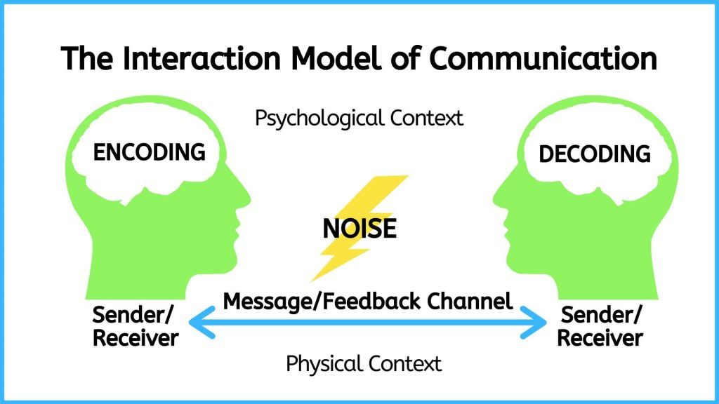
Figure 1.4: The Interaction Model of Communication

The Interaction Model takes physical and psychological context into account.
- Physical context includes the environmental factors in a communication encounter. The size, layout, temperature, and lighting of a space influence your communication. Imagine the different physical contexts in which the nurse-client encounter takes place and how this can affect communication. You may be attempting to have an emotionally laden discussion with a client in a room where the beds are only separated by curtains. You may be assessing a client in the community where the lighting is dim. Whether it’s the size of the room, the temperature, or other environmental factors, it’s important to consider the role that physical context plays in communication.
- Psychological context includes the mental and emotional factors in a communication encounter. Stress, anxiety, and emotions are just some examples of psychological influences that can affect communication. For example, you may be communicating with a client who is in pain and afraid in the emergency room. You may be introducing yourself to one client, but worried about another client who is grieving. Alternatively, you may be communicating with groups of clients and families who are experiencing myriad of emotions.

Nursing Example
A nurse has worked 11 hours and is attending to a client recently admitted to the hospital. The 68-year-old client is waiting for a bed and is stationed on a stretcher in the emergency room hallway. The client sought emergency care after experiencing severe abdominal pain and passing substantial blood when having a bowel movement. The client was informed that it is likely they have end-stage bowel cancer but is still awaiting a formal diagnosis and referral to oncology (cancer specialist). The nurse asks the client if the nurse can take a set of vital signs. The client responds “yes.” The nurse also tries to make the client comfortable by adjusting the head of the stretcher and asks the client if they need anything. The client has many questions and concerns and has not had anything to eat or drink in several hours but responds “no.” The nurse says “OK, well let me know if you need anything.”
Analysis: The physical context that played an important role in this example is the lack of privacy and overstimulation in a waiting area located in an emergency room hallway. The physical space likely played a role in the client’s response, which resulted in the client’s needs being unmet. The psychological context relates to the burden of a looming terminal diagnosis juxtaposed with the undignified environment. The nurse may have sensed that probing further about the client’s needs and current state of mind was needed but may have been physically tired and emotionally drained after working 11 hours. All these factors contributed to the interaction between the nurse and the client.
Pros: This model allows the user to reflect on the environment (both physical and psychological) and how this contributes to good communication. In this case, communication was deemed inadequate because the interaction was limited by the environmental context.
Cons: Although this model attends to the broader context in which communication takes place, it is also inattentive to social, political, and economic realities that shape communication. In other words, it does not consider how the nurse’s and the client’s identity inform their communication with each other.

Attribution Statement
Remixed with original content and adapted, with editorial changes, from:
Communication in the Real World: An Introduction to Communication Studies by University of Minnesota. Licensed under a Creative Commons Attribution-NonCommercial-ShareAlike 4.0 International License, except where otherwise noted.

10

Transaction Model of Communication
The Transaction Model of communication (see Figure 1.5) differs from the Transmission and Interaction Models in important ways, including the conceptualization of communication, the role of sender and receiver, and the role of context (Barnlund, 1970).
The Transaction Model of communication describes communication as a process in which communicators generate social realities within social, relational, and cultural contexts. In this model, nurses don’t just communicate to exchange messages; they communicate to:
- Create relationships.
- Form intercultural alliances.
- Shape self-concept.
- Engage with others in dialogue to create communities.
In short, you don’t communicate about your realities; communication helps to construct your realities.
The roles of sender and receiver in the Transaction Model of communication differ significantly from those in the other models. Instead of labeling participants as senders and receivers, the people in a communication encounter are referred to as communicators. Unlike the Interaction Model, which suggests that participants alternate positions as sender and receiver, the Transaction Model suggests that you are simultaneously a sender and receiver.
For example, when you first meet a client, you send verbal messages saying hello, who you are, and why you are there. Before you are done your introduction, the client is reacting nonverbally. You don’t wait until you are done sending your verbal message to start receiving and decoding the nonverbal messages of the client. Instead, you are simultaneously sending your verbal message and receiving the client’s nonverbal messages. This is an important component of this model because it helps you understand how you can adapt your communication. For example, in the middle of sending a verbal message, you can adapt your communication in response to the non-verbal message you are simultaneously receiving from your communication partner.

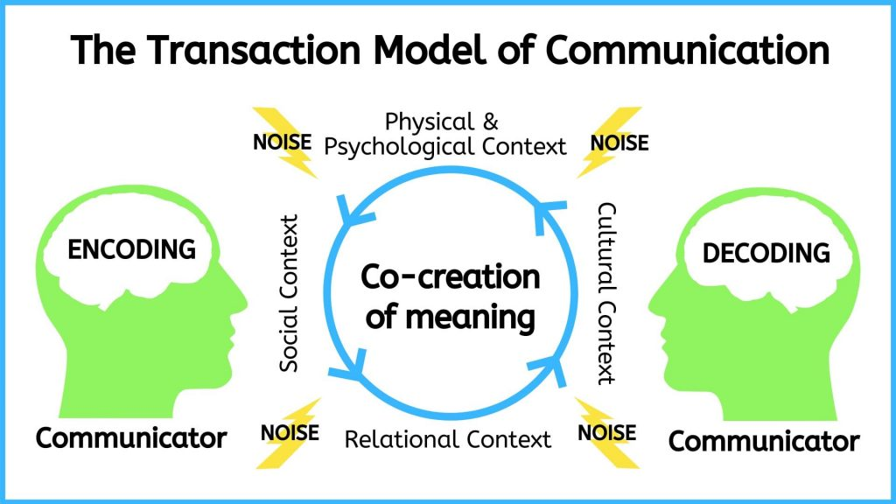
Figure 1.5: The Transaction Model of Communication

The Transaction Model also includes a more complete understanding of context. The Interaction Model portrays context as physical and psychological influences that enhance or impede communication. While these influences are important, the model focuses on message transmission and reception. Because the Transaction Model of communication frames communication as a force that shapes your realities before and after specific interactions occur, it must account for contextual influences outside of a single interaction. To do this, the Transaction Model considers how social, relational, and cultural contexts frame and influence communication encounters.
Here is a short description of each context:
- Social context refers to the stated rules or unstated norms that guide communication. As you are socialized into the nursing profession, you learn rules and norms for communicating, which are often referred to as communication strategies and principles. Some common rules that influence social contexts in nursing include being truthful during your conversations, being patient and encouraging the client to speak, demonstrating empathy, speaking clearly, making eye contact, and so on.
- Relational context includes the previous interpersonal history and type of relationship you have with a person. You communicate differently with someone you just met versus someone you’ve known for a long time. Initial interactions with people tend to be more highly scripted and governed by established norms and rules. As a nurse, you should always engage in communication in a professional manner because the nurse-client relationship is a professional one, not a personal one.
- Cultural context includes various aspects of identity such as gender, ethnicity, sexual orientation, class, and ability. While you may be able to identify some aspects of the cultural context within a communication encounter, there may also be cultural influences that you can’t see. A competent communicator shouldn’t assume they know all the cultural contexts a person brings to an encounter, because not all cultural identities are visible. Some people, especially those with identities that have been historically marginalized, are highly aware that their cultural identities influence their communication and influence how others communicate with them. Conversely, people with identities that are dominant or in the majority may rarely, if ever, think about the role their cultural identities play in their communication.
You need skills to adapt to shifting contexts, and the best way to develop these skills is through practise and reflection.

Nursing Example
A 42-year-old client and her partner are attending a fertility clinic awaiting intrauterine insemination with donor sperm. It is the client’s third attempt at the procedure, and she is becoming concerned that she may never get pregnant. The stress of getting pregnant has weighed on the client and her partner. They got into an argument on the way to clinic and are not speaking to each other. Both the client and her partner are South Asian and have experienced both racial and sexual discrimination in their past encounters with the healthcare system. A 59-year-old nurse of European decent enters the room and both the client and her partner are on their phones and barely look up at the nurse. The nurse is polite and completes her care plan. The nurse interprets their lack of attention as indifference to the situation and does not bother to counsel the client and her partner further, assuming it is not necessary. The nurse also assumes they have no questions, because it is their third attempt at the procedure.
Analysis: This example sheds light on the sort of nuances involved when communicating with clients. In this case, the nurse reads the lack of eye contact and engagement as a social convention that relays disinterest. From a relational standpoint, the nurse was unfamiliar with the couple and relied on a brief encounter, combined with information from the client’s chart. From a cultural standpoint, a shared understanding and space is needed to engage in discussions affected by culture. In this case, because of the social and relational misalignment, it was not likely the nurse and client/partner would engage in meanings of culture and socio-political context in relation to their care.
Pros: This approach offers more breadth and understanding of how intra-personal, inter-personal, and contextual factors are at play in communication. People often make assumptions predicated on these contextual factors, and therefore it is important to acknowledge these elements in practising and learning about good communication.
Cons: This approach requires analysis and critical reflection. It requires a broader understanding of historical, political, and social structures that affect communication. The specific factors affecting a particular communication encounter may or may not be possible to uncover.

Attribution Statement
Remixed with original content and adapted, with editorial changes, from:
Communication in the Real World: An Introduction to Communication Studies by University of Minnesota. Licensed under a Creative Commons Attribution-NonCommercial-ShareAlike 4.0 International License, except where otherwise noted.

11

Summary of Communication Models
See Table 1.1 for a summary of the Transmission, Interaction, and Transaction Models of communication.

Table 1.1: Communication Models

Activity: Check Your Understanding
An interactive H5P element has been excluded from this version of the text. You can view it online here:
https://pressbooks.library.ryerson.ca/communicationnursing/?p=92#h5p-8

An interactive H5P element has been excluded from this version of the text. You can view it online here:
https://pressbooks.library.ryerson.ca/communicationnursing/?p=92#h5p-9

12

Communication is Learned
Most people are born with the capacity and ability to communicate, but everyone communicates differently. This is because communication is learned rather than innate. As you have already seen, communication patterns are relative to context and culture.
As discussed earlier, context is a dynamic component of the communication process. Culture and context also influence how you perceive and define communication. Western culture tends to place more value on senders than on receivers, and on the content rather than the context of a message, like the Transmission Model. These cultural values are reflected in our definitions and models of communication. Western culture also influences communication within the healthcare domain. However, you may not have been socialized within a Westernized culture, and you may not be caring for someone who was socialized within a Westernized culture. Therefore, it is important to reflexively examine how your own culture, beliefs, and norms influence your communication, and to be aware of how you communicate.
A key principle of communication is that it is symbolic. This means that the words making up language systems do not directly correspond to something in reality. Instead, words stand in for or telegraph something. The fact that communication varies so much among people, contexts, and cultures illustrates the principle that meaning is not exclusively inherent in the selection of words. For example, let’s say you go to France on vacation and see the word poisson on the menu. Unless you know how to read French, you will not know that the symbol (word) is the same as the English symbol fish. Those two words don’t look the same at all, yet they symbolize the same object. If you went by how the word looks alone, you might think that the French word for fish is more like the English word poison and avoid choosing that for your dinner. Putting a picture of a fish on a menu would definitely help a foreign tourist understand what they are ordering, because the picture is an actual representation of the object rather than a symbol for it.
All symbolic communication is learned, negotiated, and dynamic. You know that the letters b-o-o-k refer to a bound object with multiple written pages. You also know that the letters t-r-u-c-k refer to a vehicle with a bed in the back for hauling things. But if you learned in school that the letters t-r-u-c-k referred to a bound object with written pages and b-o-o-k referred to a vehicle with a bed in the back, that would make just as much sense, because the letters don’t actually refer to the object – the word itself only has the meaning that is assigned to it.
Everyone is socialized into different languages, but we also speak differently based on the situation we are in. For example, in some cultures it is considered inappropriate to talk about family or health issues in public. However, in other cultures, it wouldn’t be considered odd to overhear people in a hospital waiting room talking about their loved ones who are currently in surgery. Additionally, some communication patterns are shared by very large numbers of people and some are particular to groups – nurses, for example, who have their own terminology and expressions that might not make sense to others. These examples aren’t on the same scale as differing languages, but they still illustrate how communication is learned, and how rules and norms influence how we communicate.

Attribution Statement
Remixed with original content and adapted, with editorial changes, from:
Communication in the Real World: An Introduction to Communication Studies by University of Minnesota. Licensed under a Creative Commons Attribution-NonCommercial-ShareAlike 4.0 International License, except where otherwise noted.

13

Theoretical Approaches to Communication and Interviewing
In addition to models of communication, many theoretical approaches can be used to inform your communication with clients and families. The theoretical approach you select may depend on the client population you work with, the institution you work in, and personal preference based on your expertise and experience.
Common approaches that align with nursing and therapeutic communication are a trauma-informed approach, a relational inquiry approach, and an anti-racist approach. The following sections provide an overview of each approach with an accompanying case study as an example.

14

Trauma-informed Approach to Communication
It is important for nurses to engage in communication from a trauma-informed approach, which involves integrating an understanding of the need for:
- physical and emotional safety
- choice and control
- empowerment
(Trauma-Informed Practice Guide, 2013, p. 12).
A trauma-informed approach can be used as one part of therapeutic communication. It involves emphasizing confidentiality, identifying the interview purpose, letting the client set the pace of the interview and shaping it based on their needs, and engaging in collaborative intervention so that the client is in control and empowered. As you apply this approach, you should always be thinking about how you can promote safety, control, and choice for the client.
Given how pervasive trauma is in clinical practice, a trauma-informed approach makes sense to incorporate into your communication and way-of-being with clients. This kind of approach is especially useful because you will often not know who has experienced trauma or the circumstances of their trauma. Trauma includes the emotional consequences of a distressing event (Centre for Addiction and Mental Health [CAMH], n.d.). Many circumstances can lead to trauma, including child abuse and neglect, sexual assault and intimate personal violence, bullying and harassment, as well as events such as car accidents, a death of someone close to you, natural disaster, and war.

Points of Consideration
Indigenous populations
Among Indigenous populations, historical and intergenerational trauma caused by Canada’s oppressive colonial policies and practices as well as the destructive effects of residential school systems takes the form of unresolved grief and trauma passed from one generation to the next (O’Neil et al., 2016; Mash et al., 2015). It has also led to a silencing of experiences (O’Neil et al., 2016), impacts on Indigenous identity (Lavallee & Poole, 2010), and has caused feelings of worthlessness, self-hatred, fear, and powerlessness (Chrisjohn & Young, 2006; Health Council of Canada, 2012), as well as mental health issues including anxiety, depression, post-traumatic stress disorder, and substance use and addictions (Assembly of First Nations, 1994; Brave Heart, 2003; Chrisjohn & Young, 2006; Mash et al., 2015; O’Neil et al., 2016).

Because the trauma-informed communication approach assumes the presence of trauma, it does not require the client to disclose their experience and thereby risk re-traumatizing them through repeated disclosure (Trauma-Informed Practice Guide, 2013).
See Case Study 1 for an example of a trauma-informed approach to interviewing.

Case Study 1
A 19-year-old client presents alone at urgent care. The reason for seeking care noted on the client’s chart is: pain, swelling, and bruising on index and middle digits of the left hand, suspected fracture. Upon entry into the examination room, the nurse observes healed bruising under the client’s right eye and contusions on the client’s neck.
RN: Hello Franco Alonso, my name is Pita Kora, I will be your registered nurse today. You can call me Pita and my pronouns are she/her. What would you like me to call you and what pronouns do you use?
Client: Franco and he/him is fine.
Rationale: Introduce self using first and last name and explains designation – this action promotes accountability for your actions, as it demonstrates that you are taking responsibility through disclosure. Asking what the client would like to be called and their pronouns contributes to the client’s sense of control and wellbeing. It also conveys respect for their chosen identity.
RN: Everything we talk about will remain confidential and will only be discussed among healthcare team members involved in your care.
Rationale: This emphasizes confidentiality, including the parameters of who will be privy to the information. This is important to disclose and does not mislead the client to believe that any information they provide will end with you. Indeed, as a nurse you are required to report the data you collect. This honesty is especially important in a trauma-informed approach to build trust and ensure safety.
Client: Ok
Rationale: In this case, you wait for the client to acknowledge your statements, which conveys respect.
RN: Today I will ask you some questions related to your injury and then I will conduct a physical assessment. I will explain all steps as I go along. It will take about 15 or 20 minutes. Does that work for you?
Client: I think so…
Rationale: By proving the client with the purpose and general plan of the interview, you share control and minimize unpredictability. By asking the client if it works for them, you include them in the process and convey collaboration. Certainty and control are important parts of creating a safe space for dialogue.
RN: Can you tell me about what happened to your fingers, Franco?
Client: They were crushed in a car door. It really hurts. I think it may be broken.
Rationale: In this case, you ask an open-ended question without assumptions. This approach is better to begin with than a series of closed-ended questions directed by you. In this case, it is important to allow the client to share their story in their own words.
RN: Ok. I’m sorry to hear. That sounds painful. We will assess for any fractures. How long ago did this happen?
Rationale: You express empathy by responding to what the client said, instead of how the fingers look. It is important to respond to what the client is telling you to build trust. Also, the statement “we will assess for any fractures” offers the client reassurance that the injury will be attended and also acknowledges the initial concern that “it may be broken.” It is important to acknowledge the client’s concern and not dismiss their concern.
Client: Last week. I didn’t think much of it at first, but the swelling hasn’t gone away and the bruising seems to be getting worse. I wasn’t sure if I should come.
RN: Ok, sure, I can understand that. I noticed some other bruises under your right eye and on your neck. Are they related to your finger injury?
Rationale: You convey empathy by stating that you can understand the client’s choices/decisions without judgement. You ask a closed-ended question about other injuries but should allow the client to respond at their pace.
Client: Not really. I mean it happened around the same time but they aren’t related.
RN: Ok [allow for silent pause].
Rationale: Silence can be a powerful form of communication. It works in two ways in a trauma-informed approach: first, it conveys to the client that you are unhurried and invested in what they are saying; second, it can give the client an opportunity to think through their responses, which can alleviate pressure on the client and promote their self-determination.
Client: It’s kind of a long story. I’m sure you’re busy.
RN: I’ll make time. Tell me more.
Rationale: The client may be testing your interest and investment to gauge the level of trust. It is important to foster trust within the client and let them know you are reliable. If this isn’t possible at that moment, explain to the client why you may not have the time but when you will have the time. For example, “I have an urgent matter down the hall, but I will return in 5 minutes to discuss further.” In such cases, it is important to follow up on your promise and not let the client down, because this is likely to damage any trust built.

Summary
A trauma-informed approach creates a safe space for clients to engage in conversation and fosters control and choice. It does not require the client to disclose trauma. However, it creates a space in which the client may feel safe to speak about trauma, if relevant, at their own pace.

Activity: Check Your Understanding
An interactive H5P element has been excluded from this version of the text. You can view it online here:
https://pressbooks.library.ryerson.ca/communicationnursing/?p=98#h5p-10

15

Relational Inquiry Approach to Communication
Relational inquiry is defined as “the complex interplay of human life, the world, and nursing practice” (Doane & Varcoe, 2015, p. 3). This means that nurses must avoid looking at the client on a merely individual level (Doane & Varcoe, 2015). As per Doane and Varcoe, drawing upon relational inquiry involves the following elements of communication:
- Intrapersonal – communicating with the client in a way that allows you to assess what is occurring within all people involved (the client, you, and others).
- Interpersonal – communicating with the client in a way that allows you to assess what is occurring among and between all people involved.
- Contextual – communicating with the client in a way that allows you to assess what is occurring around the people and situation involved.
Relational inquiry is a kind of lens you can use to perceive the world. In contrast to an individualist approach, which privileges the individual as accountable for their actions and behaviours, relational inquiry brings into focus the internal dialogue of the client, their social system, and the broader context that influences their actions and your actions as a nurse (Doane & Varcoe, 2015). This approach to therapeutic communication is important because it can help you understand the client’s situation more fully, focus on what is important to them, and collaboratively work with the client to integrate this knowledge into the care.
See Case Study 2 for an example of a relational inquiry approach to interviewing.

Case Study 2
An 8-year-old client, who uses the pronouns he/him, attends a pre-operative day surgery unit for tonsillectomy (tonsil removal) with a parent present. The client has a history of 6 strep throat infections with antibiotic treatment in the last 18 months. The client has no previous history of surgery or anaesthesia.
RN: Hello Peter Lin, my name is Ahsan Khan, I am a registered nurse. I will be caring for you until you go into surgery and then a surgical nurse will take over your care. You can call me Ahsan. What name would you like me to call you?
Client: Peter.
Rationale: You introduce yourself using first and last name and explain designation – this action promotes accountability. You explain the extent of the care being provided, including when it will end and who will take over care for the client at different stages of their procedure. This includes the client in the care plan and minimizes uncertainty about care provision.
RN: Okay, Peter. The information you share with me will only be shared with the healthcare team involved in caring for you. Before we begin, who is with you today?
Client: It’s my mom.
Rationale: You explain confidentiality at a developmentally appropriate level for an 8-year-old. Asking the client “who is with you today” allows the client to identify their relationship to their caregiver in their own words.
RN: [directed to mother] Hello, what would you me to call you?
Client’s mother: Please call me Wei.
Rationale: This approach includes the mother in the care and acknowledges her participation. Some providers refer to the parent as mom or dad as this reinforces the client (child) as the recipient of care and is also convenient for the provider for easy reference. However, calling the parent by their preferred name builds trust and rapport, acknowledges their humanity, and identifies them in the care process.
RN: Okay, Wei. [directed to both client and client’s mother] I will collect some information from you and then do a physical exam. It should take about 10 minutes. I can see in your chart here that you are scheduled for a tonsil removal and that you have signed a consent form. Can I answer any questions you have before we proceed?
Rationale: Repeating the preferred name of the client’s mother helps you remember the name, while also acknowledging the mother’s request. You offer the client and mother a timeline and plan to help them anticipate events. You invite any questions before conducting the subjective data collection. This can be a helpful tool for you to gauge the client and can also alleviate concerns up front.
Client and Client’s mother: Not really.
RN: Ok. Can you tell me about how you are feeling today, Peter?
Rationale: This question invites an intrapersonal response as it attends to feelings and emotions for the client. Most importantly, it acknowledges the importance of his thoughts and emotions as part of their care (rather than ignoring them) and gives you the opportunity to respond to any concerns.
Client: A little nervous. Will I be able to feel anything during surgery?
RN: No, you won’t feel anything during surgery. We will give you some medicine to put you into a deep sleep and when you wake up it will be over. We will also be giving you some medication for pain.
Rationale: Your response attends to the client’s concern directly by providing a definitive answer. In this case, you also anticipate the client’s concern for pain as the concept may not be well understood, given the developmental stage.
RN: How are you feeling, Wei?
Client’s mother: I’m little nervous to give Peter pain medications.
Rationale: The question invites the mother to share intrapersonal concerns about the client’s surgery. This conveys to the mother a family-centred approach, whereby they are also a care recipient.
RN: Tell me more about your concern.
Client’s mother: Well, you read so much nowadays about opioids and addiction problems caused by prescribed medications. I’m worried about Peter.
Rationale: This approach invites discussion without supposition.
RN: I can understand your concern. The pain medications the anaesthesiologist administers during the surgery are short-acting, only a couple of hours. The anaesthesiologist will speak with you just before the surgery and you can ask more specific questions at that time. After the surgery is over, the surgical nurse will make sure Peter is comfortable and will likely give him medication for pain and swelling. You can continue this treatment when you are home with Peter. Both acetaminophen and ibuprofen are over-the-counter medications and not opioids, nor are they addictive. The surgical nurse will give you specific instructions about discharge care as well as a handout. If you don’t get this information, feel free to ask.
Rationale: In this case you respond directly to the mother’s concern about pain medication while anticipating the plan of care and other points of interface with the healthcare system. This offers reassurance about future opportunities to ask and clarify concerns. Importantly, in addition to letting the mother know what to expect, you also invite the mother to ask questions. This validates the mother’s concern and also alleviates others in the event they do not provide information.
Client’s mother: Ok, that’s reassuring. I have two kids home sick from school today with the flu. Will that be an issue for Peter?
RN: It could be. Hand-washing and keeping some space from each other if possible, will be important to minimize the spread of germs. Peter will be more susceptible to getting sick after surgery.
Rationale: This explanation responds directly to the mother’s question and offers strategies to reduce the risk of spread of germs. The response is also in everyday language, free from professional jargon.
Client’s mother: Oh boy, I’ll try.
RN: Tell me about your support system to help you manage at home.
Client’s mother: I have a good support system. My sister is really helpful with the kids, and she’s in town to give us a hand.
Rationale: In the context of this case scenario, this question assesses interpersonal relations by asking about support systems for managing this situation.
RN: That sounds like a helpful support. Are there other resources that would be helpful to you?
Rationale: This question helps assess the contextual relations through the identification of resources, and contextual issues that may require attention in this scenario. It invites further discussion about factors to consider in Peter’s care and sheds light on context for the dyad.
Client’s mother: Well the thing is that this has all come at a difficult time. I’m transitioning jobs, so money is tight right now. I don’t have extra room in the budget for a sitter. I’m glad my sister is coming, I just don’t know how long she can stay. I guess my parents could help in a pinch, but they are getting older and the kids are a lot for them to manage. And poor Peter has been sick so much lately. On one hand, I’m glad Peter will be getting the surgery to prevent other cases of strep throat, but I also feel badly that this is happening at such a stressful time for everyone. And I’m worried about the recovery time.
RN: I can see how that would be stressful. It’s going to take a few days for Peter to recover. The important thing will be to avoid the spread of germs as that could extend his recovery time. And you’re right that this surgery should help reduce his risk for getting strep throat in the future. It sounds like you have some alternative ideas for support to help you manage the recovery.
Rationale: This response offers empathy and encouragement by acknowledging what the client’s mother has shared and their support system. It also offers strategies to minimize recovery, which seems to be a concern identified by the mother.
Client’s mother: I do. Thanks.

Summary
A relational care approach attends to the broader social context in which clients and their support systems are situated (Doane & Varcoe, 2015). Also, as the nurse, you should be aware of yourself and how you influence, and are integrally connected to, the client and the healthcare system (Doane & Varcoe, 2015). This approach is an especially helpful tool for family-centred care. It also requires skill and knowledge because it demands active listening and critical thinking. Unlike closed-ended checklists, you cannot predict how the conversation will unfold.

Activity: Check Your Understanding
An interactive H5P element has been excluded from this version of the text. You can view it online here:
https://pressbooks.library.ryerson.ca/communicationnursing/?p=100#h5p-11

An interactive H5P element has been excluded from this version of the text. You can view it online here:
https://pressbooks.library.ryerson.ca/communicationnursing/?p=100#h5p-12

16

Anti-racist Approach to Communication
It is important for nurses to embody an anti-racist approach to communication. In order to do so, you need to first understand the concepts of race and racism.
Race has been systemically and historically constructed as a variable of difference, whereby people are ascribed to designated groups based on biology, culture, and/or other characteristics (Bakan & Dua, 2014). Racism is the ideology and practice of sustaining, maintaining and reinforcing difference based on race (Bakan & Dua), and it results in racialized persons being excluded from everyday points of access because of their race.
Anti-racism is the active process of changing attitudes, beliefs, practices, and policies with the goal of dismantling systemic hierarchy and oppressive power (Alberta Civil Liberties Centre, ND). An anti-racism approach involves:
- Identifying and challenging racism within institutions.
- Taking specific and directed action towards eliminating racism.
- Recognizing self as an agent for change towards equity.
The focus of anti-racism is acknowledging and working to address power inequities and systemic bias predicated on race as well as unearned privilege that is afforded to non-racialized people. Linked with racism is the concept of white privilege which refers to advantage afforded to those who are to non-racialized over persons of other racial backgrounds. It does not mean that every white person is rich, healthy, or living a lavish life. In a paper entitled “White Privilege: Unpacking the Invisible Knapsack”, McIntosh (2003) lists several daily occurrences that are privileged based on race. For example, when applying for a mortgage, skin colour will not bias financial credibility when non-racialized people are applying, but it can be a significant determining factor for those of other races. Recognizing white privilege can often be conflated with feeling guilty about race, but this is not the aim. The focus on individual guilt deviates the conversation and intention of anti-racism, which is ultimately to dismantle racist structures that subjugate and discriminate against racialized people.
Nurses play an important role in adopting and embodying an anti-racist way-of-being within their respective institutions. As a nurse, you must take an anti-racist approach in your practice and advocate on behalf of your clients when you see racism. As such, communication is essential to demonstrating anti-racism. It often begins with self-reflection and consideration for the perspective of others. See Case Study 3 for an example of an anti-racist approach to communication related to a racialized client.
Case Study 3
A nurse (RN1) receives report from a colleague (RN2). During the night shift, a client was admitted for generalized abdominal pain, and elevated blood pressure and heart rate. At this time, the etiology is undetermined, but the client is scheduled for a CT scan shortly.
RN 2: Hi Rita, it was a pretty quiet night. We just admitted a patient, I can’t even pronounce her name, in bed 2, for generalized pain. She says it is in her abdomen, but who knows what is going on. She’s giving me a lot of attitude, you know how it can be. If you ask me, I think we should have sent her home and told her to come back if things get worse.
RN1: Why is that?
Rationale: RN1 recognizes that there may be some underlying racist attitudes, and attempts to open up the conversation.
RN2: Well you know how these people are … they come to emerg for every little complaint, over-dramatizing everything. They don’t care about the costs of a visit to the emergency room.
RN1: Lorna, I’m uncomfortable with you referring to this patient as ‘these people’. Your tone and choice of words insinuates that because of how the client looks and their culture that we should dismiss their complaints about pain.
Rationale: RN1 states how they feel using “I” statements and specifically refers to the racist language that RN2 used. RN1 also uses direct language to identify passive actions of RN2.
RN2: Oh no, that’s not what I meant, I am not a racist, I was not trying to say it like that. I just meant that some people are more likely to take advantage of free health care than others.
RN1: I know this might be a difficult conversation to have, but referring to a client as “these people” and “taking advantage of the system” is racist, especially since you have attached it to the patient’s race and culture.
RN2: But that’s not what I meant.
RN1: It might not be what you meant, but the words you chose and the meaning are racist, and not acceptable. Considering our conversation, it would be good that I request our manager to organize a workshop for all of us about racism and language. Additional training will illuminate how language and beliefs like “taking advantage” are micro-aggressions that become pervasive and ultimately lead to poorer treatment and access to healthcare for racialized clients. It’s important to reflect on our communication skills and ensure we are not using oppressive language in our workplace.
Rationale: RN1 is very clear in identifying the communication as racist, but also doing so a respectful way. Even RN1’s language in inclusive in terms of the group responsibility when referring to “our” workplace.

Summary
It is important to embody an anti-racist approach to communication. It often begins with self-reflection and consideration of other peoples’ perspectives. This approach involves an active process of changing attitudes, beliefs, practices, and policies with the goal of dismantling systemic hierarchy and oppressive power. As a nurse, you must acknowledge and work to address power inequities and systemic bias predicated on race as well as unearned privilege that is afforded to non-racialized people.

17

Key Takeaways

Key Takeaways
- Communication refers to the sharing of information, ideas, and feelings, and is typically intended to foster mutual understanding.
- Communication involves many forms including verbal, non-verbal, and written.
- Professional communication is important to your development as a nurse.
- This chapter introduced three models of communication: the Transmission, Interaction, and Transaction Models.
- Trauma-informed, relational inquiry, and anti-racist approaches are common theoretical methods that align with nursing and therapeutic communication.

18

References
Alberta Civil Liberties Centre, ND
Assembly of First Nations. (1994). Breaking the silence: An interpretive study of residential school impact and healing as illustrated by the stories of First Nations individuals. First Nations Health Commission.
Bakan, A. & Dua, E. (2014). Introducing the questions, reframing the dialogue. In A. Bakan & E. Dua (Eds.), Theorizing anti-racism: Linkages in marxism and critical race theories. University of Toronto Press.
Barnlund, D. C. (1970). A transactional model of communication. In K. K. Sereno & C. C. Mortensen (Eds.), Foundations of communication theory (pp. 83–92). Harper and Row.
Brave Heart, M. (2003). The historical trauma response among Natives and its relationship with substance abuse: A Lakota illustration. Journal of Psychoactive Drugs, 35(1), 7-13.
Centre for Addiction and Mental Health (n.d.). Trauma. https://www.camh.ca/en/health-info/mental-illness-and-addiction-index/trauma
Chrisjohn, R., & Young, S. (2006). The circle game: Shadows and substance use in the Indian residential school experience in Canada. Theytus Books.
College of Nurses of Ontario (2019a). Practice standard: Code of conduct. https://www.cno.org/globalassets/docs/prac/49040_code-of-conduct.pdf
College of Nurses of Ontario (2019b). Practice standard: Ethics. https://www.cno.org/globalassets/docs/prac/41034_ethics.pdf
De Dreu, C., & van Knippenberg, D. (2005). The possessive self as a barrier to conflict resolution: Effects of mere ownership, process accountability, and self-concept clarity on competitive cognitions and behavior. Journal of Personality and Social Psychology, 89(3), 345-357. https://doi.org/10.1037/0022-3514.89.3.345
Doane, G., & Varcoe, C. (2015). How to nurse: Relational inquiry with individuals and families in changing health and health care contexts. Wolters Kluwer.
Ellis, R., & McClintock, A. (1990). If you take my meaning: Theory into practice in human communication. Hodder Arnold.
Health Council of Canada. (2012). Empathy, dignity, and respect: Creating cultural safety for Aboriginal people in urban health care. https://healthcouncilcanada.ca/files/Aboriginal_Report_EN_web_final.pdf
Lavallee, L., & Poole, J. (2010). Beyond recovery: Colonization, health and healing for Indigenous People in Canada. International Journal of Mental Health and Addiction, 8(2), 271-281.
Mash, T., Coholic, D., Cote-Meek, S., & Najavits, L. (2015). Blending Aboriginal and Western healing methods to treat intergenerational trauma with substance use disorder in Aboriginal peoples who live in Northeastern Ontario, Canada. Harm Reduction Journal, 12, Article 14.
McIntosh, P. (2003). White privilege: Unpacking the invisible knapsack. In S. Plous (Ed.), Understanding prejudice and discrimination (p. 191–196). McGraw-Hill.
O’Neill, L., Fraser, T., Kitchenham, A., & McDonald, V. (2018). Hidden burdens: A review of intergenerational, historical and complex trauma, implications for Indigenous families. Journal of Child & Adolescent Trauma, 11(2), 173-186.
Registered Nurses’ Association of Ontario (2007). Healthy work environments best practice guidelines: Professionalism in nursing. Registered Nurses’ Association of Ontario. https://rnao.ca/sites/rnao-ca/files/Professionalism_in_Nursing.pdf
Schramm, W. (1997). The beginnings of communication study in America. Sage Publishing.
Trauma-Informed Practice Guide (2013). http://bccewh.bc.ca/wp-content/uploads/2012/05/2013_TIP-Guide.pdf

II

Chapter 2 - Therapeutic Communication and Interviewing
By Jennifer L. Lapum, Oona St-Amant, Michelle Hughes, Joy Garmaise-Yee

19

Learning Outcomes
By the end of this chapter, you will:

- Identify indicators of therapeutic communication consistent with the College of Nurses of Ontario “Therapeutic Nurse-Client Relationship” practice standard.
- Identify the role of the interview for subjective data collection.
- Apply the principles of the communication process involved in interviewing.
- Examine effective techniques of communication.
- Analyze interviewing techniques that are respectful of clients and families.
- Integrate developmental considerations into communication.
- Explain the role of cultural safety in therapeutic communication.

20

Introduction: Therapeutic Communication
Therapeutic communication is at the foundation of the nurse-client relationship as reflected in Figure 2.1. It is different than the conversations you have with friends, peers, family, and colleagues. Therapeutic communication has a specific purpose within the healthcare context. It is intended to develop an effective interpersonal nurse-client relationship that supports the client’s wellbeing and ensures holistic, client-centred, quality care.

Figure 2.1: Therapeutic relationship.

The word “therapeutic” is related to the word therapy: it means having a restorative and healing effect on the mind and body as well as doing no harm. It is important to consider how you communicate and how this affects the client.

Points of Consideration
Learning Therapeutic Communication
Therapeutic communication is a learned activity that requires knowledge and continued practice and self-reflection.

In this chapter, you will first learn about nurses’ accountability related to therapeutic communication, and then you will learn about the principles, approaches, and strategies used in therapeutic communication in the context of a client interview.

21

Therapeutic Communication: CNO Standard Statement
Nurses are accountable to develop an effective nurse-client relationship. Therapeutic communication is one of four standard statements in the Therapeutic Nurse-Client Relationship: it is used to “establish, maintain, re-establish and terminate the nurse-client relationship” (College of Nurses of Ontario [CNO], 2019a, p. 5).
In your new role as a nursing student and your future role as a registered nurse, you must be aware of the CNO (2019a) indicators of therapeutic communication and understand your role in meeting this standard: Therapeutic Nurse-Client Relationship, Revised 2006.
For example, the indicators specify how to introduce yourself, how to refer to the client, and how to communicate with the client. You are legally obligated to practice in accordance with the CNO standards, or nursing standards in your region.
Throughout this chapter, you will learn to apply and interpret these indicators in the context of nursing practice and the client interview.

22

The Client Interview
The client interview is an important component of nursing practice and involves several sources as reflected in Figure 2.2. It involves communicating with the client – who is considered the primary source – to collect subjective data (i.e., information that the client shares with you or the client’s family/friends). The client interview may also involve collecting data from secondary sources such as family, friends, care partners, and other healthcare providers. It is part of your assessment in which you learn about the client and combine these collected data with objective data (information that you collect when performing a physical exam).

Figure 2.2: Interview sources.

As a nurse, you must ensure that the client interview is informed by the CNO (2019) Standard on Therapeutic Nurse-Client Relationship, because therapeutic communication and relationships are the foundation of an effective client interview. To meet this standard, you must think carefully about how to communicate while conducting the client interview.
The importance of good communication cannot be overstated. It is a foundational pillar of a good interview. The interview often serves as the impetus for therapeutic action. For example, without a client disclosing chest pain, it would be difficult for you to interpret what is wrong or ailing the client. The care provided by nurses is contingent on the accuracy of the data they collect, so nurses must develop their relational skills to accurately and holistically gather useful data from clients. If data are lacking, nurses are limited in providing effective care. For example, clients may not share certain problems if they are unsure whether you care or are interested. Also, clients may be afraid to reveal relevant health information because they fear judgment or ridicule, which could impede your ability to address their health issue.
The nature of the interview is influenced by the interview purpose. For example, an interview may be short and focused, or it may be more detailed and comprehensive, depending on the client’s health needs/reason for seeking care. The interview purpose is often influenced by where you work, for example an acute or primary care setting. No matter what the purpose, there are common principles and strategies to incorporate when conducting the interview, as detailed in the upcoming sections.

Points of Consideration
Care partners
The term care partners refers to family and friends who are involved in helping to care for the client. They may be referred to as informal caregivers or family caregivers, but care partners is a more inclusive term that acknowledges the energy, work, and importance of their role.

Activity: Check Your Understanding
An interactive H5P element has been excluded from this version of the text. You can view it online here:
https://pressbooks.library.ryerson.ca/communicationnursing/?p=46#h5p-13

An interactive H5P element has been excluded from this version of the text. You can view it online here:
https://pressbooks.library.ryerson.ca/communicationnursing/?p=46#h5p-14

Attribution Statement
Content for the Points of Consideration box was adapted from:
The Complete Subjective Health Assessment by Jennifer L. Lapum, Oona St-Amant, Michelle Hughes, Paul Petrie, Sherry Morrell, and Sita Mistry, licensed under a Creative Commons Attribution-ShareAlike 4.0 International License.

23

Preparing for the Interview
You should review the client’s existing health record/chart (if applicable) so that you have a general overview of the client’s main health needs/reason for seeking care and health history. If the client is already admitted, this review will not only give you an overview of the health history, but also their last 24 hours. This is an important first step for several reasons:
- It conveys your interest and competence as a provider.
- It allows you to follow up on missing data.
- It saves the client from repetition.
- It allows you to identify any changes in the client’s health status.
You should also consider how to leverage the environment of the interview location and your position within the space. The client interview is often conducted in locations such as clinic rooms, hospital rooms, emergency rooms, and community spaces such as the client’s home. You should attend to the following principles:
- Create a quiet location so that both you and the client can hear and communicate. Some possible strategies to reduce sound may include closing the room door, closing the curtains, and turning off radios and televisions.
- Establish a welcoming environment, which may include offering the client a place to sit and avoiding physical barriers between you and the client such as a desk.
- Attend to the client’s physical comfort, which may include offering them a drink of water and inviting them to take their coat off or have a place for them to put their bag/purse. Additionally, if they are in bed, you should ensure that they are comfortable and ask if they want to sit up, if they are permitted.
- Create an inclusive space in which care partners are invited to be part of the interview based on the client’s wishes.
- Ensure a private space so that the client feels comfortable to share personal information and that this information is kept confidential. Sometimes it will not be possible to ensure a completely private space, such as when a curtain is the only barrier. In this case, try to avoid using the client’s name and other client information loudly so that others can’t overhear.
- Maintain professional boundaries (CNO, 2019a) this facilitates a trusting and therapeutic relationship between nurse and client. You must understand your professional role and ensure that your relationship with the client does not become personal (e.g., meeting the client outside of work hours, disclosing personal information, or accepting/exchanging gifts).
In preparation for the client interview, you must first be aware of the legislation and nursing standards concerning privacy and confidentiality. The Personal Health Information Protection Act (2004) states that clients have the right to have their personal health information kept private, and healthcare professionals are legally required to keep this information confidential. You must emphasize that client data is kept confidential and only shared with relevant members of the healthcare team directly involved in the client’s care. You may want to re-emphasize confidentiality when addressing sensitive interview topics such as trauma and violence, sexual health, and substance use. The client owns their personal health information; as a custodian of this information, you must request permission before disclosure (CNO, 2019b). However, there are certain situations where consent for disclosure is not required (e.g., “to eliminate or reduce a significant risk of harm to a person” [CNO, 2019b, p. 7]).

Points of Consideration
Abuse and neglect
In certain conditions, a nurse must disclose personal health information. You are legally required to report suspected child abuse or neglect, and elder abuse when the person lives in a retirement or a long-term care home in Ontario. You must report to a children’s aid society “if you have reasonable grounds to suspect that a child is or may be in need of protection” (Ontario Ministry of Children, Community, and Social Services, n.d.). For a client in a retirement home, you must report to the Registrar of the Retirement Homes Regulatory Authority; and for a client in a long-term care home, report to the Director at the Ministry of Health and Long-Term Care (Community Legal Education Ontario, 2019). You must also report to the College of Nurses of Ontario (2020) if a client discloses or you observe a “nurse who poses a serious risk of harm to patients” (sexual abuse, incompetent care, physical or mental incapacity to provide safe care, or professional misconduct).

Activity: Check Your Understanding
An interactive H5P element has been excluded from this version of the text. You can view it online here:
https://pressbooks.library.ryerson.ca/communicationnursing/?p=48#h5p-15

An interactive H5P element has been excluded from this version of the text. You can view it online here:
https://pressbooks.library.ryerson.ca/communicationnursing/?p=48#h5p-16

24

Self Reflection Prior to the Interview
Like everyone, nurses are susceptible to stress, sadness, anger, and an array of other emotions. Despite good intentions, your communication will be strongly influenced by your mood, thoughts, and emotions. Self-reflection is an important tool for recognizing your emotional state and minimizing unintentional miscommunication with clients, i.e., non-therapeutic communication. See Figure 2.3.


Figure 2.3: Self-reflection

See Table 2.1 for strategies on how you can self-reflect before commencing the client interview.
Table 2.1: Self-reflecting on emotions and thoughts.

As you self-reflect, consider that the healthcare environment often intensifies emotions for clients and their families. It can be a place where people experience pain, discomfort, and stress. Clients may hear bad news and confront truths about themselves, or experience intense joy and relief. Because such extremes can exist in the healthcare space, the client is often more attune to you (the provider) than you may be aware. The client may be telegraphing your body language or intuiting your choice of words. For this reason, providers need to be self-aware and temporarily suspend their own needs in order to authentically connect with the client.

Points of Consideration
Mindfulness
Mindfulness can be a useful strategy for connecting with clients and authentically being fully in the moment as they respond. It’s easy to get caught up in the fast-pace clinical environment and be distracted by preceding events. Clients pick up on distraction and this can undermine trust.
Mindful meditation has been proven to reduce stress among healthcare professionals, including nurses. Once learned, it can be used at any time, and can improve your therapeutic communication with the client.

25

Beginning the Interview
There is a standard way to begin interviews so that the client knows who you are and why you are there.
Introducing yourself and addressing the client
Begin by introducing yourself by name and category to the client, and determine how the client wants to be addressed (CNO, 2019a). Also, best practice has shifted to include your own pronouns and ask what pronouns the client uses in order to create an inclusive environment. For example, a nurse may say, “Hello, I am Mac Li Ken Ji. I am a registered nurse. Please call me Mac. My pronouns are he/him. How would you like me to refer to you and what pronouns do you use?” It is important not to use the term “preference” when referring to pronouns and gender as these are not preferences.
Because registered nurse is a protected title, you can only refer to yourself as a nurse when you are a member of the College (i.e., the College of Nurses of Ontario). If you are a nursing student, you should identify your category based on your institutional requirements. For example, you may consider identifying the year of the nursing program you are in (e.g., nursing student year one, nursing student year two, nursing student year three, nursing student year four). For example, in year one of the program, you may say, “Hello, I am Misa Rodriguez. I am a nursing student year one. I am working with your registered nurse, David, today.”
Identifying the purpose of the encounter
As per CNO (2019a), part of the introduction phase of the client interview is to identify your role, which involves the purpose of the encounter. You should also notify the client that any information collected will be kept confidential and if applicable, identify who the client’s information will be shared with. Nurses often let clients know that they will also be taking notes.
Here are some examples:
- Example 1: I want to interview you about your illness. It will take about 10 minutes and will begin with me asking you some questions about how you are feeling. Is that okay? [client: yes]. I also want to let you know everything that you share will be kept confidential between myself and the healthcare team who are involved in your care, which currently includes the physicians and the physiotherapists. [client: okay]. Please do note that I will be taking notes as we talk and I will be asking you questions that help me understand how your health concerns and how best to care for you today. If you have any questions, feel free to ask at anytime.
- Example 2: I see that you came into the clinic because you have been coughing. Before the physician comes in, I want to ask you a few questions related to your cough. It will take about 10 minutes. Is that okay? [client: yes]. I also want to let you know everything that you share will be kept confidential between myself and the healthcare team who are involved in your care, which includes myself and your physician at this point. [client: okay]. Please do note that I will be taking notes as we talk and I will be asking you questions that help me understand how you are feeling, your health concerns, and how best to care for you today. If you have any questions about my questions, feel free to stop me and ask.
See Film Clip 2.1 and 2.2 demonstrating an effective and ineffective introduction to the patient interview.

One or more interactive elements has been excluded from this version of the text. You can view them online here: https://pressbooks.library.ryerson.ca/communicationnursing/?p=52#video-52-1
Film Clip 2.1: Effective interview introduction. (Also, consider sharing your own gender pronouns with the client and asking what pronouns they use).

One or more interactive elements has been excluded from this version of the text. You can view them online here: https://pressbooks.library.ryerson.ca/communicationnursing/?p=52#video-52-2
Film Clip 2.2: Ineffective interview introduction.

Points of Consideration
Name and category
As a nurse, you are required to introduce yourself by your first and last name and your category (College of Nurses of Ontario, 2019d). By using your full name, you relay accountability and take responsibility for your work. There are situations when nurses do not use their full name or use a pseudonym, which is permitted as long as the employer is aware and the College of Nurses of Ontario is able to identify you through your employer; for example, this is permitted when you have reasonable grounds for your safety (College of Nurses of Ontario, 2019c).

Activity: Check Your Understanding
An interactive H5P element has been excluded from this version of the text. You can view it online here:
https://pressbooks.library.ryerson.ca/communicationnursing/?p=52#h5p-17

26

Types of Interviewing Questions
There are three types of questions that guide the client interview.
- Closed-ended questions
- Open-ended questions
- Probing questions

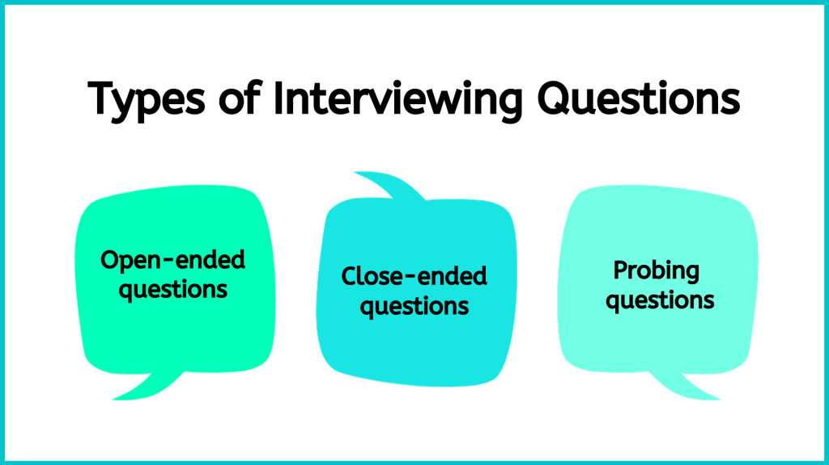
Figure 2.4: Types of interviewing questions

Closed-ended questions are direct questions that you ask when you are seeking precise information. These types of questions typically generate a short answer and do not facilitate a dialogue. Here are some examples in which the answers are typically one word:
- “Do you smoke?”
- “Have you been tested for tuberculosis?”
- “What year were you born?”
- “Do you take the medication as directed?”
- “When did your rash start?”
Open-ended questions are types of questions that invite the client to share descriptive answers, open up about their experience, and answer in a way that is most relevant or comfortable from their perspective. In response to open-ended questions, clients typically talk in sentences and may even tell stories (as opposed to the short answers to closed-ended questions). Although clients may provide a short answer, this type of question still provides the opportunity for you to probe further. Here are some examples:
- “What was going on in your life when you first started feeling depressed?”
- “Tell me about when you first started smoking.”
- “How have you been feeling in the past week?”
- “Tell me about the challenges you are having with your medication regimen?
You should listen to the answer carefully so that you can authentically respond to what the client said and possibly probe further.
Probing questions are types of questions and statements that allow you to gather more subjective data based on a client’s response. These types of questions can also be used to summarize and clarify a client’s response or resolve discrepancies that you identify. These questions and statements can be open- or closed-ended. Here are some examples:
- “Tell me more.”
- “How did that affect you?”
- “When talking about your health, you said ‘don’t cross the bridge til you come to it,’ can you tell me what you mean by that?”
- “You said that you are doing ‘well’ since your partner’s death, but I noticed that you are teary eyed as you are speaking about them. Can you talk a bit about that?”

Points of Consideration
Learning how to respond
Sometimes you won’t know how to respond when a client says something. For example, they may say something that you don’t understand or something that surprises you or takes you off guard. You may consider responding with statements like, “Tell me more” or “Tell me more about what you mean by that.” Avoid statements that may conjure judgement such as “why” or “how come” – these statements can be interpreted as a demand for an explanation and make the client feel defensive.

Activity: Check Your Understanding
An interactive H5P element has been excluded from this version of the text. You can view it online here:
https://pressbooks.library.ryerson.ca/communicationnursing/?p=54#h5p-18

27

Communication Strategies
There are many communication strategies that should be used to facilitate therapeutic communication. See Table 2.2 for a list of these strategies and considerations and examples on how they build the therapeutic relationship.
Table 2.2: Communication strategies.

One or more interactive elements has been excluded from this version of the text. You can view them online here: https://pressbooks.library.ryerson.ca/communicationnursing/?p=56#video-56-1
Film Clip 2.3: Demonstration of false reassurance.

One or more interactive elements has been excluded from this version of the text. You can view them online here: https://pressbooks.library.ryerson.ca/communicationnursing/?p=56#video-56-2
Film Clip 2.4: Demonstration of how to avoid false reassurance.

Activity: Check Your Understanding
An interactive H5P element has been excluded from this version of the text. You can view it online here:
https://pressbooks.library.ryerson.ca/communicationnursing/?p=56#h5p-19

28

Non-Verbal Communication Strategies
Non-verbal communication strategies are ways you communicate without speaking, for example through facial expressions, hand gestures, eye contact, and body language. See Figure 2.5.


Figure 2.5: Non-verbal communication

In many situations, much of your communication occurs through non-verbal behaviours. Non-verbal communication can be a useful strategy for communicating emotions like empathy, compassion, and acceptance. It is often how nurses respond, rather than what they say, that leaves a lasting impression on clients, so it is important to be aware of how you communicate using non-verbal behaviours.
Non-verbal behaviours must align with your verbal behaviours so that clients clearly understand what you are saying. For example, it would be confusing for the client if you had a somber tone of voice, distancing posture, and avoided eye contact while attempting to maintain a therapeutic relationship with the client.
Try to ensure positioning where you are both at the same vertical level and a slight angle towards one another. This positioning conveys an open and non-confrontational and non-authoritative space. Whenever possible, avoid standing over the client if they are sitting or lying in bed. It is better to sit down, which also conveys that you have time to listen to them.
There are many models to inform your non-verbal communication. One helpful model is called SURETY (Stickley, 2011) reflected as a modified version in Figure 2.6:

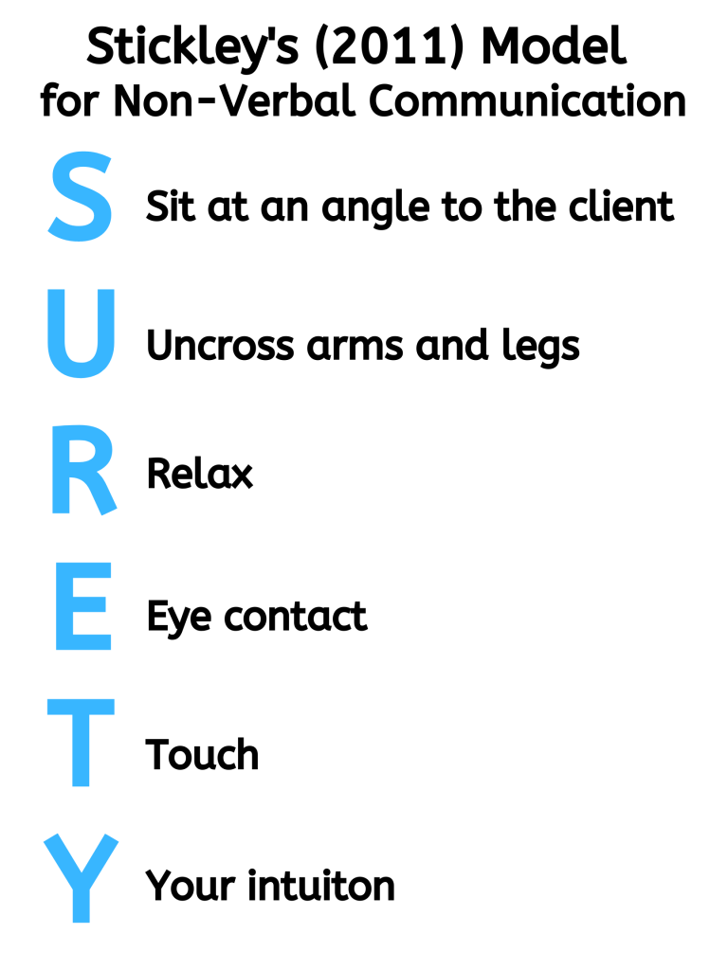
Figure 2.6: The SURETY model.

Points of Consideration
Physical touch
Touch can be therapeutic with clients when used appropriately. It can convey empathy and compassion. You should strike a balance about when it is therapeutically appropriate and when it is an intrusion for clients. It will take practice to learn when touch is appropriate.

Activity: Check Your Understanding
An interactive H5P element has been excluded from this version of the text. You can view it online here:
https://pressbooks.library.ryerson.ca/communicationnursing/?p=58#h5p-20

29

Cultural Considerations
Therapeutic communication with clients and families requires attention to a person’s culture. It is important to note that:
- People are cultural beings. At a basic level, culture includes a person’s beliefs and values. It refers to a person’s practices or their way of life. It includes a person’s ethnicity, spirituality, and religion, but it is much more than these components.
- Culture is deeply embedded in each person and everything they do, including how they communicate and what is meaningful to them. It is essential to understand because it shapes the way we think, feel, and behave. It can determine what is considered taboo, appropriate, and meaningful.
- Culture is socially transmissible (Kashima, 2019) meaning that it can be passed from one person/generation to the next, making verbal and non-verbal communication a vital way to impart and share culture. Often, from an Indigenous perspective, culture is not merely the sum of a person’s individual characteristics; “it is an emergent property of individuals interacting with their natural and human environment” (Kim, Park, & Park, 2000, p. 67). As a result, culture is not static – cultural patterns are dynamic and shift throughout a person’s life.
Cultural safety is an important component of therapeutic communication, because culture is so dynamic and deeply embedded in a person’s way of being. In the context of therapeutic communication, you must examine your own culture and how it affects the ways you communicate with clients. This self-awareness is vital to provide culturally safe care to clients and facilitate health equity (Curtis et al., 2019).
A relational approach can facilitate communication that embraces cultural safety because it relies on your dialogical engagement with the client. In other words, nurses should suspend what they assume they know about culture, and let clients direct nurses with regard to how culture is meaningful to them. This approach encourages you to consider the relational interplay (Doane & Varcoe, 2015) of communication, the client’s culture, and your own culture. Like everyone, nurses are cultural beings with ethnocentric tendencies – you will tend to view the world and your client from your own cultural perspective. From a relational perspective, you must understand your own culture and your ethnocentric tendencies so that you are positioned to recognize and understand the client’s culture.
Part of a relational approach also involves positioning yourself as an inquirer who is in a “space of knowing/not knowing, being curious, looking for what seems significant” (Doane & Varcoe, 2015, p. 6). See Table 2.3 on how to develop yourself as an inquirer and understand the interplay of your culture and the client’s culture.
Table 2.3: Understanding culture.

Activity: Check Your Understanding
An interactive H5P element has been excluded from this version of the text. You can view it online here:
https://pressbooks.library.ryerson.ca/communicationnursing/?p=60#h5p-21

30

Developmental Considerations
A person’s age needs to be considered when conducting the client interview. Most importantly, you need to consider a client’s developmental stage. Developmental stage does not always align with a client’s chronological age. With regard to communication, a focus on developmental stage includes attention to areas such as language and cognitive and socio-emotional development. At times, you may need to modify your communication so that you are appropriately engaging with the client at a level they understand.
There are many ways to construct chronological age categories. Broadly, children are considered anyone under 18 and adults are considered anyone 18 and older. More specifically, you could consider the categories used in this resource:
- Newborns and neonates: newborns are birth to a few hours old and neonate is up to 28 day.
- Young children: clients who are 5 years and younger, including infants (28 days to 1 year), toddlers (1–2 years), and preschoolers (3–5 years).
- Older children and adolescents: clients who are 6–17 years, including older children/school-age children (6–12 years) and adolescents (13–17 years).
- Adults and older adults: clients who are 18 years and older, including adults (18 years and older) and older adults (65 years and older).
See Film Clip 2.5 of an expert pediatric nurse speaking about how communication varies between children and adults.

One or more interactive elements has been excluded from this version of the text. You can view them online here: https://pressbooks.library.ryerson.ca/communicationnursing/?p=62#video-62-1
Film Clip 2.5: Interview with an expert pediatric nurse.

The following sections provide tips on broad chronological age categories including young children, older children and adolescents, and adults including older adults.

31

Young Children
You should use a combination of verbal and non-verbal communication with infants. Be constantly aware and adapt your use and choice of communication strategies based on the infant’s response.


Figure 2.7: Young children

Most infants enjoy hearing the human voice, and this is how they learn and make sense of language. You should talk to them in a relaxed and pleasant tone of voice even though they cannot verbally respond. It’s also okay to use baby talk with infants as it can help with language development: baby talk is a type of speaking where you use enhanced vocal intonation and hyperarticulation of sounds such as vowels and consonants.
In terms of non-verbal communication, you should have a relaxed body posture, smile, use appropriate eye contact, and gestures with your hands; these techniques are important with all children because non-verbal language can facilitate their sense of safety.
With children, you should adapt your communication to their developmental stage. Tailor your language to a level that children will understand, avoiding long complex sentences and instead using short sentences with simple words. Although you may use baby talk with infants, you should use a different approach with toddlers, who often want to be included in the conversation. As children get older, they enjoy receiving compliments and encouragement to connect with them (e.g., “look how much you have grown” or “great job!”).
Because care partners (typically parents) are usually present with young children, it’s important to involve them so that the child feels safe. Here are some points to consider with care partners:
- While communicating with a parent, the infant or toddler may sit on their parent’s lap and/or play with a toy. This introductory communication can help the child get familiar and comfortable with you, particularly at the first meeting.
- Children may behave differently because they are afraid or not feeling well. For example, they may hind behind the care partner or refuse care from the healthcare provider or cry or scream. These behaviours can create stress for the care partners, so it’s important to be patient and demonstrate unconditional positive regard.
- Some or all the client interview will be conducted with the care partner when the child is unable to speak or fully articulate. Because care partners are considered a secondary source of data, you should ask them to clarify and elaborate how they know what they are sharing with you. For example, if they say that their baby is in pain, ask how they know this.
- At times during the interview, it may be appropriate to interview the parent without the child present, particularly when talking about sensitive topics.

Activity: Check Your Understanding
An interactive H5P element has been excluded from this version of the text. You can view it online here:
https://pressbooks.library.ryerson.ca/communicationnursing/?p=64#h5p-33

32

Older Children and Adolescents
Older children and adolescents are usually at a stage where they can participate in the client interview in a more active way and articulate their experiences, emotions, and needs. Thus, it is important to address them as the client first, as opposed to the care partner. Care partners are often still involved, but you should offer the child/adolescent the opportunity to speak with you privately at times. For example, you might say to the client: “At this age, I often like to provide time to speak with you alone. Are you okay if I ask your mom or your dad to step out for a few minutes?”
You should continue to use a combination of non-verbal and verbal language and communication strategies. In terms of non-verbal communication, use eye contact with a relaxed and open posture that demonstrates interest in what they are saying. Smiling may be appropriate depending on the topic. You should also facilitate the interview using strategies such as nodding and statements that encourage the client to continue sharing (e.g., “uh huh” and “tell me more”). Be aware of your facial expression and vocal intonation to ensure you are conveying empathy, acceptance, and a non-judgmental attitude. You may want to include fun objects or games, or include the child in the assessment process (e.g., “would you like to try tapping on your own knee with this reflex hammer?”).
Adolescents are in a transitional stage where they are still children but are moving closer to adulthood. It is important to recognize and respect their self determination. Additionally, emotional and cognitive capacity will vary from adolescent to adolescent and from situation to situation. Therefore, your communication strategies will need to shift based on the adolescent and the situation. Overall, you should convey acceptance, honesty, and respect. Avoid talking to them as a child, as this is often interpreted as demeaning. Some adolescents are old enough to make their own decisions regarding some aspects of their health care: in many jurisdictions, this capacity to consent, which includes being able to understand and weigh risks and benefits, is determined by maturity level rather than by age.

Figure 2.8: Adolescents

When discussing sensitive and intimate topics, it is important to recognize that adolescents often feel self conscious, embarrassed, and have a fear of being judged. Your communication strategies should convey acceptance and understanding of what they are experiencing. You should have an open and non-judgmental attitude so that you can cultivate a trusting relationship with the client. Permission statements can be particularly useful as they can help normalize what an adolescent may be experiencing.

Activity: Check Your Understanding
An interactive H5P element has been excluded from this version of the text. You can view it online here:
https://pressbooks.library.ryerson.ca/communicationnursing/?p=66#h5p-24

33

Adults and Older Adults
Adulthood is a large age category including everyone 18 years and older, but there is great diversity within this group. Some adults will have had minimal encounters with nurses and others will have had extensive encounters. Younger adults in their late teenage years and early twenties may share characteristics with adolescents, so you may use many of the same communication strategies. You should also examine and acknowledge your own biases and tendencies to stereotype older adults and constantly re-assess your own assumptions so that they do not negatively affect your communication.

Figure 2.9: Adults and older adults.

With older adults, it is important to give them time to process and answer questions, as they may have a slower response time. Avoid making assumptions about their hearing or vision or cognitive capacity. Rather, speak in a clear voice and face them while you speak as you would with all clients. It can be helpful to write down instructions or educational information for older adults, as they are often dealing with substantial quantities of health information.
Some older adults may have a care partner present with them because they are managing multiple illnesses and may have cognitive or physical impairments that cause disabilities. When a care partner is present, you should engage in an inclusive communication approach. After engaging in the introductory phase with the client, ask about who the person with the client is. If appropriate, you should consider the client and care partner as a dyad in which both are recipients of care, but the client should be your main focus during your assessment. Avoid assuming that care partners can better answer questions for older clients. For example, direct your questions to the client even though the care partner may help answer some of the questions.

Activity: Check Your Understanding
An interactive H5P element has been excluded from this version of the text. You can view it online here:
https://pressbooks.library.ryerson.ca/communicationnursing/?p=106#h5p-25

34

Additional Considerations
As a nurse, you will encounter other populations and situations that will require you to thoughtfully consider how to best communicate in a way that is respectful, effective, and therapeutic. You might not even know when you are caring for certain populations, because it may not be obvious, so it is always best to ground your communication in best practices (e.g., College of Nurses of Ontario practice standard concerning therapeutic nurse-client relationship). For example, it is not necessarily readily apparent when a language discordance exists, or when a person is experiencing intense emotions, or when a person has a disability.
Language discordance
There will be times when you and the client and/or family do not speak the same language. In this case, you need to carefully assess and evaluate their understanding.
Here are some strategies to address language discordance:
- Speak directly to the client using simple language (no jargon, no medical language).
- Be aware of your non-verbal language and consider how gestures may help the client understand what you are trying to communicate.
- Use pictures and/or have a paper and pen for them to write down notes and questions.
- Consider how best to incorporate the care partner into conversations if they speak the same language as you, but the client does not. Care partners can be an integral part of the care processes and may be constantly translating what is going on for their loved one. Thus, in everyday communication, you may consider engaging the care partner in interpreting for you and the client. For example, it may be appropriate to ask them to interpret when introducing yourself and asking the client about benign and less sensitive topics (e.g., “Are you hungry?” “Can you sit up?”).
- However, sometimes the use of an interpreter is needed. Many healthcare institutions have access to interpretation services, but these can be expensive. You may also have professional colleagues who are trained in the ethics of interpretation and can help.
- Consider using a translating app such as Google Translate that can help you translate one language into another. Although you may not speak the other language, you can show the written translation to the client so that they can read it. Additionally, the client can also type concerns, responses to your questions, and their own questions into the translating app.
Emotions
Clients commonly experience sadness, anger, fear, anxiety, embarrassment, and other emotional responses in the context of health and illness. It is important that you cultivate a therapeutic environment where clients feel comfortable to open up about their emotions. Open-ended questions like “Tell me about how you are feeling” can facilitate discussions about a client’s emotional response. Additionally, you might consider using permission statements to help normalize how the client is feeling and provide an opening for them to speak about emotions. For example, “Clients often experience sadness or anger when they are diagnosed, how are you feeling?”
It is important that you acknowledge the client’s emotions and provide space for them to experience the emotions. Avoid changing topics. Give the client time to voice their emotions or even cry. Using silence and active listening are effective communication strategies during these circumstances.
Violence and trauma
Many clients will have experienced violence and trauma in their lives such as abuse, bullying, grief or loss of a loved one, or natural disasters or war. You will often not even be aware that they have experienced violence or trauma, so it’s best to use a trauma-informed approach with all clients, as discussed in Chapter 1. Approach all clients with the assumption that they may have experienced violence and trauma at some point in their lives. Reflect on how best to help them feel safe and provide them as much choice and control in the clinical encounter as possible.
Some communication strategies that are consistent with a trauma-informed approach include:
- Introducing who you are and why you are there.
- Explaining each step of what you are doing.
- Asking permission to touch.
- Giving the client options on what topic to discuss first.
Communicating with clients about violence and trauma requires knowledge, skill, and experience. This field of study is vast and deep. As you develop foundational communication skills, you will have opportunities to build knowledge about trauma-informed communication. For now, recognize that there is much more to know about trauma-informed approaches and that an in-depth understanding is needed to best care for these clients.
Hearing and visual impairment
You can inquire about the presence of any hearing or visual impairment and what is best for the client in terms of communication. For people with hearing and visual impairment, begin by minimizing any background noises or distractions. You should speak in a clear, slightly louder voice, steady tone with a deeper pitch. Avoid shouting and using a high pitch as this can distort sounds and make your words more difficult to hear. You should face the client directly and clearly articulate your words so that they can read your lips and attend to non-verbal cues as necessary. If the client has an assistive device (e.g., glasses or a hearing aid), make sure that they have access to the device.
Intellectual impairment
Some of your clients will have intellectual or cognitive impairments that may result in disabilities affecting their ability to learn and reason (e.g., Down syndrome, fetal alcohol syndrome). You should consider how each client can best participate in communication (e.g., listening, talking, understanding and processing information). You should engage in active listening and determine what is important to the client. Speak clearly and ask simple questions. Speak in a positive tone with a steady pace and avoid speaking slower as this can come across as patronizing. You may encourage them to bring someone with them that they trust, such as a care partner; you should still focus your attention on the client but also create an inclusive space for the care partner to be involved.
Substance impairment
A client under the influence of drugs and substances (alcohol, cannabis, prescribed medications, and/or illegal street drugs) can have altered capacity to think, reason, and communicate. Although some of these substances may be illegal and non-prescribed, it is important to maintain a non-judgmental attitude and convey unconditional positive regard. As a nurse, it is not your job to judge a client. Rather, you should use a relational inquiry approach to understand the circumstances that have influenced their choices and respect that each client has agency and self-determination.
While the client is under the influence of a substance, use communication strategies that facilitate their capacity to understand what you are saying and communicate with you while maintaining safety. Thus, you should speak clearly and in short simple sentences. Focus on the reason for seeking care or the priority issue. There will be time for a collaborative discussion and health promotion after the effects of the substances have dissipated.
Escalation
Communication is a particularly important strategy to use when your purpose is to de-escalate a situation. Escalation can occur in any healthcare situation when clients are encountering intense emotions and experiences entangled with stress, fear, anger, uncertainty, pain, and lack of control. This can lead to the client spiraling out of control, agitation, aggression, and even violence. Contextual factors may include clients who have received bad news such as a diagnosis, clients who are under the influence, and/or clients who are having a mental health crisis. Attend to your own safety and be aware of the potential risk factors. It is important to notify a colleague(s) when interviewing a client who is at risk of, or has a history of, escalating.
De-escalation includes ways to reduce and/or prevent escalation. De-escalating communication strategies include:
- Acknowledge and value how the client feels and be non-judgmental.
- Avoid downplaying or judging how the client feels.
- Engage in active listening to understand the situation and explore the reason for the escalation.
- Offer genuine interest, concern, and empathy.
- Remain calm and do not allow your voice or non-verbal communications to demonstrate rising emotions.
- Recognize the client’s self-determination and collaborate with them on how to address the issue.
- Maintain your safety, but do not act afraid.
- Maintain your professionalism and do not take the situation personally.
Inappropriate communication from the client
There will be times when clients engage in inappropriate communication. This kind of communication may include verbal and non-verbal language such as inappropriate physical touch, violent or aggressive behaviour, harassing language (e.g., name-calling, threats), and sexualized language. As a nurse, you should rely on the CNO (2019a) practice standard about the therapeutic nurse-client relationship. Keep in mind that there is meaning associated with all client behaviour and that you should attempt to understand it (CNO, 2019a).
Consider these strategies when responding to inappropriate client language:
- If applicable, ensure your personal safety. Depending on the situation, this may involve moving toward the doorway or having it in your sight, leaving the room, or calling for help.
- Acknowledge the language/behaviour and clearly let the client know that it is inappropriate, do so in a professional and non-judgmental manner.
- Remind the client that as a nurse you only engage in professional relationships with clients and families.
- Ask the client if their language has something to do with the effects of their health or illness.

Activity: Check Your Understanding
An interactive H5P element has been excluded from this version of the text. You can view it online here:
https://pressbooks.library.ryerson.ca/communicationnursing/?p=108#h5p-26

35

Concluding the Interview
Concluding the interview has three main purposes:
- First, to ensure that you have understood everything necessary in order to best care for the client.
- Second, to ensure that the client has had the opportunity to share what is important to them and add any additional information.
- And finally, to ensure that the client knows what the next steps are with regard to their care. Be specific and don’t assume the client knowns what to expect. Offer them handouts if available so they can review information at home.
As part of the conclusion, you should provide a brief summary of the data you have collected. This summary should reflect what the client said and may include paraphrasing what they said. You might start the summary off by saying “The interview is coming to a close and I would like to share a summary of what we discussed.” The length of the summary will depend on the comprehensiveness of the interview and the complexity of the client’s needs, but it is usually a few sentences summarizing the pertinent data. This can be followed up by a couple of questions such as “Did I capture what you said accurately?” and “Is there anything else that you would like to share with me that is important to your care?”
Finally, you should discuss the next steps related to the client’s care. For example, these may include a physical assessment or having another health professional come in to talk with them. Make sure you ask the client if they have any questions before concluding the interview. Finally, close the interview in a therapeutic way, which may involve using the name that they prefer to be called and thanking them for sharing their information.

36

Key Takeaways

Key Takeaways
- Therapeutic communication is the foundation of the nurse-client relationship.
- Therapeutic communication is one of four standards to “establish, maintain, re-establish and terminate the nurse-client relationship” as per the College of Nurses of Ontario.
- Privacy and confidentiality are important components of the client interview.
- Consider the client interview thoughtfully and use a combination of communication strategies.
- It is important to attend to the client’s developmental stage and their state of mind.

37

References
College of Nurses of Ontario. (2020). What to report. https://www.cno.org/en/protect-public/employers-nurses/reporting-guide/what-to-report/
College of Nurses of Ontario. (2019a). Therapeutic nurse-client relationship, revised 2006. https://www.cno.org/globalassets/docs/prac/41033_therapeutic.pdf
College of Nurses of Ontario. (2019b). Confidentiality and privacy – personal health information. https://www.cno.org/globalassets/docs/prac/41069_privacy.pdf
College of Nurses of Ontario. (2019c). Professional conduct: Professional misconduct. https://www.cno.org/globalassets/docs/ih/42007_misconduct.pdf
College of Nurses of Ontario (2019d). Code of Conduct. https://www.cno.org/globalassets/docs/prac/49040_code-of-conduct.pdf
Community Legal Education Ontario. (2019). When does elder abuse have to be reported? https://www.cleo.on.ca/en/publications/elderab/when-does-elder-abuse-have-be-reported
Curtis, E., Jones, R., Tipene-Leach, D., Walker, C., Loring, B., Paine, S., & Reid, P. (2019). Why cultural safety rather than cultural competency is required to achieve health equity: A literature review and recommended definition. International Journal for Equity in Health, 18(1). https://doi.org.10.1186/s12939-019-1082-3
Doane, G., & Varcoe, C. (2015). How to nurse: Relational inquiry with individuals and families in changing health and health care contexts. Wolters Kluwer.
Kashima, Y. (2019). What is culture for? In D. Matsumoto & H. Hwang (Eds.), The handbook of culture and psychology (2nd ed., pp. 123-160). Oxford University Press.
Kim, U., Park, Y-S., & Park, D. (2000). The challenge of cross-cultural psychology: The role of Indigenous psychologies. Journal of Cross-Cultural Psychology, 31, 63-79. https://doi.org/10.1177/0022022100031001006
Ontario Ministry of Children, Community, and Social Services. (n.d.) Reporting child abuse and neglect. http://www.children.gov.on.ca/htdocs/english/childrensaid/reportingabuse/index.aspx
Personal Health Information Protection Act. (2004). https://www.ontario.ca/laws/statute/04p03
Stickley, T. (2011). From SOLER to SURETY for effective non-verbal communication. Nurse Education in Practice, 11, 395-398. https://doi.org/10.1016/j.nepr.2011.03.021

III

Chapter 3 - Interprofessional Communication in Nursing
By Jennifer L. Lapum, Charlotte Lee, Michelle Hughes, Oona St-Amant, and Joy Garmaise-Yee

38

Learning Outcomes

By the end of this chapter, you will:
- Understand the relevance of interprofessional communication.
- Identify the relationship between interprofessional communication and interprofessional collaboration.
- Summarize the principles and strategies of interprofessional communication.
- Examine the factors that influence interprofessional communication.
- Understand the role of communication in the context of interprofessional conflict.
- Explore resources to facilitate interprofessional communication.
- Examine the role of self-reflection in interprofessional communication.

39

Interpersonal Communication
Interpersonal communication can be defined as the process of exchanging messages between people whose lives mutually influence one another. This kind of communication involves two or more people who are interdependent. For example, the communication you engage in with family, friends, and peers is considered interpersonal communication, as illustrated in Figure 3.1. Interpersonal communication builds, maintains, and evolves relationships, so it is foundational to many aspects of everyday life.


Figure 3.1: Example of interpersonal communication

Interpersonal communication is interactive and structured by social expectations, including unspoken norms that are assumed or taken for granted during language exchange. These norms are often culturally influenced and contextually relevant, but although they are instituted early in life, they are not immutable – they change and evolve over time. For example, how you greet people (vocal intonation, whether you address someone by their prefix, whether you shake hands or bow) can change over the years. Furthermore, social expectations are shaped by the parties involved, so how you speak with friends will be different from how you speak with a professor, for example.
Interpersonal communication is also usually goal-oriented and fulfills instrumental and relational needs.
- Instrumental needs are focused on the goal of achieving a specific outcome. For example, you may speak with your roommate about what to cook for dinner, or speak with a professor about how to position yourself for success in a course.
- Relational needs are focused on the goal of evolving a relationship or communicating the uniqueness of a specific relationship. This goal usually involves meeting the needs of an individual person as well as the shared needs of the parties involved. For example, two nurses may have a conversation to resolve a conflict they have been having.
One type of interpersonal communication that will be important in your work as a healthcare professional is interprofessional communication. Let’s move on and explore this type of communication!

Activity: Check Your Understanding
An interactive H5P element has been excluded from this version of the text. You can view it online here:
https://pressbooks.library.ryerson.ca/communicationnursing/?p=118#h5p-27

Attribution Statement
Adapted from:
https://open.lib.umn.edu/communication/chapter/1-1-communication-history-and-forms/

40

Interprofessional Communication
Within the context of health care, interprofessional communication can be defined as communication among members of a client care team, which may include members of various professional groups. For example, it may involve you as the nurse, clients, families, and also other healthcare professionals such as physicians, physiotherapists, midwives, pharmacists, dieticians, and personal support workers.


Figure 3.2: Interprofessional communication

Interprofessional communication involves verbal, written, and non-verbal communication as defined in Chapter 1.
During interprofessional communication, verbal communication may include conversations between two or more members of the interprofessional team, usually in person as illustrated in Figure 3.2 or over the telephone. See Table 3.1 for specific communication types and examples that are common in healthcare.
Written communication in the interprofessional context commonly includes documentation notes in a client’s chart such as progress notes, physician orders, medication administration record, diagnostic reports, referral letters, and discharge notes. Other examples may include faxes and emails, and more recently, texts.
Finally, non-verbal communication in the interprofessional context involves meaning and interpretation conveyed through body language such as facial expressions, eye contact, body position, and gestures. It is important to be aware of your body language and ensure that it aligns with your verbal language.

Table 3.1: Examples of interprofessional communication

Activity: Check Your Understanding
An interactive H5P element has been excluded from this version of the text. You can view it online here:
https://pressbooks.library.ryerson.ca/communicationnursing/?p=121#h5p-28

41

Interprofessional Communication and Collaboration
Interprofessional communication is a fundamental component of interprofessional collaboration. Effective interprofessional collaboration fosters effective teamwork among members of an interprofessional client care team to optimize client outcomes (Canadian Interprofessional Health Collaborative, 2010), ensuring that clients are safe throughout the healthcare system (Canadian Nurses Association, n.d.a.).
Because of the significance of interprofessional collaboration, the Canadian Interprofessional Health Collaborative has developed a National Interprofessional Competency Framework, as shown in Figure 3.3.

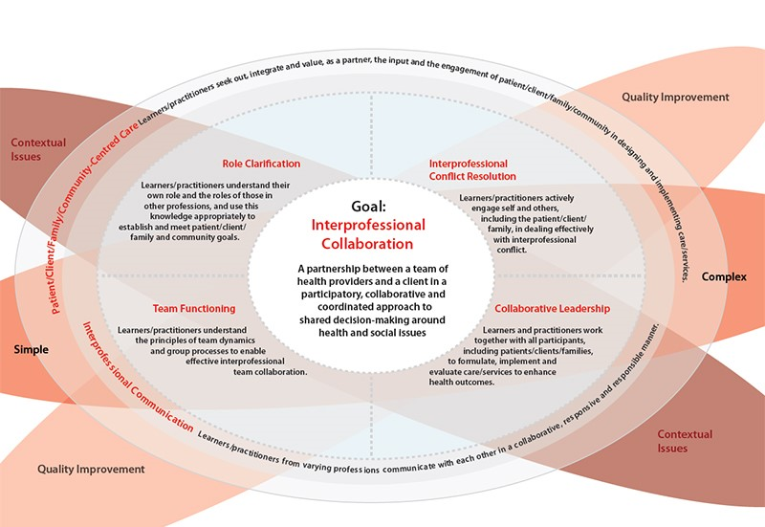
Figure 3.3: National Interprofessional Competency Framework

As shown in Figure 3.3, six interdependent competency domains have been identified to achieve the goal of interprofessional collaboration (Canadian Interprofessional Health Collaborative, 2010). These are defined as the “knowledge, skills, attitudes, and values that shape the judgements essential for interprofessional practice” (Canadian Interprofessional Health Collaborative, 2010, pg. 9) and include:
- Interprofessional communication
- Patient/client/family/community-centred care
- Role clarification
- Team functioning
- Interprofessional conflict resolution
- Collaborative leadership
The first two competencies have a strong influencing role in all healthcare situations, so as shown in the figure, they encircle the other four competencies. This framework can assist you in contributing to effective healthcare team functioning with a focus on communication and working together collaboratively.
This chapter focuses specifically on the competency domain of interprofessional communication. This plays a central role in interprofessional collaboration because it supports the other five competency domains (Canadian Interprofessional Health Collaborative, 2010).
To fulfill the interprofessional communication competency, nurses and all healthcare professionals must develop the capacity to “communicate with each other in a collaborative, responsive and responsible manner” (Canadian Interprofessional Health Collaborative, 2010, p. 16). This means that each healthcare professional is responsible for engaging in effective communication in the specific clinical and interprofessional context in respectful, explicit, and clear ways (Lyndon et al., 2011). It is important to actively respond to the perspectives of everyone involved, including the client and other healthcare professionals. Table 3.2 presents strategies for effective interprofessional communication, adapted from the Canadian Interprofessional Health Collaborative.
Table 3.2: Strategies for effective interprofessional communication
Consistent execution of successful communication requires attentive listening skills, administrative support, and collective commitment (Lyndon et al., 2011). Other principles of interprofessional communication include:
- Speak clearly with appropriate vocal intonation and at a moderate pace.
- Use simple and clear language.
- Maintain eye contact and show confidence in what you are saying.
- Be efficient in your communication.
- Incorporate adequate, relevant, and timely information.
- Engage in active listening and ask questions for clarification.
- Speak up and seek clarification if needed until your concern regarding a client is addressed.
- Put clients first: always remember – and if appropriate, remind your interprofessional team members – that your decisions and actions affect the client and the client should be the focus of your discussions.
- Show respect in your communication patterns.

Activity: Check Your Understanding
An interactive H5P element has been excluded from this version of the text. You can view it online here:
https://pressbooks.library.ryerson.ca/communicationnursing/?p=123#h5p-29

An interactive H5P element has been excluded from this version of the text. You can view it online here:
https://pressbooks.library.ryerson.ca/communicationnursing/?p=123#h5p-30

42

Factors Influencing Interprofessional Communication
There are several factors that can influence interprofessional communication in positive or negative ways – and can therefore have positive or negative effects on healthcare professionals and client outcomes.
The factors affecting interprofessional communication can be divided into three main categories: those related to the physical environment, those related to the context, and those related to communication styles of the people involved. See Figure 3.4.

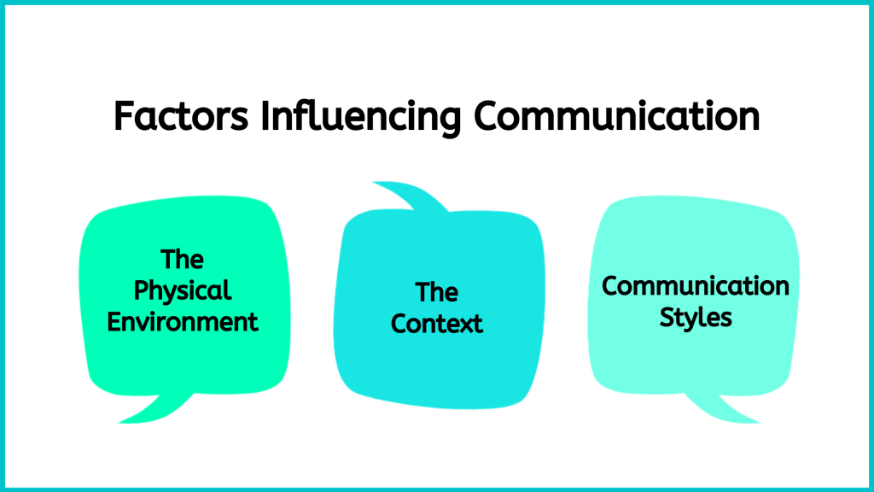
Figure 3.4: Factors affecting interprofessional communication

You should consider these factors and how you can modify your communication patterns to engage in effective interprofessional communication.
- First, you will often be working in physical environments that are sometimes noisy and have many moving parts including clients, families, and multiple members of interprofessional teams. In addition to the many people, there may be beeping machines and overhead announcements. You should be aware that this can cause sensory overload: healthcare environments are often unfamiliar for clients and their families, so you should take this into consideration.
- Second, interprofessional communication in healthcare environments takes place in a complex context involving a lot of information and dynamic and complex clinical situations that require a high level of acuity. It can be very intense, with life-threatening conditions, death, uncertainty, fear, and anxiety – and can lead to work overload. This context can also influence the dynamic nature and intensity of interprofessional conversations. The hierarchical relationships that exist in interprofessional teams and imbalances of power or ideas about power can also affect how individuals communicate and interpret conversations. It is vital that you communicate clearly, compassionately, and systematically.
- Third, each group of healthcare professionals has their own culture and communication styles, which may not align with those of other healthcare professionals. For example, nurses are often taught to be descriptive and embed narrative elements in their communication. This descriptive style capitalizes on a comprehensive and storied approach. Other healthcare professionals, such as physicians and pharmacists, are taught to be more concise and efficient. As you can imagine, these two communication styles may not always align, so you should reflect on how to tailor your communication to the person or group that you are speaking with, while still communicating your point of view as a nurse.
Table 3.3 presents examples of ineffective interprofessional communication and strategies to manage each one.

Table 3.3: Ineffective communication
*HCP = healthcare professional
Now, you have learned about the factors that positively and negatively influence interprofessional communication. Inevitably, despite healthcare professionals’ best intentions, conflict is common in interprofessional contexts. Let’s examine this next!

43

Conflicts in an Interprofessional Environment
Conflict can be defined as a state of serious opposition between two or more perspectives that influences thinking and actions. For example, people may disagree because they have different perspectives. However, varying perspectives alone do not lead to conflict: conflict emerges when one individual’s behaviours impede another individual’s interests or goals, resulting in negative emotions such as fear, anger, and frustration (Barki & Hartwick, 2004, as cited in RNAO, 2012).
Different perspectives will inevitably arise in any context, whether it is at work, with friends, or with colleagues. In an interprofessional environment, different perspectives will occur even when communication is relatively good. For example, healthcare professionals may have different disciplinary perspectives that inform their understanding of a situation, and may have different priorities in terms of client care. Communication can become problematic when these perspectives and priorities contradict another. Conflict is also more likely if interprofessional communication is sub-optimal and ineffective. Other factors that may contribute to conflict include lack of respect for others’ perspective, and differences in values, age, gender, education, ethnicity and culture, as well as elements related to professional roles such as responsibilities, power, and scope of practice (RNAO, 2012).
As shown in Figure 3.5, you can consider several strategies to prevent or manage conflict including:
- Use a client-centred approach to frame discussions.
- Use an evidence-informed approach to make decisions.
- Be open to hearing varying disciplinary perspectives.
- Engage in self-reflection.
- Engage in respectful discussions.
- Reflect on the perspectives of all team members.
- Share your perspective and rationale.

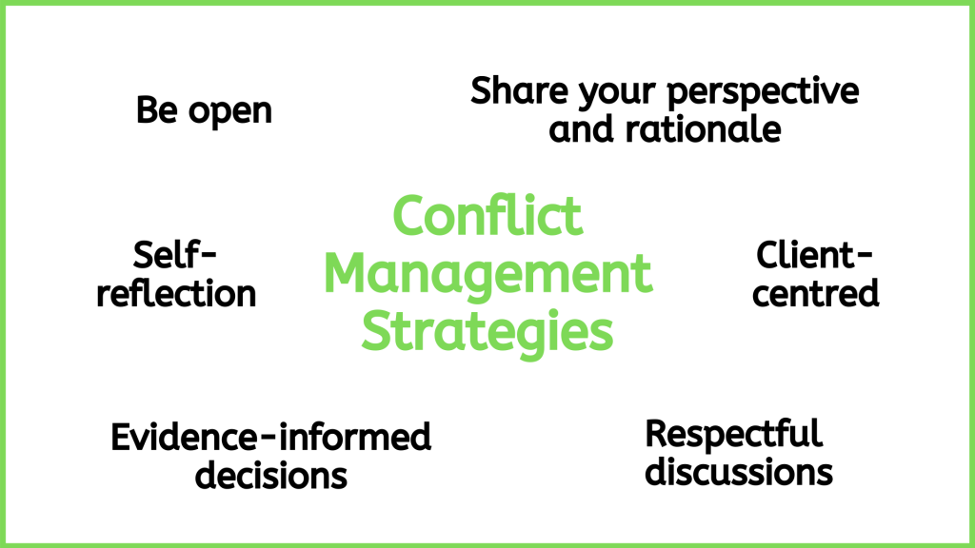
Figure 3.5: Conflict management strategies .

First, use a client-centred approach. This ensures the focus is on the client as a whole person and that the patient is cared for in ways that respect their “autonomy, voice, self-determination, and participation” in their own care (Registered Nurses Association of Ontario, 2006).
Second, use an evidence-informed approach. This will help you critically engage in discussions that are informed by the evidence, rather than personal preference.
Third, it is essential that you be open to hearing, respectfully discussing, and reflecting on the perspectives of all team members (Lyndon et al., 2011). In addition to sharing your perspective, share the rationale for it. Along with a client-centred and evidence-informed approach, this kind of effective dialogue will benefit the person who is the focus of care and decisions: the client.

Points of Consideration
Interprofessional communication can be optimized using a client-centred perspective and an evidence-informed approach. It should be guided by discussions that are centred on the client’s wellbeing and incorporate the best possible evidence for each client.

Preventing and managing interprofessional conflict involves responsibility at both individual and systemic levels. The interpersonal nature of conflict is important, but contextual and organizational factors can also contribute. In the context of nursing, interprofessional team members are often working in environments where they are dealing with feelings such as frustration, burnout, dissatisfaction, and a sense of being undervalued. This kind of environment requires a high level of acuity and can be very emotionally draining.
It is imperative to consider whether healthcare organizations and systems are supporting collaboration and conflict resolution, or contributing to negative emotions (RNAO, 2012). For example, are processes and systems set up for easy communication? Do teams work together or are there divisions and hierarchies? Is there shared decision-making and accountability, or a culture of blame, disrespect, and fear of reprisal? Are certain health professionals particularly overworked? To prevent and reduce interprofessional conflict, the RNAO (2012) has developed specific recommendations for organizations to consider related to organizational structures and climate, leadership support, staffing practices, communication practices, and professional components.
The next section explores what can happen if conflicts are left unresolved and escalate to harassment and bullying.

44

Harassment and Communication
Effective intraprofessional (within a discipline) and interprofessional (across disciplines) communication and interactions are essential to effective work environments and quality and safety in healthcare. Civility is a key component of effective communication and interactions, and is particularly important because of the stressful and complex nature of healthcare environments and decision making.
Civility involves treating others (e.g., healthcare team members) with respect, listening to their perspective, considering their feelings within an encounter, and respecting differences, but also working to seek common ground when needed. It is essential to emphasize that civility involves engaging in authentic, respectful, and inclusive ways with others; civility fosters a feeling of belonging and community even when there is conflict or differences in perspectives (Clark et al., 2022).
Incivility is a serious issue in teamwork (in both intraprofessional and interprofessional environments). Incivility within communication encounters or interactions involves the covert (subtle) or overt disrespect of another person. Examples include discourtesy, eye rolling, gossiping, rude comments, name calling, complaining, and physical actions including violence – all of these behaviours that can cause emotional and physical harm to a person. Conflict management strategies and communication training are known to assist nurses to deter and address uncivil behaviours as well as foster clarity and trust.
Bullying and harassment are often referred to as types of incivility addressed to a specific person. Although these terms are similar, harassment specifically is a type of discrimination based on factors such as religion, race, age, sex, and disability (Canadian Human Rights Commission, n.d.). Bullying and harassment are typically repetitive behaviours (happen more than once) and harm or humiliate another person. However, they can also include serious one-time incidents of unwanted verbal and/or physical behaviour (Canadian Human Rights Commission, n.d.).
These behaviours usually occur in the context of a real or perceived power imbalance. For example, the person who is bullying often thinks they have more power (e.g., more seniority, authority, specialized title/role, more education). This type of incivility may also occur between nurses as forms of horizontal violence, which is lateral violence within a group.
Many forms of harassment and bullying can occur within the nursing profession (intraprofessional) and across various healthcare professionals (interprofessional). They may be physical such as unwelcome touching of your body or the attire you wear. More often, they take the form of non-verbal and verbal behaviours. This includes demeaning, humiliating, and belittling language, hurtful teasing/jokes, name-calling, slurs, insults, and criticism as opposed to critique. Non-verbal behaviours specifically can include eye-rolling and other facial and bodily expressions. Other bullying and harassing behaviours include ostracism and purposefully ignoring someone and not helping colleagues or continually assigning someone workloads that are considered difficult and problematic.
Keep in mind that intraprofessional or interprofessional conflict does not constitute incivility or harassment. You will have conflict in the workplace where you have strong opposing points of view. Additionally, your supervisor or a peer may even provide feedback or constructive criticism in a supportive manner – this also does not constitute incivility or harassment. There may be uncivil behaviour in the workplace that also does not constitute harassment or bullying, but still should be addressed (Government of Canada, 2015).
You may not readily recognize that you are being bullied or harassed, and not everyone who bullies or harasses is aware of behaviour. Sometimes these behaviours arise because of interprofessional conflict, but they can also be caused by personal issues. For example, healthcare team members could have stress at home, financial concerns, or anger management issues. All of these factors can affect how they engage with others in all settings, including the healthcare environment – and the stresses associated with the healthcare environment can also be contributing risk factors.
Whatever the reason, you have the right to a workplace that is free from any form of incivility including bullying and harassment. See Figure 3.6.
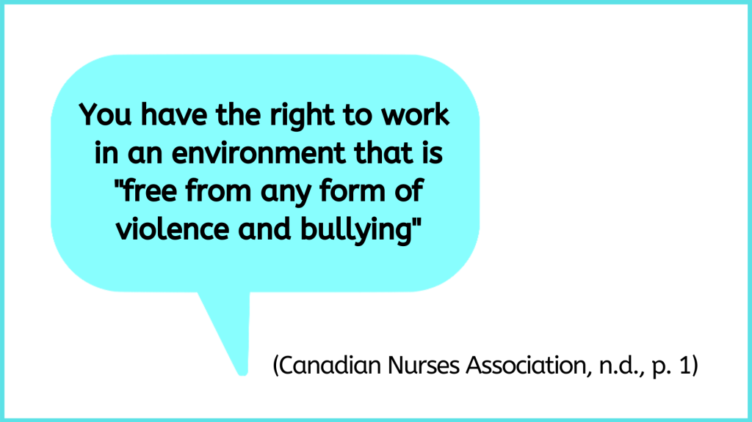
Figure 3.6: Workplace free from harassment

Professional nursing associations have been instrumental in addressing and managing bullying and harassment in the workplace. It is important for all nurses to attend to this form of violence in the workplace and take a leadership role in order to make change. Nursing has a legacy as an oppressed group because of its history as a subordinated profession (i.e., being considered subservient to the medical community) and because of socio-cultural structures like nursing being deemed gendered work. Oppressed group behavior can lead to horizontal violence, when parties in the same group lash out or exhibit violence toward each other in response to external dominant power. In such cases, members of an oppressed group feel subjugated and powerless against a dominant group and essentially take it out on each other. It is important to be aware of this dynamic as we work toward creating workplaces that are free from and intolerant to violence.
Why is it important to understand incivility, violence, harassment, and bullying?
Violence, harassment, and bullying are identified as occupational health and safety hazards that are underreported and often unrecognized (Becher & Visovsky, 2012).
As a nursing student, you need to be aware of what incivility, harassment, and bullying are and how to deal with them. These behaviours are not always conscious choices, so self-reflection and awareness are important first steps toward eliminating this type of incivility and violence in the workplace. Being the victim of bullying can have traumatic effects on self-esteem, mental health, and confidence in the workplace. Additionally, systemic bullying within an interprofessional team setting can affect staff morale, job performance, team functioning, and importantly, client care.
What should you do if you observe incivility, or someone being harassed?
First, if you observe incivility, step in and support the person on the receiving end.
Second, if you feel comfortable and safe, have a discussion with the person who is demonstrating the uncivil behaviour. Avoid participating in confrontational dialogue. Engage in an inquisitive discussion to better understand why it is occurring, and, if the person understands what they are doing and its impact on the other person. For example, you might say to them, I noticed that you have repeatedly rolled your eyes and interrupted X when they were sharing their perspective. Were you aware of that behaviour?
Third, if the incivility or harassment continues, report and document the incidents to your manager and the human resources department. If it is your manager who is creating the uncivil environment or doing the harassing, human resources should be your main point of contact.

Points of Consideration
“I am a nursing student. What should I do if I believe I am experiencing incivility in the learning environment or feel that I am being harassed or bullied in my clinical placement or in school?”
First, recognize this is not your fault and you do not deserve this. You have the right to a civil learning environment free of incivility, violence, harassment, and bullying. You deserve to be respected and supported in your learning.
Consider how to respond using conflict resolution strategies: https://pressbooks.library.ryerson.ca/communicationnursing/chapter/professional-communication-in-conflict-resolution/ Although it may not seem like it, the person who may be creating the incivility in the learning environment or doing the bullying or harassment might not realize they are doing it and they may not realize the impact of their actions. It is always best to speak with the person if you can do so. Have a private conversation and share your perspective and how you are being affected, but do so in a non-confrontational manner.
If at first, you feel too intimidated to do so, consider speaking with an instructor or a trusted individual within your school or university so that they can support you, brainstorm with you about how to approach the situation, and if needed, provide appropriate resources. In some cases, your support person may advise you to contact a senior leader in the school or possibly the Office of Discrimination and Harassment Prevention Services, or the Office of Sexual Violence Support and Education (these are services at Ryerson University, but all institutions have similar resources).

Activity: Check Your Understanding
An interactive H5P element has been excluded from this version of the text. You can view it online here:
https://pressbooks.library.ryerson.ca/communicationnursing/?p=129#h5p-31

45

Resources to Facilitate Interprofessional Communication
There are numerous resources to facilitate interprofessional collaboration and teams, including interprofessional communication.
Ideally, all healthcare professionals including nurses would speak up for the sake of clients, clearly state what they think is happening in a specific situation, and explain what and why they think certain actions should be taken (Lyndon et al., 2011). However, some healthcare professionals may struggle to voice their concerns and their perspectives, particularly if they feel less empowered or marginalized by another healthcare professional. One objective of interprofessional communication tools is to provide structure and clarity to convey succinct, comprehensive, and relevant information to another healthcare professional to improve client care.
Several standardized tools have been developed to facilitate interprofessional communication (Canadian Medical Protective Association, 2011) and prevent and manage harassment, errors in the workplace, and miscommunication. The SBAR tool, and its variations including ISBAR, is one common communication tool that can facilitate effective verbal communication when communicating with another healthcare professional about a client or during handover. It provides a framework so that communication is focused, concise, and complete.
ISBAR, detailed in Figure 3.7, is an acronym for Introduction, Situation, Background, Assessment, Recommendation. It was first introduced by the military in the United States to facilitate communication (NHS Improvement, n.d.) and has since been taken up in the healthcare arena to enhance client safety by facilitating communication among healthcare professionals and ensure the most important information is included (NHS improvement, n.d.; Spooner et al., 2016).

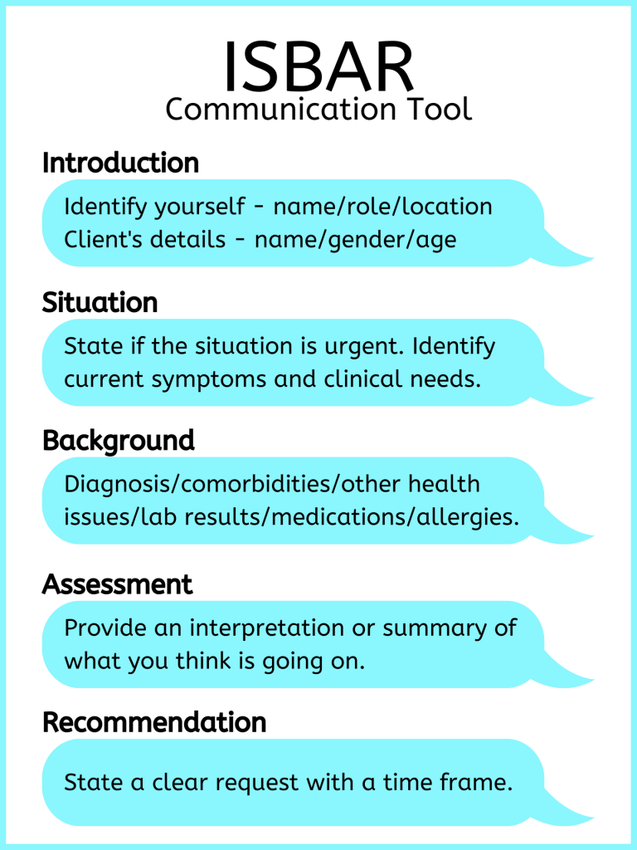
Figure 3.7: ISBAR
Using the ISBAR effectively takes practice. Check out Film Clip 3.1 about ISBAR [3:08].
One or more interactive elements has been excluded from this version of the text. You can view them online here: https://pressbooks.library.ryerson.ca/communicationnursing/?p=131#oembed-1
Film Clip 3.1: ISBAR
Research suggests that nurses do not comprehensively use elements of ISBAR, and the sections on assessment and recommendation are consistently neglected (Spooner et al., 2016). It is important to reflect on how you communicate and how you can improve through comprehensive use of tools. See Table 3.4 for an example of effective use of the ISBAR to guide communication.
Table 3.4: Example of ISBAR Use

Points of Consideration
Think about what you want to say and how you want to say it before you say it. Organize your thoughts first.

Activity: Check Your Understanding
An interactive H5P element has been excluded from this version of the text. You can view it online here:
https://pressbooks.library.ryerson.ca/communicationnursing/?p=131#h5p-35

46

Self-reflection in Interprofessional Communication
In a workplace setting, you are responsible for your own communication, actions, and behaviours. You should begin by engaging in self-reflection. Start by thinking about your personal values concerning communication. What factors do you believe are important in shaping how you communicate effectively? How do you speak with others? What bothers you or empowers you within a communication encounter? What are your strengths when communicating with another person? What are some areas for improvement in your communication? Consider how your strengths and barriers may influence a communication encounter. For example, how do barriers influence your capacity to engage in communication and your capacity to deliver and receive a message?
Some of your communication barriers may be very personal and may have developed when you were a child. Reflect on the following questions:
- Do you rely on informal speak patterns, such as slang, colloquialisms, and abbreviations (e.g., “What’s the bottom line?” or “Come again?”)?
- Do you engage in excessive use of first-person pronouns or delaying expressions (e.g., “I think that maybe, well I wonder if the person needs to be assisted, you know?”)?
- Do you get nervous when speaking to another person or speaking in a group of people? If so, how does that affect your communication? Do you avoid talking or stumble over your words? Do you avoid eye contact?
- Do you speak quietly to the extent that others have difficulty hearing you?
- Do you have communication quirks such as saying “like” or “umm” a lot?
- Do you become distracted easily and lose your point when talking?
- Do you lack focus and go off on an unrelated tangent and talk too much?
- Do you rely on jargon?
- Do your emotions influence your capacity to engage in communication effectively?
- Are there any cultural differences that might affect your communication with another person?
- Do you feel you lack credibility?
- How do you feel about speaking up on issues that you are concerned about when people around you do not share the same view?
- Are you comfortable seeking resolution with another individual that has authority or power?
Next, reflect on the professional values of communication and nursing that you strive to achieve. You may consider these in the context of the nursing role and what is expected of you as a nurse. For example, competencies for entry-to-practice involve roles associated with being a communicator, an advocate, a collaborator, and a leader (College of Nurses of Ontario [CNO], 2018). Each of these roles will require you to communicate and use a variety of strategies, including conflict resolution, to “create and maintain professional relationships” (CNO, 2018, p. 6).
Some of your communication barriers may be related to your professional capacity. Reflect on the following points:
- What do you see as collaborative behaviour within an interprofessional encounter? How can you be confident that your communication is clearly understood by other individuals in a teamwork setting (especially those who have a different training background)? How can you help others understand your role as a nurse or nursing student?
- Think of a situation in which you were able to respond assertively and non-assertively to someone in a professional environment. What factors aided and hindered your ability to be assertive?
- Practice positive self-talk. Healthcare professionals are often hyper-aware of our own errors and assume our colleagues are as well. Consider what contributes to your self-perception as a professional – what is realistic and what is exaggerated?
- Ensure consistency in verbal and non-verbal communication: reflect on how your non-verbal reactions correspond with the interprofessional context and the verbal communication. Do your thoughts pervade your actions and get inadvertently communicated to others?
- When possible, start by speaking with the colleague with whom you are in conflict. Gossip and rumours often begin with the compulsion to share. Are you more likely to talk to someone directly or talk to others about a problem? Use ‘I’ statements when possible. These statements require you to express what you think or feel, instead of simple projection on a colleague or (mis)identification of their motives/behaviours.

47

Key Takeaways

Key Takeaways
- Interprofessional communication occurs between members of various professions and can also include the client/family.
- Interprofessional communication is a fundamental component of interprofessional collaboration and optimizing client outcomes.
- Several factors influence interprofessional communication, including the physical environment, context, and communication styles.
- Respectful interprofessional communication and interaction is essential to safe and effective work environments, including healthcare settings.
- ISBAR is a commonly used tool that can facilitate effective communication with other healthcare professionals.
- Awareness of one’s personal communication styles and values helps facilitate interprofessional communication.

48

References
Becher, J., & Visovsky, C. (2012). Horizontal violence in nursing. Medsurg Nursing, 21(4), 210-213.
Canadian Human Rights Commission. (n.d.). What is harassment? https://www.chrc-ccdp.gc.ca/en/about-human-rights/what-harassment
Canadian Interprofessional Health Collaborative. (2010). A national interprofessional competency framework. https://phabc.org/wp-content/uploads/2015/07/CIHC-National-Interprofessional-Competency-Framework.pdf
Canadian Medical Protective Association. (2011). Strengthening inter-professional communication. https://www.cmpa-acpm.ca/en/advice-publications/browse-articles/2011/strengthening-inter-professional-communication#structured_communication_tools
Canadian Nurses Association. (n.d.a). Position statement – Interprofessional collaboration.
https://cna-aiic.ca/~/media/cna/page-content/pdf-en/Interproffessional-Collaboration_position-statement.pdf
Canadian Nurses Association. (n.d.b). Joint position statement – Workplace violence and bullying. http://cna-aiic.ca/~/media/cna/page-content/pdf-en/workplace-violence-and-bullying_joint-position-statement.pdf
Clark, C., Gorton, K., & Bentley, A. (2022). Nursing Outlook (in press). https://doi.org/10.1016/j.outlook.2021.11.001
College of Nurses of Ontario. (2018). Entry-to-practice competencies for registered nurses. https://www.cno.org/globalassets/docs/reg/41037-entry-to-practice-competencies-2020.pdf
Government of Canada (2015). Is it harassment? A tool to guide employees. https://www.canada.ca/en/government/publicservice/wellness-inclusion-diversity-public-service/harassment-violence/harassment-tool-employees.html
Registered Nurses Association of Ontario. (2006). Client centred care. https://rnao.ca/sites/rnao-ca/files/Client_Centred_Care.pdf
Lyndon, A., Zlatnik, M., Wachter, R. (2011). Effective physician-nurse communication: A patient safety essential for labor & delivery. American Journal of Obstetrics & Gynecology, 205(2), 91-96. doi: 10.1016/j.ajog.2011.04.021
NHS Improvement. (n.d.). SBAR communication tool – situation, background, assessment, recommendation. Retrieved from: https://improvement.nhs.uk/documents/2162/sbar-communication-tool.pdf
Spooner, A., Aitken, L., Corley, A., Fraser, J., & Chaboyer, W. (2016). Nursing team leader handover in the intensive care unit contains diverse and inconsistent content: An observational study. International Journal of Nursing Studies, 61, 165-172.

1

Glossary
open-ended question

care partners

closed-ended question

closed-ended questions

health equity

Interaction Model of communication

open-ended question

relational inquiry approach

trauma-informed approach

way-of-being

